0722-3D打印儿童安全座椅接口盖生产记录
Child safety seat interface cover
🖨️ CNC机加工
🖥️ 打印机: Stratasys
📦 材料: 摆放着未成型的液态光敏
生活再难，也别停下脚步。就像接下这个儿童安全座椅接口盖的单子，有人因为急需这款产品找到我们。
No matter how difficult life gets, don't stop moving forward. Just like when we took on the order for this child safety seat interface cover; someone urgently needed this product and found us.
________________________________________________________________________________
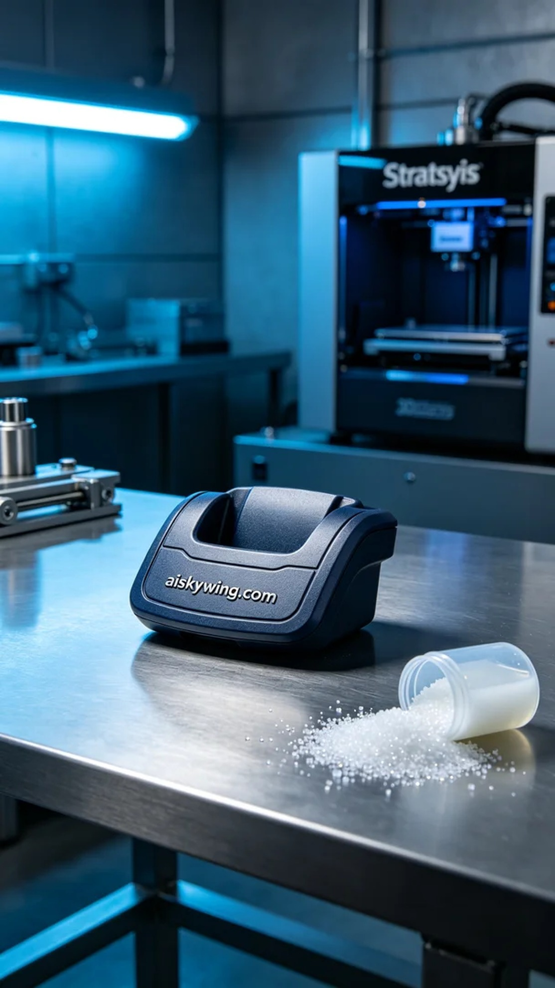
Life may be tough, but we must keep moving forward. Just like when we took on the project for a children's car seat interface cover, someone reached out to us for a much-needed replacement part.
For this project, we chose to utilize liquid photopolymer resin as the raw material. This material has excellent fluidity and fine molding capabilities. We set the printer parameters to a layer thickness of 0.1 mm, a printing temperature of 25°C, a power setting of 80%, and a speed of 60 mm per hour to ensure both quality and efficiency.
The entire printing process went smoothly. The Stratasys printer operated steadily, and the liquid resin was injected into the print head, forming the structure of the children's car seat interface cover. Throughout the printing process, we closely monitored the device's operation, routinely checking the progress to ensure that each layer met our quality standards.
After printing was completed, we moved on to the post-processing phase. First, we placed the printed cover into a cleaning tank and used a specialized cleaning agent to remove any residual resin from the surface. Next, we proceeded to sand the cover to eliminate any burrs, ensuring a smooth finish and feel. Finally, we cured it under a UV lamp for 30 minutes to enhance its strength and durability, inspecting it thoroughly to confirm that every detail met our standards.
While the production process was intricate, the final result was rewarding. The creation of the children's car seat interface cover not only let us gain valuable experience but also provided a solution for our friend.
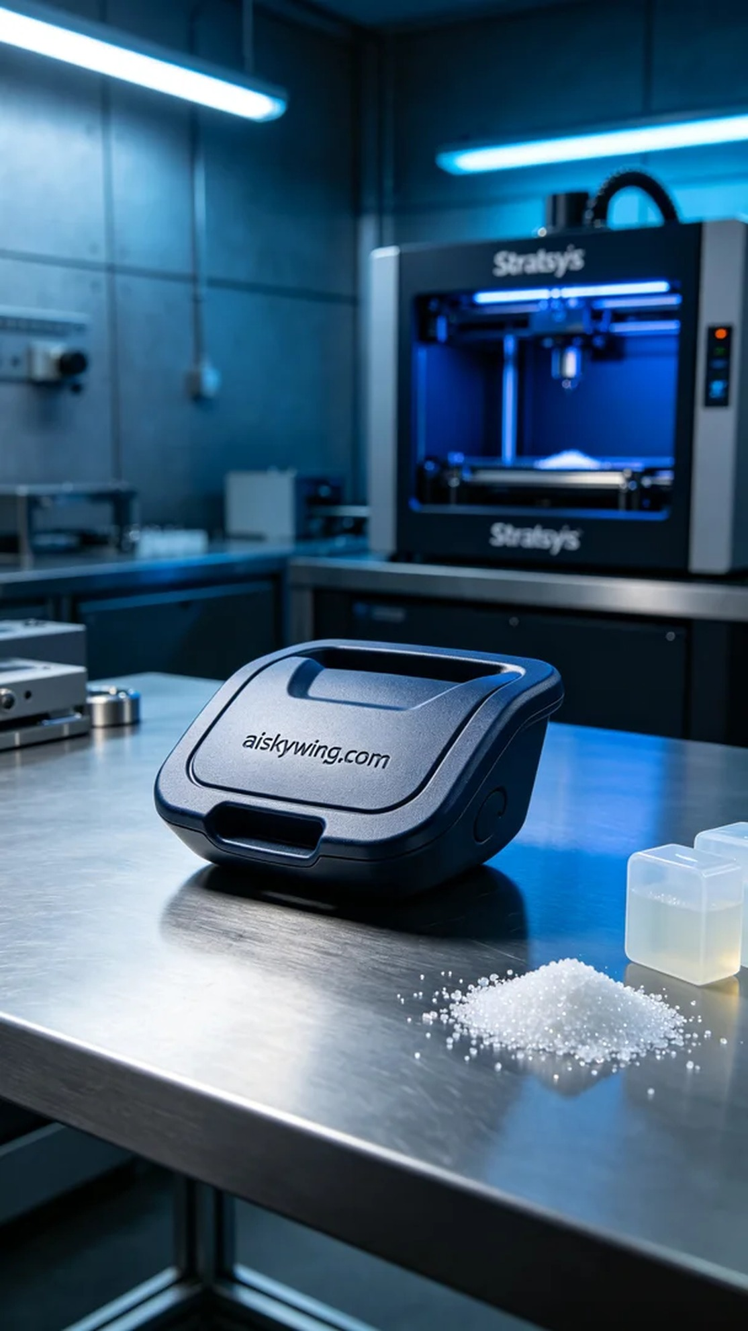
我们接到一位朋友的消息，他提到需要一个儿童安全座椅接口盖来替换损坏的部件。为了满足他的需求，我们决定使用Stratasys品牌的3D打印技术进行生产，确保产品的精度和质量。
在此项目中，我们选择了未成型的液态光敏树脂作为原材料。这种材料具有良好的流动性和精细的成型能力。打印机的参数设置为层厚0.1毫米，打印温度为25°C，功率设定为80%，速度为每小时60毫米，以便在保证打印质量的同时，缩短生产时间。
整个打印过程顺利进行。Stratasys打印机运转平稳，液态光敏树脂顺利注入打印头，形成儿童安全座椅接口盖的结构。在打印过程中，我们全程监控设备运行情况，定期检查打印进度，确保每一层的质量都符合标准。
打印结束后，我们进入后处理阶段。首先，我们将打印好的接口盖放入清洗槽中，使用专用清洗剂去除表面的残留树脂。接着，对接口盖进行打磨，以去除可能存在的毛刺，确保其光滑度和触感。最后，我们对其进行固化处理，在UV灯下放置30分钟，以增强其强度和耐用性，经过检验，确保每一个细节都达到我们的标准。
这次的生产过程虽然繁琐，但最终的结果令人满意。儿童安全座椅接口盖的制作，不仅让我们积累了经验，也为这位朋友解决了问题。
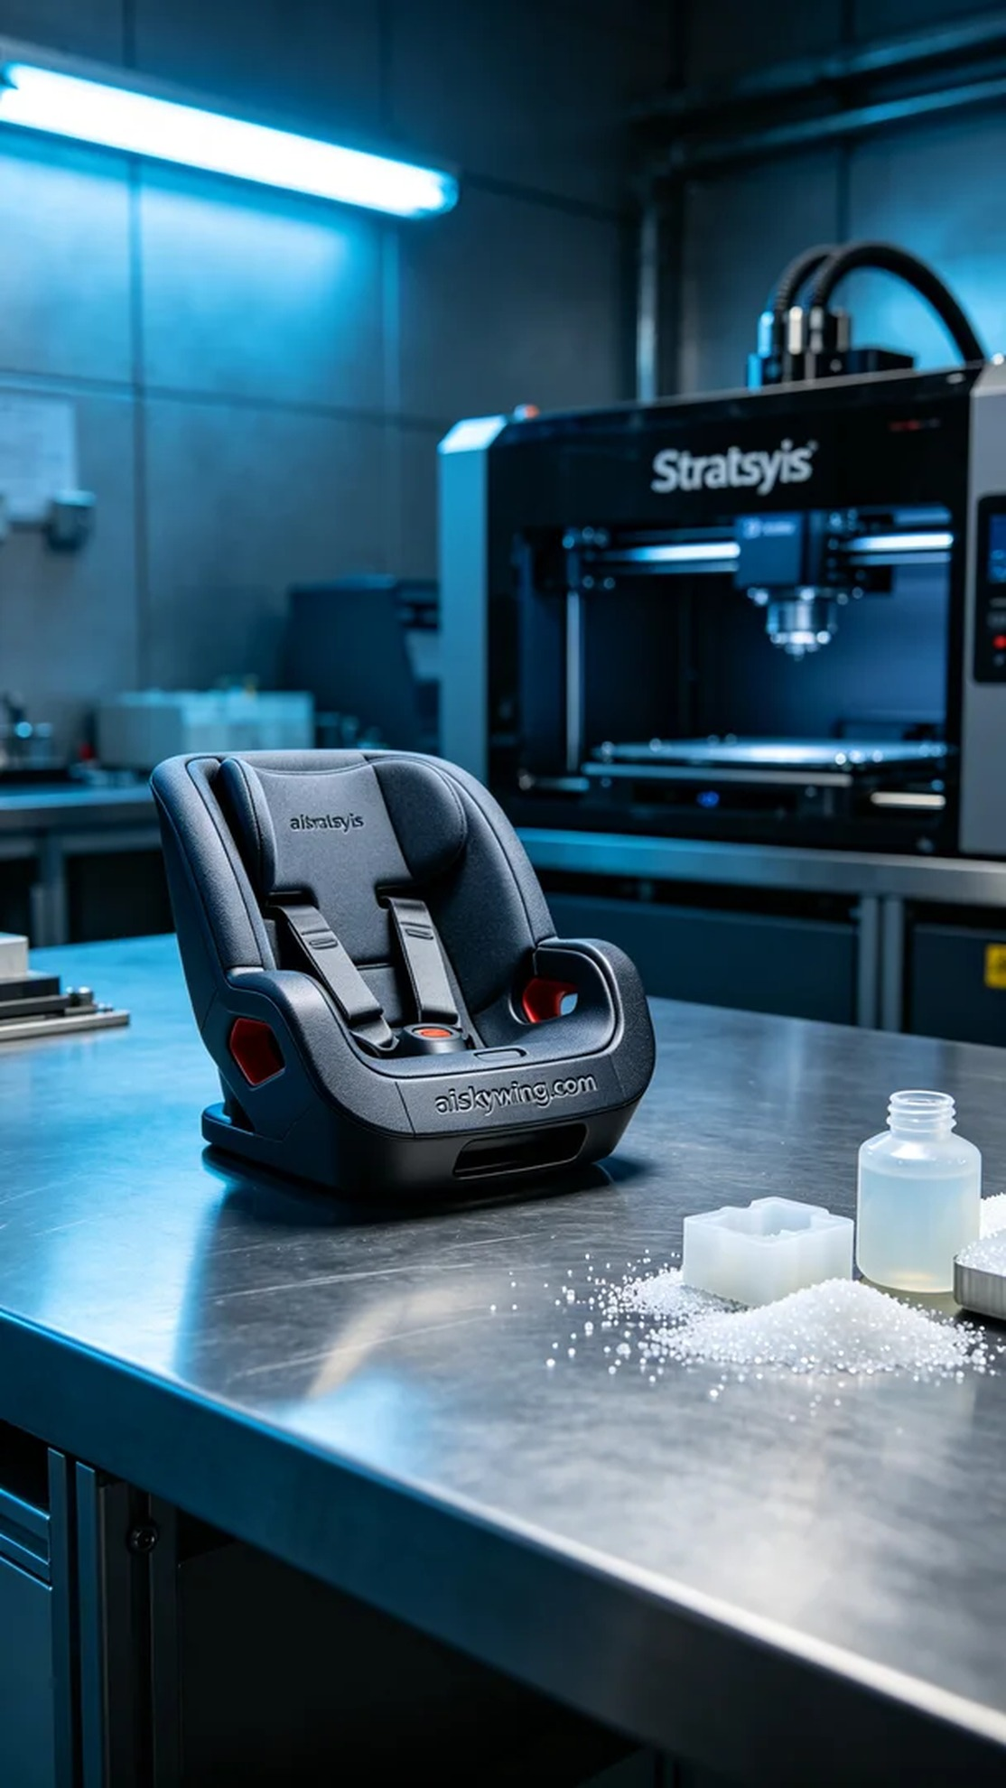
Aiskywing Industrial 3D Printing
Child safety seat interface cover


