0723-充电口盖铰链的生产记录
Charging port cover hinge
🖨️ CNC机加工
🖥️ 打印机: Rize
📦 材料: 高透明高耐温
生活再难，也别停下脚步。就像接下这个充电口盖铰链的单子，有人因为缺少一个耐用的保护件而找上我们。
No matter how difficult life gets, don't stop moving forward. Just like when we received the order for the charging port cover hinge; someone reached out to us because they were lacking a durable protective component.
________________________________________________________________________________
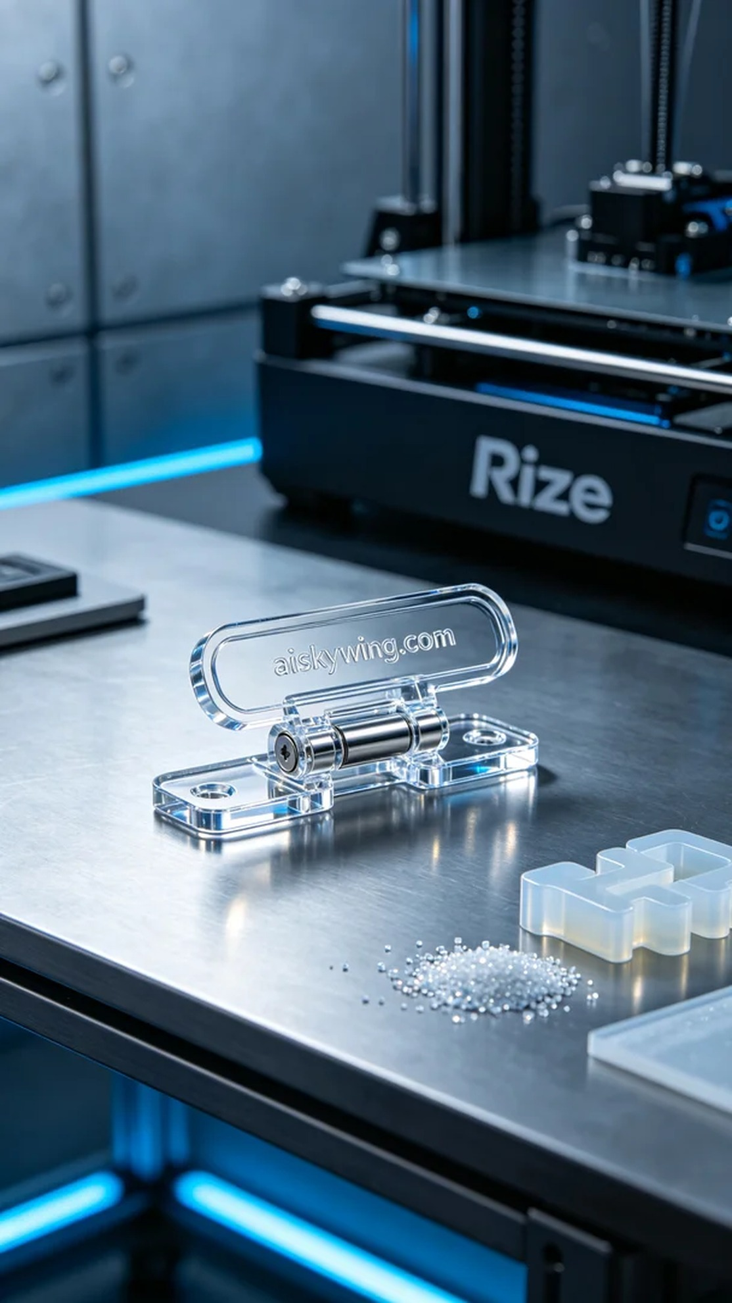
Life can get tough, but that shouldn't stop us. Just like taking on the task of the charging port cover hinge, someone reached out to us because they needed a durable protective part.
When preparing for this project, we chose high transparency and high-temperature PC engineering plastic as the material. We decided to use the Rize brand 3D printer, known for its excellent performance with clear materials. The printing parameters were set to a layer thickness of 0.1mm, a temperature of 60℃, power at 70%, and a printing speed of 30mm per second, with an estimated completion time of 4 hours.
During the printing process, the Rize printer operated smoothly, and the liquid photopolymer resin gradually solidified under heat and light. We continuously monitored the printing, ensuring that each layer bonded perfectly without defects. As we observed, the shape of the part gradually emerged, and the engraving of "aiskywing.com" became clearly visible.
Once the printing was complete, we moved on to the post-processing stage. First, we separated the part from any uncured resin, then placed it into a cleaning tank, using an ultrasonic cleaner to remove any residual resin on the surface. Following that, we proceeded to polish the part to enhance its smoothness and tactile quality, and then cured it to ensure it met the required temperature resistance. After inspection, all parameters were confirmed to be up to standard, and the part quality met our expectations.
After this entire production process, the charging port cover hinge not only fulfilled its intended purpose but also provided users with a positive experience. We are satisfied with this project and look forward to the next challenge that awaits us.
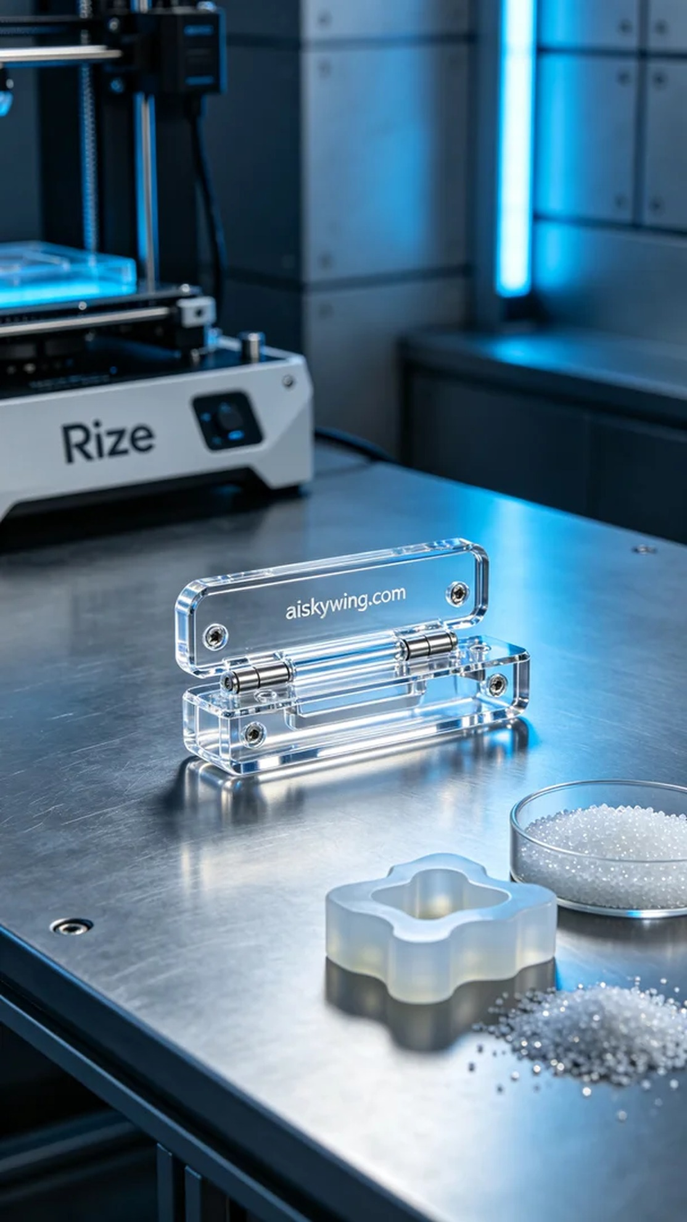
在社交媒体平台Twitter上，有人因充电口盖铰链的破损，求助于我们。他们需要一个耐用且高质量的零件来替换，确保产品的安全性和美观性。我们决定用高透明高耐温的PC透明工程塑料来制作这个部件，以满足他们的需求。
准备工作开始时，我们选用了Rize品牌的3D打印机，这款设备在高透明材料的打印方面表现优异。我们将打印参数设置为层厚0.1毫米，温度设定在60℃，功率为70%，打印速度为30毫米每秒，预计完成时间为4小时。这些参数的选择旨在确保部件的精度和表面质量。
打印过程中，Rize打印机运行稳定，液态树脂材料在加热和光照的作用下逐渐固化。我们时刻监控打印过程，确保每一层都能完美粘合，避免出现任何瑕疵。在观察中，部件的形状逐渐显现，"aiskywing.com"的字样也清晰可见。
打印完成后，我们进入后处理阶段。首先将部件与未固化的树脂分离，随后将其放入清洗槽中，用超声波清洗机进行清洗，去除表面的残余树脂。接下来对部件进行了打磨，以提升光滑度和手感，最后进行了固化处理，确保其耐温性达到要求。经过检验，所有参数均符合标准，部件质量达到了预期。
经过这次的生产过程，充电口盖铰链不仅达到预期效果，还能给使用者带来良好的体验。我们对这个项目感到满意，并期待着下一个挑战的到来。
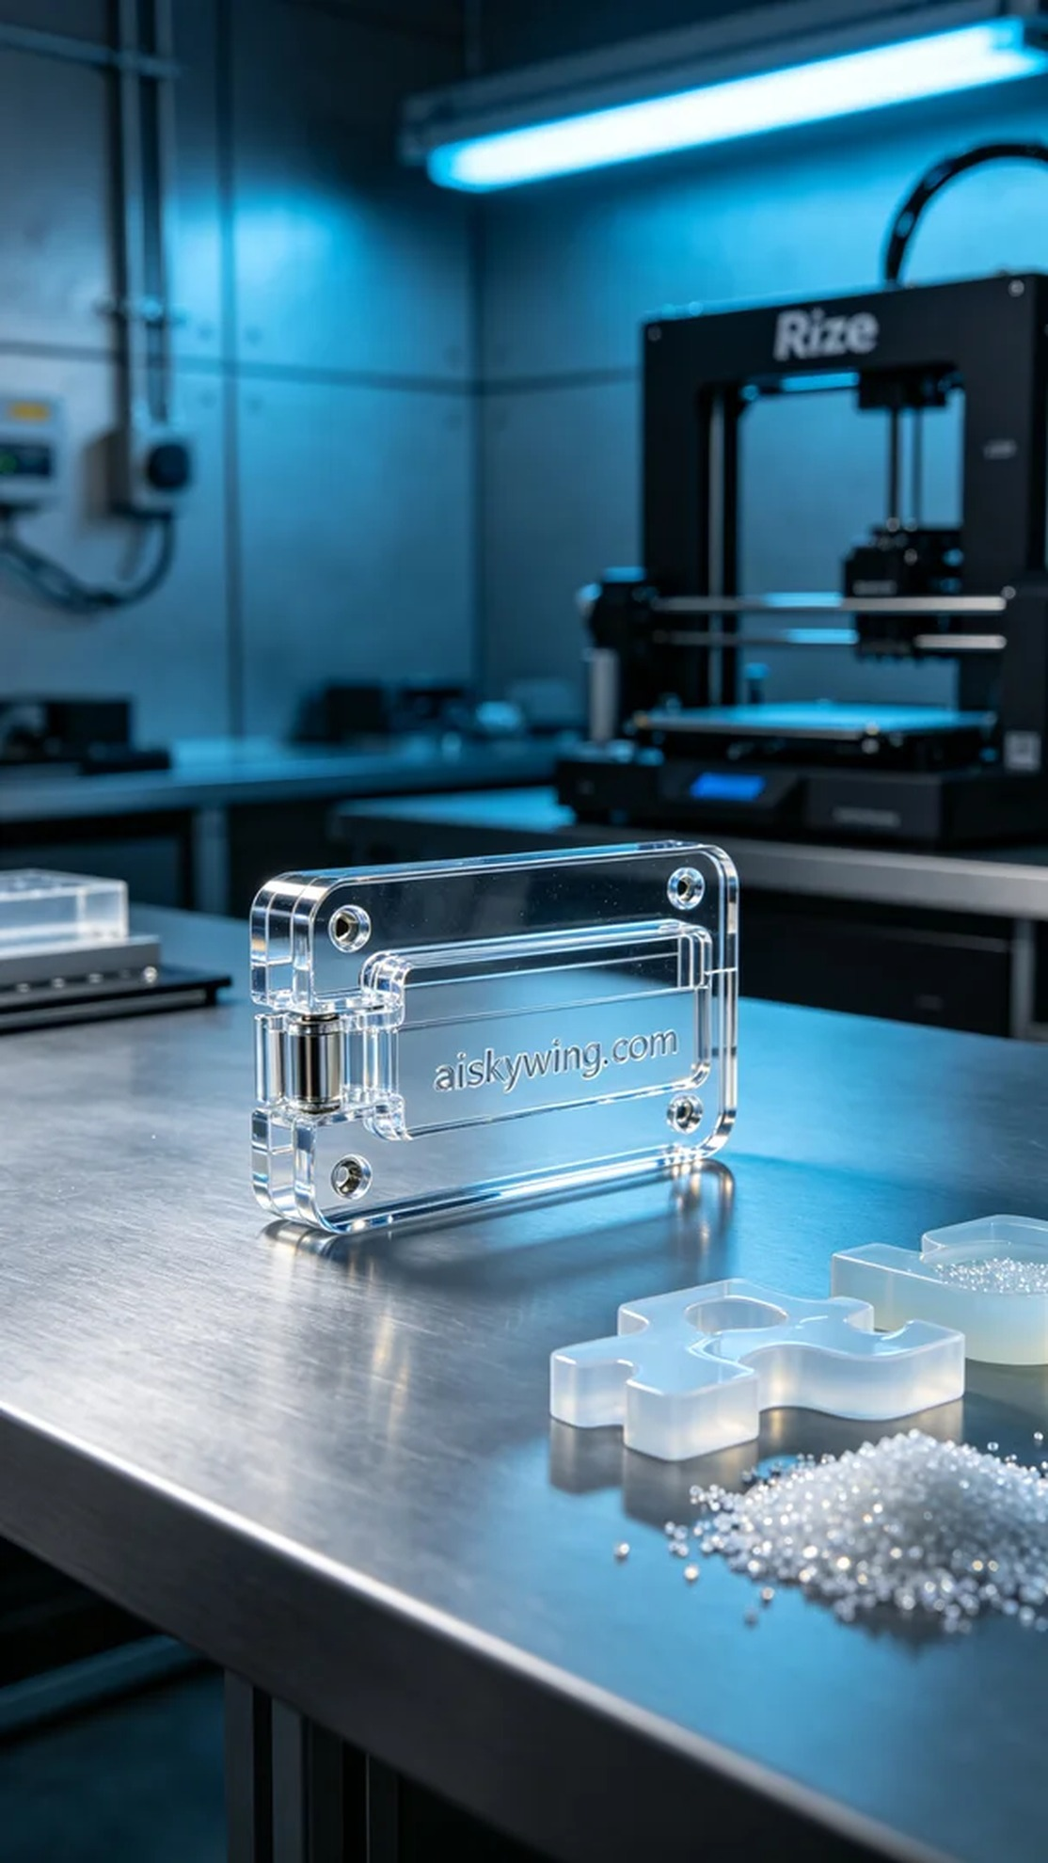
Aiskywing Industrial 3D Printing
Charging port cover hinge


