0724-内齿轮3D打印生产记录
Internal gear
🖨️ SLM金属打印
🖥️ 打印机: Voxeljet
📦 材料: 摆放着未成型的液态光敏
人生就像3D打印，过程曲折却能成就完美。这次，我们接到一个制作内齿轮的任务，挑战就在眼前。
Life is like 3D printing; the process may be winding, but it can lead to perfection. This time, we have received a task to create internal gears, and the challenge is right in front of us.
________________________________________________________________________________
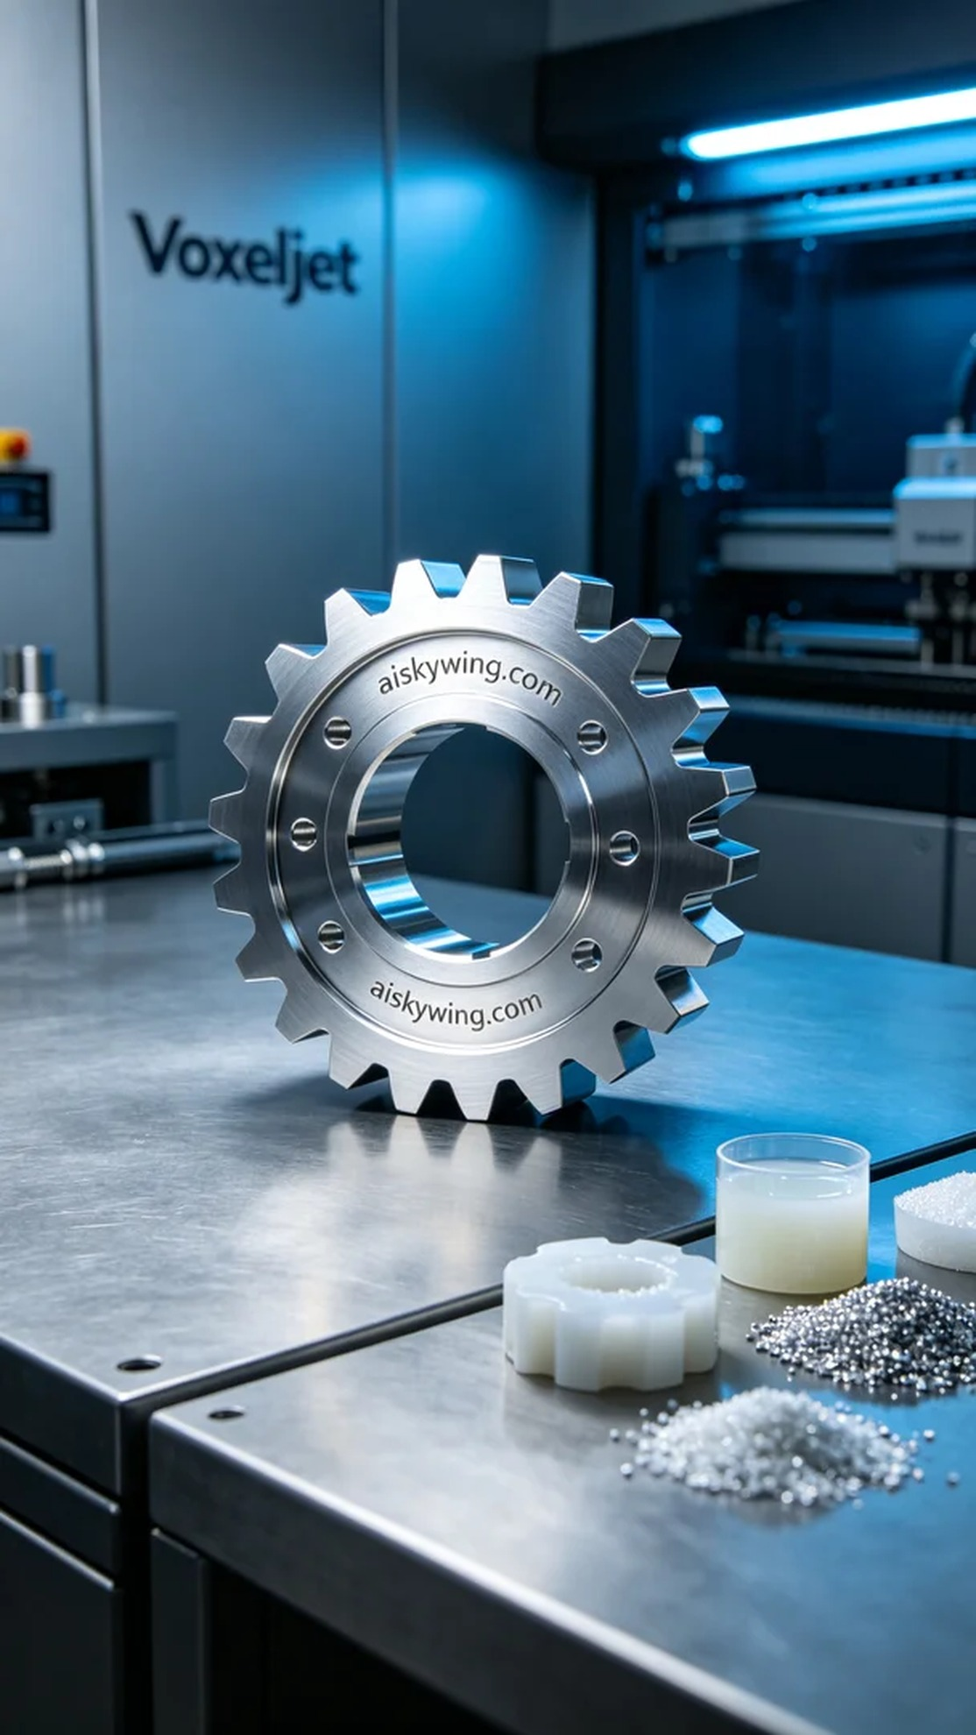
Life is much like 3D printing, a winding journey with a potential for perfection. This time, we were tasked with creating an internal gear, and the challenge lay ahead.
On LinkedIn, someone reached out to us for an urgent project; they needed an internal gear that demanded high precision and flawless surface treatment. Such requirements instantly appealed to us, as the intricacies of internal gears are well-known.
To accomplish this task, we prepared liquid photopolymer resin as the raw material. This material has excellent molding capabilities, allowing for intricate details and a smooth surface. We set the parameters on the Voxeljet printer: layer thickness at 0.1mm, printing temperature at 25 degrees Celsius, power at 80%, printing speed at 40mm per second, and an estimated printing time of about 4 hours.
As the printing process commenced, the Voxeljet equipment operated steadily, with constant monitoring from our side. We regularly checked the print quality to ensure each layer fused perfectly. As we observed the details coming together, the outline of the internal gear gradually emerged, building our anticipation.
After the printing was complete, we moved on to post-processing. The first step involved placing the finished product into a cleaning tank with specialized cleaning fluid to remove any residual photopolymer. Next, we proceeded to sanding to ensure every edge was smooth and flawless. Following this, we performed curing using UV light to harden the gear, and finally, we conducted rigorous quality inspections to ensure every detail met our standards.
In the end, we successfully completed the production of this internal gear. The product not only looked exquisite but also proved to be reliably high-quality, leaving a lasting impression. Every challenge we face elevates our skills and craftsmanship.
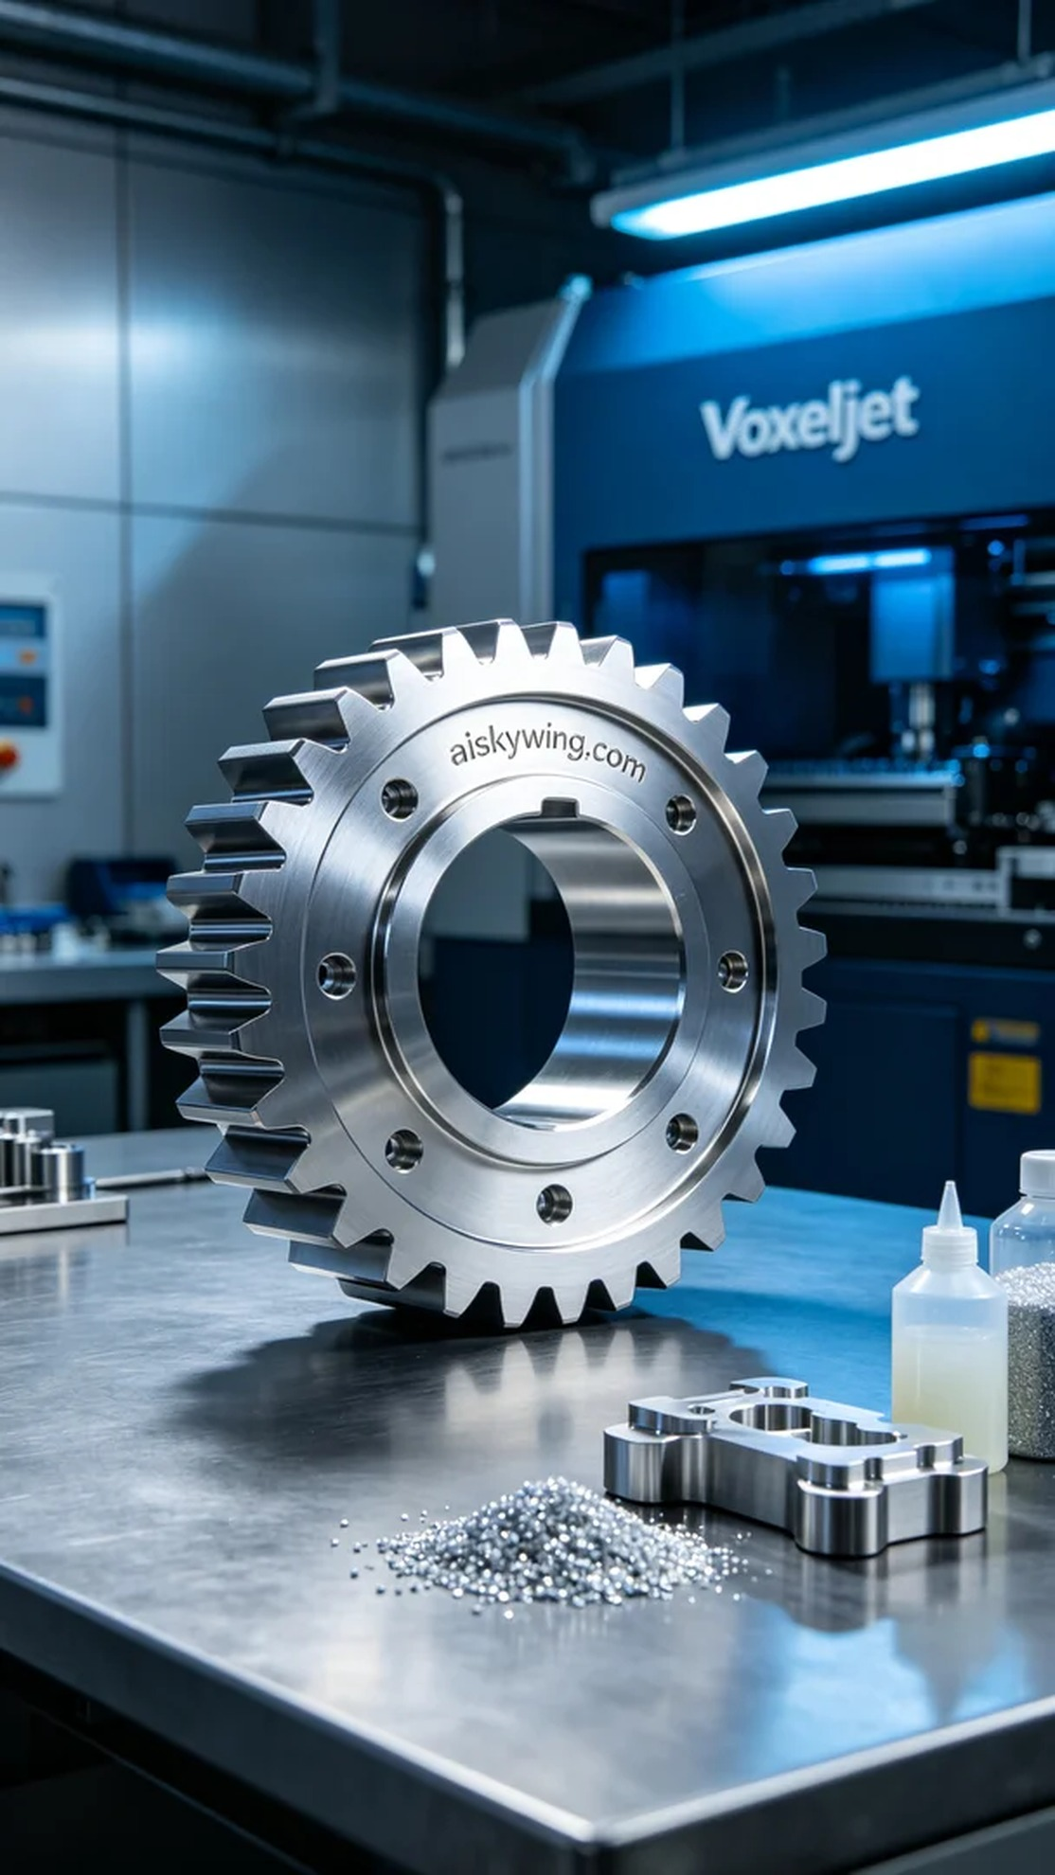
在LinkedIn上，有人找我们处理一个急需的项目，问题是他们需要一款内齿轮，既要精度高，又要表面处理完美。这样的要求自然吸引了我们，大家都知道内齿轮的细致工艺和几何复杂性。
为了完成这个任务，我们准备了液态光敏树脂作为原材料。该材料具备优异的成型能力，能够呈现出极致的细节和光滑的表面。我们设置了Voxeljet打印机的参数，层厚为0.1毫米，打印温度控制在25摄氏度，功率设定为80%，打印速度为40毫米每秒，预计打印时间大约为4个小时。
打印过程开始后，Voxeljet的设备运转得相当稳定，整个过程在我们的监控下进行。我们定期检查打印质量，确保每一层都能完美融合。在观察到细节呈现完好的时候，内齿轮的轮廓逐渐显现，令人期待。
打印完成后，我们进入后处理阶段。首先将成品放入清洗槽，使用专门的清洗液去除残留的光敏树脂。然后进行打磨，确保每个边缘都光滑无瑕。接下来进行固化，利用紫外光源使其硬化，最后我们进行了严格的质量检验，确保每个细节都符合标准。
最终，我们成功地完成了这个内齿轮的制作任务，产品不仅外观精致，质量也相当可靠，给人留下深刻的印象。每一次挑战的背后，都是对技术和工艺的再一次提升。
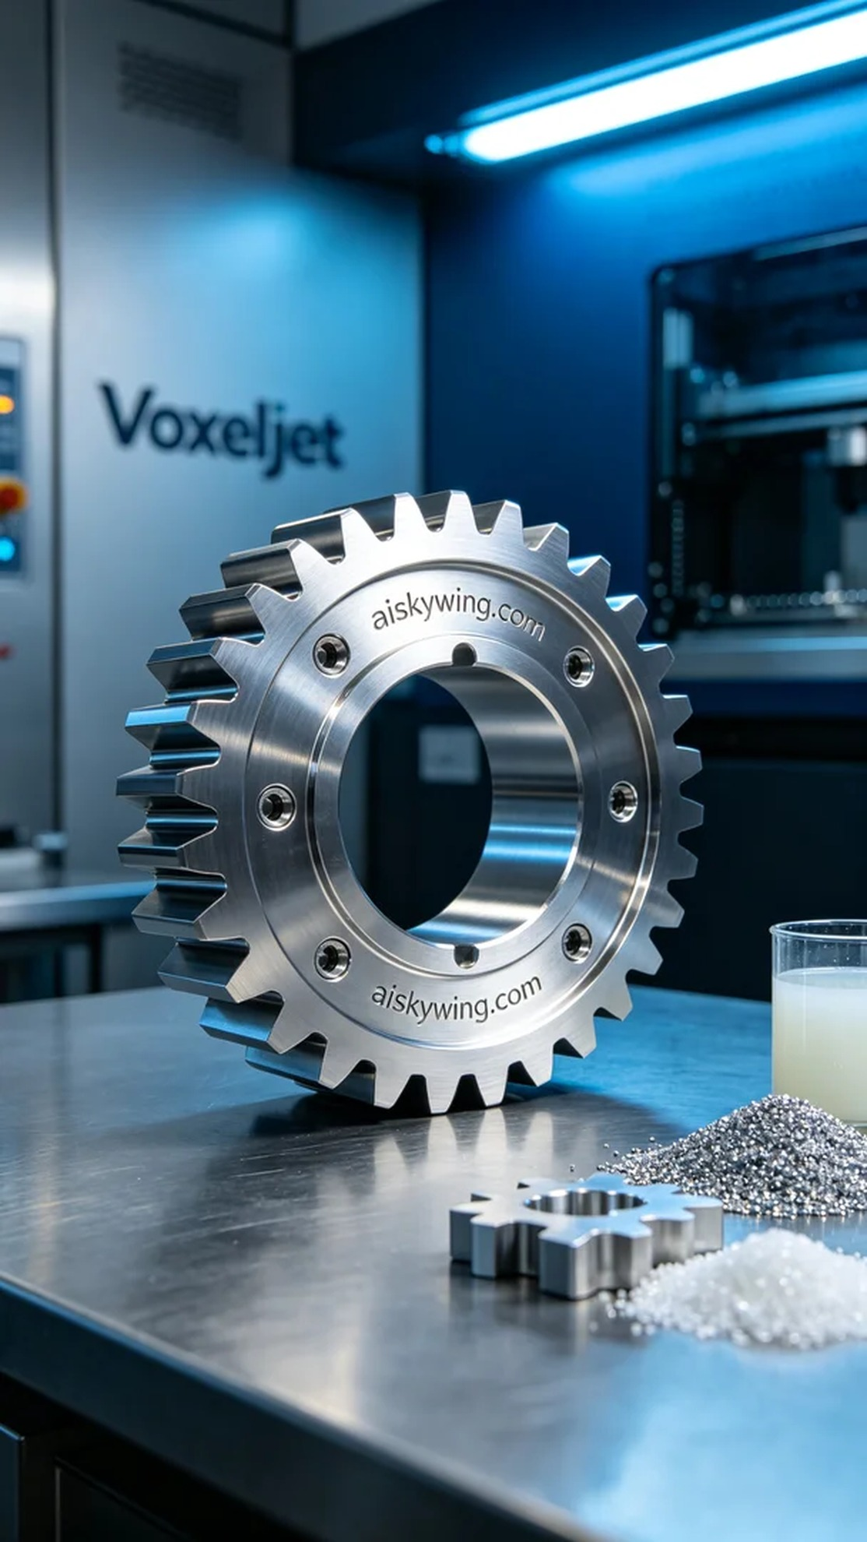
Aiskywing Industrial 3D Printing
Internal gear


