0725-减速器外壳制作全记录
Gearbox housing
🖨️ CNC机加工
🖥️ 打印机: Stratasys
📦 材料: 摆放着未成型的液态光敏
生活再难，也别停下脚步。就像我们接下这个减速器外壳的活儿，虽然挑战重重，但每一步都能让我们更坚定。
No matter how difficult life gets, don't stop moving forward. Just like when we took on the job of the speed reducer housing, although there are many challenges, each step makes us more resolute.
________________________________________________________________________________
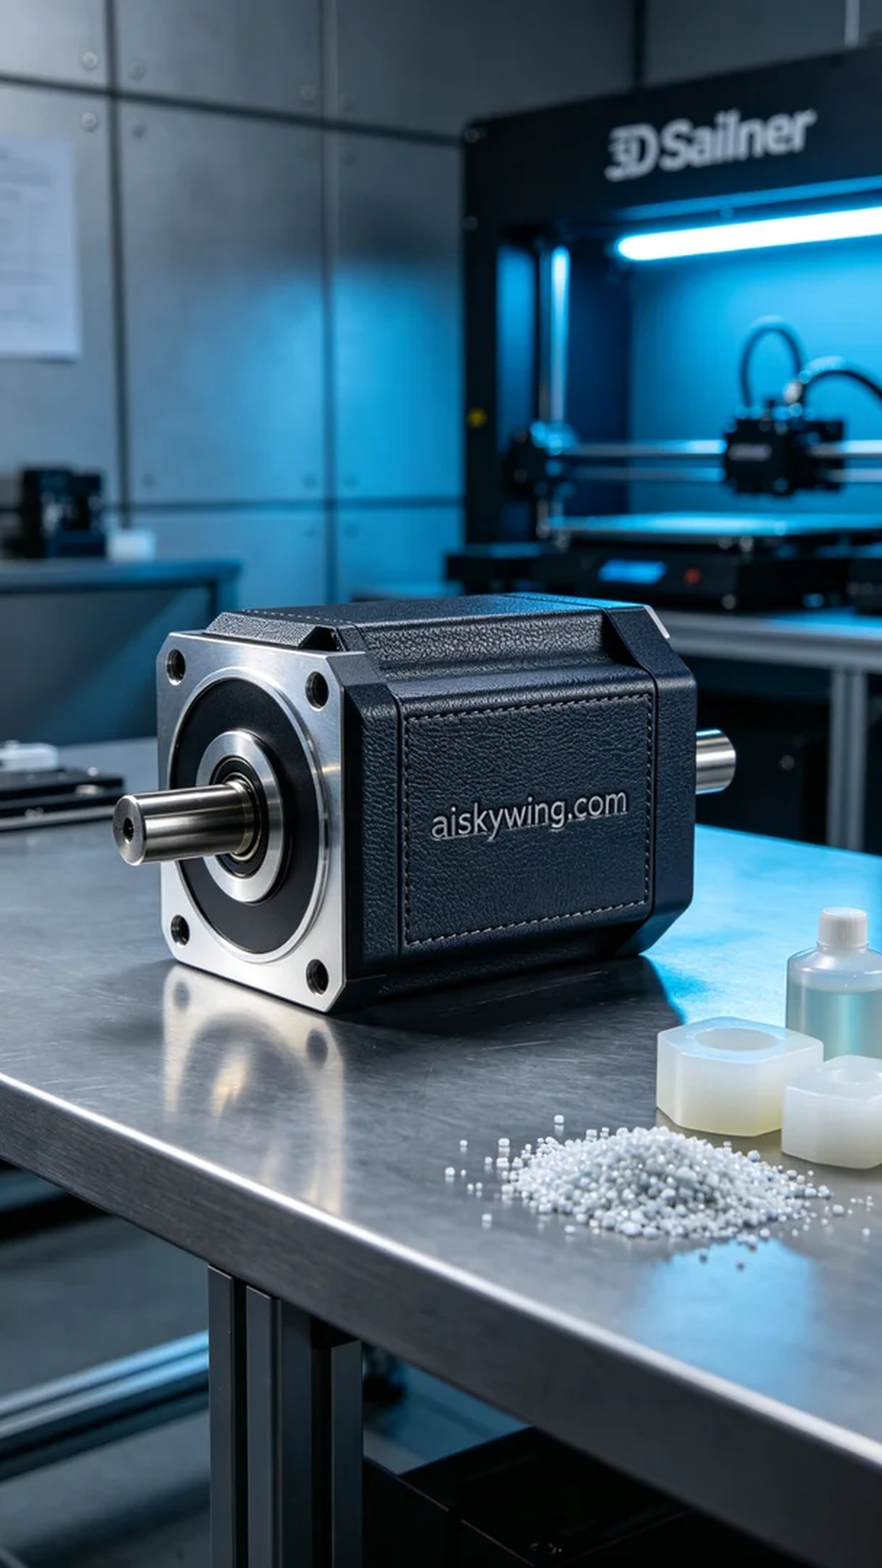
Life can be tough, but we must keep moving forward. Just like when we took on the task of creating this gear reducer housing; every challenge makes us more determined.
On Instagram, someone reached out looking to enhance the performance of their machinery with a custom-made high-precision gear reducer housing. After discussing their specific needs, we immediately began preparations for the project.
For this housing, we used uncured liquid photopolymer resin, which possesses excellent forming characteristics and wear resistance, making it suitable for industrial-grade applications. We set the Stratasys 3D printer parameters to a layer thickness of 0.1 mm, temperature at 25 degrees Celsius, power at 50%, and speed set to 30 mm/s, with an expected print time of around 8 hours.
The printing process proceeded smoothly, with the Stratasys printer operating at a consistent speed and the liquid photopolymer resin flowing seamlessly into the print head. We monitored the equipment throughout the process to ensure that each layer formed accurately. As time passed, the outline of the gear reducer housing became increasingly clear, building anticipation.
After printing, we entered the post-processing phase. First, we soaked the finished product in a cleaning solution to remove any uncured resin from the surface, then used fine sandpaper to polish it, ensuring a smooth and flawless surface. Next, we performed a curing treatment to guarantee its strength and durability, followed by a thorough inspection to ensure that every detail met our standards.
In the end, this gear reducer housing was completed, and thanks to our hard work, it not only looks fantastic but also performs reliably. Providing high-quality products like this truly makes us proud.
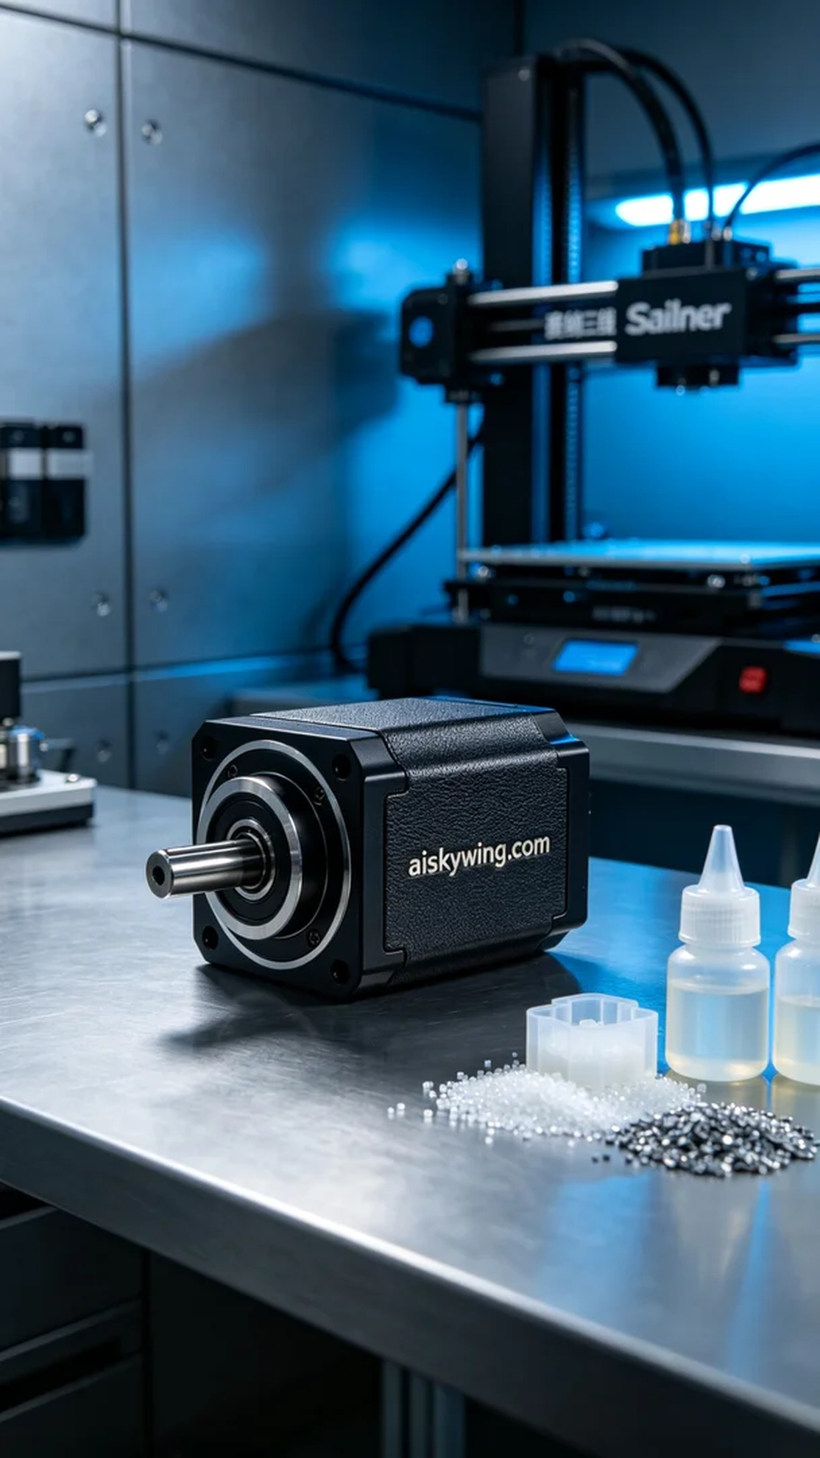
在Instagram上，有人因为想要提升自己机器的性能，找到我们，希望能定制一款高精度的减速器外壳。经过沟通，我们确定了这个项目的具体需求，立刻开始了准备工作。
此次制作的减速器外壳采用的是未成型的液态光敏材料，这种材料具备优异的成型特性和耐磨性，非常适合工业级使用。我们将Stratasys 3D打印机的打印参数设定为0.1毫米的层厚，温度调至25摄氏度，功率为50%，速度设定为30mm/s，预计打印时间在8小时左右。
打印过程非常顺利，Stratasys打印机以稳定的速度运转，液态光敏材料顺畅注入打印头。我们全程监控设备运行状态，确保每一层都能准确成型。随着时间的推移，减速器外壳的轮廓逐渐清晰，令人期待。
打印完成后，我们进入了后处理环节。首先，将成品放入清洗液中浸泡，去除表面未固化的树脂，接着用细砂纸进行打磨，确保表面光滑无瑕疵。之后进行了固化处理，确保其强度和耐用性，最后进行了严密的检验，确保每个细节都满足标准。
最终，这款减速器外壳制作完成，经过我们的努力，它不仅外观精美，而且性能稳定。能够为客户提供高质量的产品，真是让人倍感骄傲。
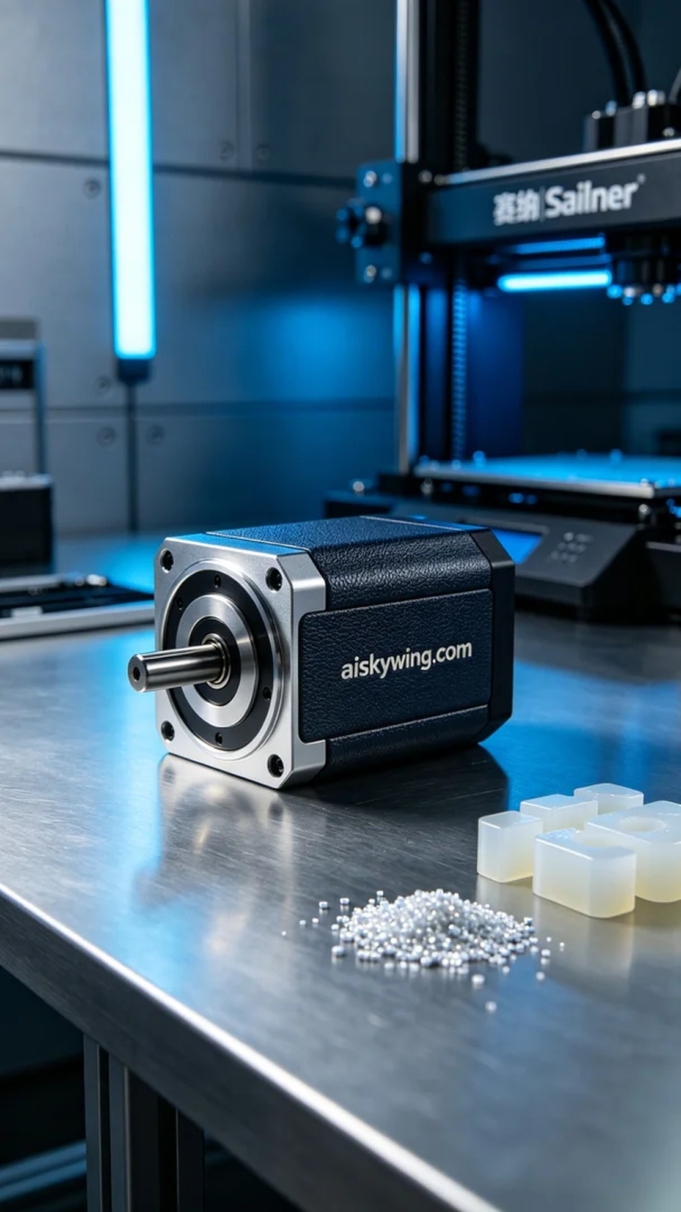
Aiskywing Industrial 3D Printing
Gearbox housing


