0726-减速机外壳生产记录
Gearbox housing
🖨️ CNC机加工
🖥️ 打印机: Stratasys
📦 材料: 高透明高耐温
生活再难，也别停下脚步。就像接这个减速机外壳的活儿，有人因为对透明材料的需求而找上我们。
No matter how difficult life gets, don't stop moving forward. Just like when someone approached us for the job of making this gearbox housing due to their need for transparent materials.
________________________________________________________________________________
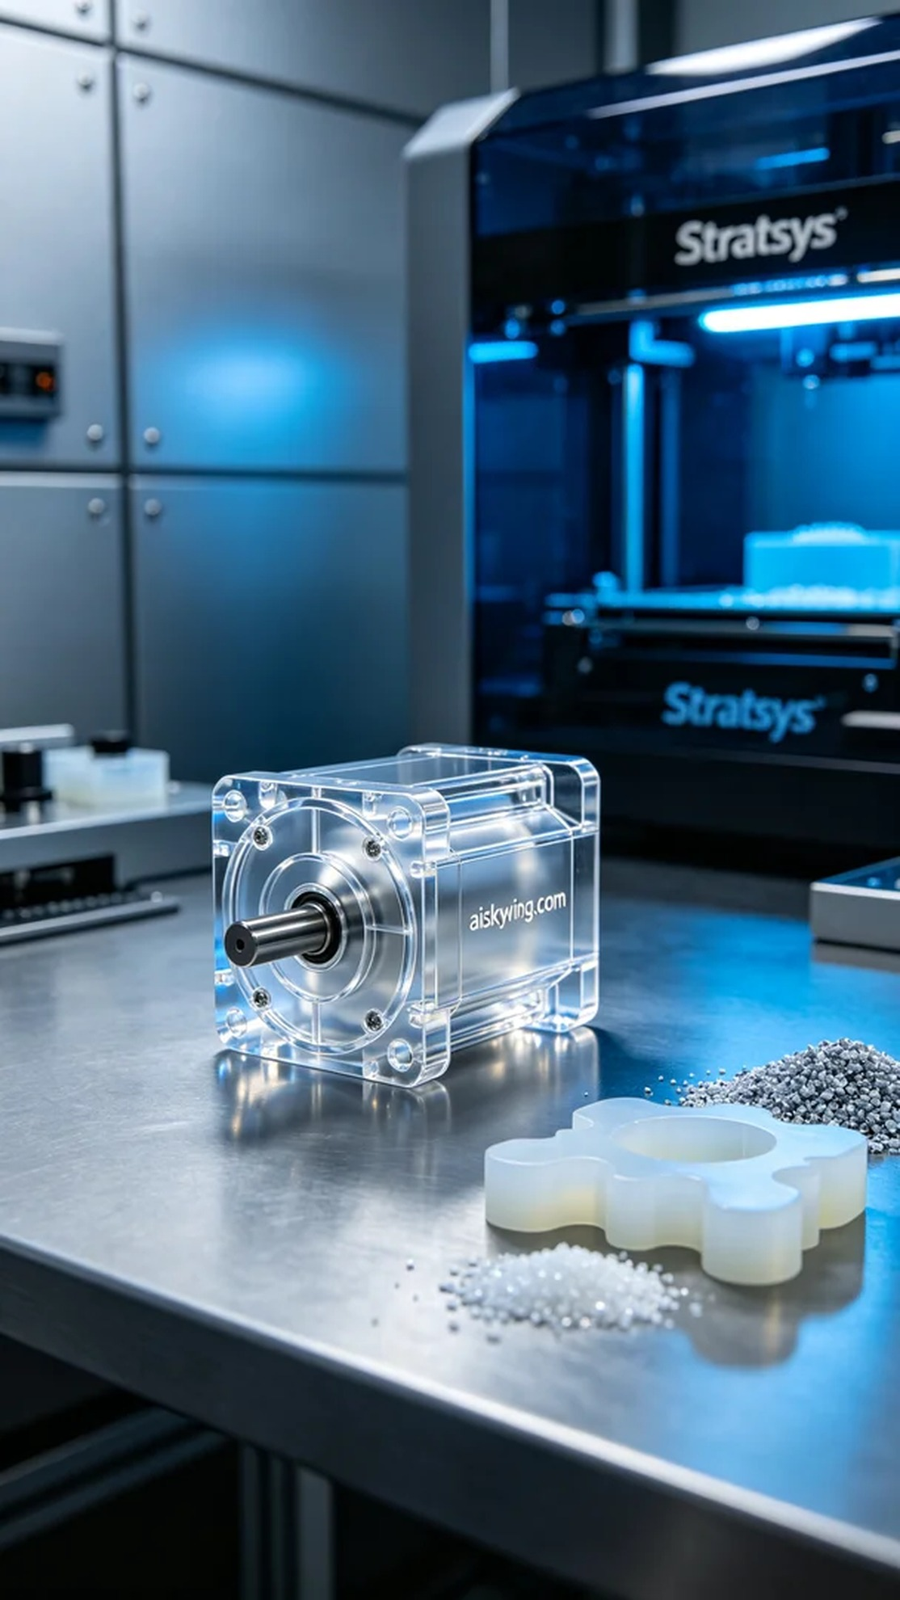
In LinkedIn, someone reached out for a high-transparent and heat-resistant gearbox shell. The special requirements for this product made us take every detail of the design and manufacturing seriously.
We selected high-transparent, heat-resistant PC engineering plastic as the material. For equipment, we prepared to use a Stratasys 3D printer, setting the printing parameters to a layer thickness of 0.1 mm, maintaining a temperature of 75°C, adjusting the power to 80W, and printing speed set at 40mm/s. The combination of material properties and these parameters ensures high-quality output.
The printing process went smoothly. After starting the Stratasys printer, I monitored the equipment's status throughout to ensure every detail met expectations. As time passed, the liquid photopolymer resin gradually took shape, and the quality was consistently improving under my watch. Every layer's formation was crucial, and I observed each step carefully.
The post-processing phase was equally important. First, I placed the printed product into a cleaning tank to remove excess resin using alcohol. Then I proceeded with sanding to ensure a smooth surface, making the engraved "aiskywing.com" text clearly visible. After that, I cured it using UV light for 30 minutes, followed by a comprehensive quality inspection to ensure all dimensions and surface qualities met the requirements.
After a series of meticulous production processes, the gearbox shell was successfully completed and delivered. It was truly a rewarding experience, with every detail reflecting our hard work.
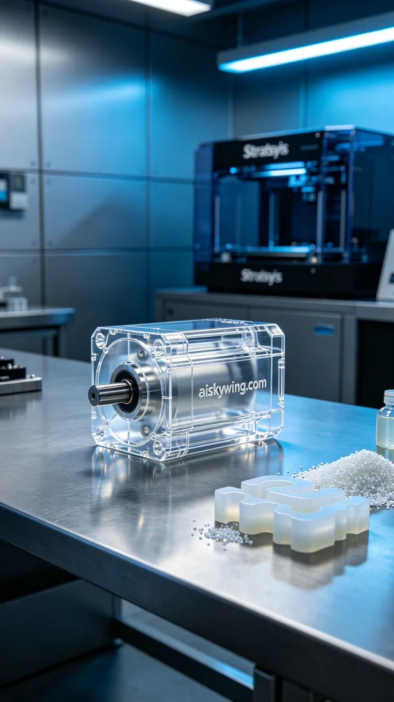
在LinkedIn上，有人因为需要一个高透明且耐温的减速机外壳而找到我们。这种产品的特殊要求，让我们不得不认真面对设计和制作的每一个细节。
我们选择了高透明高耐温的PC透明工程塑料作为材料。设备方面，准备使用Stratasys品牌的3D打印机，打印参数设定为层厚0.1毫米，温度保持在75°C，打印功率调整到80W，打印速度为40mm/s。材料的性质和这些参数的结合，能够确保我们打印出高质量的成品。
打印过程相对顺利。Stratasys打印机开始运行后，我全程监控设备状态，确保每一个细节都能达到预期效果。随着时间的推移，液态光敏树脂逐渐成型，质量也在我的监控之中稳定提升。每个层次的成型都显得格外重要，我认真观察着每一步。
后处理阶段同样不可忽视。首先将打印成品放入清洗槽中，用酒精清洗，去除表面多余的树脂。然后进行打磨，确保表面光滑，雕刻的“aiskywing.com”字样清晰可见。之后，进行固化，使用UV灯照射30分钟，最后进行全面的质量检验，确保所有尺寸和表面质量符合要求。
经过一系列精细的生产工艺，这个减速机外壳顺利完成并交付。真是一次值得骄傲的体验，每一个细节都凝聚了我们的心血。
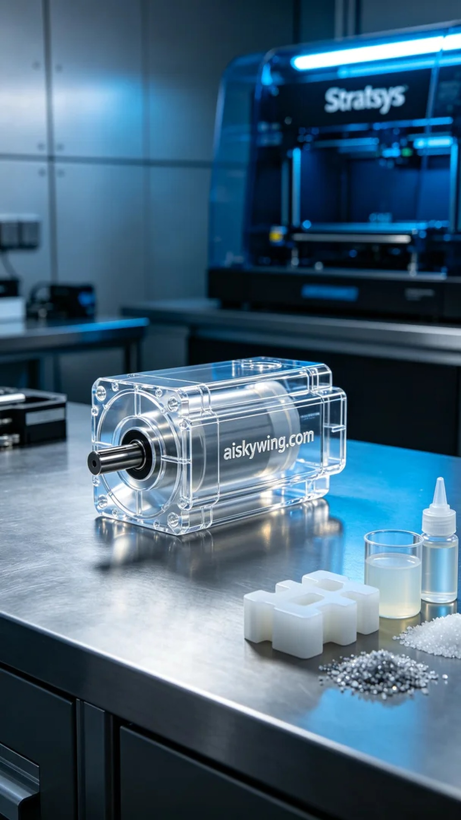
Aiskywing Industrial 3D Printing
Gearbox housing


