0727-3D打印凸轮的生产记录
Cam
🖨️ CNC机加工
🖥️ 打印机: Mimaki
📦 材料: 高透明高耐温
生活就像3D打印，每一步都要精雕细琢。就像最近在LinkedIn上，有人找我们做这个凸轮置于画面正中央的项目，遇到了一些技术难题。
Life is like 3D printing; every step requires meticulous craftsmanship. Recently, someone reached out to us on LinkedIn for a project involving placing a cam in the center of the frame, and we encountered some technical challenges.
________________________________________________________________________________
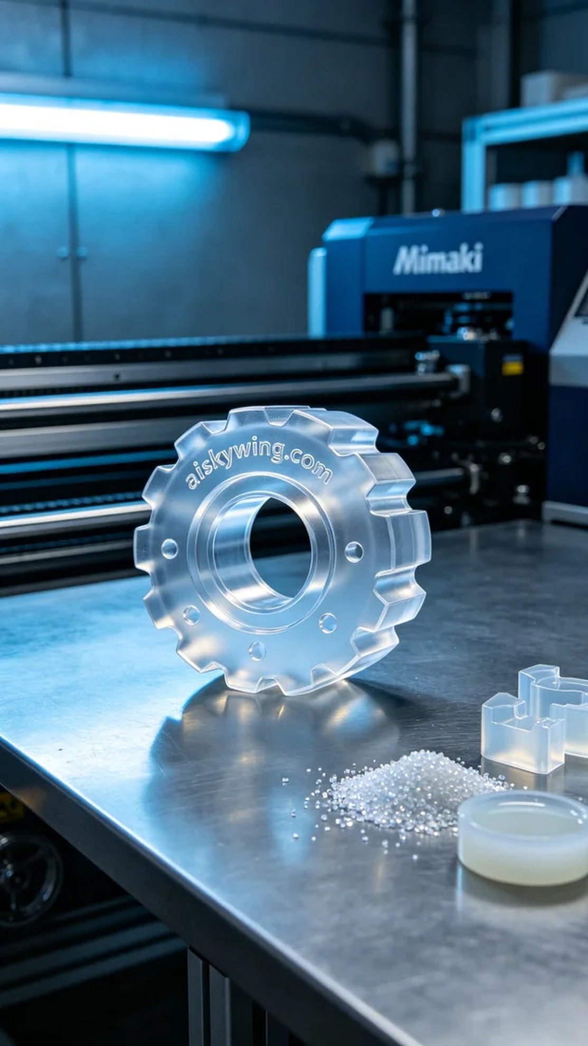
Life is like 3D printing; every step needs to be crafted with care. Recently on LinkedIn, someone approached us about a project involving a cam placed centrally in the image, facing some technical challenges.
In this new project, someone wanted to produce a perfect cam. After some discussion, we understood their strict requirements for high transparency and temperature resistance. To meet these needs, we selected high transparent, high-temperature engineering plastic as the raw material, which not only provides extreme clarity but also maintains stability in high-temperature environments. We utilized the Mimaki brand 3D printer for precise printing.
For device preparation, we set the layer thickness on the Mimaki printer to 0.1 mm, adjusted the printing temperature to 60°C, kept the power at 70%, and set the printing speed to 20 mm/s. This ensures that the products we create have rich details and smooth surfaces. All parameters were validated through multiple tests to ensure the print quality meets expectations.
During the printing process, the device operated smoothly as the liquid resin layered perfectly under the extruder. We monitored the entire process, ensuring each layer was precisely formed. Throughout the printing, the ambient temperature and humidity were maintained at appropriate levels to avoid material deformation or bubble formation.
The post-processing stage is equally crucial. After printing, we placed the finished product in a cleaning tank, using specialized cleaning solutions to remove any residual resin on the surface. We then proceeded to sand the piece to ensure a flawless and smooth surface. Finally, the product underwent UV curing treatment to enhance its durability and transparency, followed by quality inspection to ensure that every item met factory standards.
In the end, this cam underwent a series of meticulous processes, demonstrating our professionalism and dedication. Through our efforts, the project was successfully completed, and the satisfaction of the individual was high.
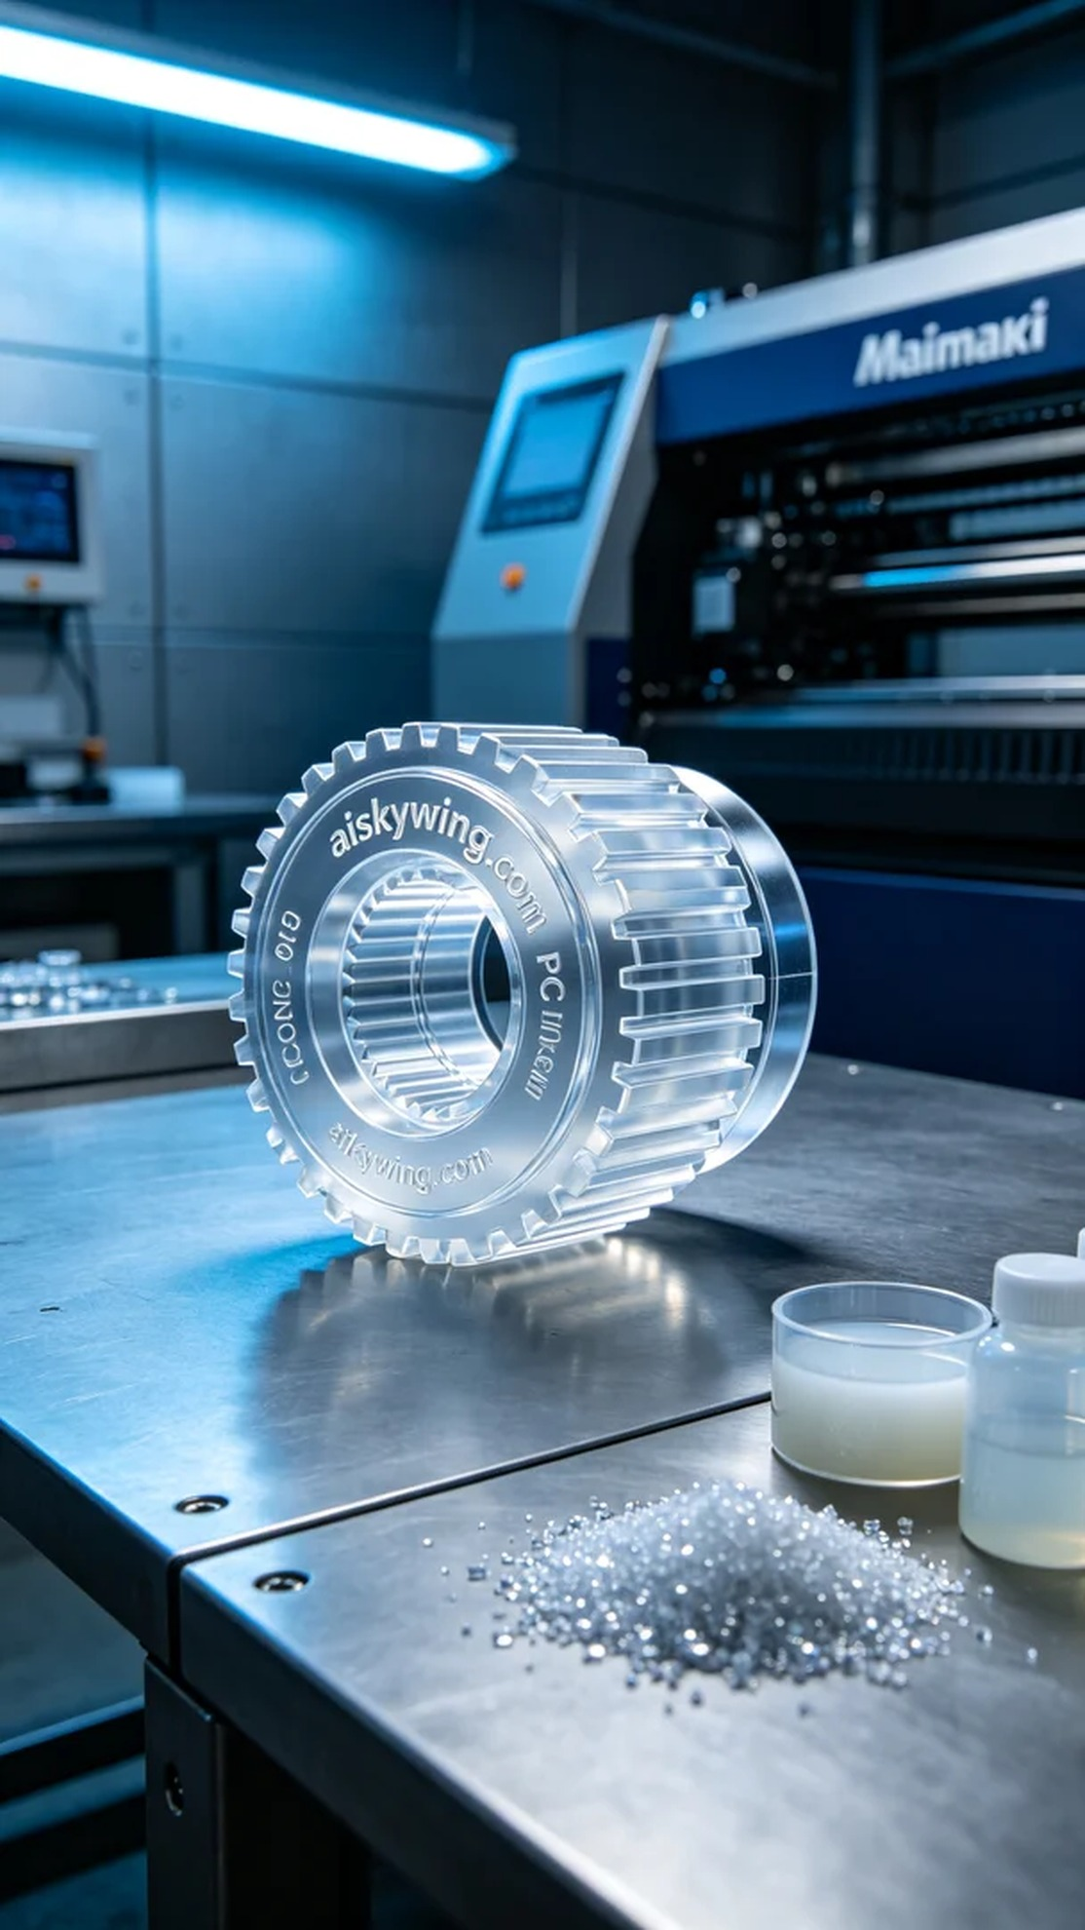
我们的新项目中，有人希望制作一个完美的凸轮。经过沟通，我们了解到他们对产品的高透明度和耐温性有着严格的要求。为了满足这些需求，我们选择了高透明高耐温的工程塑料作为原材料，这种材料不仅能提供极致的清晰度，而且在高温环境下也能保持稳固的性能。我们还使用了Mimaki品牌的3D打印机，准备进行精密打印。
在设备准备方面，我们将Mimaki打印机的层厚设置为0.1毫米，打印温度调至60°C，功率保持在70%，打印速度设定为20毫米每秒。这样可以确保我们制作出的产品细节丰富，表面光滑。所有的参数经过多次实验验证，确保打印质量达到预期。
打印过程中，设备运行平稳，液态树脂在打印头的挤出下逐层成型。我们全程监控，确保每一层都能精准到位。打印期间，环境温度和湿度保持在适宜的范围，避免了材料的变形或气泡产生。
后处理环节同样至关重要。打印完成后，我们将成品放入清洗槽中，使用专用清洗液去除表面残留的树脂。然后进行打磨，确保表面光滑无瑕。最后，成品经过UV固化处理，以增强其耐用性与透明度，经过质量检验后，确保每一件产品都符合出厂标准。
最终，这个凸轮经过一系列的工艺流程，从原材料到成品都体现了我们的专业与用心。通过我们的努力，这个项目得以圆满完成，客户满意度也很高。
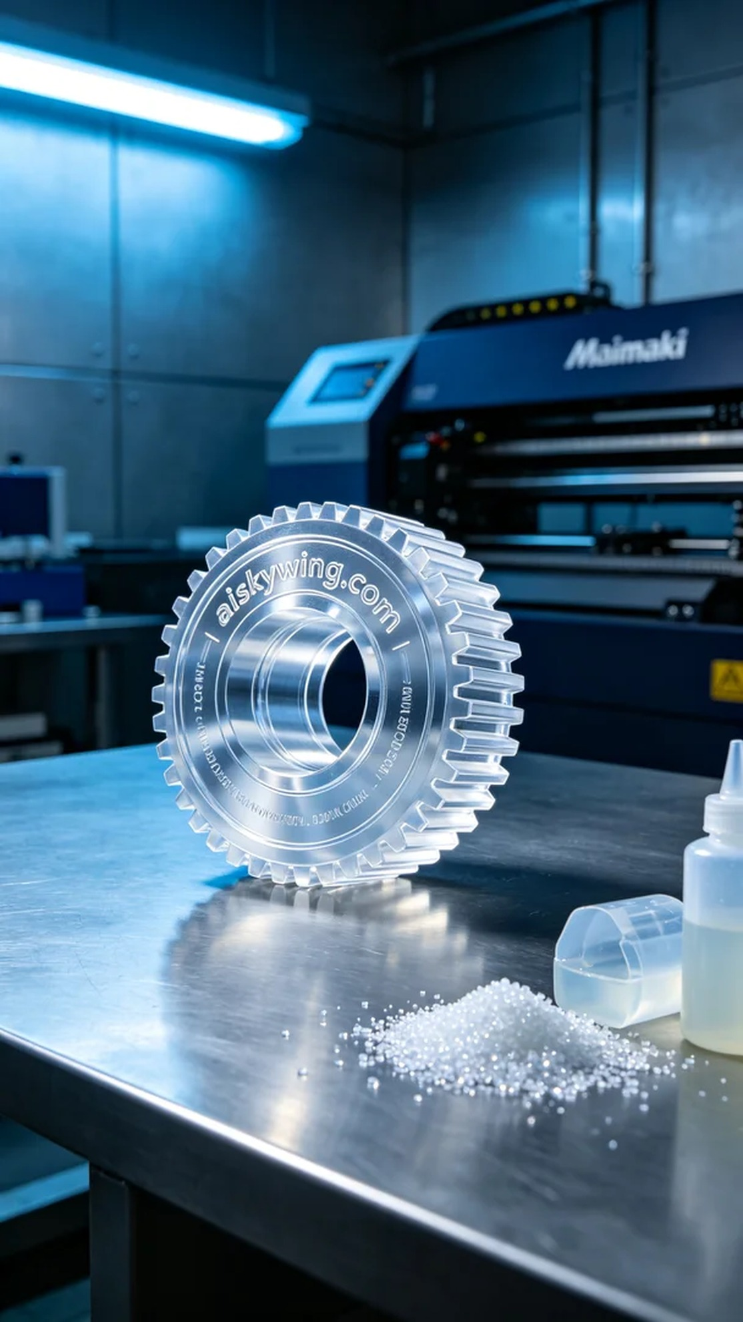
Aiskywing Industrial 3D Printing
Cam


