0728-出风口拨片生产记录
Air outlet flaps
🖨️ CNC机加工
🖥️ 打印机: Voxeljet
📦 材料: 高透明高耐温
生活就像3D打印的过程，总有挑战和未知。最近在YouTube上，有人因为需要一款出风口拨片寻求我们的帮助，这正是我们要解决的问题。
Life is like the process of 3D printing, full of challenges and uncertainties. Recently, someone on YouTube reached out for our help in finding a vent clip, which is exactly the problem we aim to solve.
________________________________________________________________________________
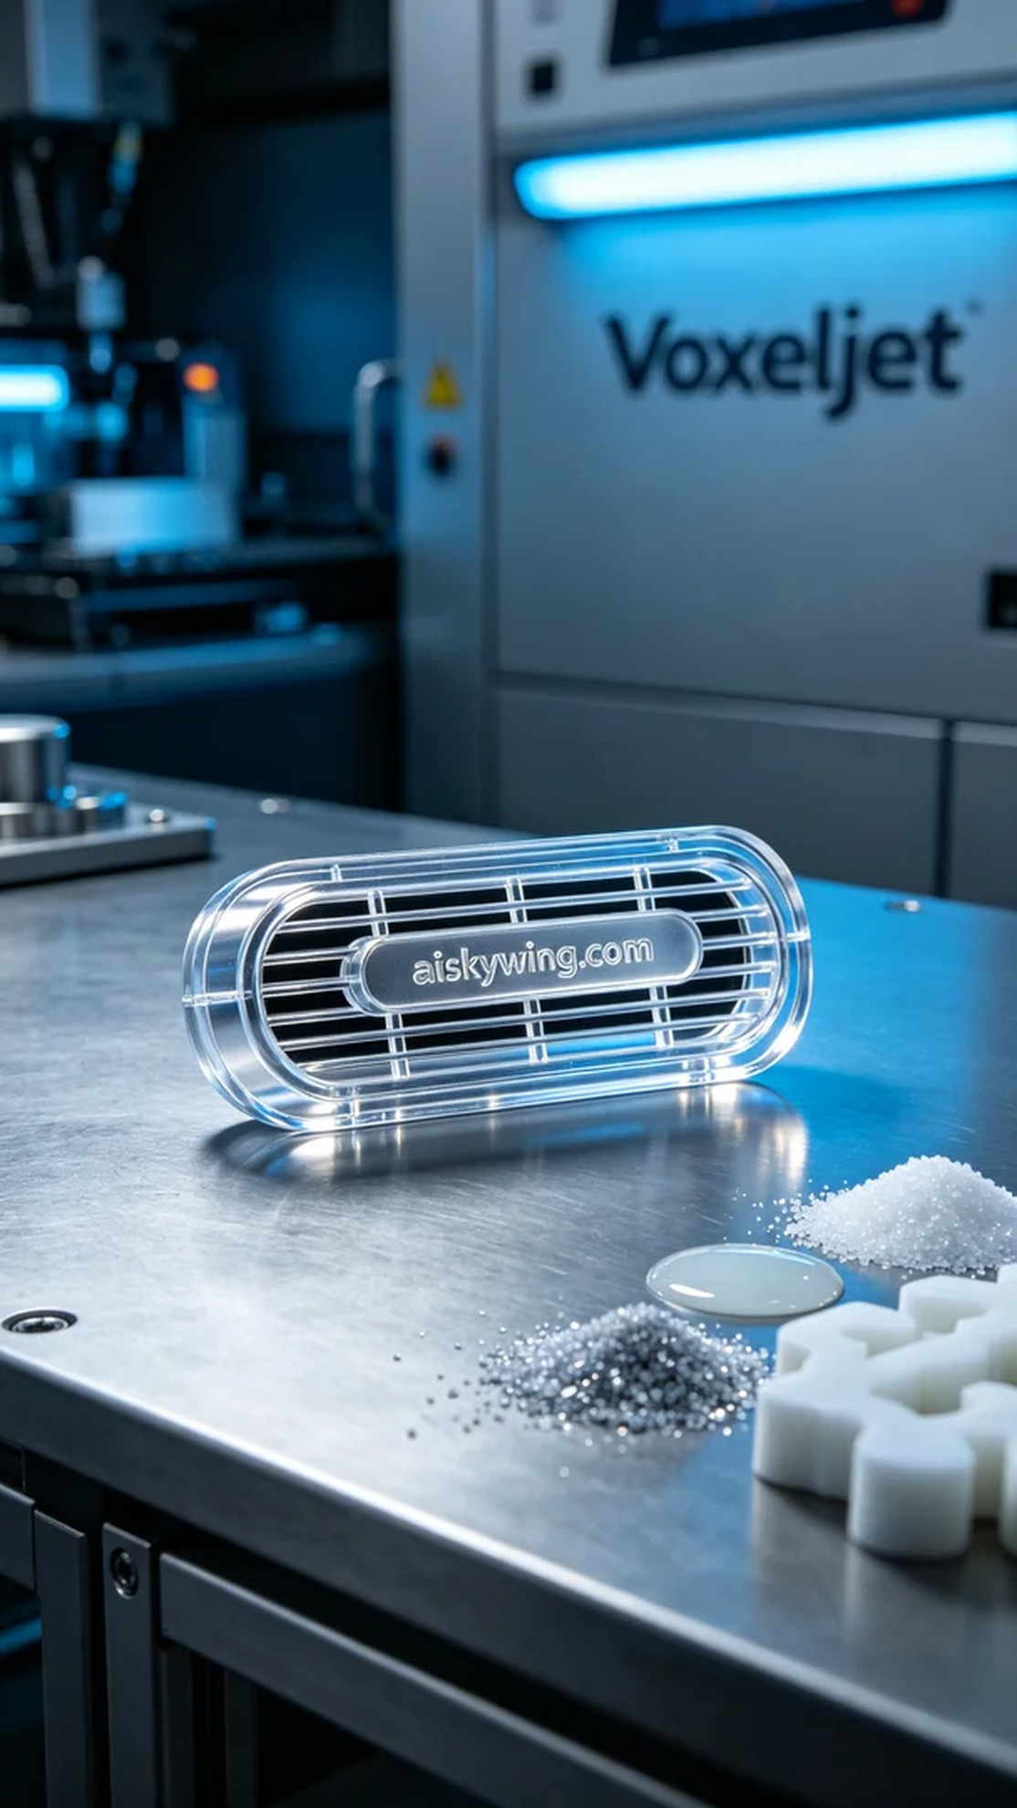
Life is like the process of 3D printing, filled with challenges and uncertainties. Recently, someone reached out for help on YouTube regarding a request for an air outlet blade, and this is exactly the issue we aimed to solve.
To meet the user's needs, we decided to use high-transparent, high-temperature-resistant PC engineering plastic for the production of the air outlet blade. This material boasts excellent transparency and heat resistance, making it suitable for harsh industrial environments. We also prepared the Voxeljet brand 3D printer to ensure printing precision.
During the printing process, we set the layer thickness to 0.1mm, with a printing temperature of 60°C, power set to 80%, and speed maintained at 50mm per hour. The entire printing process took approximately 3 hours, allowing for clarity in detail and structural strength in the product.
As the printing proceeded, the equipment ran smoothly, with ongoing monitoring throughout the process. We regularly checked the print quality to ensure each layer progressed as expected. Our focus remained on the details of the air outlet blade, as even minor errors could impact the final outcome.
Once printing was complete, we removed the product for post-processing. First, we cleaned it to remove any residual resin; next was sanding to ensure a smooth surface; then curing to achieve optimal strength and heat resistance; and finally, a stringent inspection to ensure the air outlet blade met all specifications.
After this series of meticulous operations, the air outlet blade finally appeared before us. Each time presents challenges, but each success brings a sense of fulfillment.
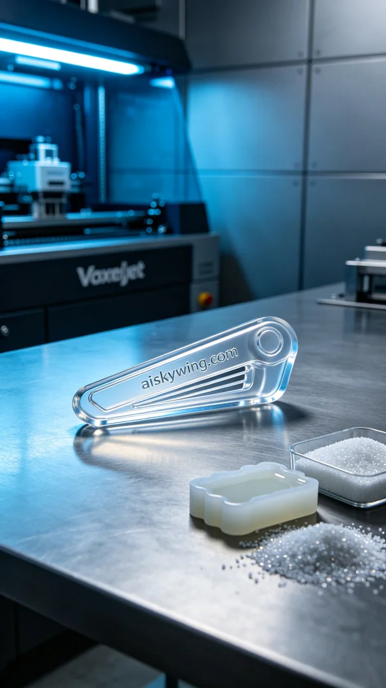
为了满足用户的需求，我们决定使用高透明高耐温的PC透明工程塑料进行出风口拨片的生产。这种材料具备很高的透明度与耐温性，适合严苛的工业环境。同时，我们准备了Voxeljet品牌的3D打印机，确保打印精度。
在打印过程中，我们设置了层厚为0.1毫米，打印温度为60°C，功率调至80%，速度保持在每小时50毫米。整个打印过程大约需要3小时，这样的参数能够保证细节的清晰度以及产品的结构强度。
随着打印的进行，设备稳定运行，整个过程都在监控之中。我们定期检查打印质量，确保每个层次都如预期般顺利。目光始终集中在出风口拨片的细节上，因为任何微小的错误都可能影响最终效果。
打印完成后，我们将产品取出并进行后处理。首先是清洗，把残留的树脂清理干净；接着进行打磨，确保表面光滑；然后是固化，使材料达到最佳的强度和耐热性；最后，进行严格的检验，确保出风口拨片符合所有规格。
经过这一系列的精细操作，出风口拨片终于呈现在眼前。每一次都充满挑战，但每一次的成功也让人倍感欣慰。
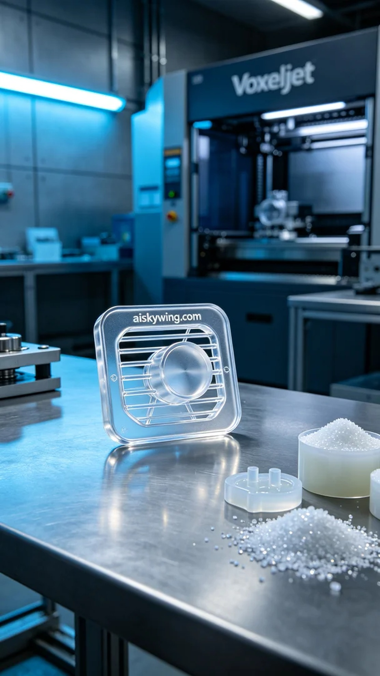
Aiskywing Industrial 3D Printing
Air outlet flaps


