0729-刀库的3D打印生产记录
Tool magazine
🖨️ SLM金属打印
🖥️ 打印机: Mimaki
📦 材料: 摆放着未成型的液态光敏
生活再难，也别停下脚步。就像接下这个刀库置于画面正中央的单子，制作它是我的责任与挑战。
No matter how difficult life gets, don't stop moving forward. Just like taking on the task of placing this tool holder in the center of the frame, it is my responsibility and challenge to create it.
________________________________________________________________________________
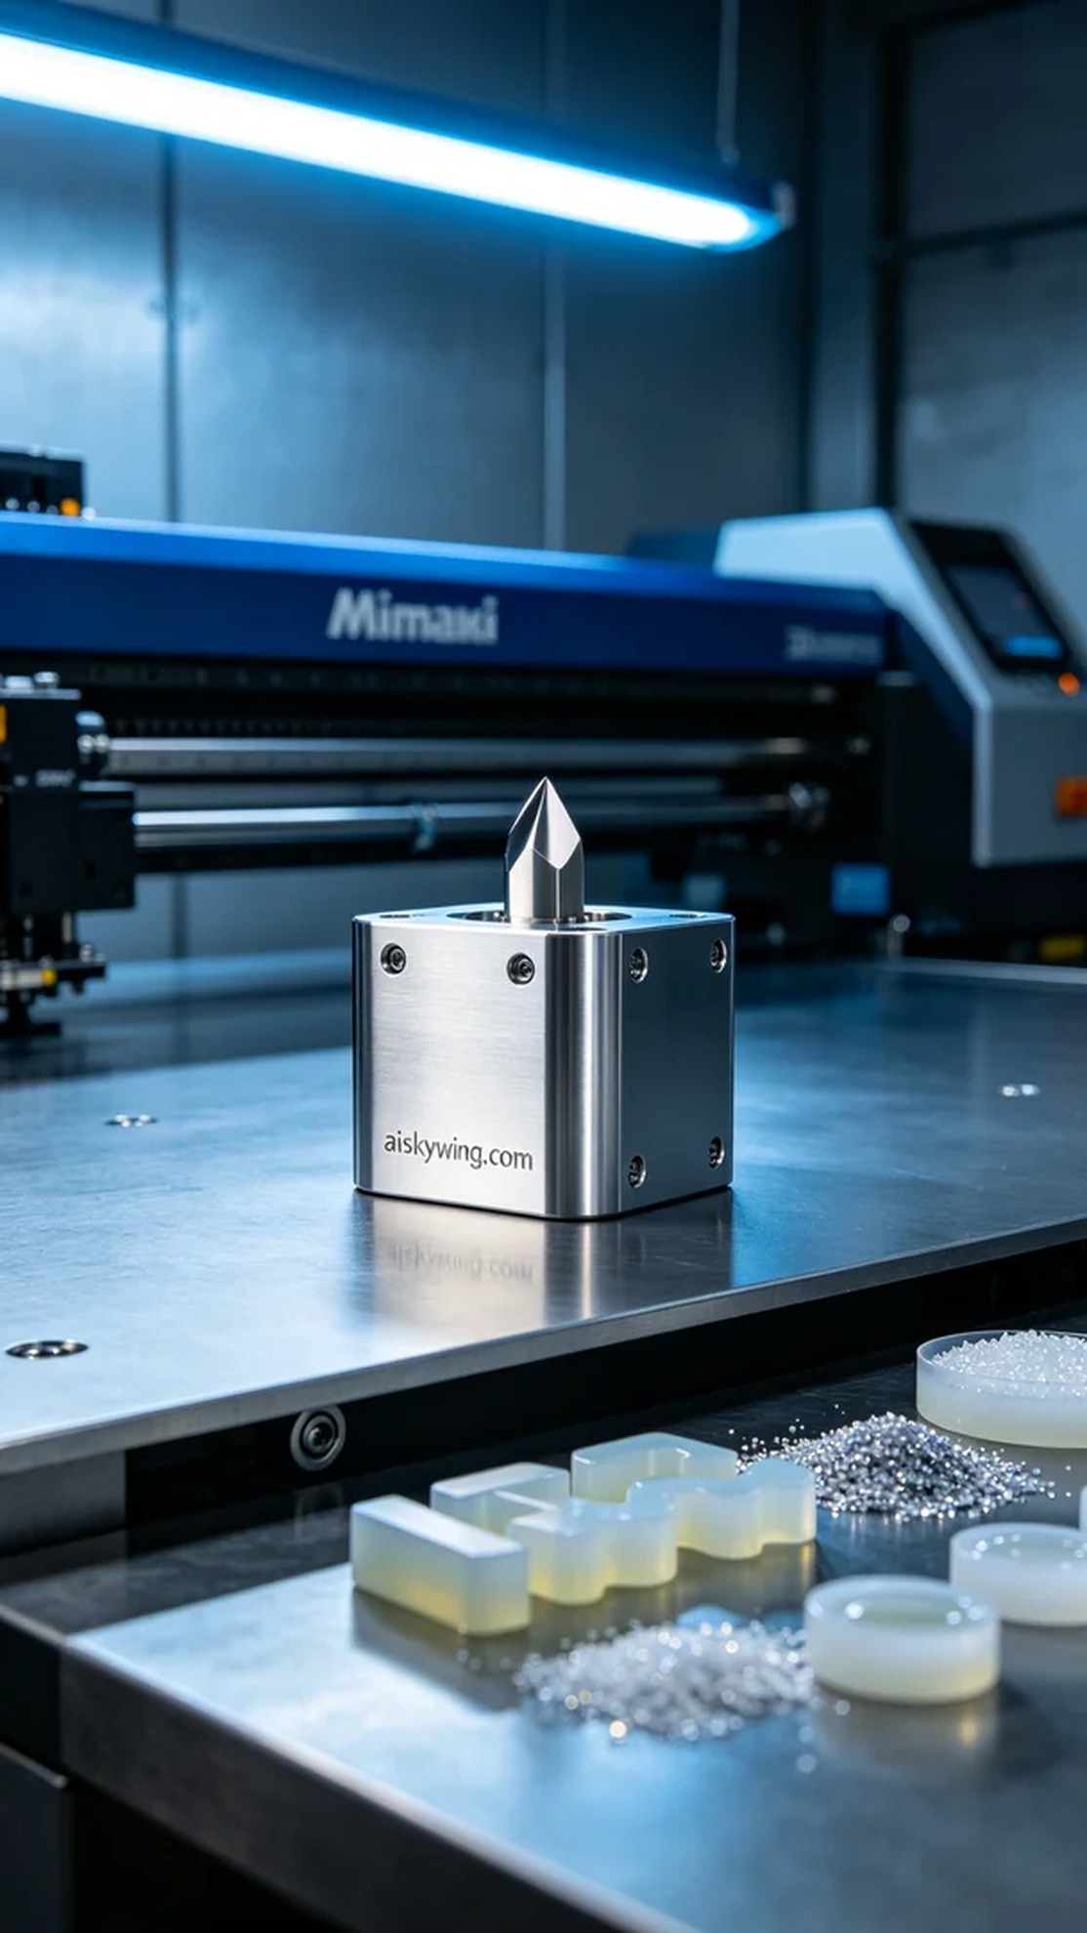
Someone contacted me via WhatsApp, seeking a precision tool holder with a high-gloss metallic finish. To meet their expectations, I decided to produce it using a Mimaki printer.
The selected material was unformed liquid photopolymer resin, known for its excellent fluidity and high precision, ideal for 3D printing metal components. For the print settings, I chose a layer thickness of 0.1mm, maintained a printing temperature of 25°C, adjusted the power to 60%, and set the speed to 40mm/s, expecting the entire print process to take about 8 hours.
Once the printing commenced, the Mimaki printer operated steadily while I monitored the device's status and print quality closely. Throughout each layer's printing, I paid careful attention to the curing of the resin, ensuring no bubbles or defects appeared. As time passed, the shape of the tool holder gradually became visible, reflecting the cold industrial light.
After printing was complete, I conducted a series of post-processing procedures on the finished product. First, I placed the tool holder in a cleaning tank, using a cleaning solution to thoroughly remove any residual resin on the surface. Next, I sanded it down with fine sandpaper to ensure a smooth and shiny finish. Finally, the tool holder was placed in a UV curing chamber for solidification, confirming that its strength and durability met the requirements. After comprehensive inspection, the results were satisfactory.
The entire production process allowed me to appreciate the combination of technology and craftsmanship. The finished tool holder not only met design requirements but also showcased the charm of Mimaki printing technology. Each challenge I face is an opportunity for my technical growth.
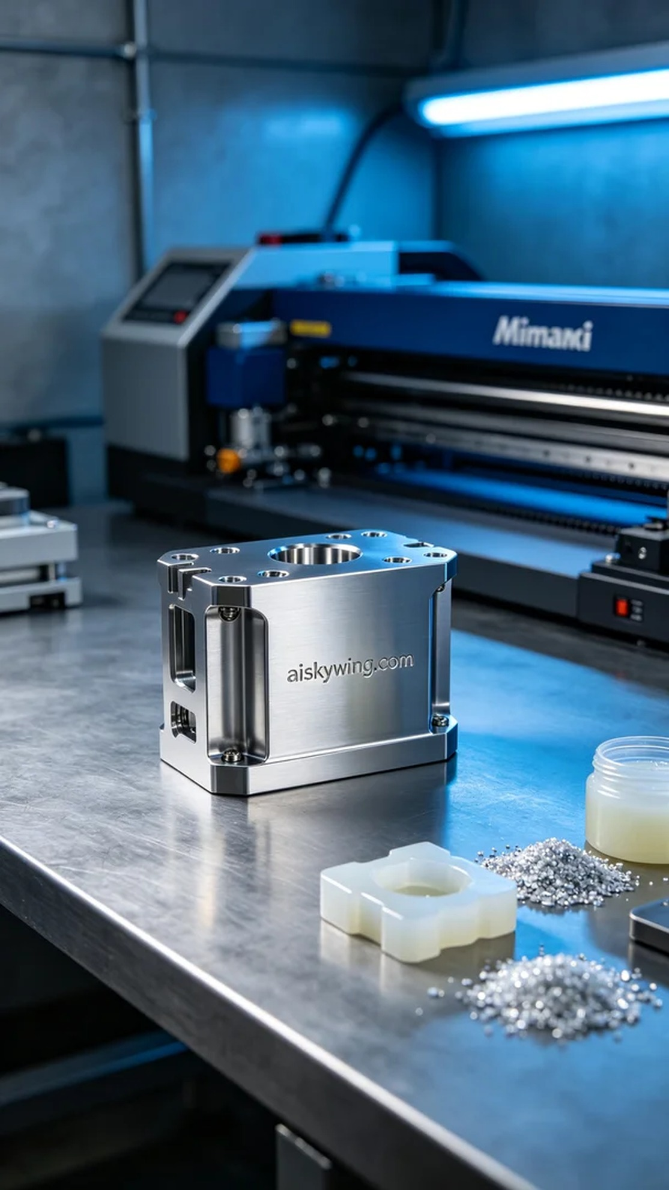
有人通过WhatsApp联系我，想要一款刀库，要求精确且具备高光金属质感。为了满足他们的期望，我决定使用Mimaki打印机进行生产。
选用的原材料是未成型的液态光敏树脂，这种材料具有良好的流动性和高精度特点，适合用于3D打印金属部件。在打印参数设置上，我选择了层厚0.1mm，打印温度保持在25℃，功率调至60%，速度设定为40mm/s，整个打印过程预计需要8个小时。
打印开始后，Mimaki打印机稳定运行，我时刻关注设备状态和打印质量。在每一层打印的过程中，我仔细监控树脂的固化情况，确保没有出现任何气泡或缺陷。随着时间的推移，刀库的形状逐渐清晰可见，反射出冷峻的工业光线。
打印完成后，我对成品进行了一系列后处理工序。首先将刀库放入清洗槽中，使用清洗液彻底去除表面残留的树脂。随后，采用细砂纸进行打磨，确保表面平滑且光亮。最后，将刀库放入紫外线固化箱中进行固化处理，确认其强度和耐用性达到要求，经过全面检验，结果合格无误。
整体制作过程让我感受到了科技与工艺的结合，刀库的成品不仅满足了设计要求，更展现了Mimaki打印技术的魅力。每一次的挑战，都是我技术成长的机会。
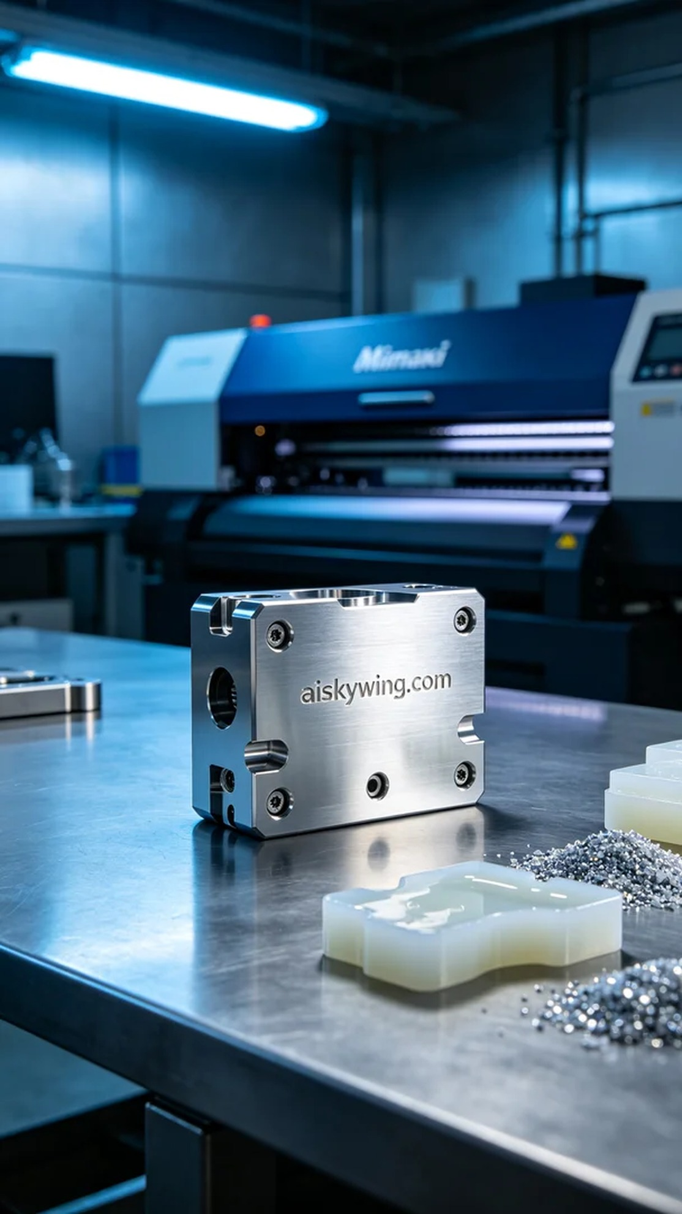
Aiskywing Industrial 3D Printing
Tool magazine


