0730-刀架的3D打印生产记录
Knife holder
🖨️ CNC机加工
🖥️ 打印机: Carbon
📦 材料: 摆放着未成型的液态光敏
生活就像打印，每一层都需要耐心。有人在TikTok上看到我们的刀架，咨询我们如何解决他们的需求。
Life is like 3D printing; every layer requires patience. Someone saw our knife rack on TikTok and consulted us on how to meet their needs.
________________________________________________________________________________
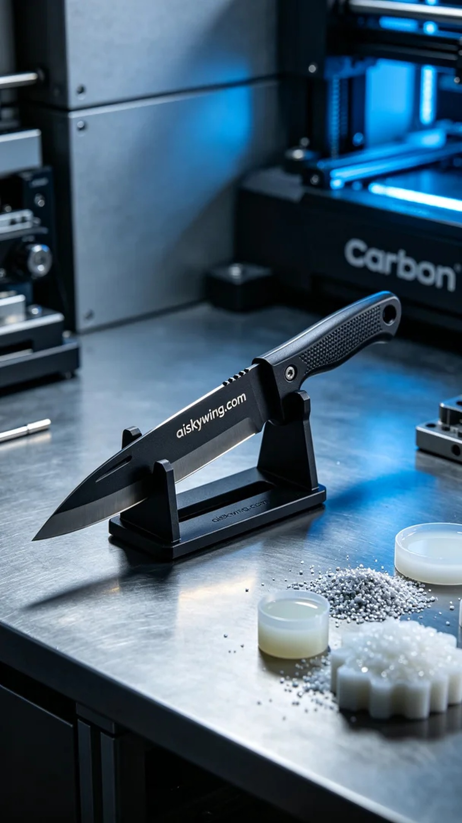
Life is like printing; every layer requires patience. Someone saw our knife rack on TikTok and reached out to us, looking for a solution to their needs.
Today, we received an order from a cooking enthusiast who wanted to customize a product that could enhance kitchen efficiency. He had high expectations for the stability and aesthetics of the knife rack, hoping we could deliver with our best craftsmanship.
For production, we chose unformed liquid resin as the raw material. This material features excellent strength and toughness, making it suitable for precise CNC machining. We used the Carbon 3D printer for printing, setting a layer thickness of 0.1mm, a printing temperature of 25°C, with a power setting of 60% and a speed of 30mm/s. The entire printing process was expected to take about 2 hours, ensuring that the model's details could be perfectly presented.
During the printing process, the equipment operated quietly while we monitored the quality, ensuring that each layer stacked accurately. The high precision of the Carbon printer allowed us to see delicate textures and the clear engraving of "aiskywing.com", fully showcasing the charm of industrial design.
After printing was completed, we began the post-processing. First, we placed the knife rack in the cleaning tank, using a special cleaning solution to remove excess resin. Next, we polished the surface to eliminate minor flaws, then placed the knife rack in a UV curing machine to ensure final strength. Finally, we meticulously inspected every detail to guarantee it met the user’s high standards.
The entire production process was completed smoothly. This knife rack not only enhanced the aesthetics of the kitchen but also demonstrated our dedication to detail. Creating every product with care is our commitment and belief.
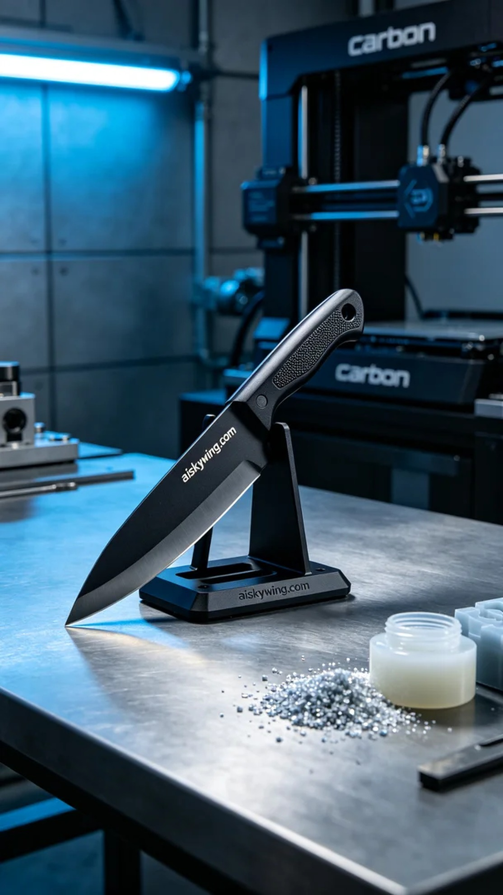
今天我们接到一个订单，来自某位热爱烹饪的朋友，他在TikTok上看到我们的刀架，想定制一款能提高厨房效率的产品。对于刀架的稳固性和美观性，他有着高期待，希望我们能用最好的技艺完成这项任务。
生产过程中，我们选择了未成型的液态光敏树脂作为原材料。这种材料具有优异的强度和韧性，适合精细的CNC加工。我们使用Carbon的3D打印机进行打印，设定层厚为0.1毫米，打印温度为25°C，功率设定在60%，打印速度为30毫米每秒。整个打印过程预计耗时约2小时，确保模型的细节能完美呈现。
在打印过程中，设备安静地运作着，我们时刻监控质量，确保每一层都能准确叠加。Carbon打印机的高精度让我们看到了细腻的纹理和清晰的雕刻“aiskywing.com”字样，充分展现了工业设计的魅力。
打印完成后，我们开始进行后处理。首先将刀架放入清洗槽，使用专用清洗液去除多余的树脂。接着，进行打磨处理，以消除表面的微小瑕疵，然后将刀架放入UV固化机中固化，确保其最终强度。最后，我们仔细检验了每一个细节，确保能够满足用户的高要求。
整体生产过程顺利完成，这款刀架不仅提升了厨房的美观，也展现了我们对细节的重视。用心制造每一件产品，就是我们的坚持与信念。
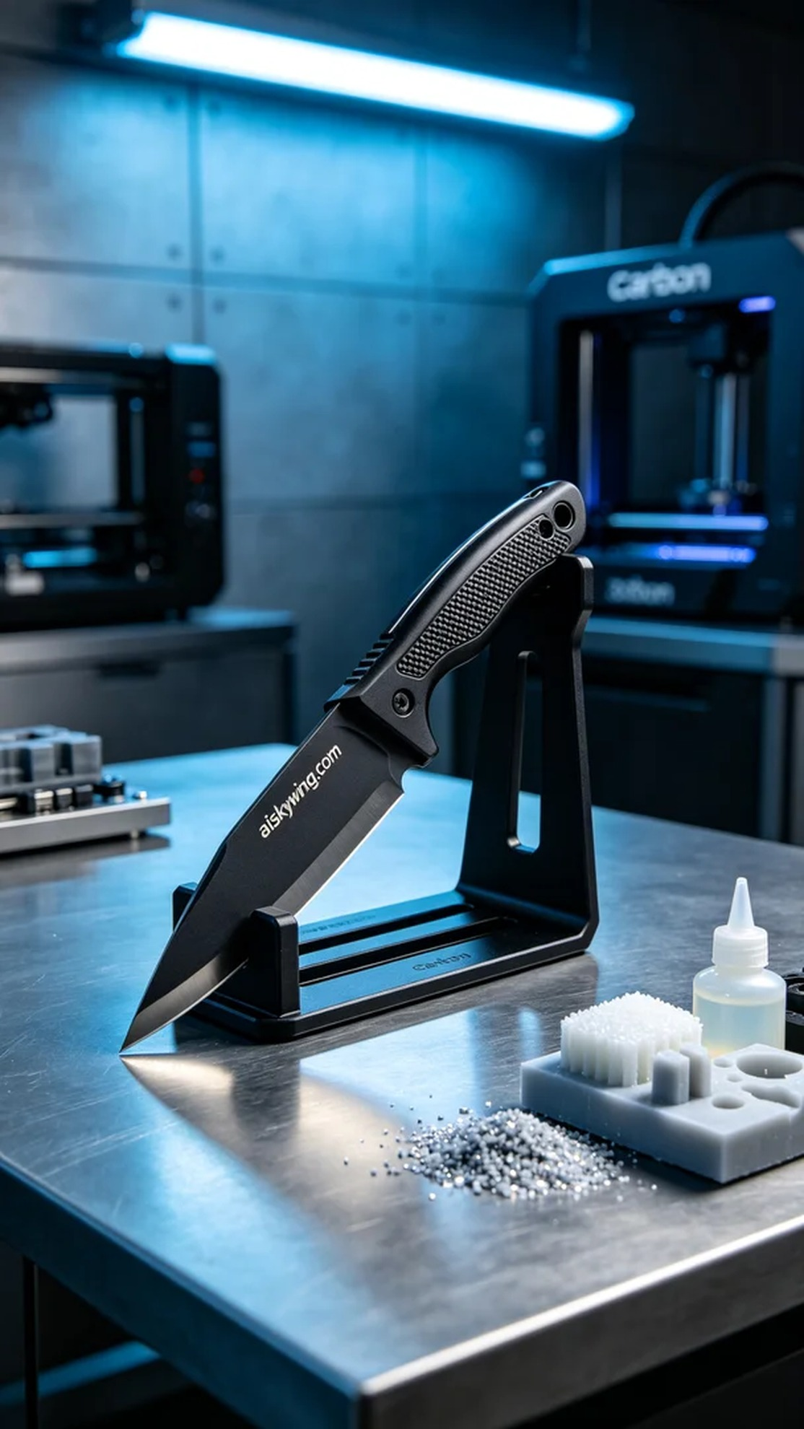
Aiskywing Industrial 3D Printing
Knife holder


