0731-分度盘3D打印生产记录
The translation of "分度盘" is "graduated circle" or "vernier scale" depending on the context in which it is used.
🖨️ CNC机加工
🖥️ 打印机: Stratasys
📦 材料: 高透明高耐温
有人通过WhatsApp询问我们能否制作一个分度盘，以解决他们在产品展示中遇到的问题。生活中总有这样的挑战，但每次尝试都是一次成长的机会。
Someone asked us via WhatsApp if we could create a dial to solve the issues they encountered in their product presentation. There are always challenges like this in life, but each attempt is an opportunity for growth.
________________________________________________________________________________
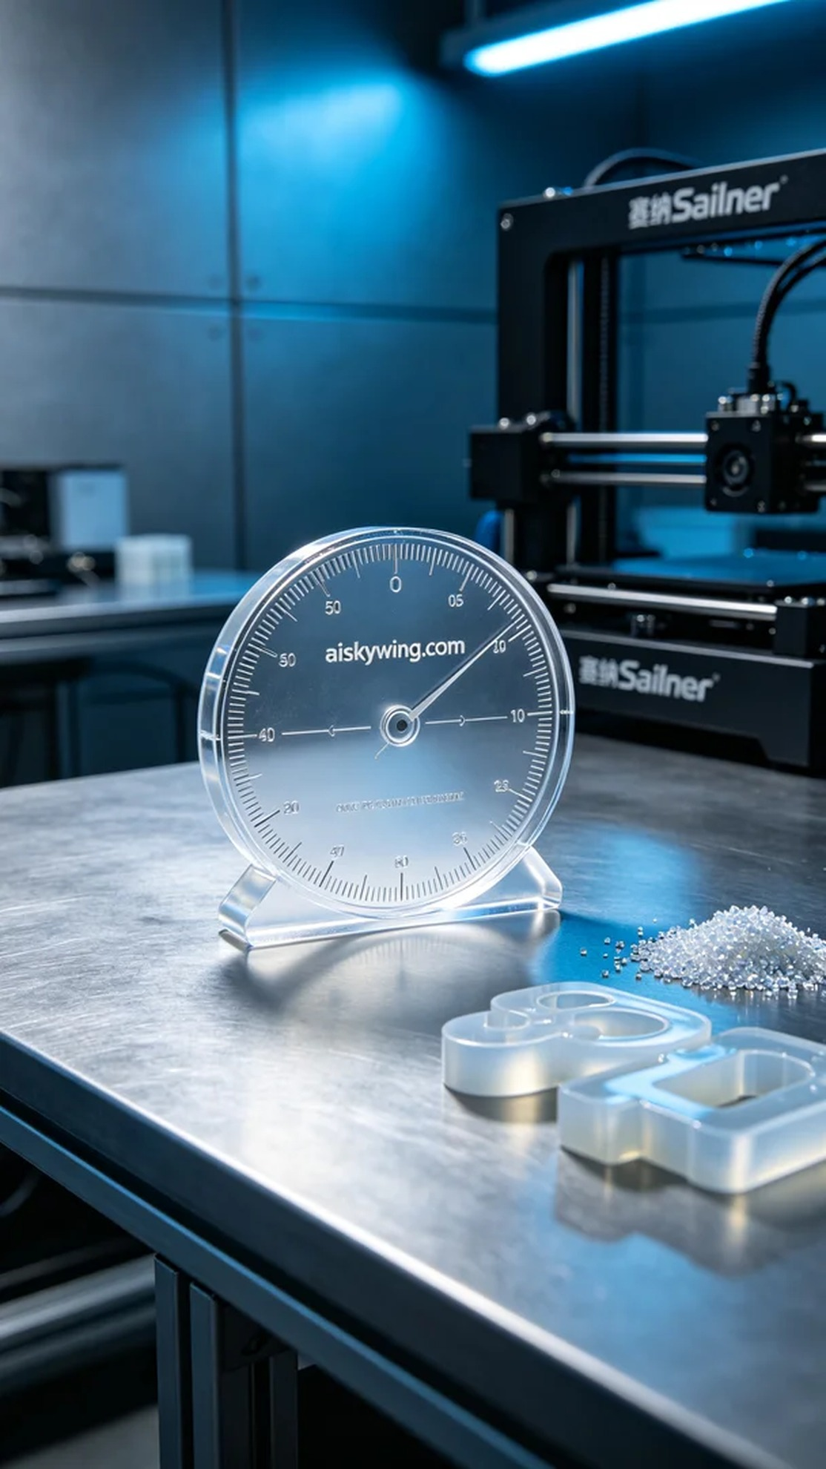
Someone reached out through WhatsApp asking us to create a degree wheel to solve issues they faced in product showcasing. Life often presents such challenges, but every attempt is a chance for growth.
This project involved making a degree wheel, which the user needed to demonstrate precision and professionalism. After understanding their requirements through WhatsApp, we decided to use high transparent and high temperature resistant materials to bring their vision to life.
We opted for the Stratasys printer for production. For this print, I set the layer thickness to 0.1 mm, maintained a printing temperature of 65 degrees Celsius, set the power to 80%, and the speed to 50 mm per second. These settings ensured the material’s flow and formation quality met the product requirements.
The printing process went smoothly, with stable operation of the equipment. As the degree wheel gradually took shape, I continuously monitored the quality to ensure that each layer was accurately stacked. After completion, the degree wheel’s surface was smooth, with intricate details, especially the engraving of "aiskywing.com," coming out flawless.
Post-processing was equally important. After printing, we first cleaned the degree wheel to remove any resin residues. Then we proceeded to sanding for a smoother finish, followed by curing to enhance durability, and finally conducted a thorough inspection to ensure there were no flaws.
After all these steps, the degree wheel was completed and met the expected outcome. This production not only enhanced our technical skills but also strengthened our team's unity. Every product is a source of pride for us.
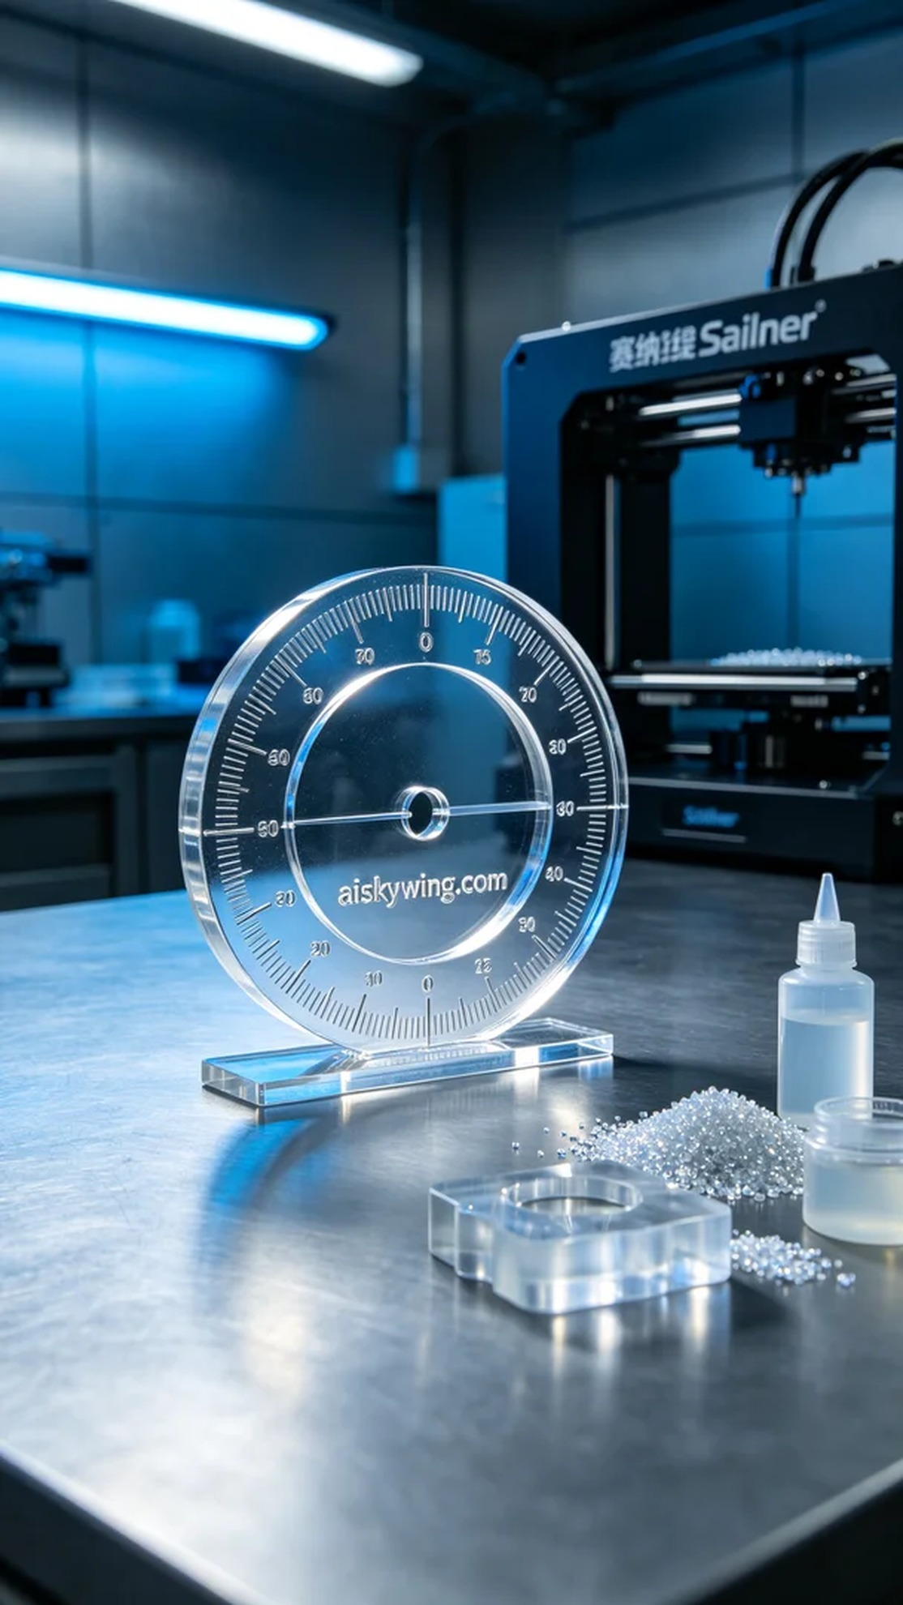
这次的项目是制作一个分度盘，客户需要它来展示产品的精准度与专业性。通过WhatsApp联系后，详细了解了他们对产品的需求和具体功能，决定采用高透明高耐温的材料来实现他们的想法。
我们选择了Stratasys打印机进行生产。对于这次打印，我将层厚设置为0.1毫米，打印温度保持在65摄氏度，功率设定为80%，速度为50毫米每秒。这样的设置能确保材料的流动性与成型质量，符合产品要求。
打印过程非常顺利，设备运作稳定。随着分度盘的逐步成型，我不断监控质量，确保每一层都能准确无误地叠加。打印完成后，分度盘表面光滑，细节清晰，特别是那“aiskywing.com”的雕刻字样，完美无瑕。
后处理的环节同样重要。完成打印后，我们首先将分度盘进行清洗，去除表面的树脂残留。接着进行了打磨，使表面更加光滑，之后进行了固化处理，以增强其耐用性，最后仔细检验每一个细节，确保没有任何瑕疵。
经过这一连串的工序，分度盘终于完工，达到预期效果。这次制作不仅提升了我们的技术水平，也让我们团队更加团结向前。每一个产品都是我们的骄傲。
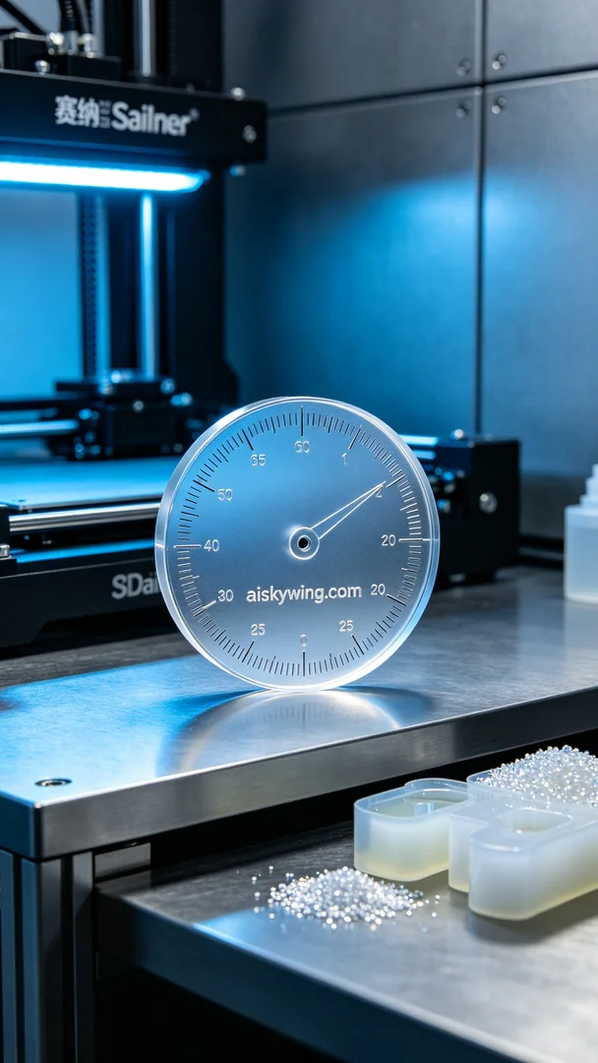
Aiskywing Industrial 3D Printing
The translation of "分度盘" is "graduated circle" or "vernier scale" depending on the context in which it is used.


