0732-分配模块外壳3D打印生产记录
Allocation module shell
🖨️ SLM金属打印
🖥️ 打印机: HP
📦 材料: 摆放着未成型的液态光敏
生活中的每一步都有它的意义，就像有人在Instagram上找到我们，希望我们为他们打造这个分配模块外壳，解决产品制造的难题。
Every step in life has its significance, just like when someone finds us on Instagram, hoping we can create this allocation module shell for them to solve the challenges of product manufacturing.
________________________________________________________________________________
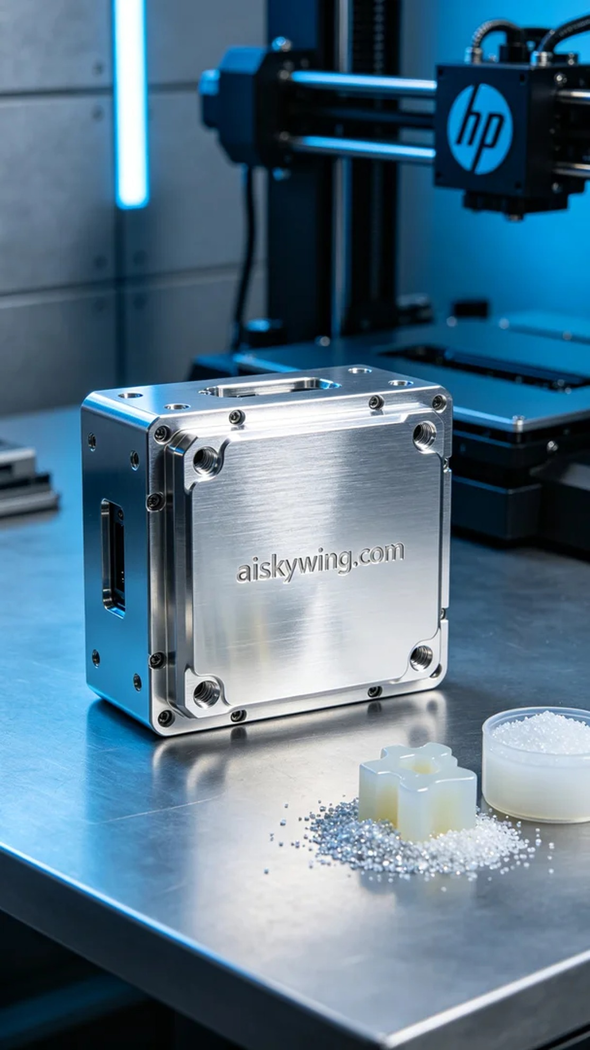
Every step in life has its significance, just like someone found us on Instagram, hoping we could create a distribution module shell for them to solve their manufacturing challenge.
This task arose from a request for a high-quality distribution module shell. They were looking for a product that is durable, well-sealed, and visually appealing, matching their industrial design requirements.
We selected unformed liquid photosensitive resin as the raw material, known for its excellent fluidity and forming characteristics, perfect for achieving high precision prints. Using the HP 3D printer, we set the print parameters: a layer thickness of 0.1 mm, printing temperature at 25 °C, power set to 70%, and print speed at 40 mm per second, with an estimated total print time of 4 hours.
Throughout the printing process, we closely monitored the machine's performance to ensure each layer cured evenly. The HP printer operated stably, with no issues arising during the print. We regularly checked the material feeding system and the print head to ensure smooth material flow and maintain product quality.
After printing, we moved to the post-processing stage. First, we cleaned the finished product with a specialized cleaning solution to remove any residual photosensitive resin. Following the cleaning, we performed sanding to enhance the surface smoothness. Next, the product was placed in a curing machine to ensure strength and stability. Finally, each product underwent a meticulous inspection to ensure it met quality standards.
Every production is a new experience, and the successful print of the distribution module shell adds another highlight to our team's efforts. We look forward to taking on more challenges in the future and creating even more possibilities.
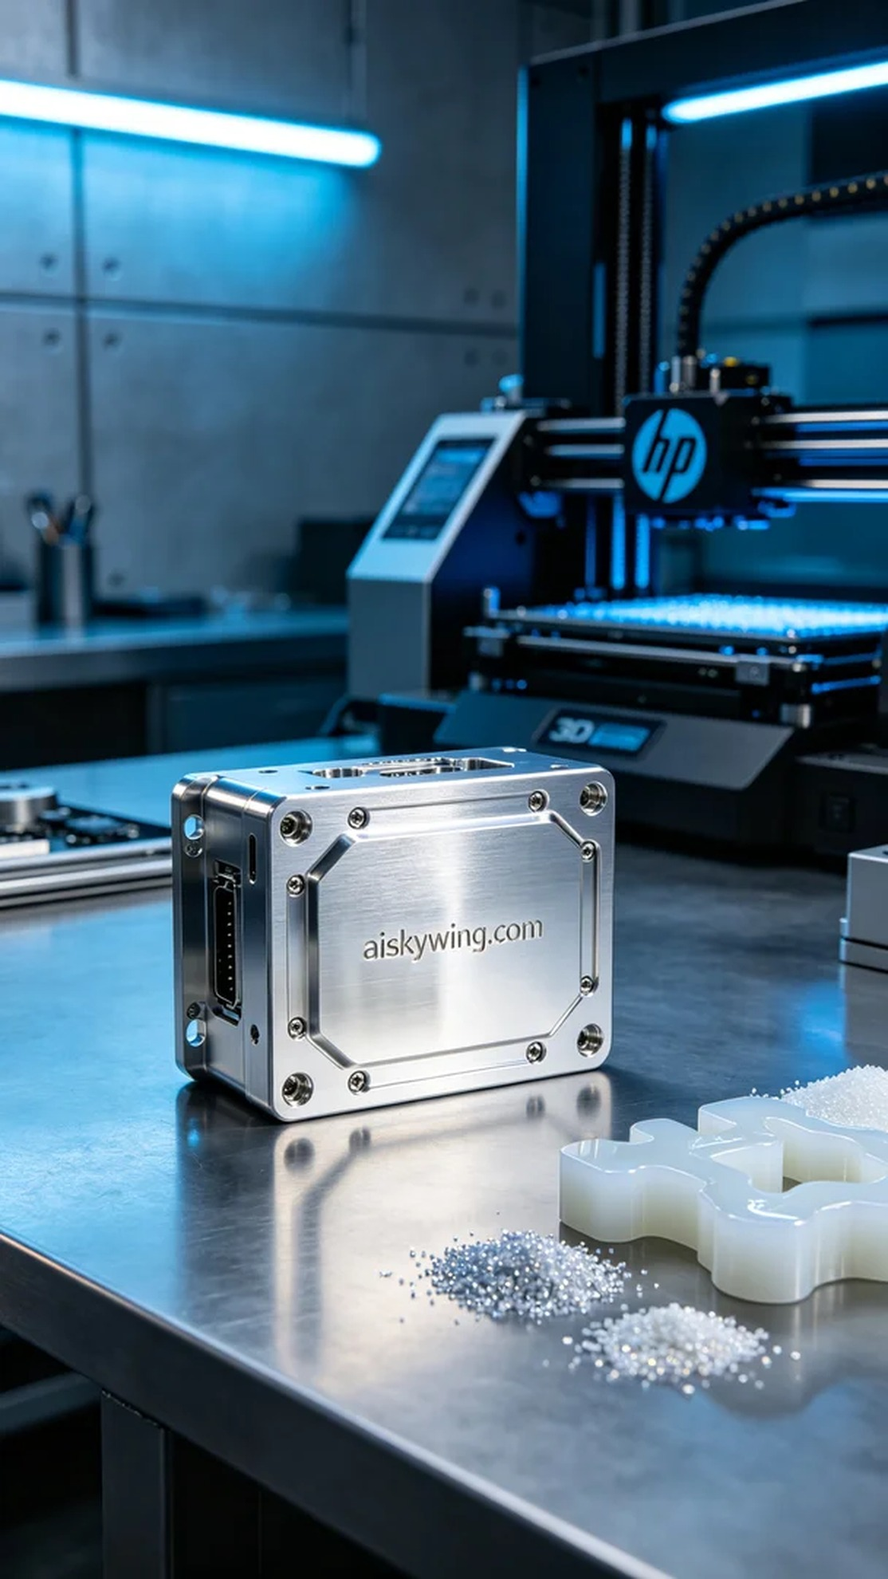
这次的工作源于一个来自Instagram的请求，有人在寻找一个高质量的分配模块外壳，要求我们提供专业的3D打印解决方案。通过沟通了解到，他们希望得到一款密封性好、耐用且外观精致的产品，符合他们的工业设计需求。
我们选择使用未成型的液态光敏树脂作为原材料，这种材料具有良好的流动性和成型特性，能够在高精度打印中展现出色的细节。根据HP 3D打印机的要求，我们设定了打印参数：层厚0.1毫米，打印温度设定在25摄氏度，功率为70%，打印速度为40毫米每秒，总打印时间预计为4小时。
在打印过程中，我们认真监控设备的运行状态，确保每层材料都能均匀固化。HP打印机的表现稳定，打印过程顺利，没有出现任何故障。我们定期检查进料系统和打印头，以确保材料的流动畅通无阻，保持产品质量的稳定性。
打印完成后，我们进入了后处理阶段。首先用专用清洗液对成品进行清洗，去除残留的光敏树脂。清洗后，我们进行打磨处理，以提升表面光滑度。接下来，将成品放入固化机中固化，以确保其强度和稳定性。最后，我们对每个产品进行仔细检验，确保符合质量标准。
每一次的生产都是一次全新的体验，分配模块外壳的成功打印，为我们团队又添了一笔亮色。期待在以后的工作中继续挑战，创造更多的可能性。
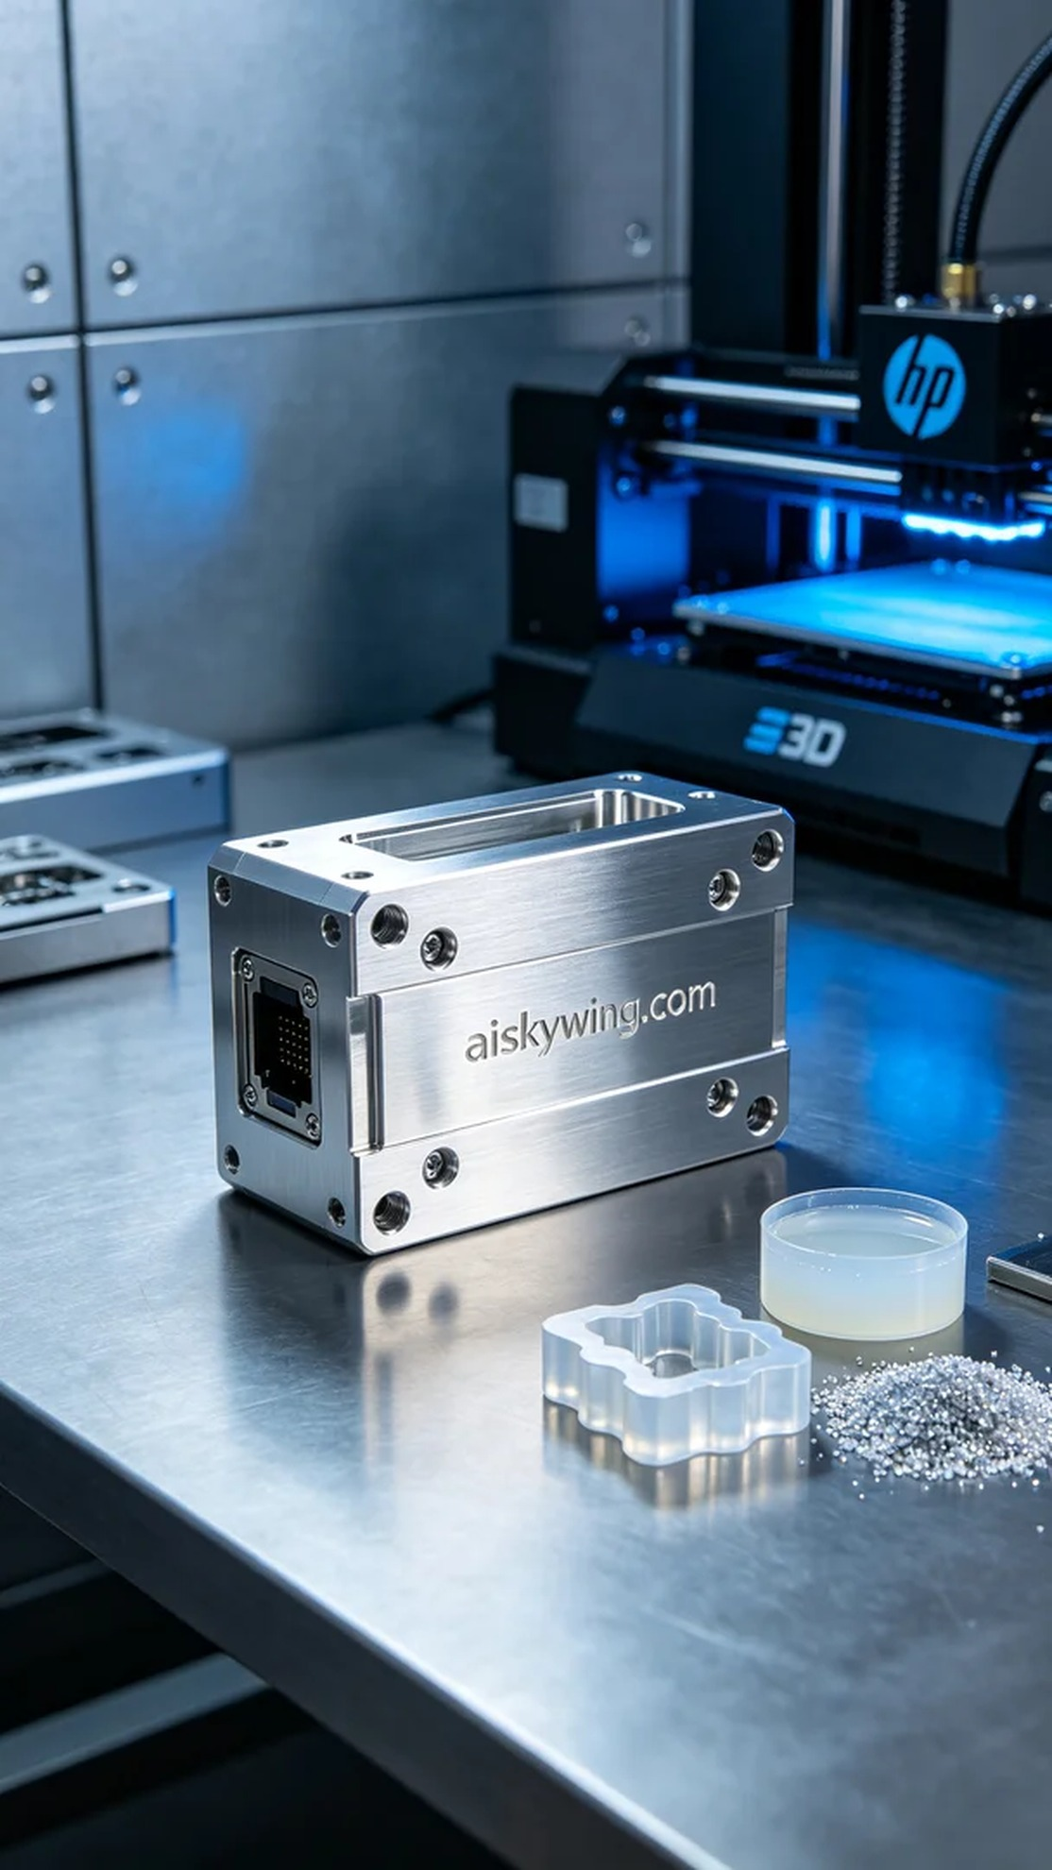
Aiskywing Industrial 3D Printing
Allocation module shell


