0733-切换模块外壳的3D打印记录
Switching module shell
🖨️ CNC机加工
🖥️ 打印机: Voxeljet
📦 材料: 摆放着未成型的液态光敏
生活就像一个3D打印机，需不断调整才能实现理想的形状。今天，我们接到一个关于切换模块外壳的项目，迫切需要解决的问题就是如何确保精准与质量。
Life is like a 3D printer; it requires constant adjustments to achieve the ideal shape. Today, we received a project regarding the switch module casing, and the urgent issue to address is how to ensure precision and quality.
________________________________________________________________________________
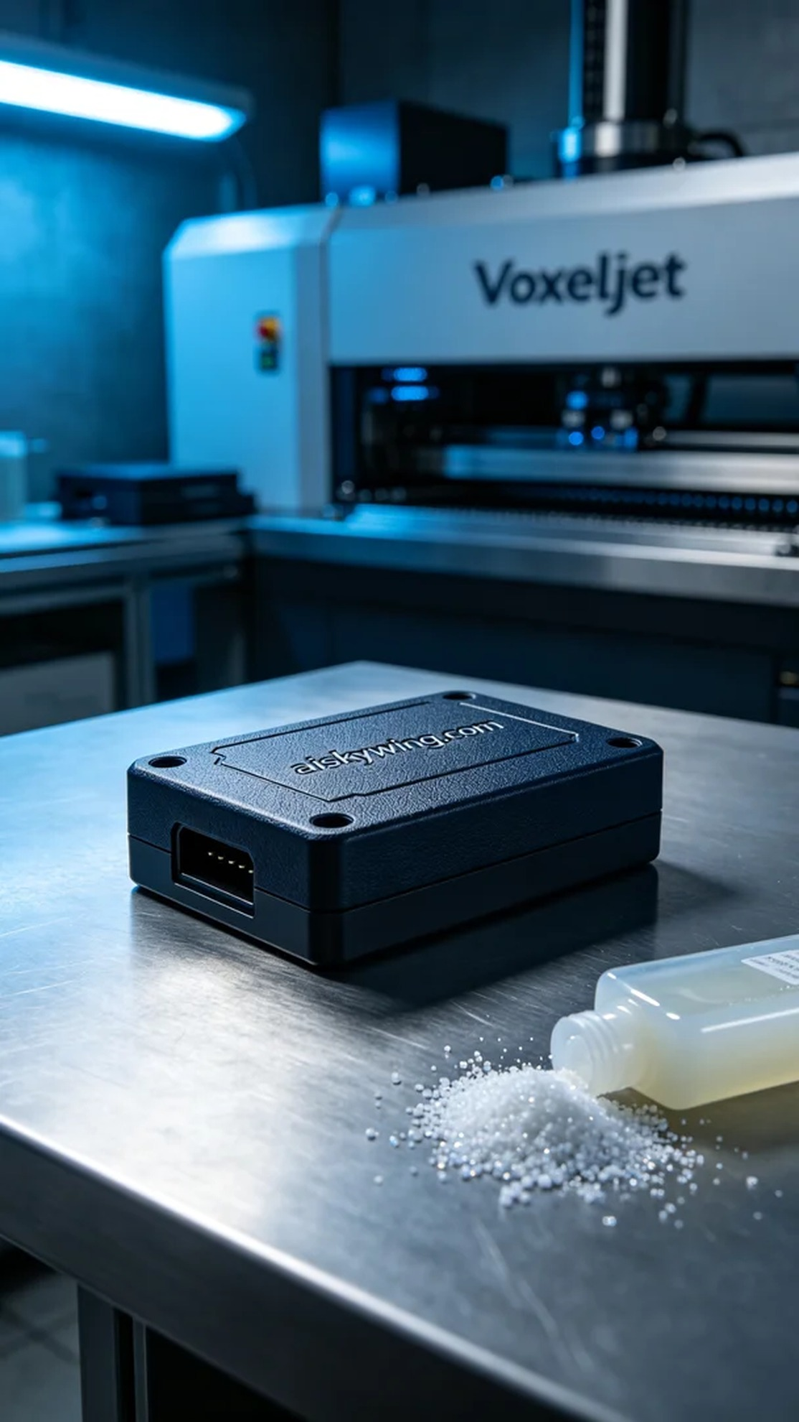
Life is like a 3D printer; it requires constant adjustments to achieve the desired shape. Today, we received a project for a switch module casing, urgently needing to solve the issue of precision and quality.
To accomplish this, we chose to use liquid photopolymer resin as our raw material. This material features excellent moldability and a delicate surface finish, meeting our high-quality requirements. We utilized a Voxeljet 3D printer for the project, setting parameters to a layer thickness of 0.1mm, a printing temperature of 25℃, a power setting of 80-90W, a speed of 50mm/s, with an estimated printing time of 4 hours.
During the printing process, we closely monitored the operation of the equipment to ensure every detail met our expectations. As the liquid resin solidified layer by layer on the printing platform, the casing gradually took shape. Throughout this process, we employed sensors to detect printing precision, ensuring no deviations occurred.
Once printing was completed, we proceeded to post-processing. First, we cleaned the printed casing to remove any uncured resin from the surface. Next, we sanded it down to ensure a smooth surface and enhanced tactile feel. Finally, we placed it into a curing device for further solidification, reinforcing the casing's strength. Following these steps, we meticulously inspected the final product to ensure it met quality standards.
After several laborious steps, we successfully manufactured a high-quality switch module casing. This was not only a technical breakthrough but also a testament to our teamwork.
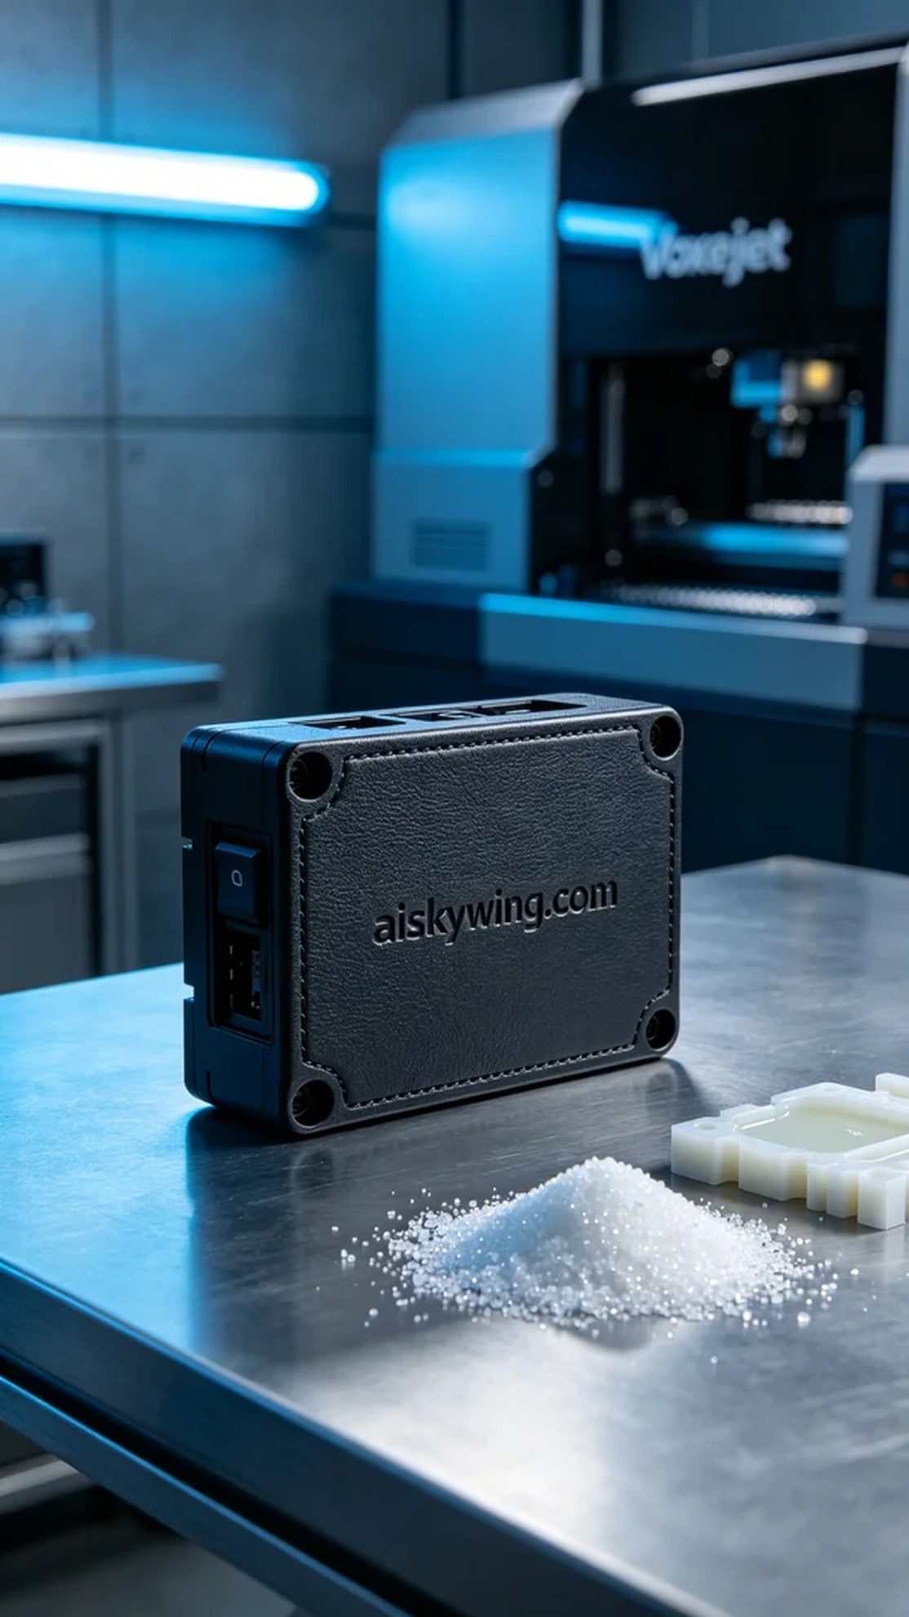
在YouTube上，有人看到了我们最近的项目，询问我们能否为他们制作一个切换模块外壳。这个外壳的设计要求高精度与良好的手感，而我们正是凭借经验来解决这类问题的。
为此，我们选择使用液态光敏树脂作为原材料，这种材料具备优异的成型性和细腻的表面效果，能够满足高质量的需求。同时，我们使用Voxeljet的3D打印机进行打印，设置参数为层厚0.1mm，打印温度为25℃，功率设定在80-90W之间，速度为50mm/s，预计打印时间为4小时。
打印过程中，我们严格监控设备的运行，确保每个细节都符合预期。随着液态树脂在打印平台上逐层固化，切换模块外壳逐渐成型。在这一过程中，我们使用传感器检测打印精度，确保没有任何偏差。
完成打印后，我们进入后处理环节。首先，对打印好的外壳进行清洗，去除表面未固化的树脂；接着，进行打磨，确保表面光滑并加强触感；最后，将其放入固化设备中进行进一步的固化处理，加固外壳的强度。完成这些步骤后，我们还需对成品进行仔细检验，确保质量达到标准。
经过几道工序的努力，最终我们成功地制造出了高质量的切换模块外壳。这不仅是一次技术上的突破，更是团队合作的见证。
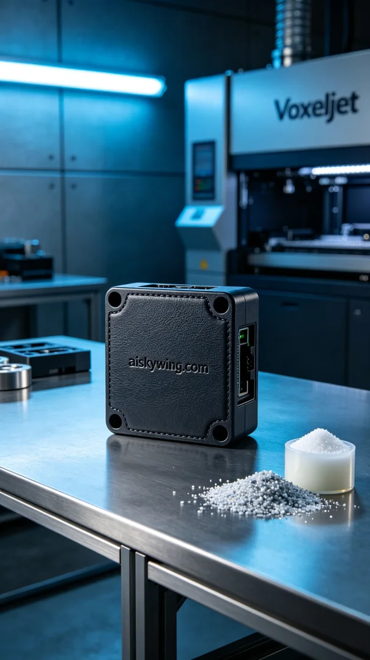
Aiskywing Industrial 3D Printing
Switching module shell


