0736-前保险杠装饰的3D打印生产日志
Front bumper trim
🖨️ CNC机加工
🖥️ 打印机: Rize
📦 材料: 摆放着未成型的液态光敏
生活再难，也别停下脚步。就像接下这个前保险杠装饰的单子，有人通过WhatsApp找到我们，寻求解决方案。
No matter how difficult life gets, don't stop moving forward. Just like when we took on the order for the front bumper decoration; someone reached out to us via WhatsApp seeking a solution.
________________________________________________________________________________
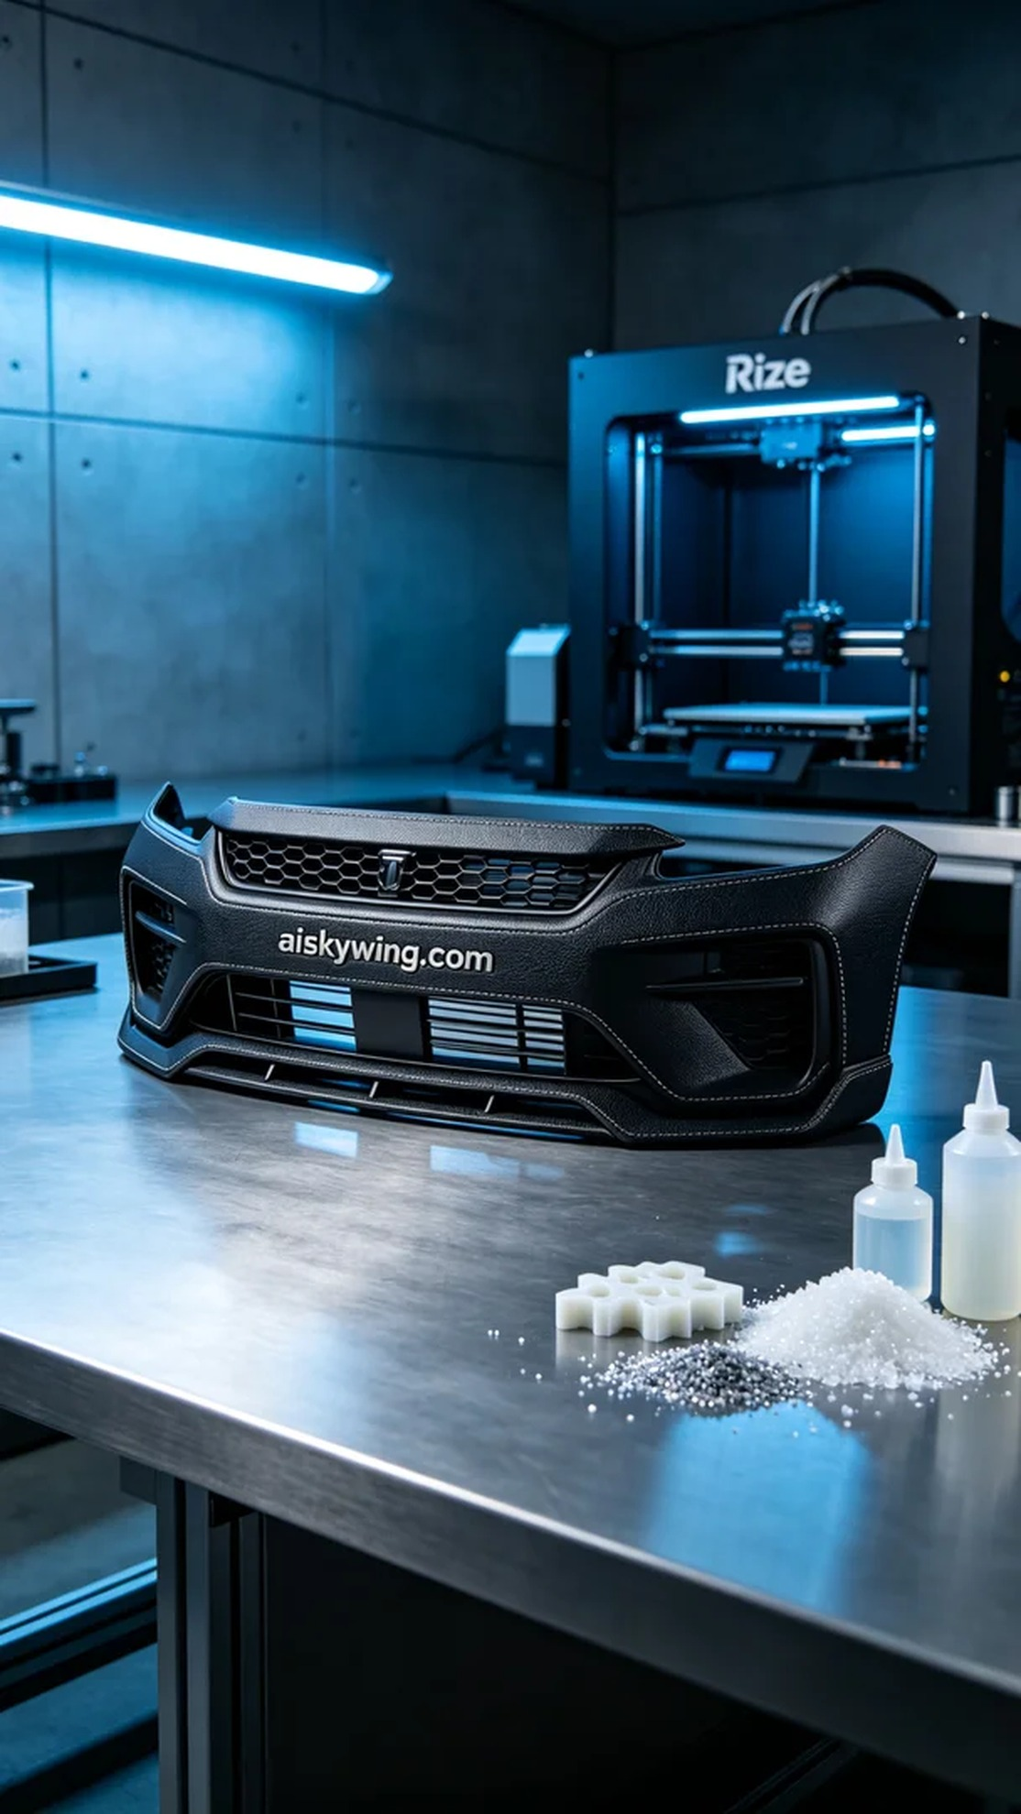
Life can be tough, but we should never stop moving forward. Just like taking on this project for the front bumper decoration, someone reached out to us via WhatsApp seeking a solution.
For this front bumper decoration, we decided to use uncured liquid photopolymer resin, which we would print using a Rize printer. This material has excellent forming characteristics, allowing for fine details to appear in a relatively short time. We set the layer thickness to 0.1 mm, maintained a temperature of 25 degrees Celsius, adjusted the power to 80%, and set the speed to 30 mm per second, estimating the total printing time to be around 6 hours.
During the printing process, the Rize printer operated smoothly, precisely depositing layers of liquid photopolymer resin. We monitored the printing status continuously to ensure that each layer met our expectations. The printer's intelligent monitoring system provided real-time feedback on the printing progress, ensuring that everything was on track. Particularly mesmerizing was the emergence of the intricate surface texture and the clearly engraved "aiskywing.com" as the project progressed.
Once the printing was completed, we moved on to the post-processing phase. First, we washed the product to remove any residual resin, ensuring a smooth surface. Next, we used fine sandpaper to meticulously polish the product, eliminating any minor imperfections. Finally, we placed it in a curing station for UV curing, making the product more robust and durable. The entire inspection process was rigorously controlled to ensure that every detail was flawless.
After completing all these processes, the front bumper decoration undoubtedly showcased its outstanding quality and technical precision. The final product not only met our expectations but also filled us with confidence for future projects.
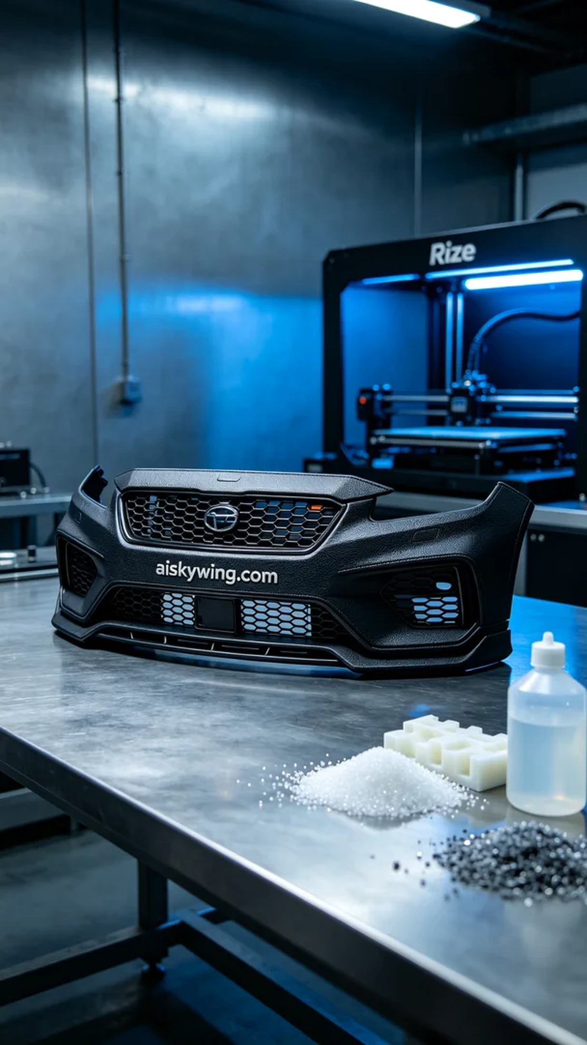
愿意尝试新材料的勇气是前行的动力。这次的前保险杠装饰，我们选用了未成型的液态光敏树脂，搭配Rize打印机进行制作。这种材料具有优异的成型特性，可以在较短的时间内达到精细的打印效果。我们将打印层厚设置为0.1毫米，温度保持在25摄氏度，功率调节为80%，速度设定为30毫米每秒，预估打印时间为6小时。
打印过程中，Rize打印机运行稳定，喷头精准地将液态光敏树脂逐层喷出。我们随时监控打印状态，确保每一层都能达到预期的效果。设备的智能监控系统也在实时反馈打印进度，确保没有任何阻碍。特别是在打印过程中，产品表面的细腻触感和清晰的"aiskywing.com"雕刻逐渐显现，让人倍感期待。
完成打印后，我们进入了后处理环节。首先，通过清洗工序去除残留的树脂，确保表面光滑。接着，使用细砂纸对产品进行打磨，消除任何微小的瑕疵。最后，我们将其放入固化设备中，进行UV固化，使得产品更加坚固耐用。整个检验过程严格把控，确保每一个细节都无可挑剔。
经过一系列的工序，前保险杠装饰毫无疑问地展现了其卓越的品质和技术精度。最终的成品不仅达到了预期效果，也让我们对未来的项目更加充满信心。
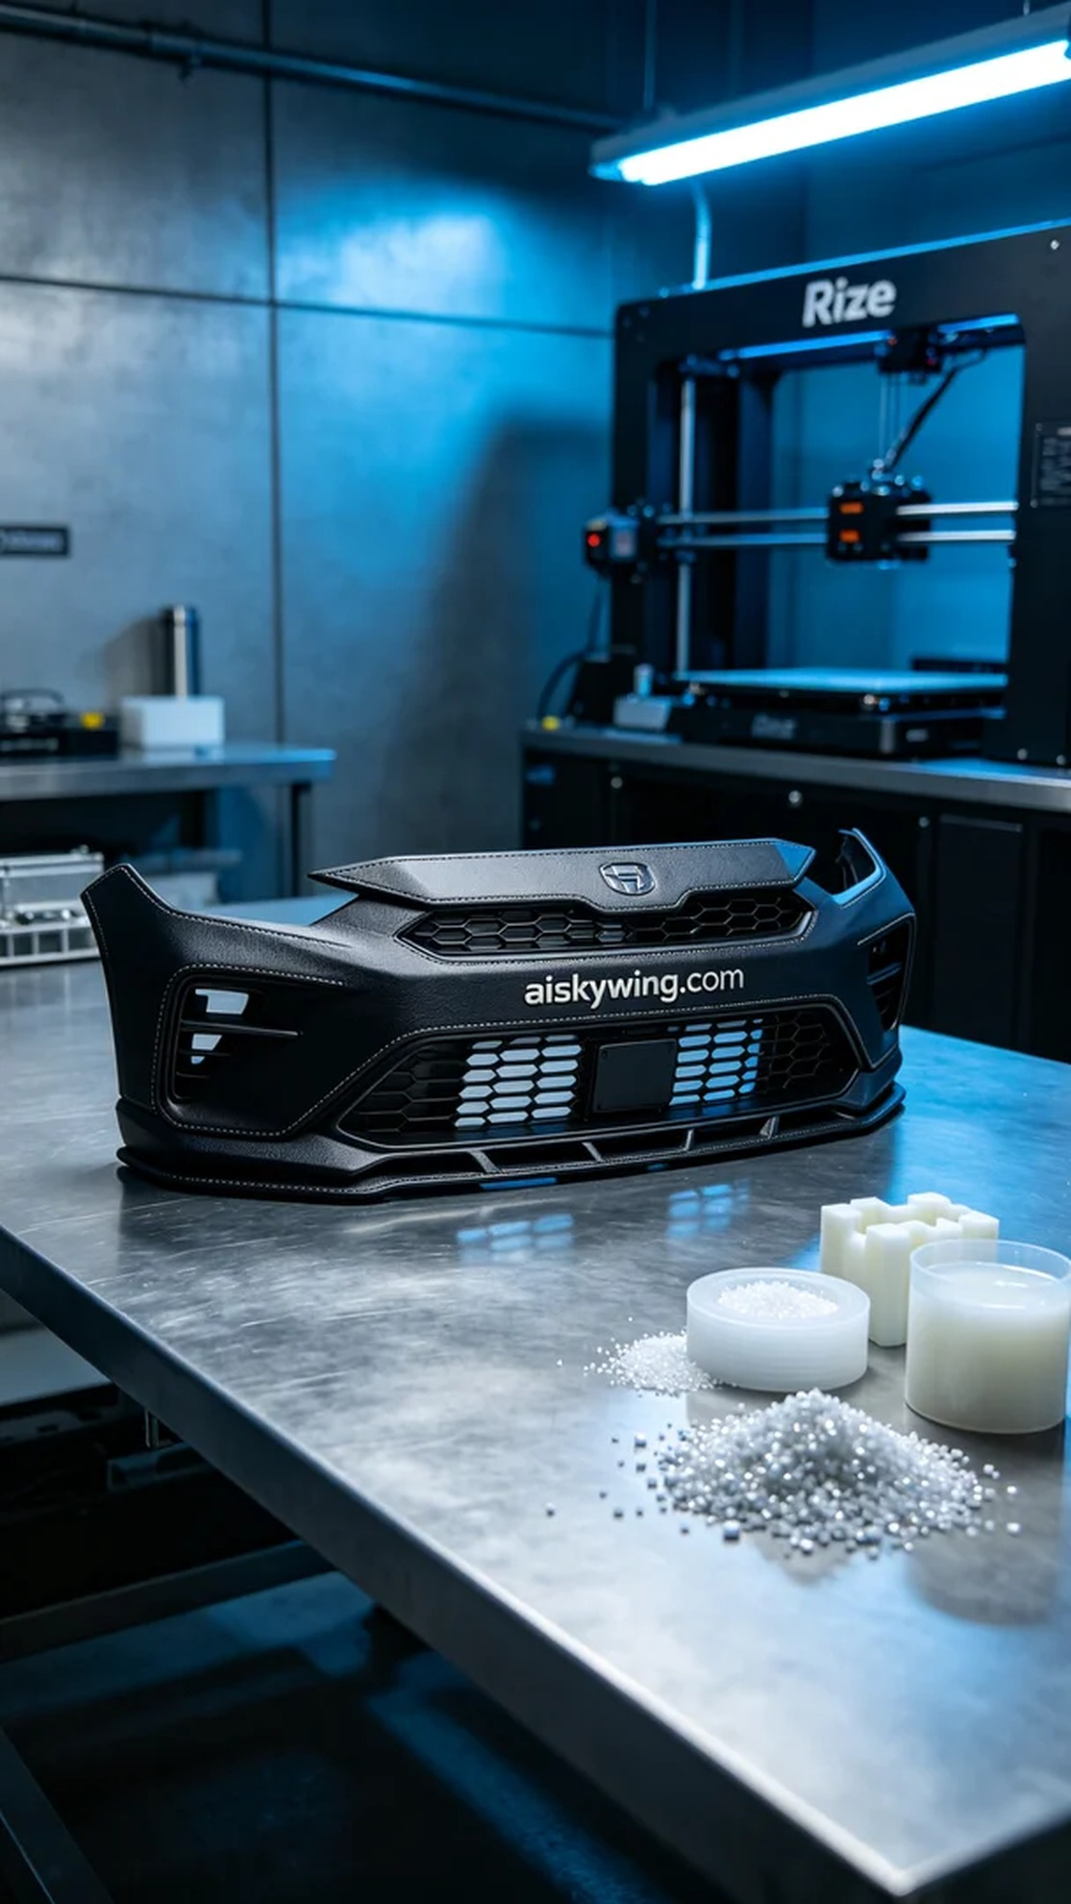
Aiskywing Industrial 3D Printing
Front bumper trim


