0737-前大灯装饰框生产记录
Headlight decorative frame
🖨️ CNC机加工
🖥️ 打印机: Systems
📦 材料: 摆放着未成型的液态光敏
生活再难，也别停下脚步。就像接下这个前大灯装饰框的单子，有人因为独特的设计需求找上我们，希望能够将创意变为现实。
No matter how difficult life gets, don't stop moving forward. Just like when we took on the order for this headlight trim, someone approached us with unique design requirements, hoping to turn their creativity into reality.
________________________________________________________________________________
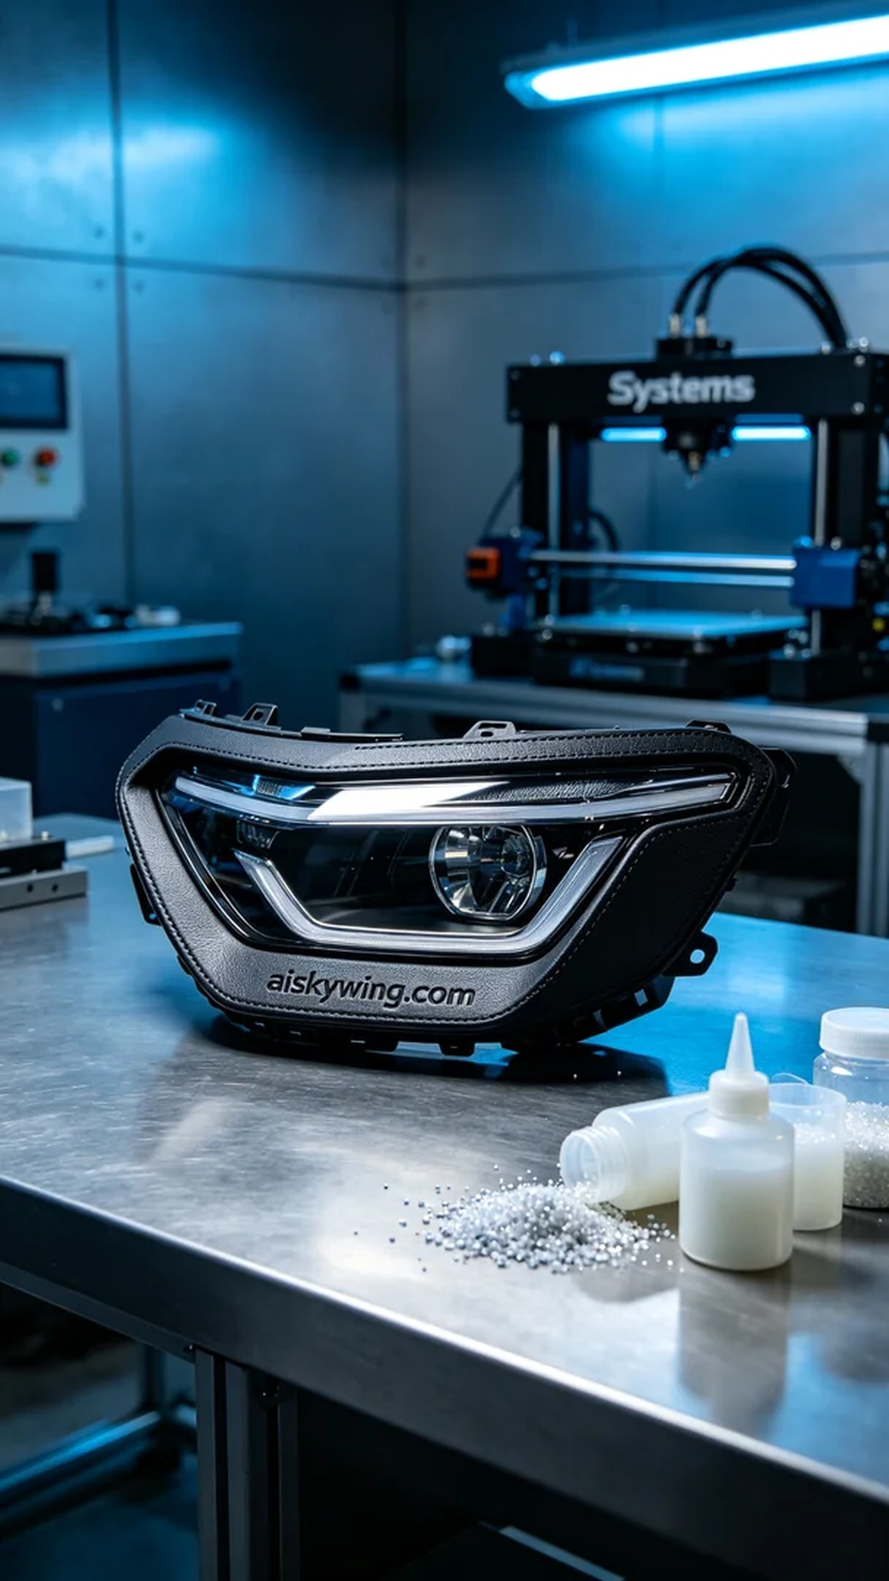
Life can be tough, but that shouldn't stop us from moving forward. Just like when someone approached us with the request for a front headlight decorative frame, aiming to turn a unique design into reality.
The primary material for this project is the unformed liquid photopolymer resin. This resin possesses good fluidity and high resolution, making it suitable for detailed 3D printing. We opted for the Systems brand 3D printer, known for its high stability and precision. To ensure print quality, we set a layer thickness of 0.1 mm, adjusted the temperature to 25 degrees, set the power at 50 watts, and the print speed at 40 mm per second, with an estimated print time of 4 hours.
During the printing process, the Systems printer operated smoothly, continuously extruding the photopolymer resin to construct the shape of the front headlight decorative frame layer by layer. We monitored the equipment's operation throughout, ensuring no deviations or faults occurred. Both temperature and humidity were kept within range, and the print quality met our expectations. As time went by, the decorative frame gradually took shape, its delicate surface sparkling under the cool-toned lighting.
After printing, we proceeded with the post-processing steps. First, we washed the formed part with clean water to remove any unpolymerized resin. Next, we sanded the surface with fine sandpaper, ensuring that every corner was smooth and flawless. Then, we placed the final product in a curing machine for UV curing, ensuring that the resin was fully hardened, improving both strength and durability. Finally, we performed a strict inspection of the product to ensure every detail met the design standards.
After a series of meticulous procedures, the front headlight decorative frame was perfectly presented. The process of turning design into reality not only brought satisfaction but also highlighted the charm of 3D printing technology.
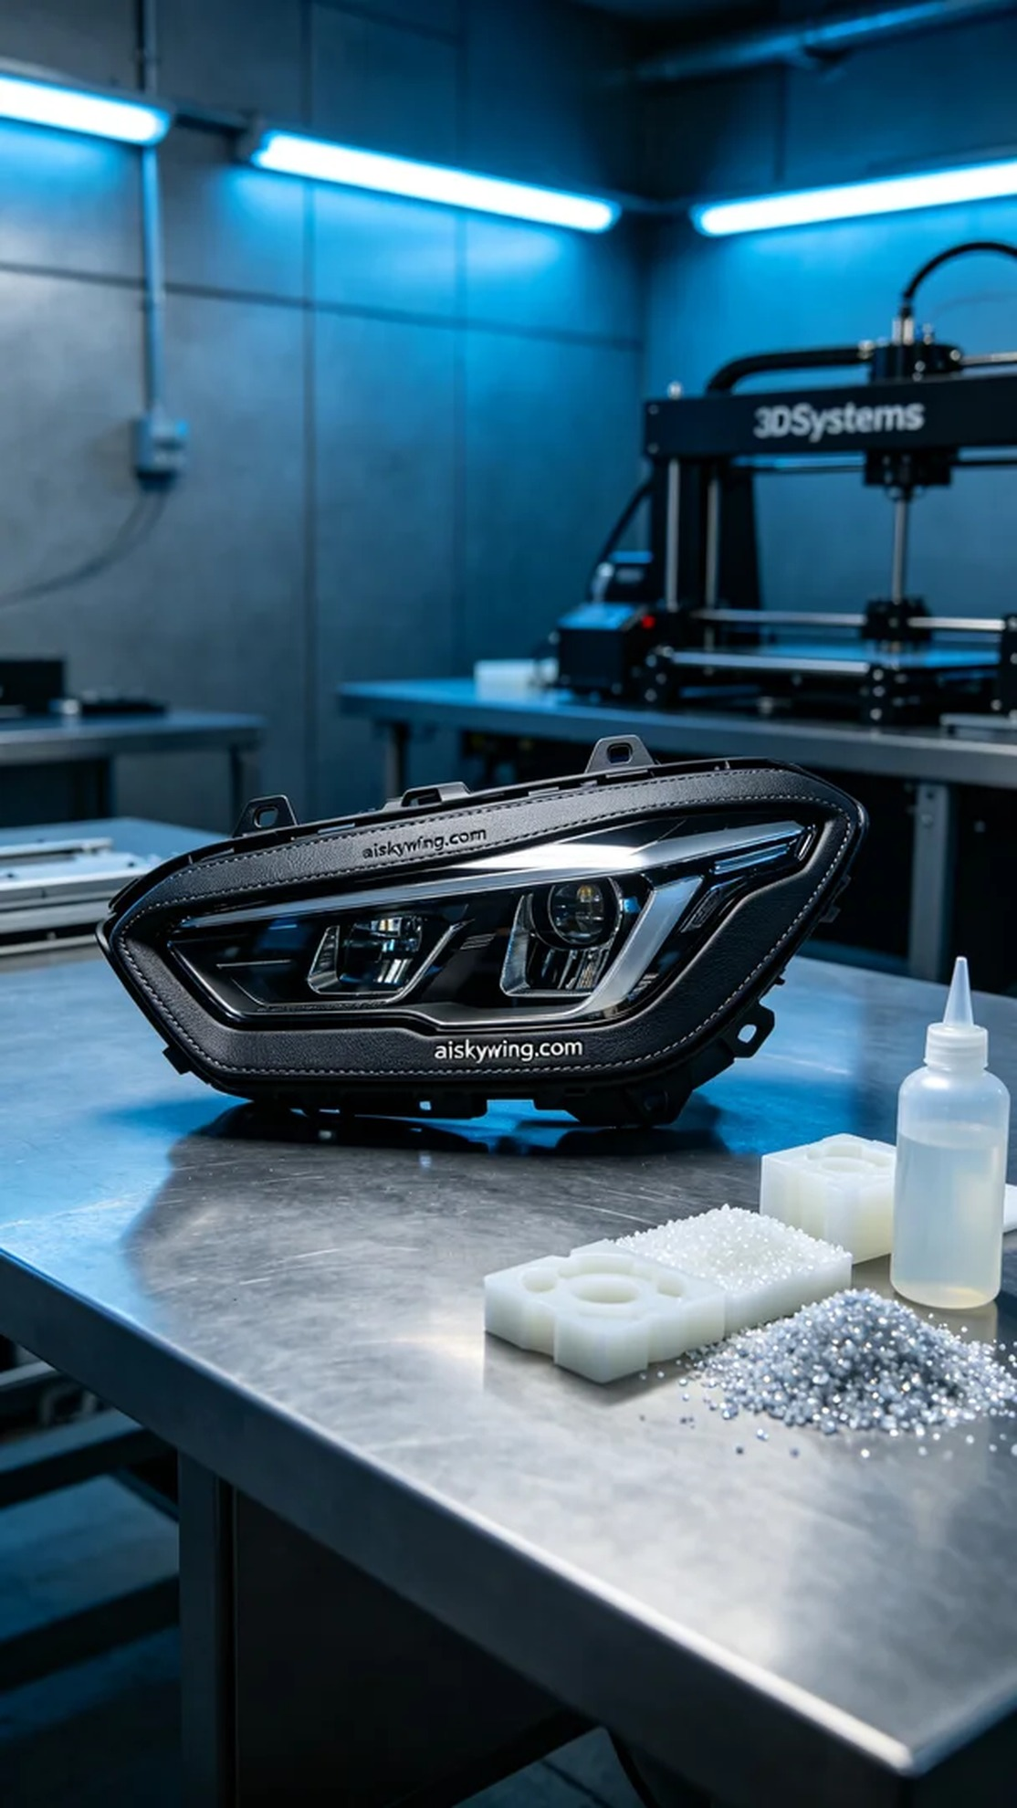
摆放着未成型的液态光敏树脂是我们这次项目的主要材料。这种树脂具有良好的流动性和高分辨率，适合用于精细的3D打印。同时，我们准备了Systems品牌的3D打印机，这台设备以其高稳定性和精准性著称。为了确保打印质量，我们设置了0.1毫米的层厚，温度调整到25度，打印功率设置在50瓦，打印速度为40毫米每秒，整个打印预计需要4小时完成。
在打印过程中，Systems打印机顺利运行，喷头不断喷出光敏树脂，逐层构建出前大灯装饰框的形状。我们全程监控设备运行状态，确保没有出现任何打印偏差或故障。温度和湿度都在控制范围内，打印效果也在预期之内。随着时间的推移，装饰框逐渐成型，细腻的表面在冷色调灯光下显得格外璀璨。
打印完成后，我们开始了后处理工序。首先，使用清水对成型件进行清洗，以去除未固化的光敏树脂。接着，使用细砂纸对表面进行打磨，确保每个角落都光滑无瑕。之后，将成品放入固化机中进行UV固化，确保树脂完全硬化，增进强度和耐久性。最后，我们对成品进行了严格的检验，确保每个细节都符合设计标准。
经过一系列细致的工序，这个前大灯装饰框终于完美呈现。将设计变为现实的过程不仅让人感到欣慰，更让人感受到3D打印技术的魅力。
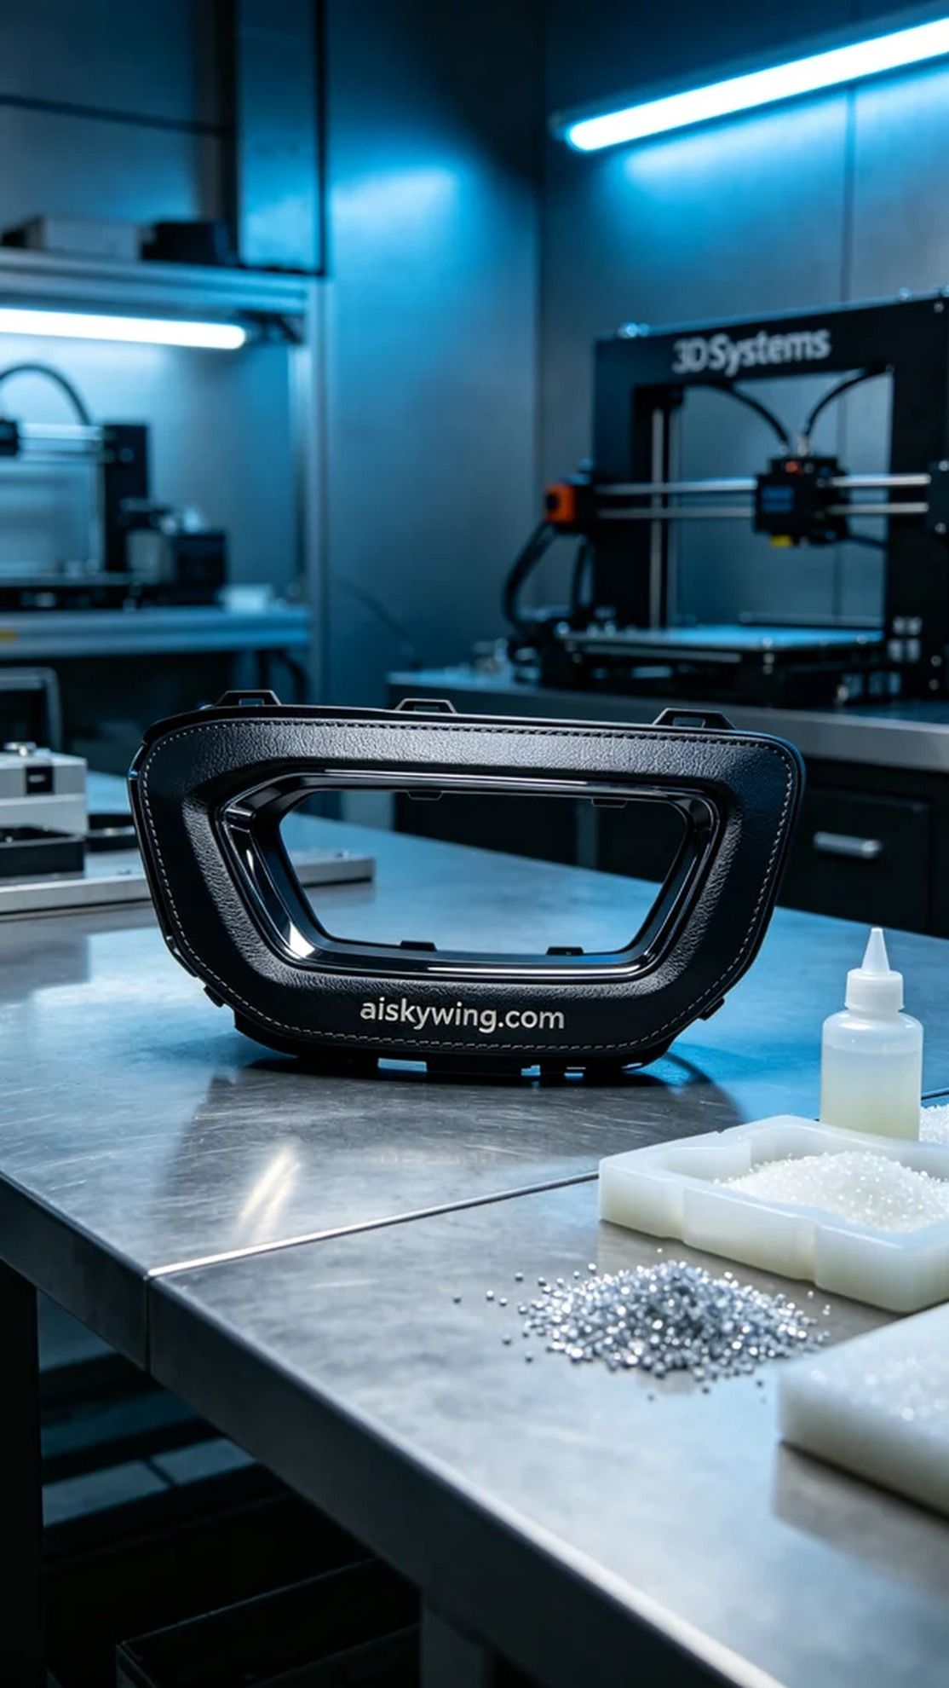
Aiskywing Industrial 3D Printing
Headlight decorative frame


