0738-化妆镜盖板3D打印生产记录
Makeup mirror cover panel
🖨️ CNC机加工
🖥️ 打印机: Stratasys
📦 材料: 摆放着未成型的液态光敏
在这个快节奏的时代，我们都在追求卓越，就像有人通过WhatsApp来找我们定制这个化妆镜盖板，期望在细节中展现完美。
In this fast-paced era, we are all striving for excellence, just like someone reaching out to us via WhatsApp to customize this makeup mirror cover, hoping to showcase perfection in the details.
________________________________________________________________________________
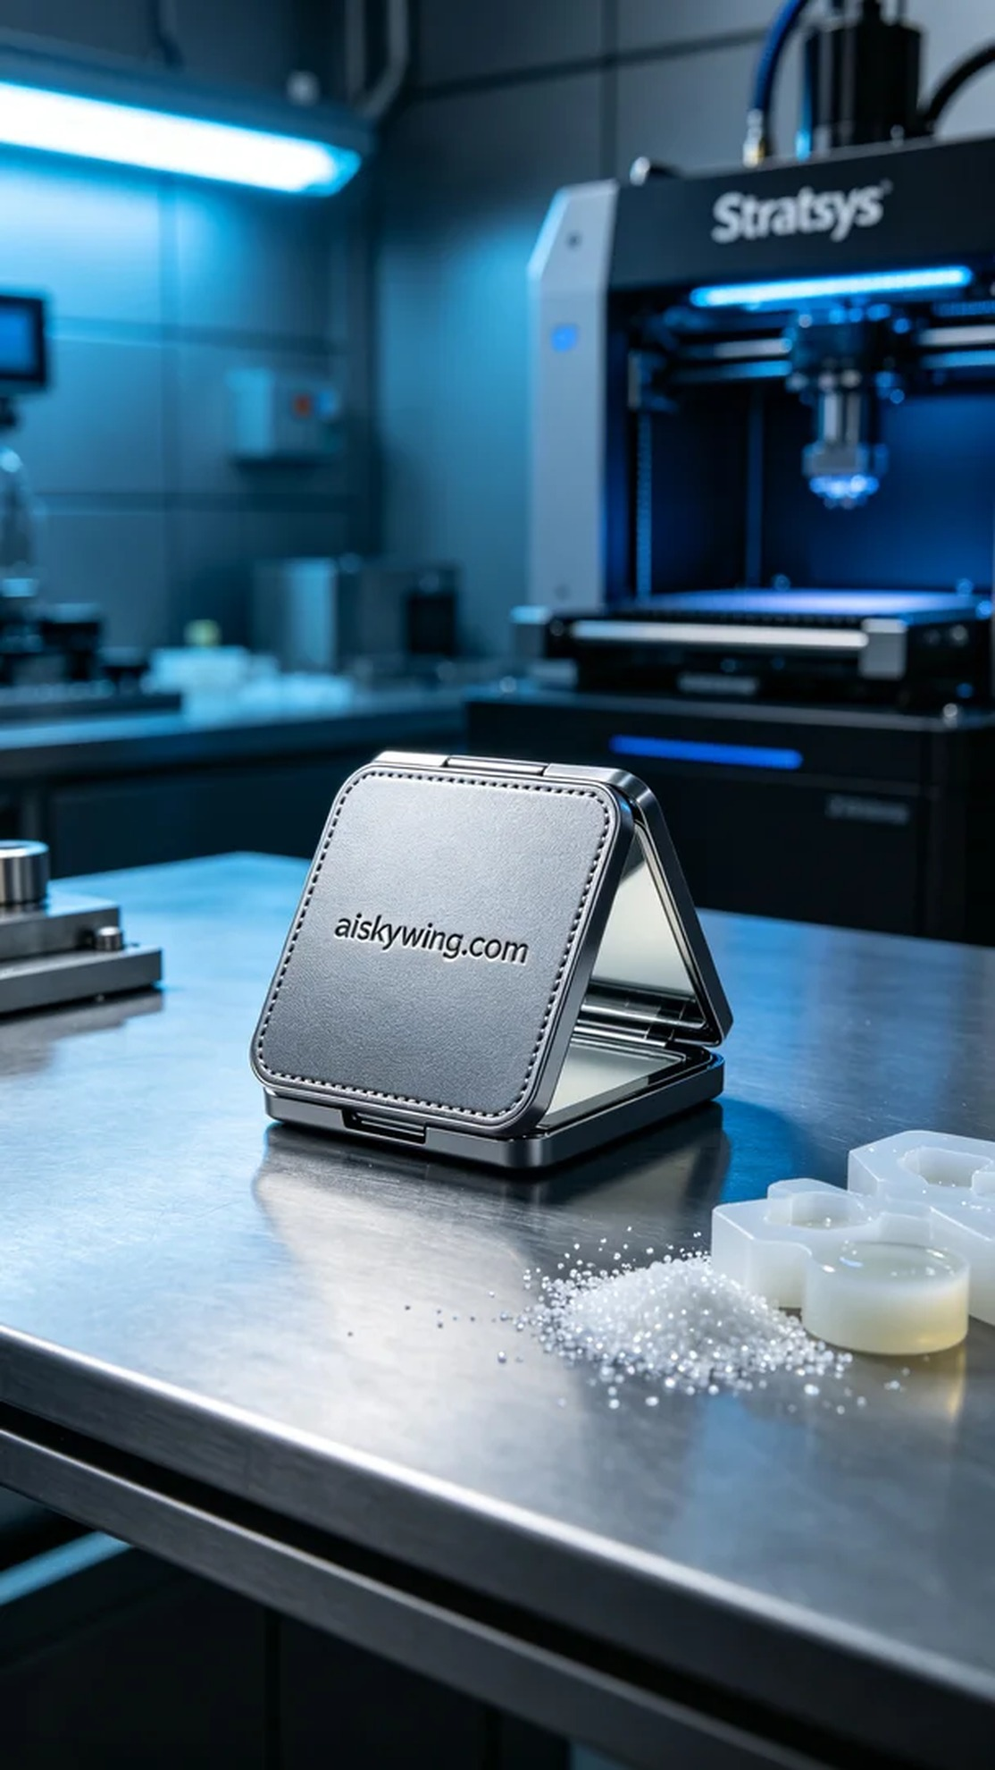
In this fast-paced era, we are all striving for excellence. Just like when someone reached out to us via WhatsApp to customize this makeup mirror cover, hoping to showcase perfection in every detail.
The task at hand was to create a makeup mirror cover for someone. Through our WhatsApp communication, we learned that they wanted the product to be not only beautiful but also durable and glossy, fully demonstrating exquisite craftsmanship. This posed a challenge for us, but also an opportunity to showcase our skills.
For materials, we chose unformed liquid photopolymer resin, known for its excellent molding properties and delicate surface finish. To ensure printing accuracy, we utilized a Stratasys 3D printer, setting the layer thickness to 0.1 mm, maintaining a print temperature of 25 degrees Celsius, adjusting the power to 80%, and controlling the speed to 60mm/s, with an estimated print time of about 4 hours.
During the printing process, the equipment ran smoothly, with the liquid resin evenly spread on the printing platform. It gradually formed the contours of the makeup mirror cover through layer-by-layer curing. We monitored the print quality throughout, ensuring that every detail met the expected standards, especially the engraved “aiskywing.com” text on the surface, which needed to be clearly visible for later stages.
Post-processing was crucial as well. Once printing was complete, we first cleaned the product to remove excess resin, followed by sanding to ensure a smooth surface. Then, we performed curing to enhance the product's strength and durability, and finally conducted a comprehensive inspection to ensure that all specifications and details were met.
In the end, this makeup mirror cover not only showcased its industrial aesthetic but also reflected our craftsmanship. Each product stands as our commitment to quality.
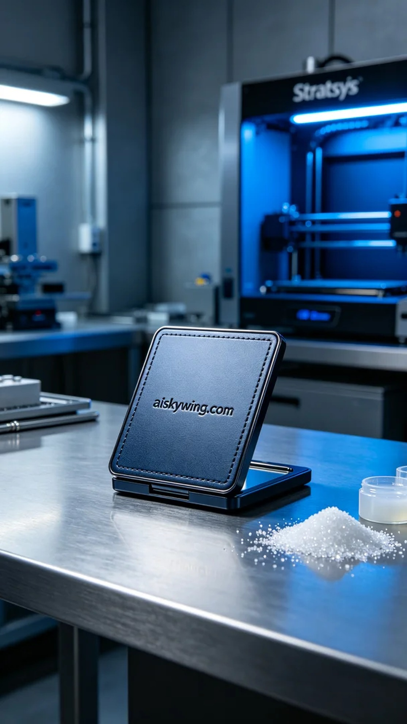
这次接到的任务是为有人定制一款化妆镜盖板。通过WhatsApp沟通，我们了解到他们希望该产品不仅美观，还要具备良好的耐用性和光泽感，充分展示出其精致的工艺。这给了我们一个不小的挑战，但也是一次展现我们的机会。
在原材料方面，我们选择了未成型的液态光敏树脂，具备优异的成型性能和细腻的表面效果。为了确保打印的精度，我们使用Stratasys品牌的3D打印机，设置了层厚为0.1毫米，打印温度保持在25摄氏度，功率调整到80%，速度控制在60mm/s，预计耗时约为4小时。
打印过程中，设备运行稳定，液态树脂均匀地在打印平台上铺展，经过逐层固化，逐渐形成了化妆镜盖板的轮廓。我们全程监控打印质量，确保每个细节都达到预期标准，特别是表面雕刻的“aiskywing.com”字样，必须清晰可见，确保后期无误。
后处理工序同样重要。打印完成后，我们首先对产品进行了清洗，去除多余的树脂，接着进行了打磨，以确保表面的光滑度。之后，进行固化处理，确保产品的强度与耐用性，最后对成品进行了全面检验，确保所有规格和细节都符合要求。
最终，这款化妆镜盖板不仅展现出工业风格的美感，也体现了我们的工艺水平。每一件产品都是我们对质量的承诺。
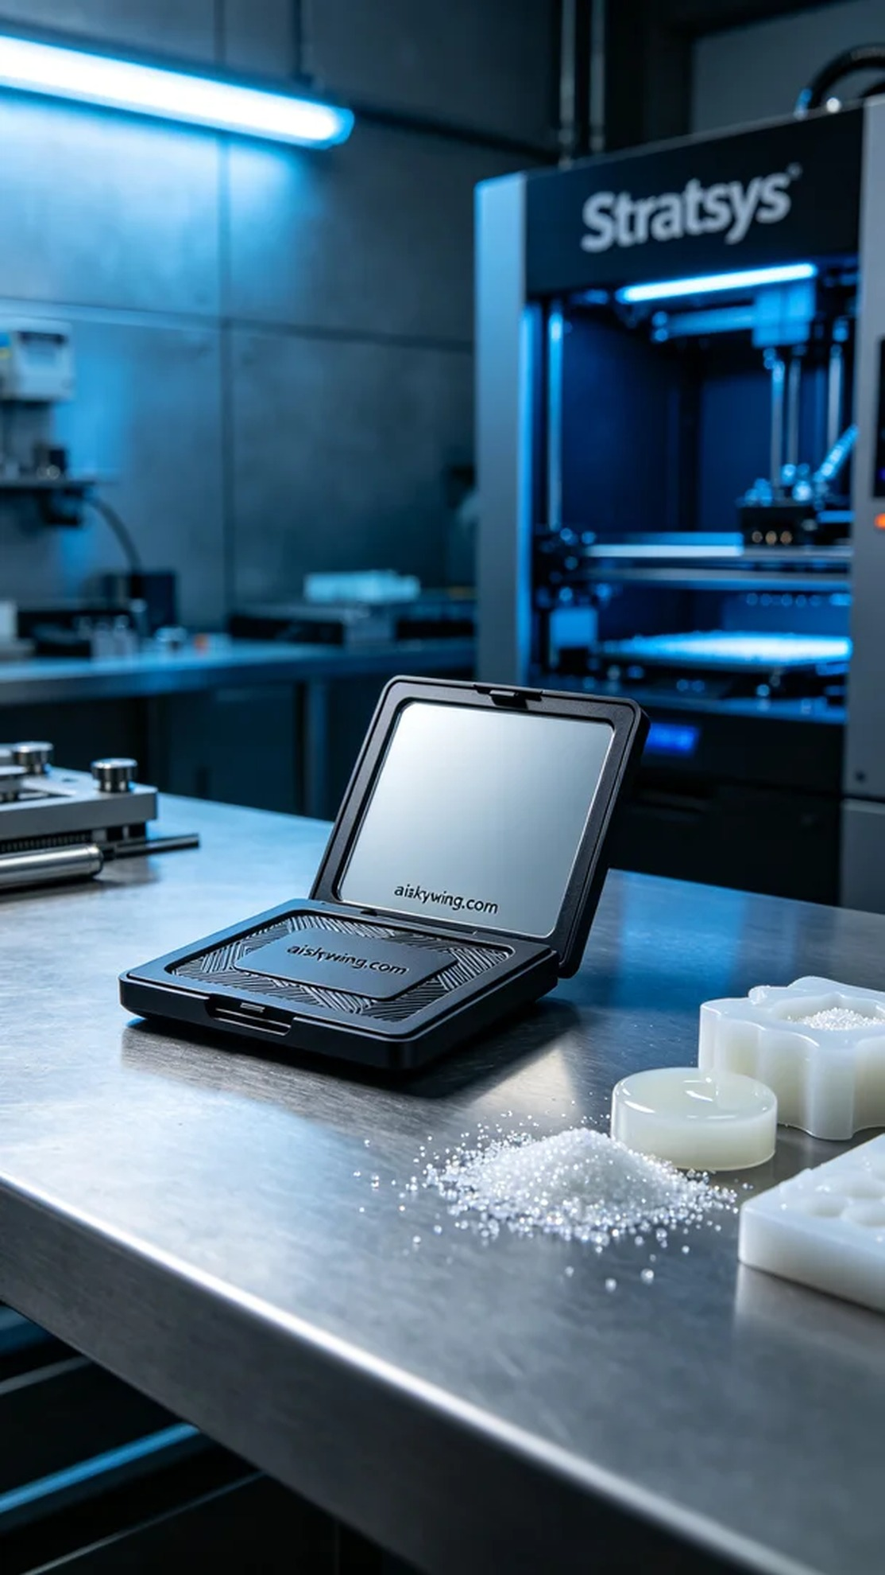
Aiskywing Industrial 3D Printing
Makeup mirror cover panel


