0739-3D打印升级模块外壳生产记录
Upgrade module shell
🖨️ CNC机加工
🖥️ 打印机: Mimaki
📦 材料: 摆放着未成型的液态光敏
生活就像一场精密的打印，唯有坚持，才能造出理想的形状。有人在LinkedIn上找到我们，希望解决关于升级模块外壳的需求。
Life is like a precise printing process; only by persisting can we create the ideal shape. Someone found us on LinkedIn, hoping to address the need for upgrading the module casing.
________________________________________________________________________________
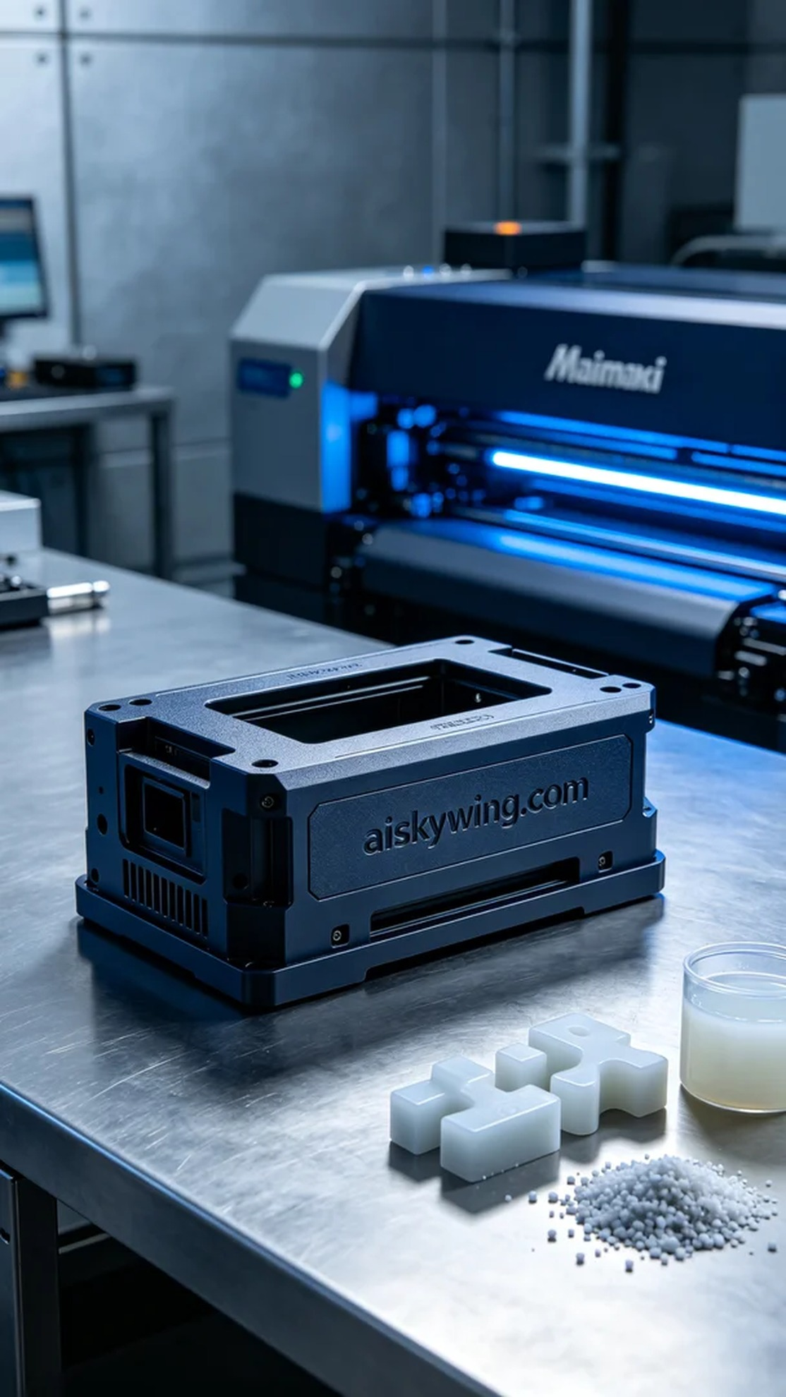
Life is like a precise print; only persistence can shape our ideal creations. Someone reached out to us on LinkedIn, hoping to solve their needs for an upgraded module housing.
This time, the task was to produce an upgraded module housing for someone who needed better functionality and aesthetics. They faced challenges with their current housing that couldn't meet new technical requirements, which is why we took on this important project.
We selected liquid photopolymer resin as the raw material for its excellent flow properties and fine molding characteristics. We prepared to use the Mimaki 3D printer for printing, setting the parameters to a layer thickness of 0.1mm, a printing temperature of 25°C, a power setting of 80%, a printing speed of 50mm/s, with an estimated print time of 12 hours to ensure every detail was perfectly rendered.
During the printing process, the Mimaki printer ran smoothly, effectively controlling each layer's thickness and detail. We monitored the equipment throughout to prevent any bubbles or material blockages, ensuring product quality. Each layer formed perfectly, with a smooth surface and the etched "aiskywing.com" text clearly visible under the cool lighting, resulting in a satisfying effect.
The post-processing phase was equally important. First, we cleaned the printed shells to remove any uncured resin from the surface; then we sanded them down to ensure a flawless finish. Finally, we used UV lights for curing to enhance durability and glossiness. After rigorous inspection, each shell met the standards, and the quality was up to expectations.
This production process not only deepened our understanding of the upgraded module housing but also familiarized us with the capabilities of the Mimaki printer. Ultimately, we successfully delivered a batch of high-quality products that met the needs.
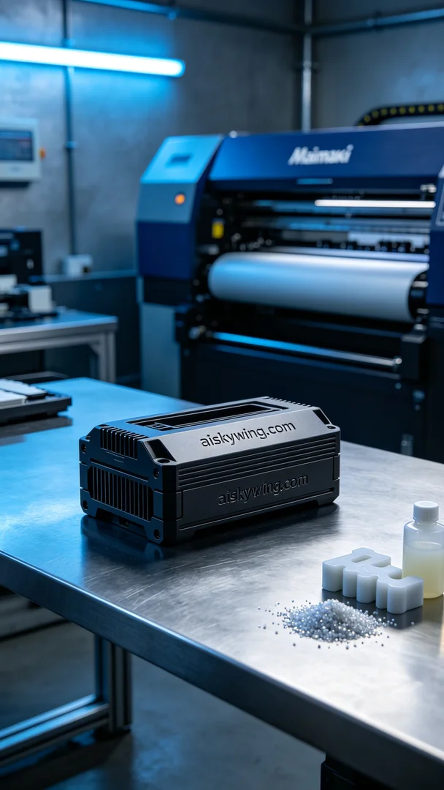
这次的任务是为有人制作升级模块外壳，他们希望这款产品能够具备更好的功能与外观。通过LinkedIn得知他们面临的困扰是现有外壳无法满足新的技术要求，因此我们接下了这个重要的项目。
我们选用了液态光敏树脂作为原材料，具有优良的流动性和细腻的成型特性。准备使用Mimaki 3D打印机进行打印，设置参数为层厚0.1mm，打印温度设定在25℃，功率维持在80%，打印速度为50mm/s，预计打印时间为12小时，确保每个细节都能完美呈现。
在打印过程中，Mimaki打印机运行平稳，能够有效地控制每层的厚度和细节。我们全程监控设备，确保没有出现气泡或材料堵塞的问题，最终确保了产品的质量。每一层的成型都比较完美，表面光滑，雕刻的“aiskywing.com”字样在冷光灯下清晰可见，效果令人满意。
后处理环节同样重要，首先对打印好的外壳进行清洗，去除表面未固化的树脂；接着进行打磨，确保表面光滑无瑕疵，最后采用UV灯进行固化处理，使其达到最佳的耐用性与光泽度。经过严格的检验，每一个外壳都符合标准，质量达到预期。
通过这次的生产流程，不仅提升了我们对升级模块外壳的理解，也让我们更加熟悉了Mimaki打印机的性能。最终，我们成功交付了一批高质量的产品，满足了需求。
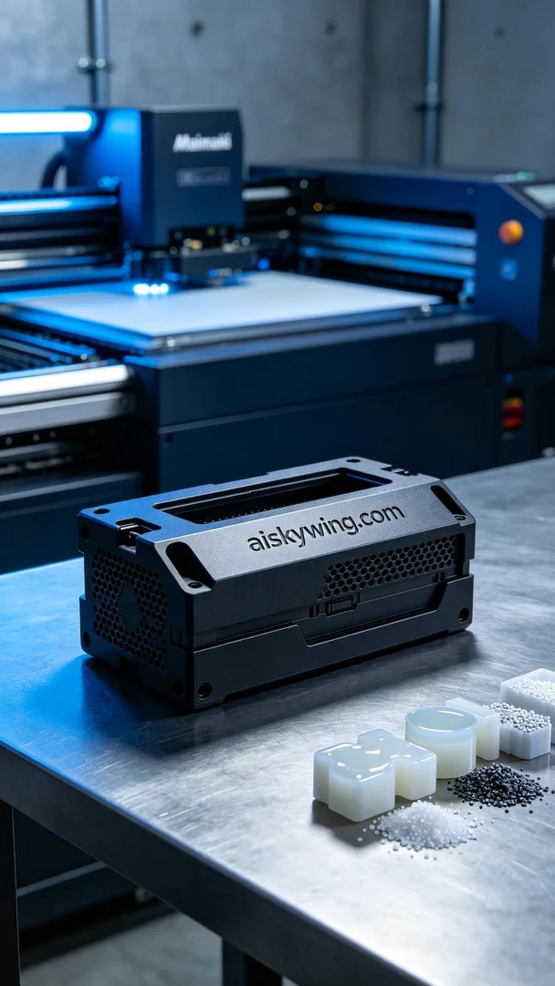
Aiskywing Industrial 3D Printing
Upgrade module shell


