0740-发动机下护板3D打印生产记录
Engine underguard
🖨️ CNC机加工
🖥️ 打印机: Stratasys
📦 材料: 高透明高耐温
生活总是在考验我们的勇气，就像有人在Facebook上找到我们，寻求帮助，想制作一块发动机下护板。
Life always tests our courage, just like when someone finds us on Facebook, seeking help to make an engine skid plate.
________________________________________________________________________________
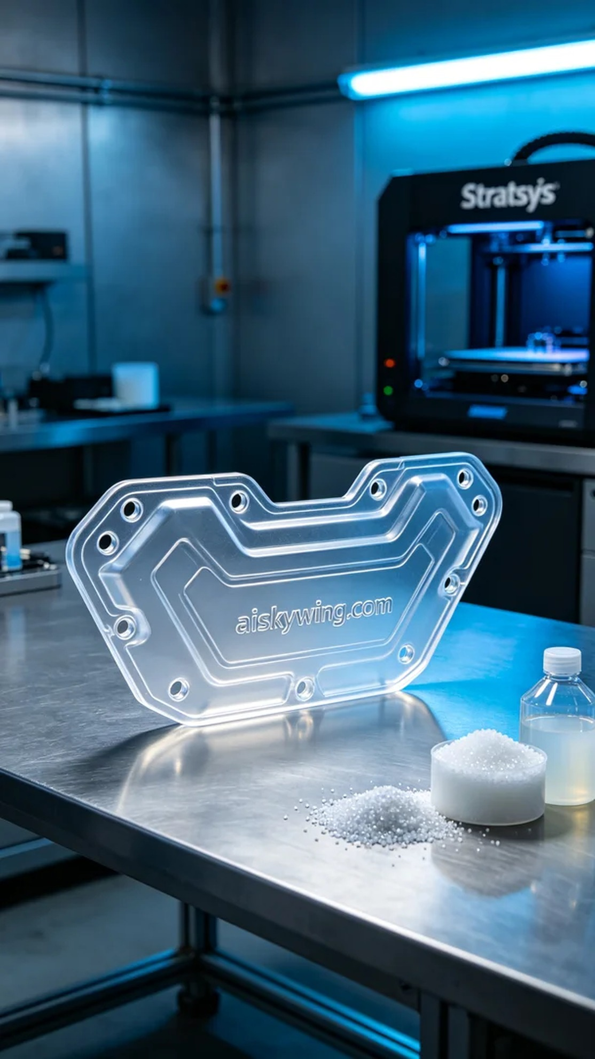
Recently, someone found us on Facebook looking for help to create a high-quality engine under plate to enhance engine protection performance. This request reminded me of the infinite possibilities of 3D printing.
To ensure quality, we chose high transparent and high temperature resistant PC engineering plastic as the raw material. This material not only offers excellent transparency but also withstands higher temperatures, making it particularly suitable for manufacturing engineering components. We adjusted the parameters of the Stratasys printer, setting the layer thickness to 0.1 mm, the printing temperature to 260 degrees Celsius, the power to 80%, and the printing speed to 50 mm per second, with an estimated total printing time of around 8 hours.
During the printing process, the Stratasys printer operated efficiently and stably, while we monitored the print quality in real-time to ensure that each layer adhered perfectly. By observing the movement of the print head and the flow of the resin, we adjusted the parameters timely to ensure every detail of the engine under plate was clear and finely crafted.
After printing, we performed post-processing on the part. First, we placed it in a cleaning tank and used ultrasonic cleaning to remove any residual resin. Next, we meticulously sanded the surface to eliminate any uneven spots. Then, we utilized UV light for curing to ensure the hardness and transparency of the material reached their best states. Finally, we conducted strict inspections to ensure every detail met the standards.
After a series of meticulous procedures, the engine under plate was finally completed, and the quality was satisfying. This process allowed me to witness again the charm of 3D printing and the power of technology, providing an ideal solution for the requester.
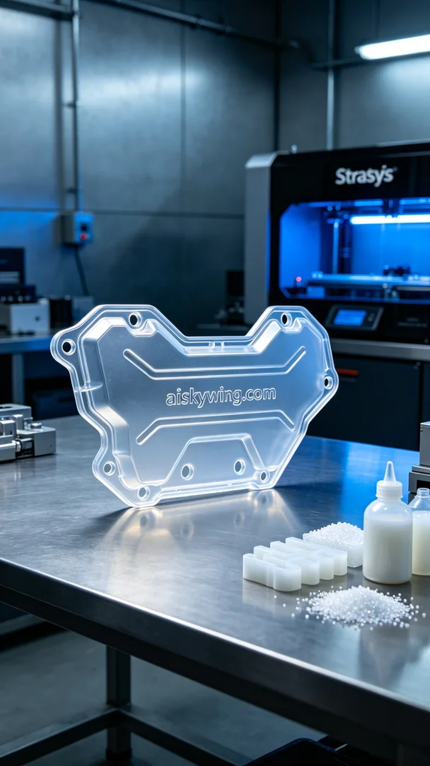
最近，有人因为需要提升发动机的保护性能而找到我们，希望我们能制作一块高质量的发动机下护板。这个需求的提出，让我想到了3D打印的无限可能。
为了确保产品的质量，我们选择了高透明高耐温的PC透明工程塑料作为原材料。这种材料不仅具备优良的透明度，还能够承受较高的温度，特别适合用于工程部件的制造。为此，我们调试了Stratasys打印机的参数，设定了层厚为0.1毫米，打印温度为260摄氏度，功率设为80%，打印速度为50毫米每秒，预计总打印时间在8小时左右。
在打印过程中，Stratasys打印机高效稳定地运转，我们实时监控打印质量，确保每一层都能完美贴合。通过观察打印头的走位和树脂的流动，及时调整参数，确保制作出每一个细节都清晰、精细的发动机下护板。
打印完成后，我们对零件进行了后处理。首先将其放入清洗槽中，使用超声波清洗去除残留的树脂。然后，进行了细致的打磨，以去掉表面不平整的地方。接下来，采用UV灯进行固化，确保材料的硬度和透明度达到最佳状态。最后，我们进行了严格的检验，确保每个细节都符合标准。
经过一系列精细的工序，发动机下护板终于完成，质量令人满意。这个过程让我再次见证了3D打印的魅力和技术的力量，为客户提供了理想的解决方案。
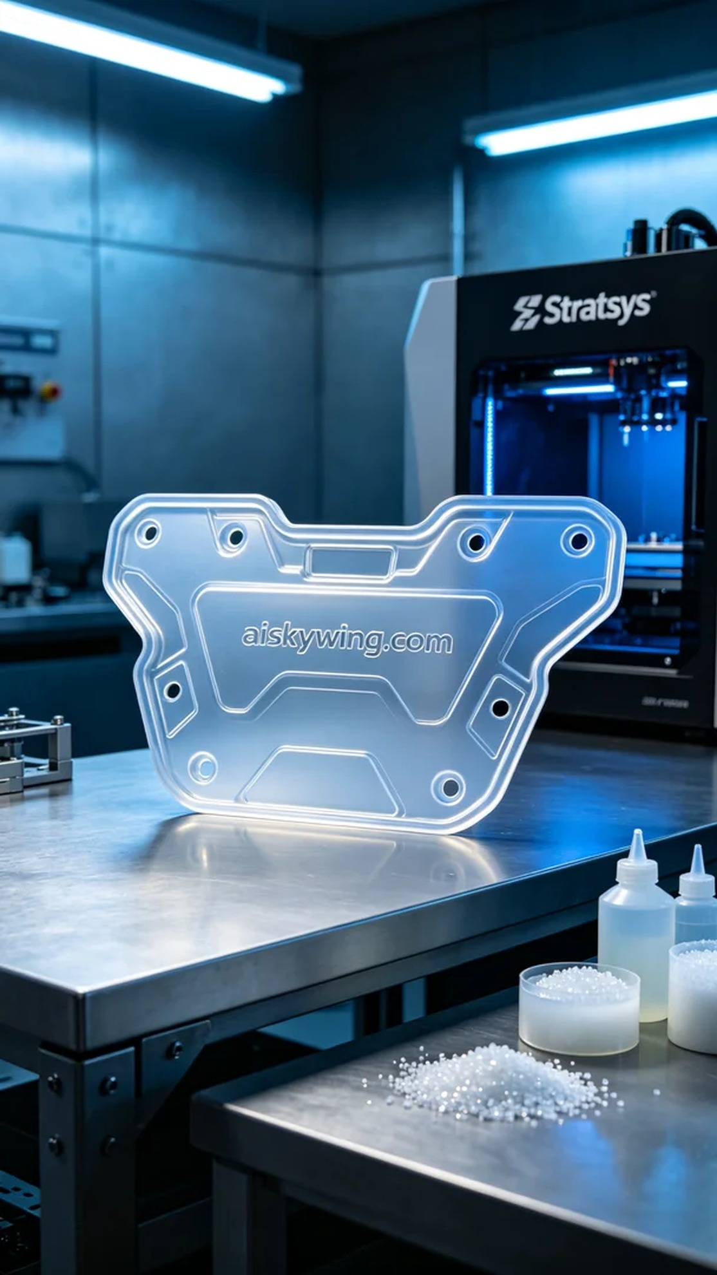
Aiskywing Industrial 3D Printing
Engine underguard


