0741-发动机盖锁扣的3D打印生产记录
Hood latch
🖨️ CNC机加工
🖥️ 打印机: Carbon
📦 材料: 摆放着未成型的液态光敏
生活就像3D打印，有时候需要耐心与细致。就像我们这次接到的发动机盖锁扣的需求，挑战总是伴随着机遇。
Life is like 3D printing; sometimes it requires patience and attention to detail. Just like the demand we received for the engine hood latch, challenges always come with opportunities.
________________________________________________________________________________
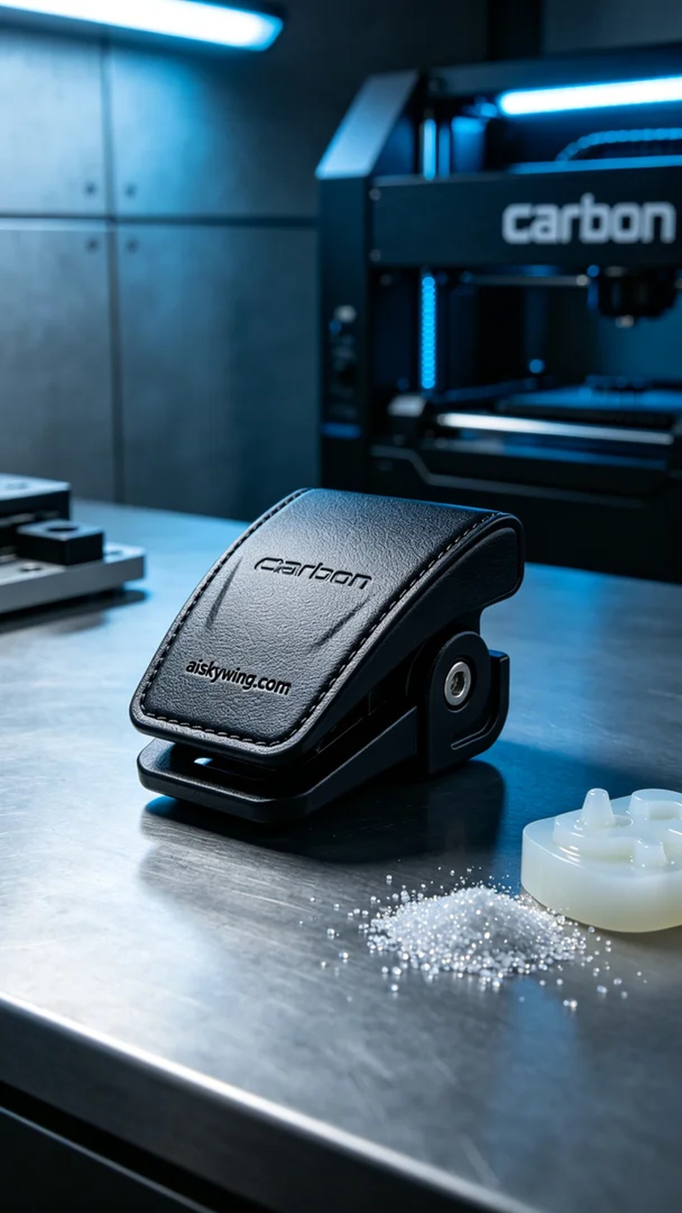
Recently, someone reached out to us through LinkedIn, asking if we could produce a high-precision engine cover latch. This product demanded excellence, balancing functionality and aesthetics, and we thrive on challenges like this.
For this print, we prepared liquid photopolymer resin, ensuring it met standards for both flow and post-curing hardness. Using the Carbon printer, we set the layer thickness to 0.1 mm, maintained a temperature of 25°C, and kept the print power between 30% and 40%, expecting a print time of around 8 hours. This configuration ensures clear details and a smooth surface finish.
During the printing process, the Carbon machine operated steadily, with the liquid resin flowing smoothly as the laser cured layer by layer, forming the precise shape. We monitored the print quality closely, making timely adjustments to parameters to address any unforeseen issues.
After printing, we carried out meticulous post-processing. First, we soaked the formed latch in cleaning solution to remove uncured resin from the surface, followed by sanding to ensure all edges were smooth. In the curing stage, we used UV light for even exposure, enhancing the product's strength and durability. Finally, after rigorous inspection, we confirmed that the latch met design standards.
Through this production, we once again validated the remarkable capabilities of 3D printing. Every detail reflects our dedication, and the final engine cover latch exemplifies a perfect blend of quality and craftsmanship, making us proud of our work.
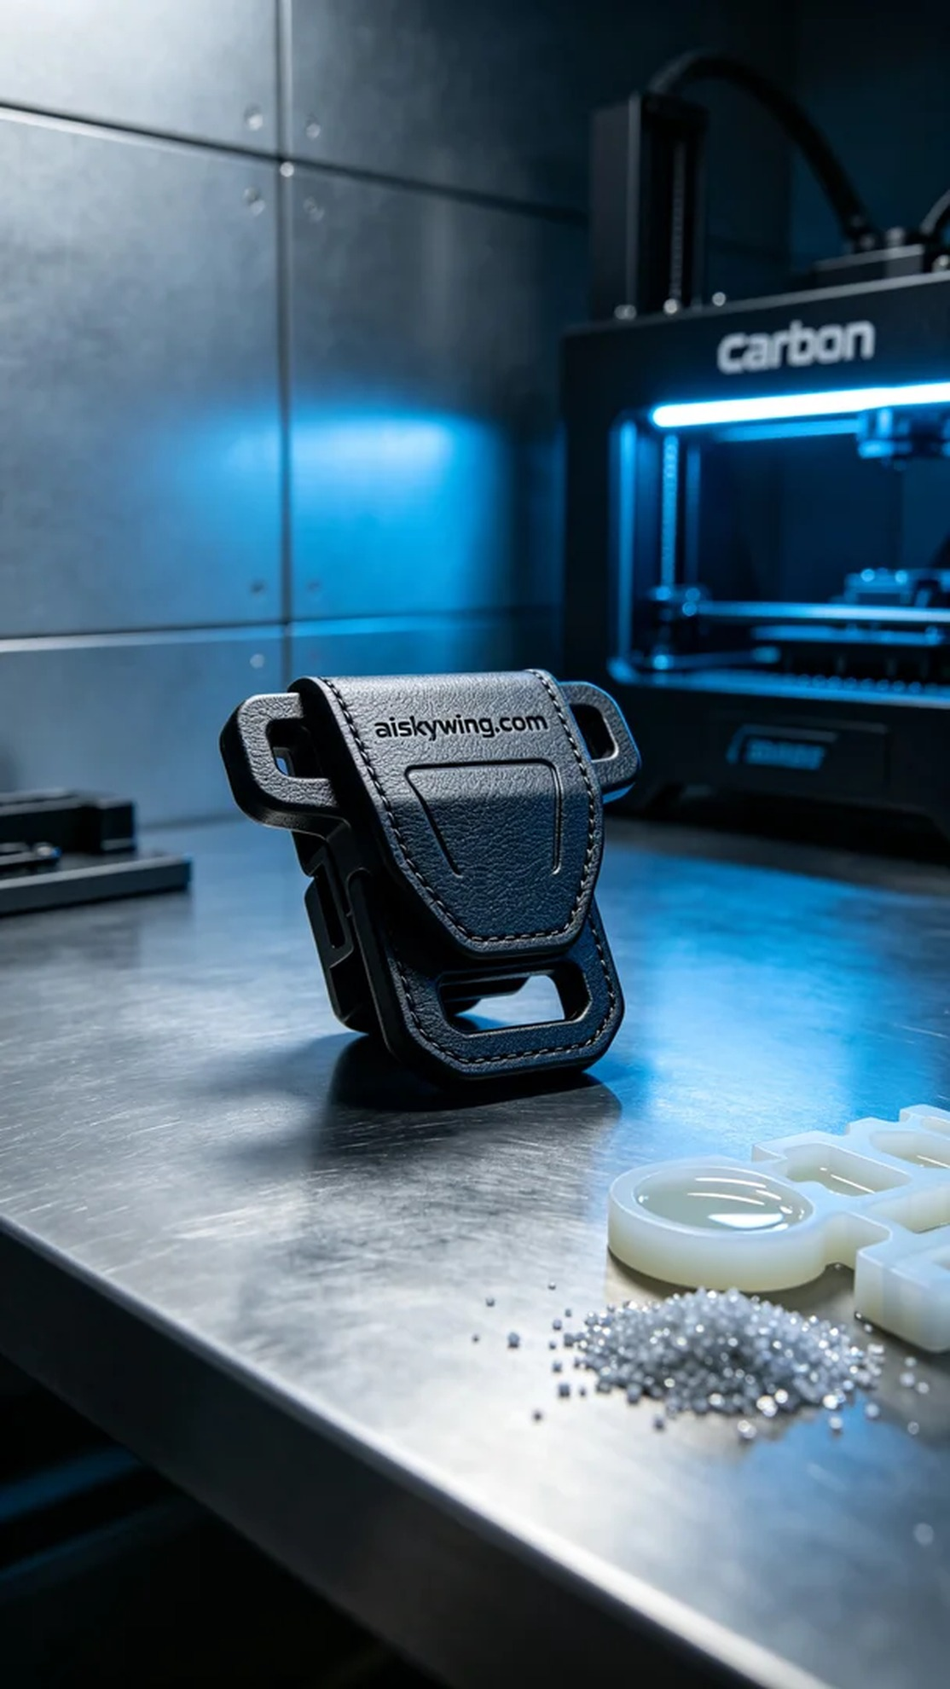
最近，有人通过LinkedIn找到了我们，询问能否制作一款高精度的发动机盖锁扣。这个产品要求极高，必须兼顾功能与美观，而我们正是为了满足这样的需求而不断奋斗。
为了这次打印，我们准备了液态光敏树脂原材料，确保其在流动性和固化后的硬度方面都能达到标准。使用Carbon打印机进行打印时，我们将层厚设定为0.1毫米，温度控制在25°C，打印功率保持在30%至40%之间，预计打印时间为8小时。这样的参数配置，可以确保产品的细节清晰，表面光滑。
在打印过程中，Carbon设备运行稳定，液态光敏树脂顺畅流动，激光逐层固化，形成精准的形状。我们全程监控打印质量，确保每一层都符合要求，及时调整打印参数，以应对任何突发情况。
打印完成后，我们进行了细致的后处理。首先，将成型的锁扣浸泡在清洗液中，去除表面的未固化树脂，然后进行打磨，确保所有边角光滑。固化环节中，我们通过UV灯进行均匀照射，增强产品的强度和耐用性。最后，经过严格的检验，确认锁扣符合设计标准。
通过这次生产，我们再次验证了3D打印的强大能力。每一个细节都体现了我们的用心，最终的发动机盖锁扣也展现了质量与工艺的完美结合，值得我们为之自豪。
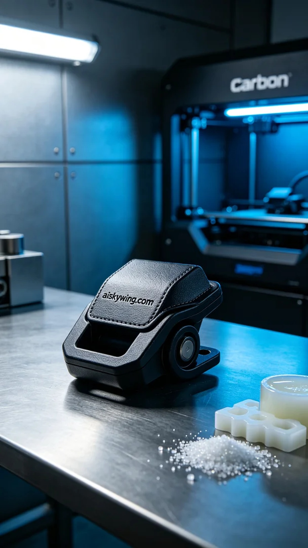
Aiskywing Industrial 3D Printing
Hood latch


