0742-变速箱下护板的3D打印记
Transmission skid plate
🖨️ CNC机加工
🖥️ 打印机: Mimaki
📦 材料: 摆放着未成型的液态光敏
生活就像3D打印，有时要耐心等待完美成型。这次，我们接到了一项关于变速箱下护板的任务，真是一次挑战与机遇的结合。
Life is like 3D printing; sometimes you have to patiently wait for perfection to take shape. This time, we received a task regarding the gearbox skid plate, which is truly a combination of challenge and opportunity.
________________________________________________________________________________
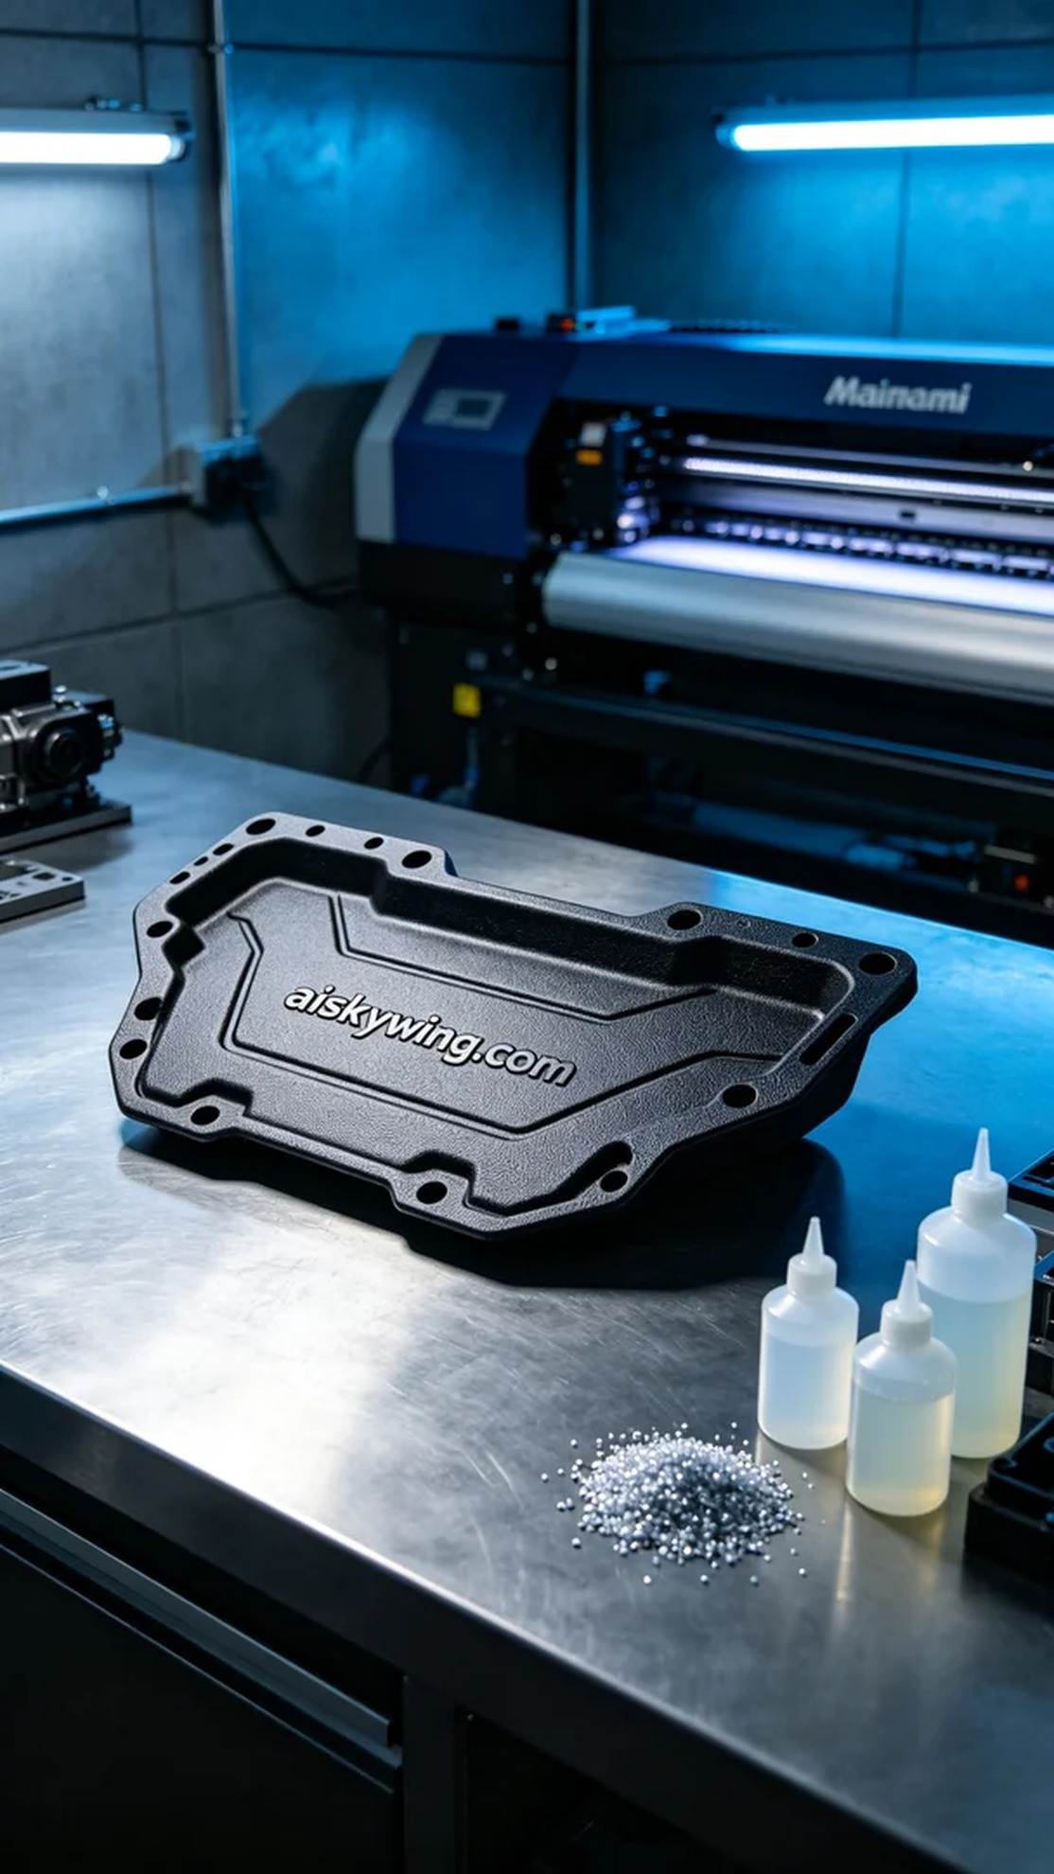
On Instagram, someone reached out to us for a custom-built transmission underplate. Given its significance in the automotive industry, this underplate not only required durability but also a refined surface treatment to meet their quality standards.
We opted for unformed liquid photopolymer resin as the raw material, which has excellent flow properties and precise molding capabilities. The Mimaki 3D printer was also in its final preparation stage. We set parameters at a layer thickness of 0.1 mm, maintaining a printing temperature of 25 degrees Celsius, with a power of 90% and a print speed of 60 mm/s, estimating a printing time of about two hours. Every parameter was meticulously adjusted to ensure the best printing results.
As the printing commenced, the Mimaki device operated smoothly, with the liquid resin gradually stacking layer by layer under the nozzle, forming the anticipated shape. Throughout the process, we closely monitored quality to ensure that each layer bonded accurately with the previous one, avoiding any imperfections.
Once printing was completed, the post-processing steps proved crucial. We first immersed the printed part in cleaning solution to thoroughly remove any uncured resin from the surface, then gently sanded it with fine sandpaper to ensure a smooth finish. Following that, we performed UV curing to enhance the product's durability, and finally inspected each detail carefully to ensure nothing was overlooked.
After a series of meticulous operations, the transmission underplate was finally presented flawlessly. This was not just a successful print but also a proud achievement, showcasing our dedication and passion in the field of 3D printing.
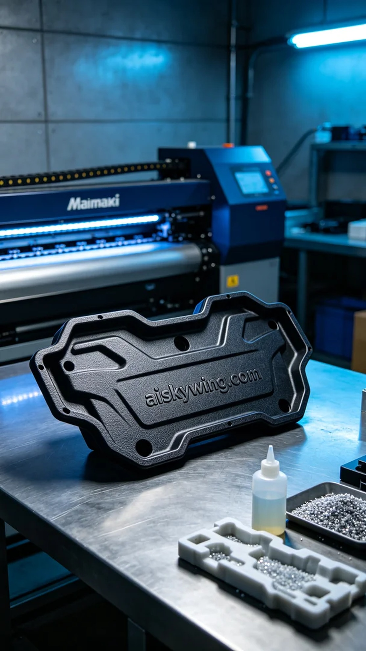
在Instagram上，有人找我们定制了一款变速箱下护板。由于其在汽车行业中的重要性，这个护板不仅需具备强度，还要有良好的表面处理，以满足他们对产品质量的要求。
我们选用了未成型的液态光敏树脂作为原材料，具有优良的流动性和精确的成型能力。Mimaki 3D打印机的准备工作也进入了最后阶段。设置参数为层厚0.1毫米，打印温度保持在25摄氏度，功率90%，打印速度为60毫米/秒，预计打印时间约为两小时。所有参数都经过仔细调试，确保打印效果能达到最佳。
随着打印的开始，Mimaki设备顺畅地运行，液态树脂在打印头的喷射下逐层堆积，逐渐形成了我们期待的形状。在整个过程中，我们始终关注着质量，确保每一层都能准确地与之前的层结合，避免出现任何瑕疵。
打印完成后，后处理工序是至关重要的。我们首先将打印件放入清洗液中，彻底去除表面未固化的树脂，接着用细砂纸轻轻打磨，确保表面光滑。之后进行UV固化，确保产品的耐用性，最后仔细检查每个细节，确保没有遗漏。
经过一系列精细的操作，变速箱下护板终于完美呈现。这不仅是一次成功的打印，更是值得骄傲的成果，展现了我们在3D打印领域的匠心与热情。
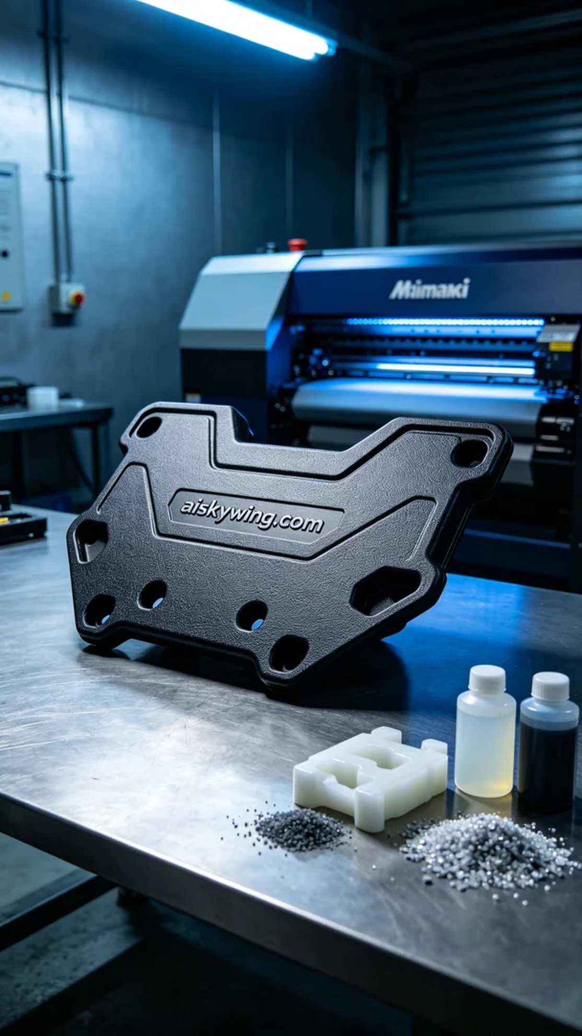
Aiskywing Industrial 3D Printing
Transmission skid plate


