0743-合并模块外壳的3D打印生产记录
Merge module shell
🖨️ CNC机加工
🖥️ 打印机: Systems
📦 材料: 高透明高耐温
生活就像3D打印的过程，充满挑战，但只要坚持，总能成型。今天接到的任务就是合并模块外壳的制作，准备好迎接挑战吧。
Life is like the process of 3D printing, full of challenges, but as long as you persevere, you will eventually shape it. Today's task is to merge the production of the module casing, so get ready to embrace the challenge.
________________________________________________________________________________
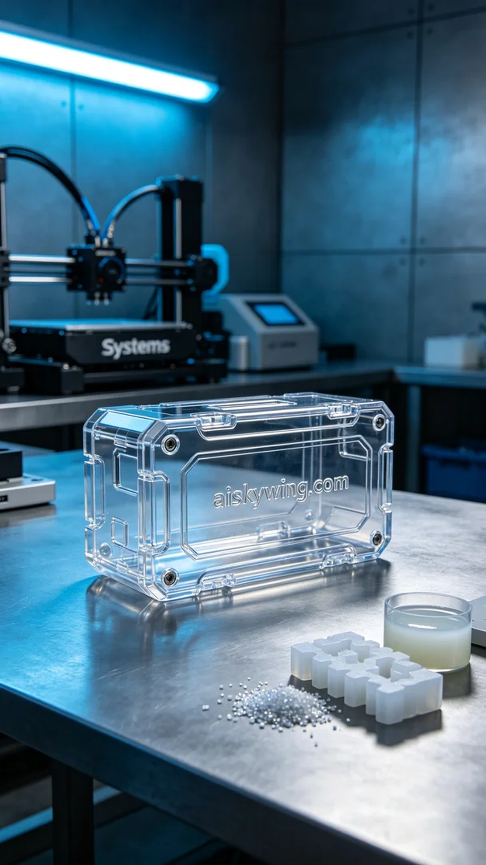
Life is like 3D printing, full of challenges, but with persistence, everything can take shape. Today’s task is to produce the merge module casing, so let's embrace the challenge.
Recently, someone contacted me via WhatsApp regarding the production of our merge module casing. They wanted us to complete a batch of high transparency and high-temperature resistant casings in a short time, with strict surface quality requirements. We immediately started preparations to ensure we could meet their needs.
To achieve high-quality prints, we chose high transparency and high-temperature resistant PC transparent engineering plastic as the raw material. This material not only has excellent temperature resistance but also provides high clarity. We used the Systems printer, carefully tuning it with a layer thickness of 0.1 mm, a printing temperature of 60 degrees Celsius, a power setting of 80%, and a printing speed of 40 mm per second, estimating a completion time of 8 hours.
As printing commenced, the Systems printer operated smoothly, and we monitored the entire process closely. We kept an eye on the print progress to ensure each layer was deposited evenly. During the printing, special attention was given to the material flow and temperature control to avoid any defects.
Upon completing the print, we moved on to the post-processing stages. First, we placed the printed parts into a cleaning tank, using a specialized cleaning solution to remove any residual resin on the surface. Next, we performed sanding to ensure the surface was smooth, achieving the desired gloss. Then, we cured the parts in a curing machine to enhance material strength and hardness. Finally, a thorough inspection was carried out to ensure each product met the standards.
After a series of meticulous procedures, the merge module casing was finally completed. This production not only enhanced our manufacturing capabilities but also reaffirmed the value of persistence and hard work.
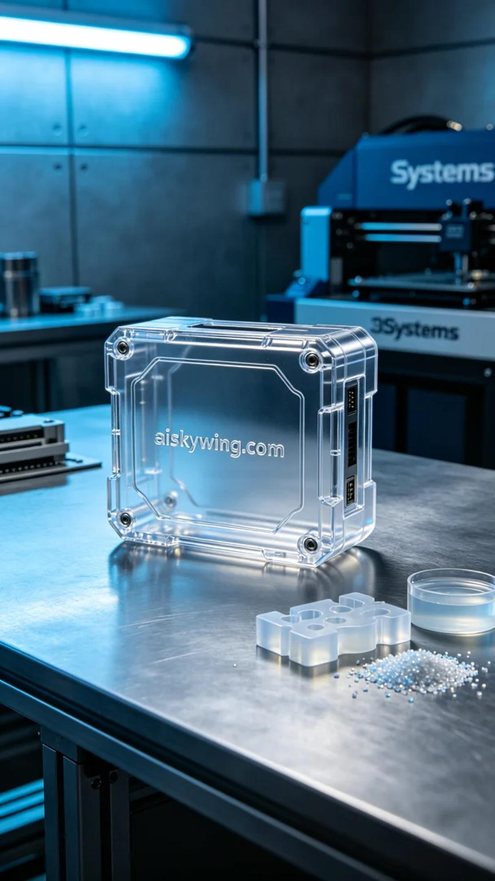
前几天，有人通过WhatsApp联系我，询问我们的合并模块外壳的制作问题。他们希望我们能在短时间内完成一批高透明高耐温的外壳，并且对表面质量要求极高。我们迅速开展了准备工作，以确保能够满足需求。
为了实现高质量的打印，我们选择了高透明高耐温的PC透明工程塑料作为原材料，这种材料不仅具有优良的耐温性能，还能提供极高的透明度。我们使用的Systems打印机经过详细调试，设置了层厚为0.1毫米，打印温度为60摄氏度，功率设为80%，打印速度则控制在40毫米每秒，预计完成时间为8小时。
打印开始后，Systems打印机平稳运行，整个过程都在我们的监控之下。我们实时观察打印进度，确保每一层都能均匀沉积。在打印过程中，我们特别注意材料的流动性和温度控制，以避免出现任何打印缺陷。
完成打印后，我们开始了后处理工序。首先，将打印件放入清洗槽中，使用专用的清洗液清除表面残留的树脂。接着，进行打磨，确保表面光滑，光泽度达到要求。然后，将成品放入固化机中进行固化处理，确保材料的强度和硬度。最后，我们进行了全面的检验，确保每一件产品都符合标准。
经过一系列精细的工序，合并模块外壳终于完成。这次生产不仅提升了我们的制作能力，也再次证明了坚持与努力的价值。
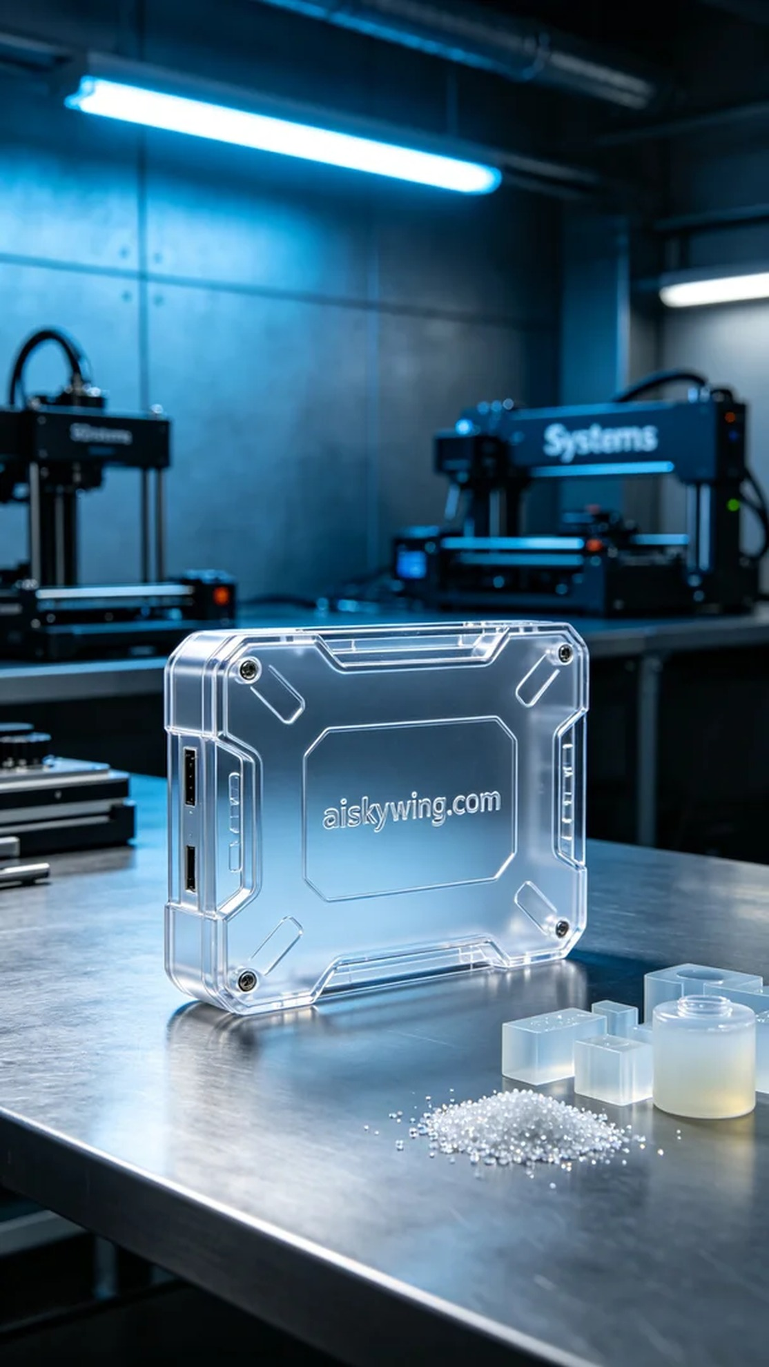
Aiskywing Industrial 3D Printing
Merge module shell


