0747-同步带轮制作生产记录
Synchronous pulley
🖨️ CNC机加工
🖥️ 打印机: Carbon
📦 材料: 摆放着未成型的液态光敏
在Facebook上，有人因为缺少高精度的同步带轮而找到我们。接下这个活儿，就像迎接生活中的挑战一样，既复杂又有趣。
On Facebook, someone reached out to us because they were lacking a high-precision timing pulley. Taking on this task is both complex and interesting, much like facing challenges in life.
________________________________________________________________________________
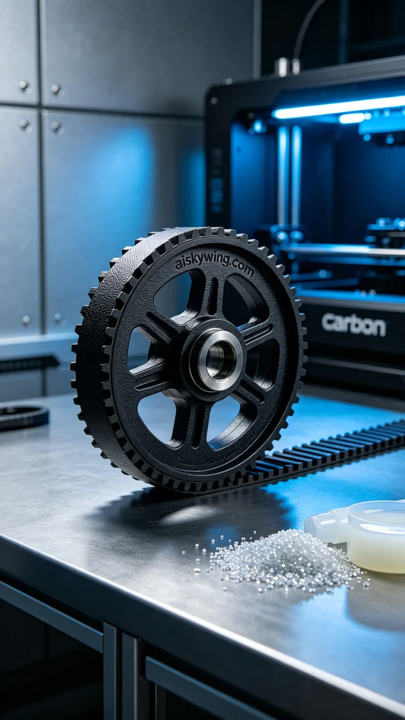
We received an order for a precision synchronous belt pulley, with a strong emphasis on high craftsmanship and material quality. This is a task that requires meticulous operations, as any minor error in CNC machining could lead to product failure.
To ensure smooth production, we prepared unformed liquid photopolymer resin as the raw material. This material has excellent flowability and adhesion, making it suitable for 3D printing. During the printing process, we set the Carbon printer's layer thickness to 0.1mm, maintained a temperature of 25 degrees Celsius, set the power to 70%, and the printing speed to 50mm/s to ensure quality.
Throughout the printing process, the Carbon printer operated smoothly with minimal noise. We monitored the print quality in real-time, ensuring each layer was precisely formed. As time passed, the printer gradually built up every detail of the synchronous belt pulley, creating anticipation.
After printing, we executed a series of post-processing steps. First, we gently removed the printed piece and placed it in a cleaning tank to remove excess resin. Next, we used fine sandpaper to polish the surface of the pulley for smoothness. Finally, we placed the formed synchronous belt pulley in a curing chamber, using UV light to cure the resin further and enhance its strength, followed by a rigorous inspection.
After a series of meticulous processes, this synchronous belt pulley was finally completed, ensuring quality and appearance. Every effort made is a respect for craftsmanship and persistence, empowering us to confidently embrace future challenges.
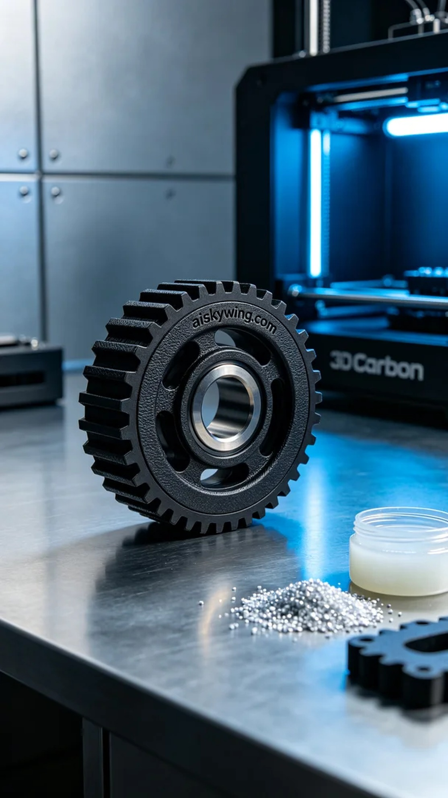
我们接到一个订单，客户急需一款精准的同步带轮，强调了对工艺和材料的高要求。这是一项需要精细操作的工作，尤其是在使用CNC机加工技术时，任何细微的误差都可能导致产品的不合格。
为确保生产顺利进行，我们准备了未成型的液态光敏树脂作为原材料。这种材料具有良好的流动性和粘附性，适合3D打印。打印过程中，我们将Carbon打印机的层厚设定为0.1mm，温度保持在25摄氏度，功率设定为70%，打印速度为50mm/s，以保证打印质量。
在打印过程中，Carbon打印机运转平稳，整台设备的噪音控制得很好。我们实时监控打印质量，确保每一层都能精准到位。随着时间的推移，打印机缓缓构建出同步带轮的每一个细节，令人期待。
打印完成后，我们进行了一系列后处理工序。首先，轻轻取下打印件，并将其放入清洗槽中，以去除多余的树脂。接着，我们使用细砂纸对轮子的表面进行打磨，以保证其光滑度。最后，我们将成型的同步带轮放入固化箱中，利用紫外线灯固化树脂并进一步提高其强度，最后进行严格的检验。
经过一系列的精细加工，这款同步带轮终于完成，质量和外观都得到了保证。每一次的努力，都是对工艺的尊重与坚持，让我们更加自信地迎接未来的挑战。
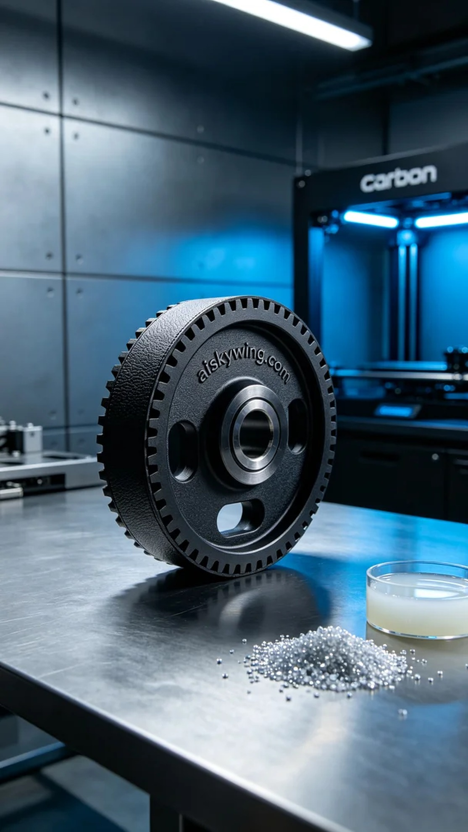
Aiskywing Industrial 3D Printing
Synchronous pulley


