0749-后包围装饰的3D打印生产记录
Rear bumper trim
🖨️ CNC机加工
🖥️ 打印机: Xjet
📦 材料: 高透明高耐温
在LinkedIn上，有人因为追求完美而找到了我们。这个后包围装饰的项目，让我再次体会到，踏实做好每一件事的重要性。
On LinkedIn, someone found us because of their pursuit of perfection. This project with the back surround decoration made me once again realize the importance of doing each task diligently.
________________________________________________________________________________
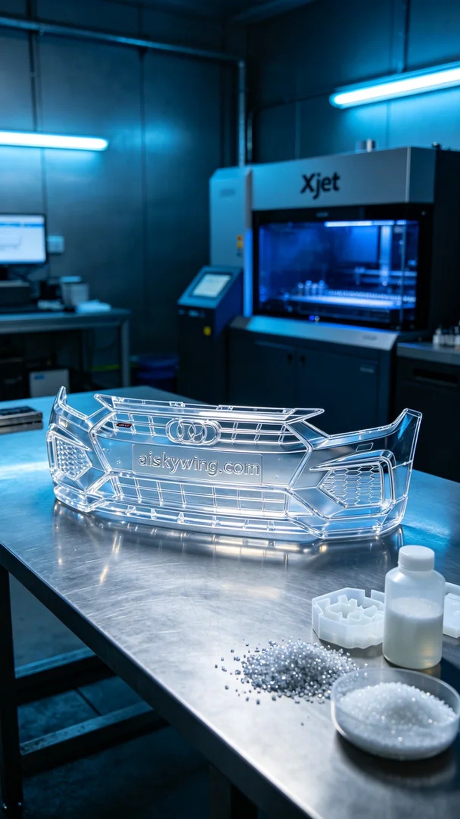
On LinkedIn, someone reached out to us because they were looking to enhance the visual appeal of their product, specifically asking for the production of this rear surround decoration. They required a product with high transparency and heat resistance, which perfectly aligned with our material selection.
We opted for a high transparent, high-temperature resistant PC engineering plastic as our raw material. This material not only withstands high temperatures but also offers excellent clarity, making it suitable for both display and industrial applications. To ensure successful printing, we used the Xjet 3D printer, setting the layer thickness to 0.1mm, printing temperature to 120°C, power at 90%, and speed set to 30mm/s, with an expected print time of 12 hours.
During the printing process, the Xjet printer operated smoothly, and we monitored the quality of each printed layer in real time. The printer emitted liquid photo-curable resin, solidifying layer by layer to form the intricate rear surround decoration. Throughout this process, we needed to maintain a careful watch on the print's condition to ensure there were no clogs or anomalies, ultimately ensuring a perfect final product.
Post-processing was a critical step. After completing the print, we cleaned the product to remove any uncured resin from the surface. Next, we meticulously sanded the piece to enhance its smoothness and transparency. Finally, we placed the product in a UV curing chamber to solidify it, ensuring its strength and stability. After a rigorous inspection, the final product met the expected standards.
Through the production of this rear surround decoration, we not only satisfied the requirement but also further enhanced our team's collaboration and technical skills. Each practice session is an opportunity for growth, propelling us forward on the path of technology.
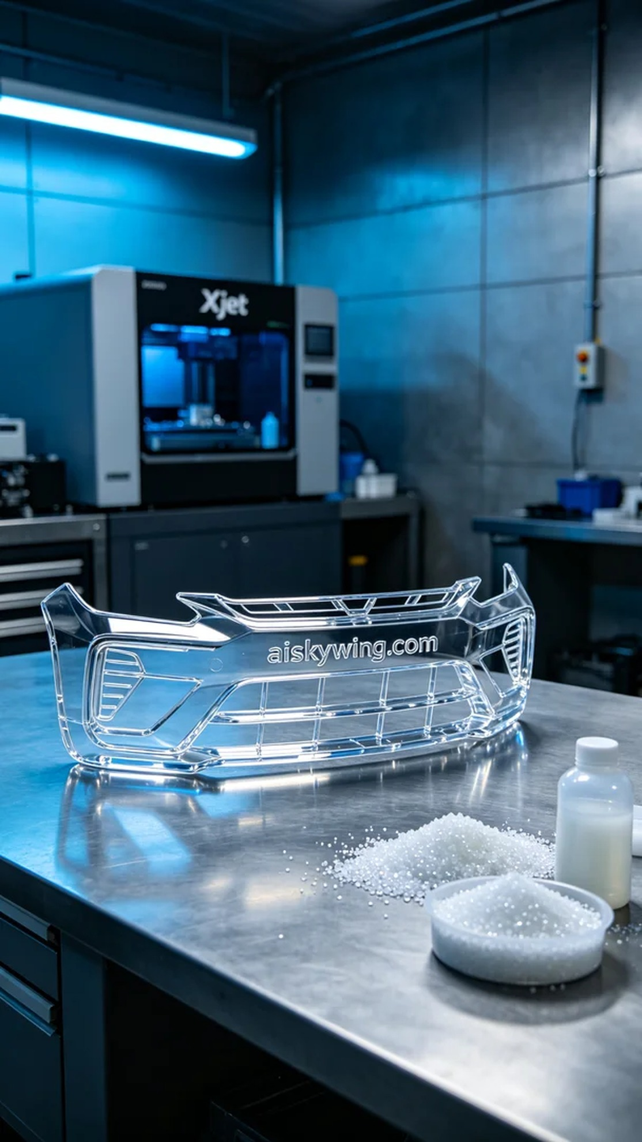
在LinkedIn上，有人因为想要提升产品的视觉效果而找到了我们，特别希望通过我们的技术完成这个后包围装饰的制作。他们需要一个具备高透明度与耐高温特性的产品，正好适合我们使用的材料。
我们选择了高透明高耐温的PC透明工程塑料作为原材料。这种材料不仅能抵抗高温，还能呈现出极佳的透明度，适合用于展示及工业用途。为了确保打印的成功，我们使用了Xjet品牌的3D打印机，设置层厚为0.1mm，打印温度为120°C，功率设定在90%，打印速度定为30mm/s，预计打印时间为12小时。
在打印过程中，Xjet打印机运行稳定，我们对每个打印层的质量进行了实时监控。打印机的喷头喷出液态光敏树脂，逐层固化，形成了精细的后包围装饰。在这个过程中，我们需要常常观察打印情况，确保没有出现堵头或其他异常，确保成品的完美。
后处理是关键的一步。完成打印后，我们将成品进行清洗，去除表面未固化的树脂。接着，通过细致的打磨，提升表面的光滑度和透明度。最后，我们将成品放入紫外线固化箱中固化，以确保其强度和稳定性。经过严格的检验，最终的成品达到了预期的标准。
通过这个后包围装饰的制作，我们不仅满足了需求，还进一步提升了团队的合作与技术能力。每一次的实践都是成长的机会，让我们在科技的道路上不断前行。
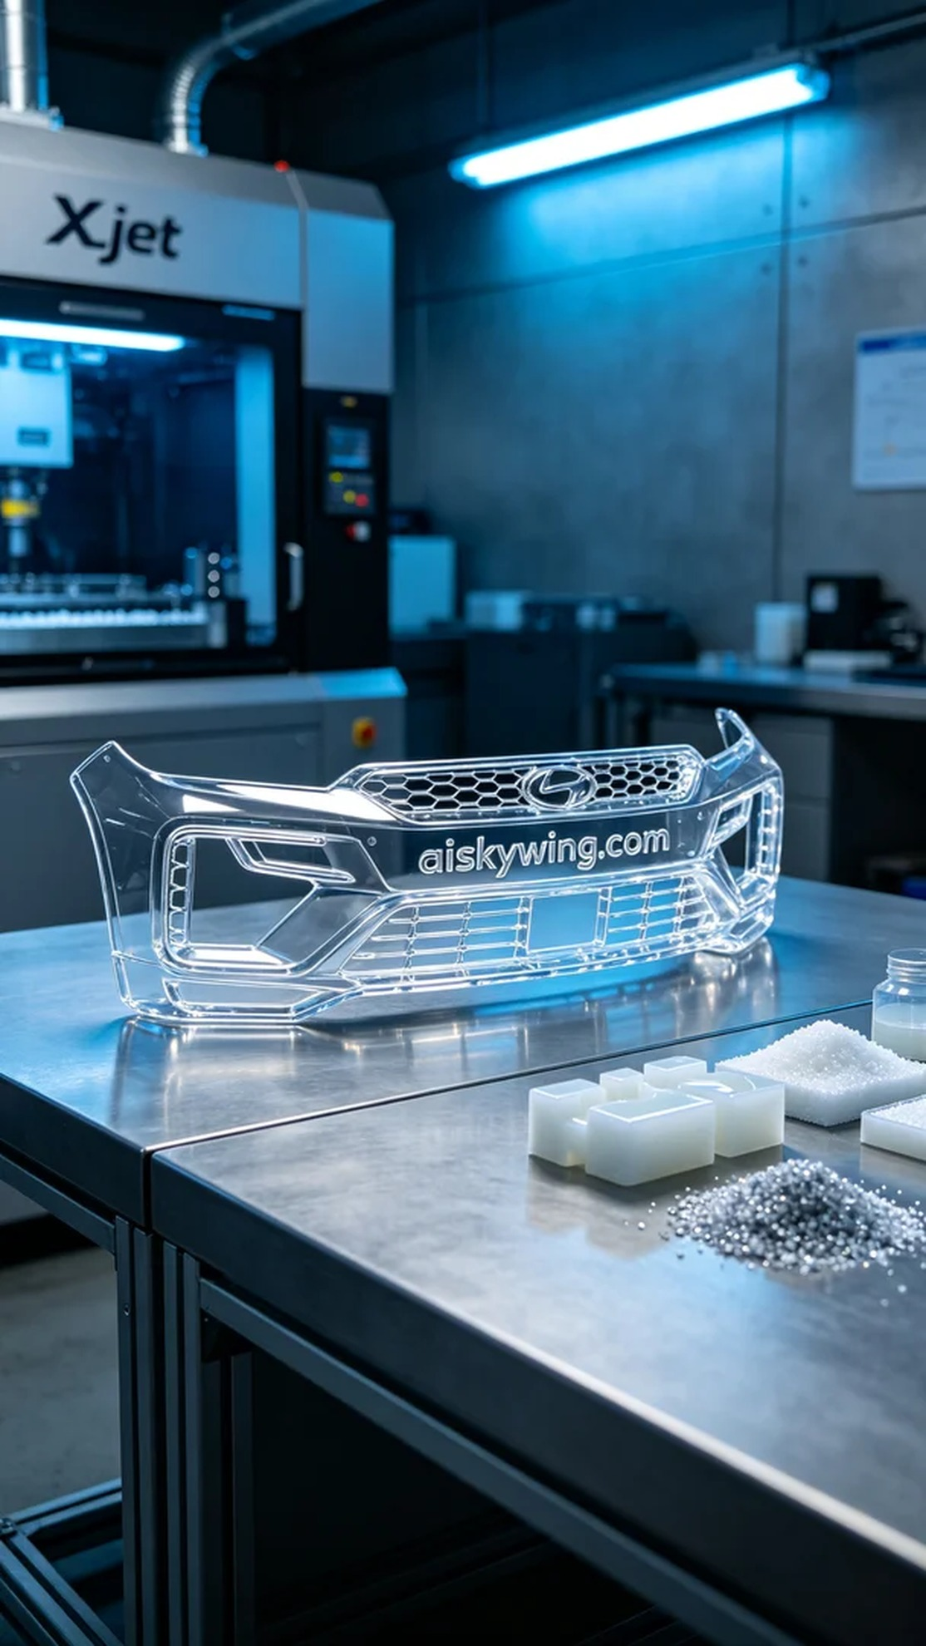
Aiskywing Industrial 3D Printing
Rear bumper trim


