0750-后备箱网兜挂钩的3D打印生产记录
Trunk net hook
🖨️ CNC机加工
🖥️ 打印机: Rize
📦 材料: 摆放着未成型的液态光敏
有时候咬牙坚持，不是为了证明什么。就像做这个后备箱网兜挂钩，我通过WhatsApp收到了一个朋友的求助信息，希望我们能帮他解决一个实际的问题。
Sometimes, gritting your teeth and persisting isn't about proving anything. It's like making this trunk net hook; I received a help request from a friend via WhatsApp, hoping we could help him solve a practical problem.
________________________________________________________________________________
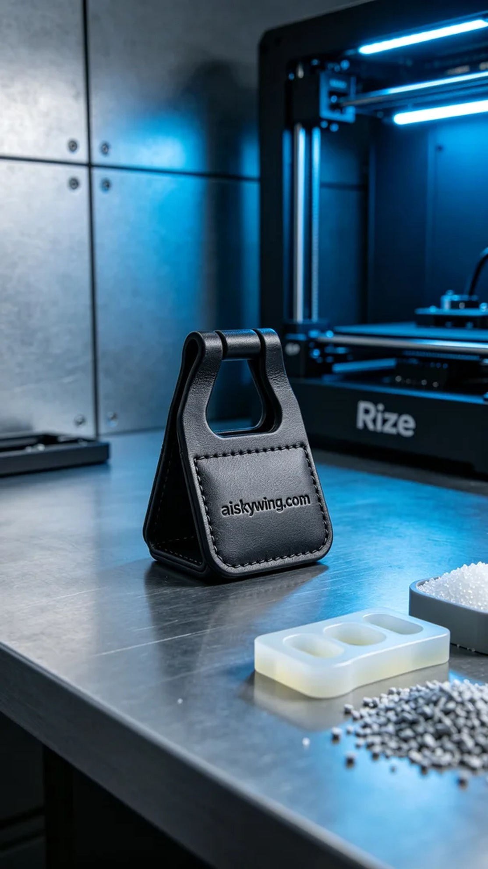
Sometimes, grit and persistence are not about proving anything. Just like the rear trunk net hook I worked on after receiving a friend's request via WhatsApp to solve a practical issue.
In our discussions, my friend expressed the need for a rear trunk net hook design that was stronger and more efficient. To meet his requirements, we began working on this 3D printing project.
We chose to use uncured liquid photopolymer resin as our raw material, known for its excellent strength and durability, ideal for this functional product. For our equipment, we prepared the Rize 3D printer, setting the printing parameters to: layer thickness of 0.1mm, printing temperature at 25°C, power at 1000 watts, speed kept at 30mm per hour, with an estimated printing time of 8 hours.
During the printing process, the Rize printer operated steadily, with the liquid photopolymer resin being precisely cured layer by layer. We closely monitored the quality throughout, ensuring that every layer met the design requirements. As the machine worked orderly, our rear trunk net hook gradually took shape.
After printing, we engaged in a series of post-processing steps. First, we placed the formed product into a cleaning tank for a thorough wash with water and an ultrasonic cleaner to remove any residual resin. Next, we sanded the product to achieve a smoother surface and better tactile feel. Finally, we cured it in a UV curing machine to enhance its strength and durability. During the final inspection, we meticulously checked the product's appearance and functionality, ensuring it met our standards.
In the end, the production process of this rear trunk net hook not only completed smoothly but also provided us with valuable experience for future projects.
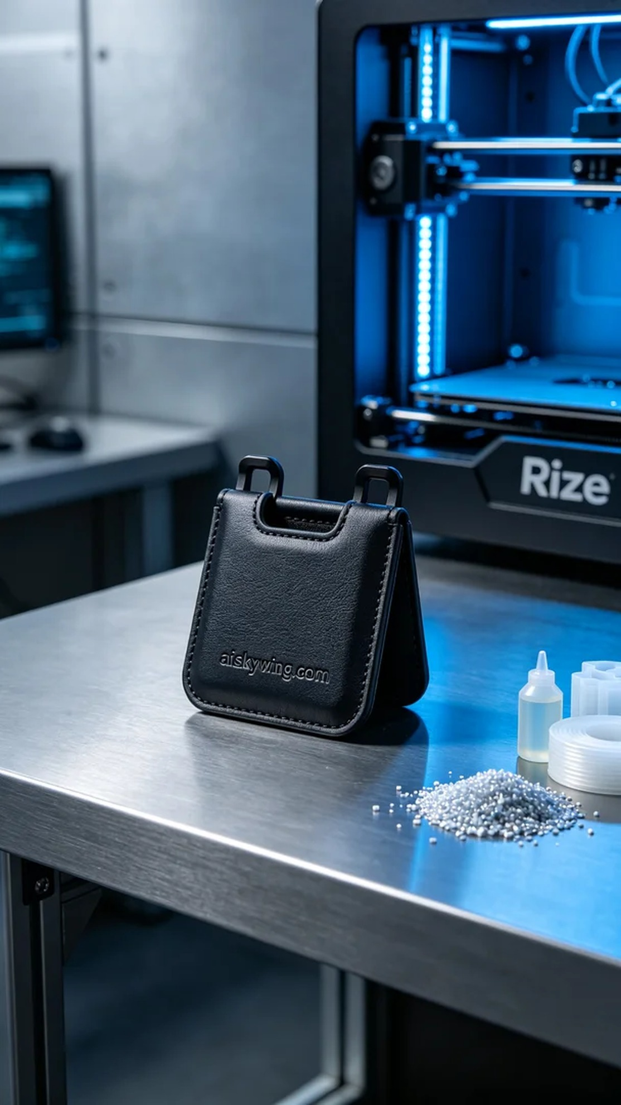
在与朋友的交流中，他提到后备箱网兜挂钩的设计需求，特别希望能实现一个更加坚固和高效的使用体验。为了满足他的需求，我们开始着手进行这项3D打印的工作。
我们选用了未成型的液态光敏树脂作为原材料，这种材料具备优良的强度和耐用性，适合这种功能性产品的制作。在设备方面，我们准备了Rize 3D打印机，并设置了打印参数：层厚为0.1毫米，打印温度为25°C，功率设置为1000瓦特，速度保持在每小时30毫米，预计打印时间为8小时。
在打印过程中，Rize打印机稳定运行，液态光敏树脂通过精准的喷头逐层固化。在质量监控方面，我们时刻关注打印进度和成品质量，确保每一层的细节都能充分体现设计要求。随着设备的有序运转，我们的后备箱网兜挂钩逐渐成型。
打印完成后，我们进行了系列的后处理工序。首先，将成型的产品放入清洗槽中，用清水和超声波清洗设备彻底清洗，以去除表面残留的树脂。随后，我们对产品进行打磨，使表面更加光滑，触感更佳。最后，将产品放入UV固化机中进行固化处理，以增强其强度和耐用性。最后的检验阶段，我们仔细检查产品的外观和功能，确保达到了预期标准。
最终，这个后备箱网兜挂钩的制作过程不仅顺利完成，也让我们在过程中积累了宝贵的经验，为未来的项目打下了基础。
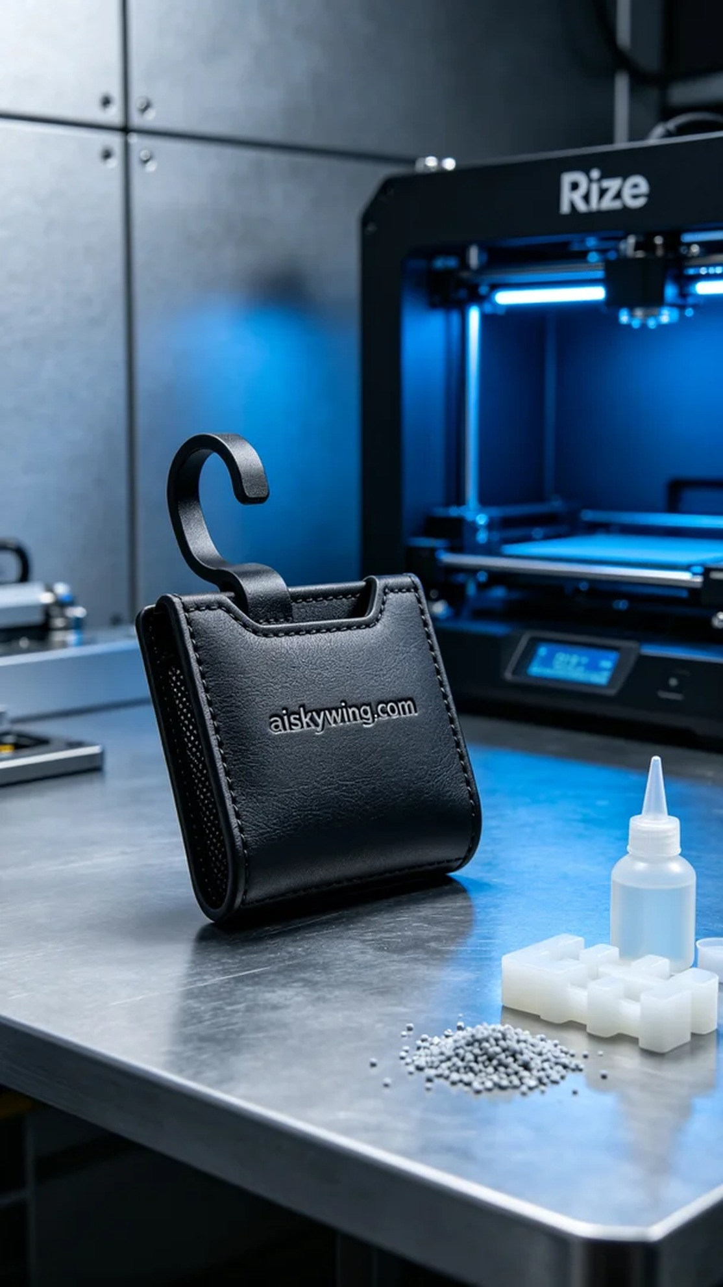
Aiskywing Industrial 3D Printing
Trunk net hook


