0751-后备箱锁扣的3D打印生产记录
Trunk latch
🖨️ CNC机加工
🖥️ 打印机: Xjet
📦 材料: 摆放着未成型的液态光敏
生活再难，也别停下脚步。就像接下这个后备箱锁扣的单子，面对挑战，我总是充满信心。
No matter how difficult life gets, don't stop moving forward. Just like taking on this job for the trunk lock, I always face challenges with confidence.
________________________________________________________________________________
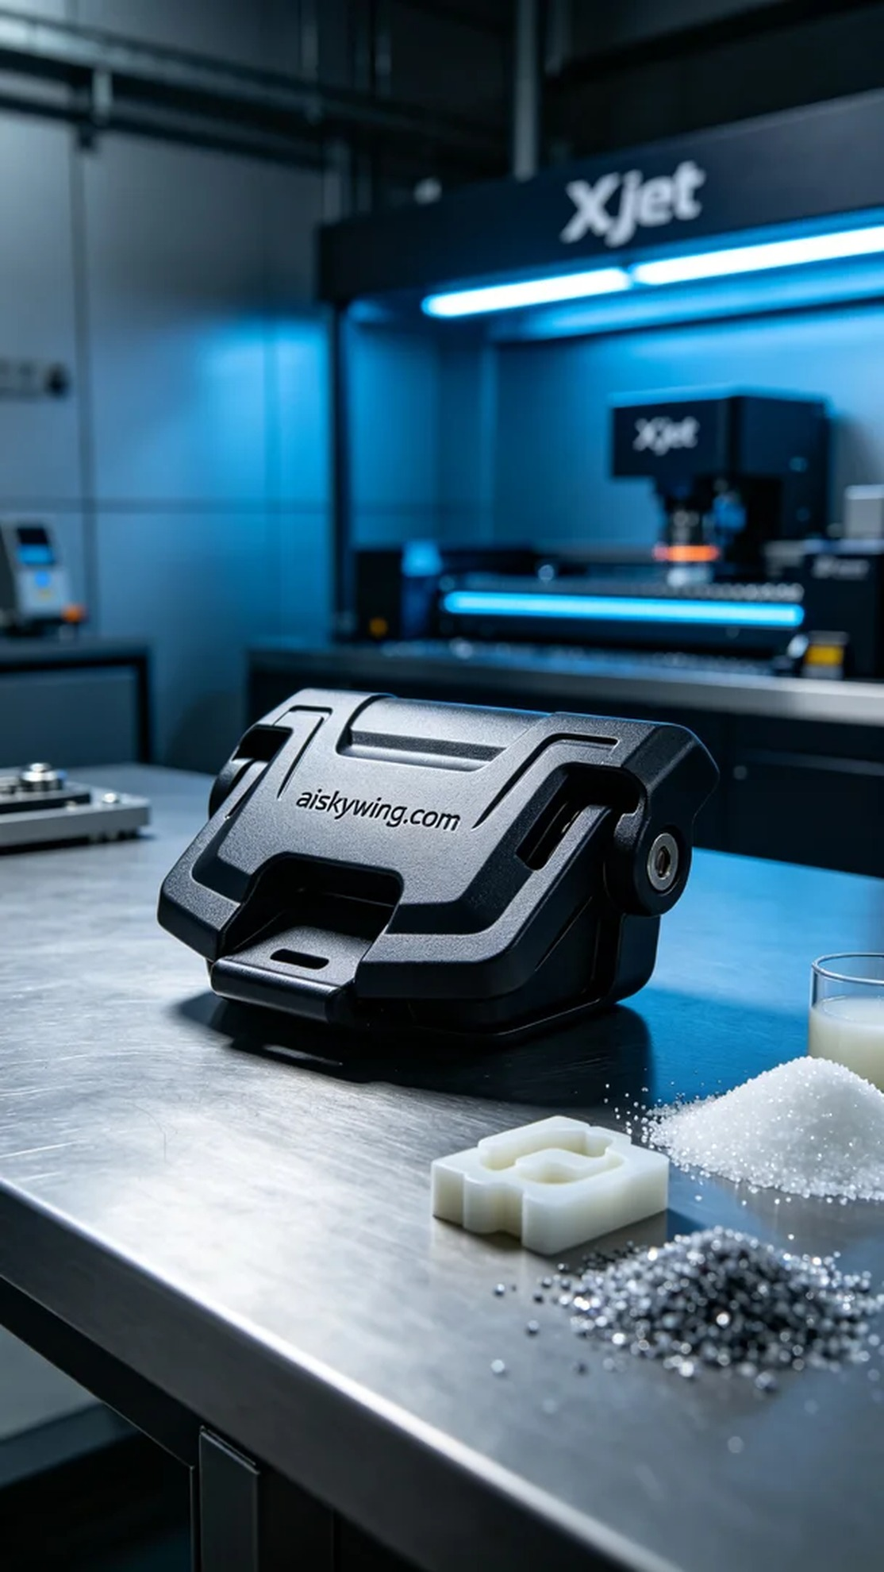
On Instagram, someone reached out to us for a trunk latch, looking for a product that is both sturdy and aesthetically pleasing. Thus, we embarked on this 3D printing journey with the goal of perfectly showcasing the details and craftsmanship of this product.
We used liquid photopolymer resin as the raw material, which boasts excellent flow and precision. During preparation, we meticulously adjusted the parameters of the Xjet printer, setting a layer thickness of 0.1mm, a printing temperature at 25℃, power level at 50%, and a printing speed of 30mm/s. The entire printing process was expected to take about 4 hours, ensuring that every detail was spot on.
During the printing process, the Xjet printer operated at a satisfying speed, with the print head accurately layering the liquid photopolymer resin. Each layer was meticulously handled, and we closely monitored the operation of the equipment to ensure there were no flaws or anomalies. With vigilant observation, the printing process completed smoothly, showcasing the clear engraving of "aiskywing.com" and exquisite texturing.
The post-processing steps are crucial for ensuring product quality. After printing, we first clean the product to remove any uncured resin. Next, we sand the surface with fine sandpaper to achieve a smoother finish, and then place the product in a UV curing machine for solidification, ensuring durability and stability. After thorough inspection, the final product met our expectations, perfectly reflecting the essence of design and technology.
This production process for the trunk latch once again made me appreciate the charm of 3D printing, where the result is not just the physical product, but a blend of technology and creativity.
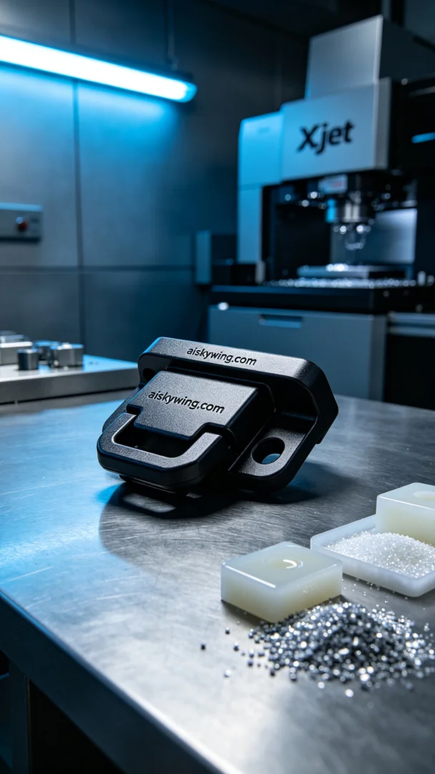
在Instagram上，有人因为后备箱锁扣的需求找到我们，想要一款既坚固又美观的产品。于是我们开始了这次的3D打印之旅，目标是完美展现出这个产品的细节和工艺。
我们使用的是液态光敏树脂作为原材料，这种材料具有优异的流动性和精细度。在准备过程中，我们对Xjet打印机的参数进行仔细调整，设定层厚为0.1毫米，打印温度保持在25℃，功率设定为50%和打印速度为30毫米/秒。整个打印过程预计耗时约4小时，确保每一个细节都能到位。
在打印过程中，Xjet打印机以令人满意的速度运转，打印头精准地将液态光敏树脂层层叠加，每一层都被细致入微地处理。我们随时监控设备的运行状态，确保没有任何瑕疵或异常发生。经过密切的观察，打印过程顺利完成，最终展现出清晰的“aiskywing.com”字样和精致的纹理效果。
后处理工序是确保产品质量的关键。打印完成后，首先对产品进行清洗，以去除未固化的树脂。随后，我们使用细砂纸进行打磨，使表面更为光滑，最后将产品放入UV固化机中进行固化，确保其耐用性和稳定性。经过严格检验，成品达到了我们的预期标准，完美地呈现出设计的理念和技术的精髓。
这次的后备箱锁扣制作过程让我再次感受到3D打印的魅力，成果不仅是产品的现实展现，更是技术与创意的结合。
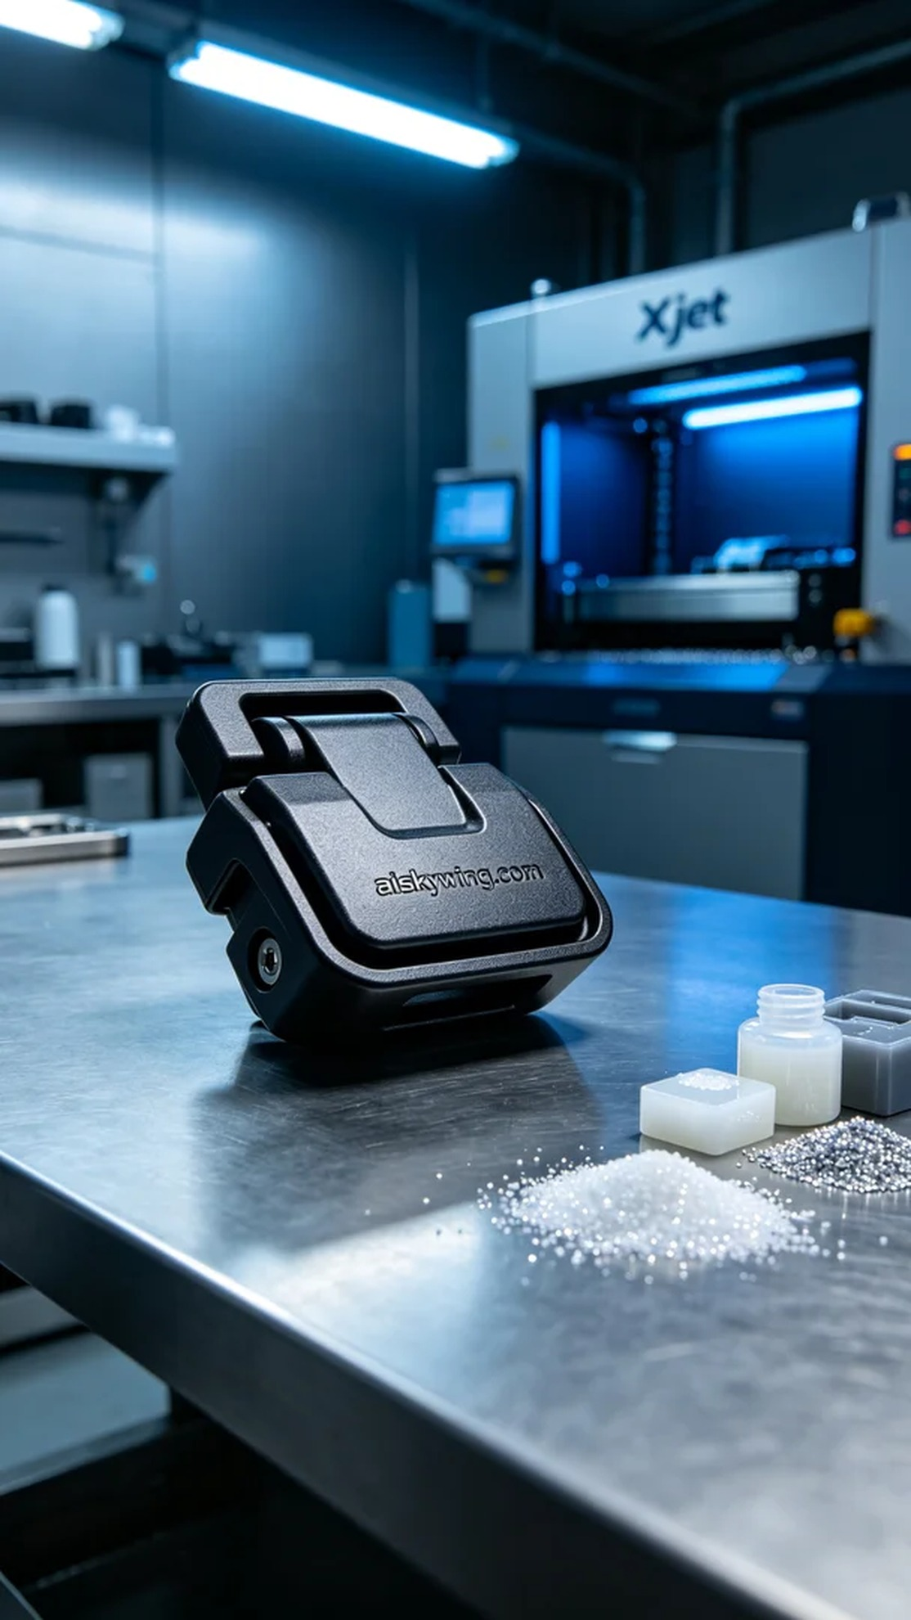
Aiskywing Industrial 3D Printing
Trunk latch


