0752-后备箱隔板卡扣的3D打印记录
Trunk divider clip
🖨️ CNC机加工
🖥️ 打印机: Mimaki
📦 材料: 高透明高耐温
有时候咬牙坚持，不是为了证明什么。就像做这个后备箱隔板卡扣，我在TikTok上看到有人为找到合适的配件而烦恼。
Sometimes, gritting your teeth and persevering isn’t about proving anything. It's like making this trunk divider clip; I saw someone on TikTok struggling to find the right accessory.
________________________________________________________________________________
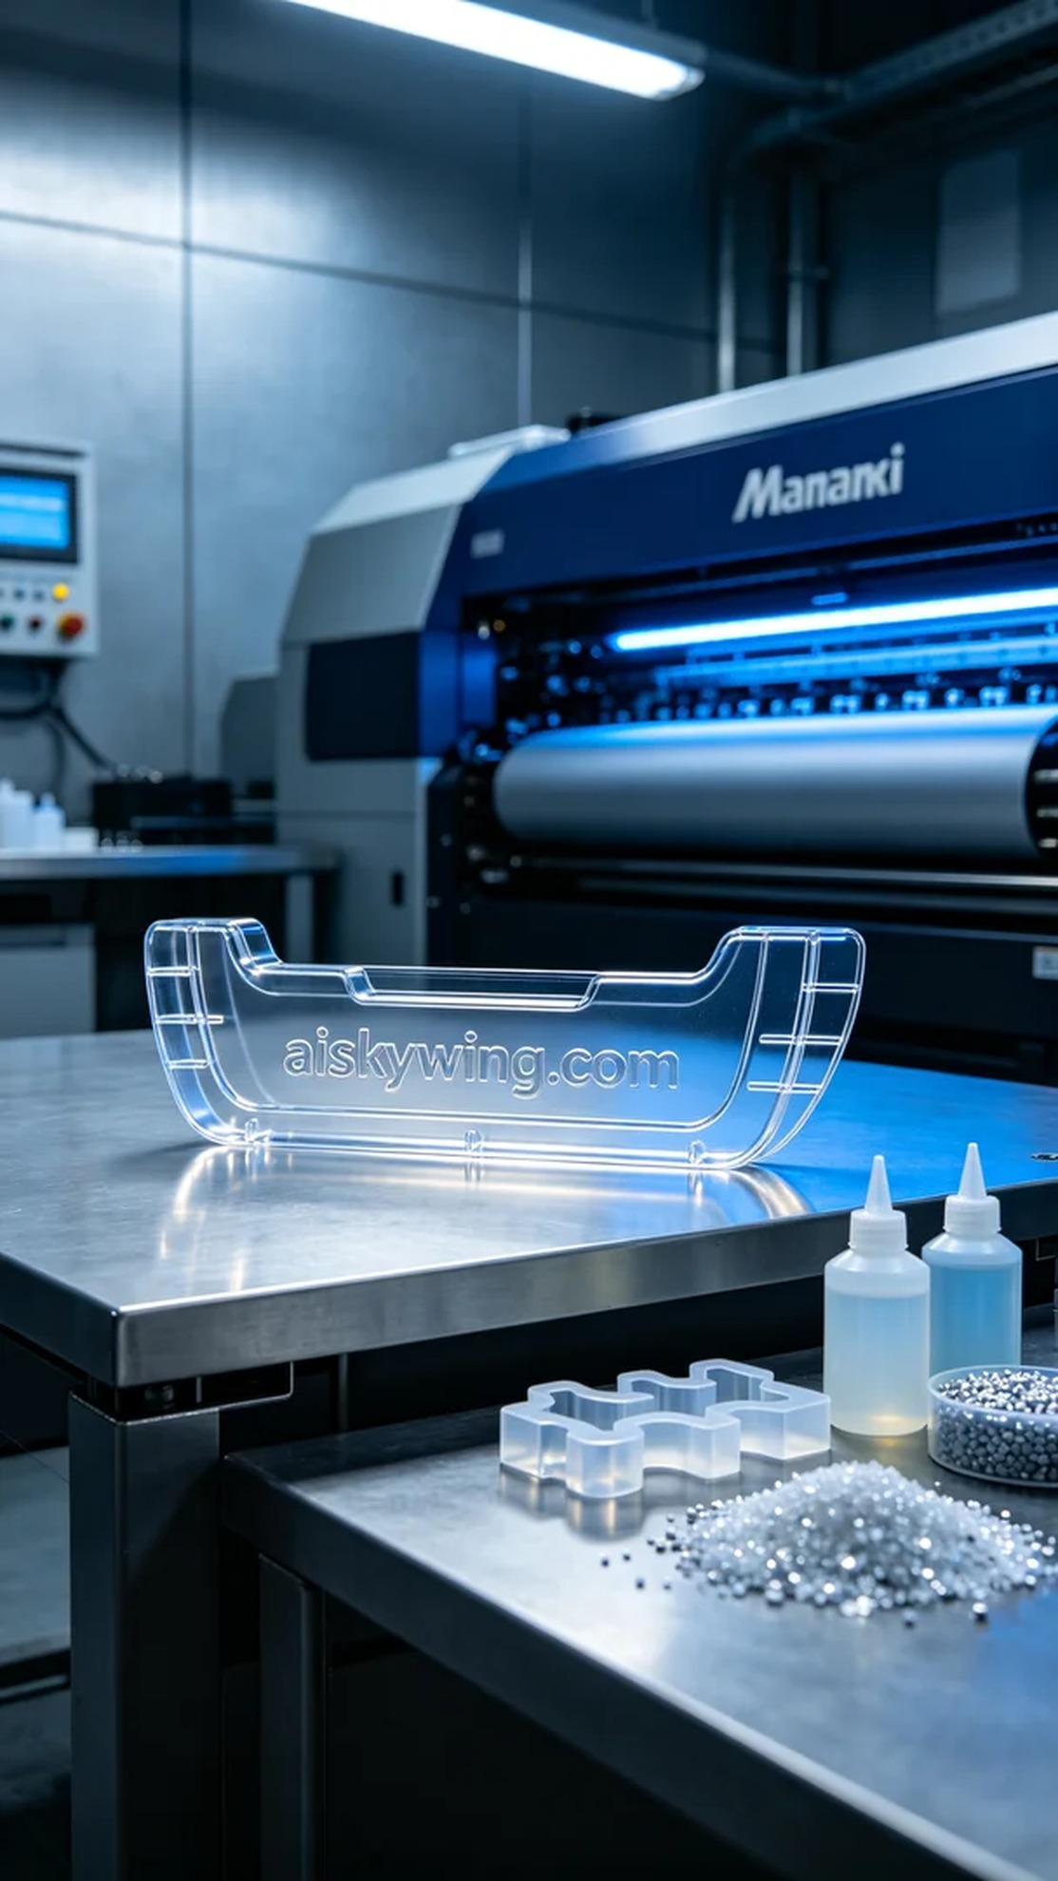
Sometimes, holding on is not about proving anything. Just like making this trunk separator buckle, I saw someone on TikTok struggling to find suitable parts, and I decided to help them with our 3D printing technology.
The product we are working on is a trunk separator buckle, which requires high transparency and heat resistance to ensure it works well in different environments. We chose high transparent, high-temperature PC engineering plastic as the raw material. This material not only provides excellent transparency but also can withstand higher temperatures, making it suitable for use in vehicles.
For the preparation, we utilized a Mimaki 3D printer, setting parameters such as a layer thickness of 0.1mm, a printing temperature of 230 degrees Celsius, a power setting of 80%, and a printing speed of 60mm per second. The expected printing time was around 4 hours.
The printing process went smoothly, with the Mimaki printer operating steadily. I kept a close eye on the process to ensure there were no bubbles or material shortages, making sure each layer was laid down evenly to guarantee the final product's quality.
Once printing was completed, we moved on to the post-processing steps. First, I cleaned the printed part using a cleaning solution to remove any uncured resin from the surface. After that, I meticulously sanded it down for a smoother finish. Then, I placed it in a UV curing box to ensure the material reached the required hardness, followed by a thorough inspection to ensure every detail met the standards.
Reflecting on this production record, it's amazing how technological advancements allow us to efficiently meet people's needs. The trunk separator buckle was successfully completed, and I look forward to handing it over to the person in need.
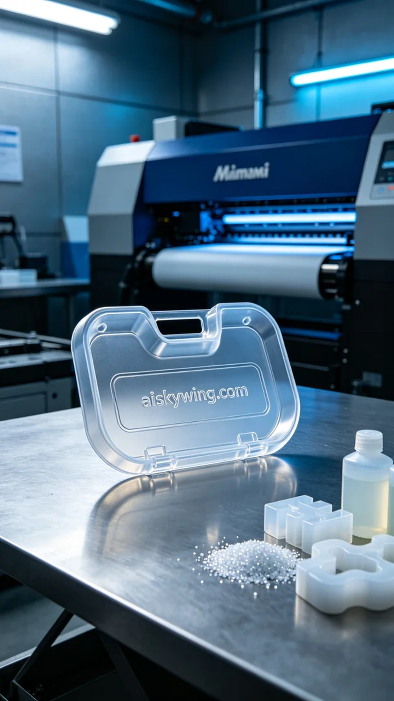
这次的产品是后备箱隔板卡扣，之前在社交媒体平台TikTok上，有人因为买不到合适的零件而寻求帮助。于是我决定利用我们的3D打印技术帮助他解决这个问题。这个卡扣需要具备高透明度和耐温性，以确保在不同环境中都能正常使用。
我们选用了高透明高耐温的PC透明工程塑料作为原材料。这种材料不仅具备出色的透明性，还能承受较高的温度，适合用于车内环境。准备工作方面，我们使用的是Mimaki品牌的3D打印机，设定参数为层厚0.1毫米，打印温度230摄氏度，功率设置为80%，打印速度为60毫米每秒。另外，预计打印时间约为4小时。
打印过程进行得非常顺利，Mimaki打印机的运行稳定，整台设备在环境监控下仔细检查，确保没有出现气泡或材料不足的情况。过程中我时刻关注打印效果，确认每一层都能均匀铺开，确保最终产品的质量。
完成打印后，进入后处理工序。首先用清洗剂对打印件进行清洗，去除表面的未固化树脂。接着，我对其进行细致的打磨，使得表面更光滑。之后在UV固化箱内进行固化处理，确保材料硬度达标，最后经过一次严格检验，确保每个细节都符合标准。
通过这次的生产记录，不禁感慨，科技的进步让我们能以更高效的方式满足人们的需求。后备箱隔板卡扣顺利完成，期待将其交到需要的人手中。
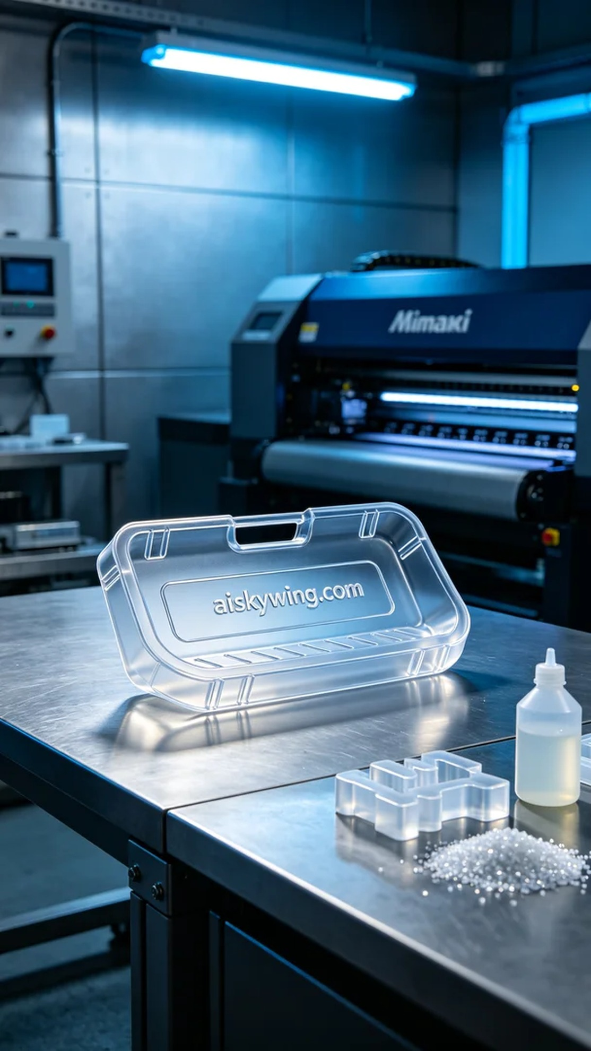
Aiskywing Industrial 3D Printing
Trunk divider clip


