0753-高精度后杠下护板加工记录
Rear bumper skid plate
🖨️ CNC机加工
🖥️ 打印机: Rize
📦 材料: 摆放着未成型的液态光敏
生活再难，也别停下脚步。就像接下这个后杠下护板的单子，有人想要解决在汽车改装中遇到的问题。
No matter how difficult life gets, don't stop moving forward. Just like taking on this order for the rear bumper skid plate, there are people looking to solve problems encountered in car modifications.
________________________________________________________________________________
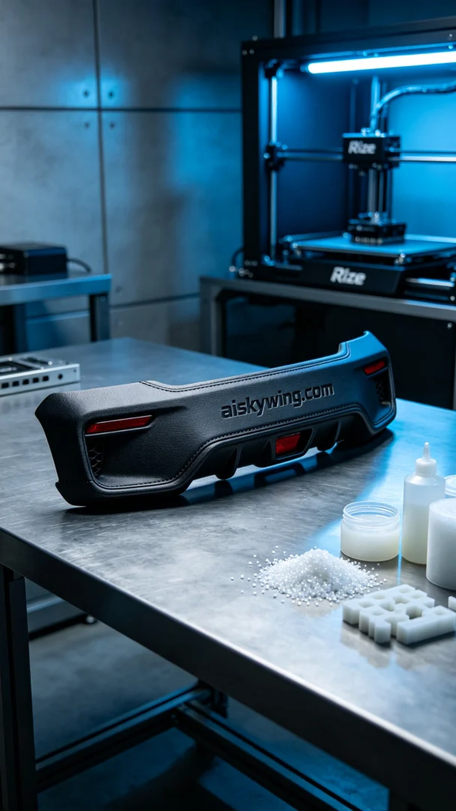
Recently, someone saw our work on TikTok and inquired if we could custom-make a rear bumper skid plate. This product not only enhances the vehicle’s appearance but also helps protect the rear structure, so we set to work on this task.
For materials, we used the liquid photopolymer resin that was placed on the table. This material has excellent forming characteristics, allowing for complex detail designs. We prepared the Rize 3D printer and set the printing parameters: layer thickness of 0.1 mm, temperature set at 25°C, power controlled at 80%, printing speed maintained at 60 mm/s, with an estimated printing time of 4 hours.
During the printing process, the machine operated smoothly as the liquid photopolymer resin gradually took shape under the printer head. We monitored the print quality closely to ensure there were no bubbles or defects. Each layer was stacked with precision, showcasing the efficiency of the Rize equipment.
Post-processing steps are equally important. Once printing was complete, we first placed the finished product in a cleaning tank to remove any uncured resin from the surface using a specialized solvent. Next, we conducted sanding to eliminate minor imperfections and ensure a smooth surface. Finally, the product was placed in a curing chamber and exposed to UV light, strengthening the physical properties of the resin, followed by a final inspection.
In conclusion, after a series of processes, this rear bumper skid plate exhibited a perfect appearance and quality, successfully completing the task. Every detail was meticulously polished, and we look forward to it adding a unique charm to every car owner's vehicle.
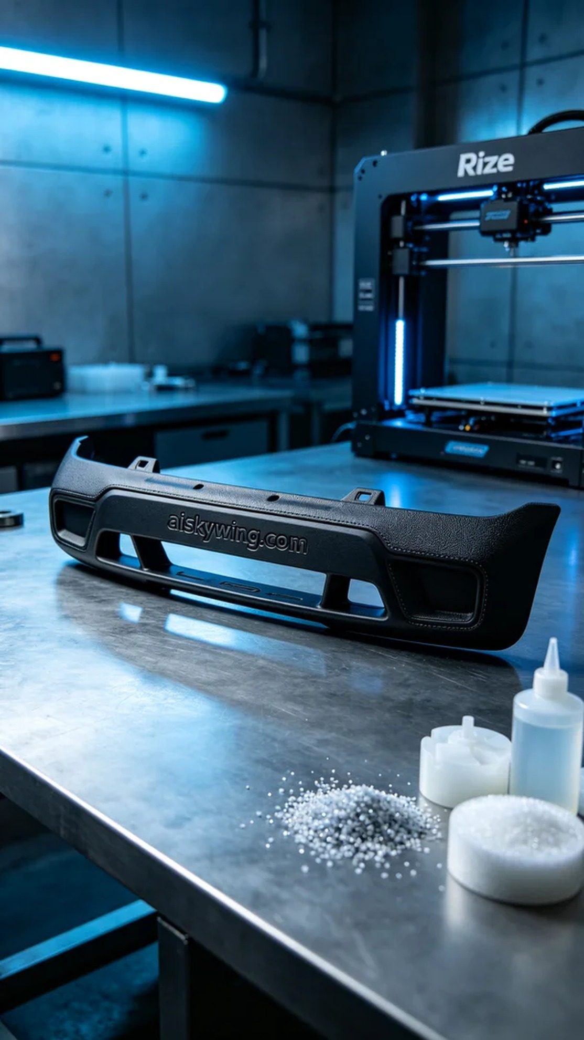
最近，有人在TikTok上看到我们的作品，询问可不可以定制一款后杠下护板。这个产品不仅能提升车辆的外观，还有助于保护后方结构，于是我们开始了这项工作。
原材料方面，我们使用的是摆放着未成型的液态光敏树脂。这种材料具有优良的成型特性，能够实现复杂的细节设计。我们准备了Rize品牌的3D打印机，设置了打印参数：层厚0.1毫米，温度设定为25摄氏度，功率控制在80%，打印速度保持在60毫米每秒，预计打印时间为4小时。
在打印过程中，机器运转平稳，液态光敏树脂在打印头的喷射下缓缓成型。我们时刻监控打印质量，确保无气泡、无缺陷。每一层的堆叠都十分精准，体现了Rize设备的高效性能。
后处理步骤同样重要。打印结束后，我们首先将成品放入清洗槽，使用专用溶剂去除表面未固化的树脂。接着，我们进行打磨，以去除细微的瑕疵，确保表面光滑。最后，产品会放入固化箱中，经过UV光照射，强化树脂的物理性能，进行最终检验。
最后，经过一系列工序后，这款后杠下护板展现出了完美的外观与品质，圆满完成了这单任务。每一个细节都经过精心打磨，期待它能为每位车主的爱车增添一份独特的风采。
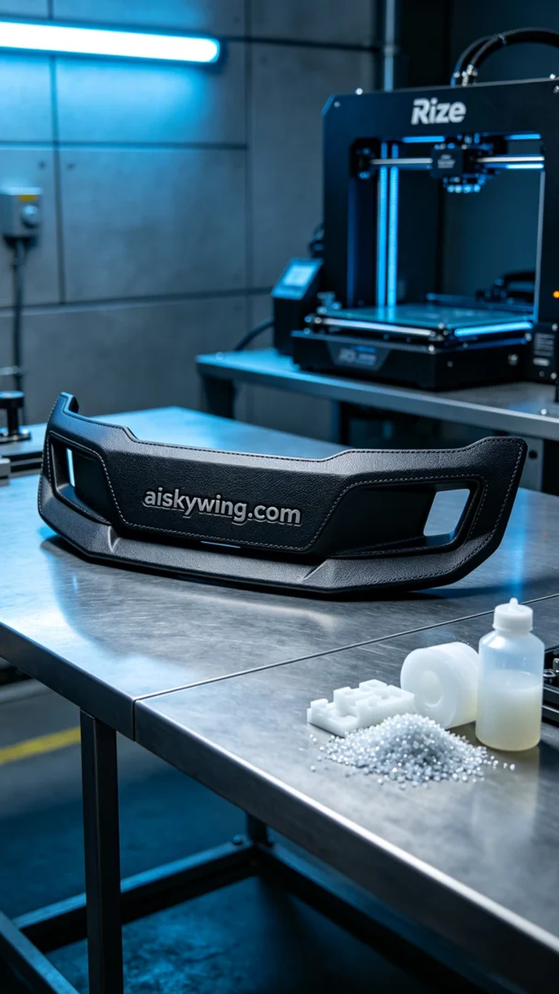
Aiskywing Industrial 3D Printing
Rear bumper skid plate


