0754-后视镜调节拨片生产记录
Rearview mirror adjustment lever
🖨️ CNC机加工
🖥️ 打印机: Voxeljet
📦 材料: 高透明高耐温
生活再难，也别停下脚步。就像接下这个后视镜调节拨片的单子，有人因为精确度不足而找到了我们。
No matter how difficult life gets, don't stop moving forward. Just like taking on this job for the rearview mirror adjustment lever, someone reached out to us because of a lack of precision.
________________________________________________________________________________
On Twitter, someone mentioned that the rearview mirror adjustment lever for their vehicle was not responding properly, affecting their driving experience. So we received a request for the production of this rearview mirror adjustment lever, hoping to restore its intended functionality through precise craftsmanship.
We selected high transparency and high-temperature resistant PC engineering plastic as the raw material. This material not only possesses exceptional clarity but also maintains good mechanical properties at high temperatures. To ensure printing quality, we utilized a Voxeljet printer, setting the layer thickness to 0.1 mm, maintaining the print temperature at 25°C, setting the power at 80%, and controlling the speed at 60 mm per hour, with the entire printing process expected to take around 7 hours.
As the printer started, the equipment operated steadily, and the cooling fan functioned normally to ensure the appropriate temperature during printing. We closely monitored the print quality, regularly checking the details, especially focusing on the clarity of the edges and the smoothness of the surface, ensuring every dimension remained within tolerances.
Upon completion of the printing, post-processing was necessary. First, we placed the finished product in the cleaning tank and used a specialized cleaning solution to remove residual resin. Next, we performed sanding to ensure a smooth surface. Then, we placed the adjusted lever into a curing device, setting the temperature at 60°C with a curing time of 20 minutes, and conducted a quality inspection to confirm all specifications and surface treatments met the standards.
After this series of processes, the rearview mirror adjustment lever was successfully produced, restoring its functionality and clarity. Each success is the best reward for our persistence and effort.
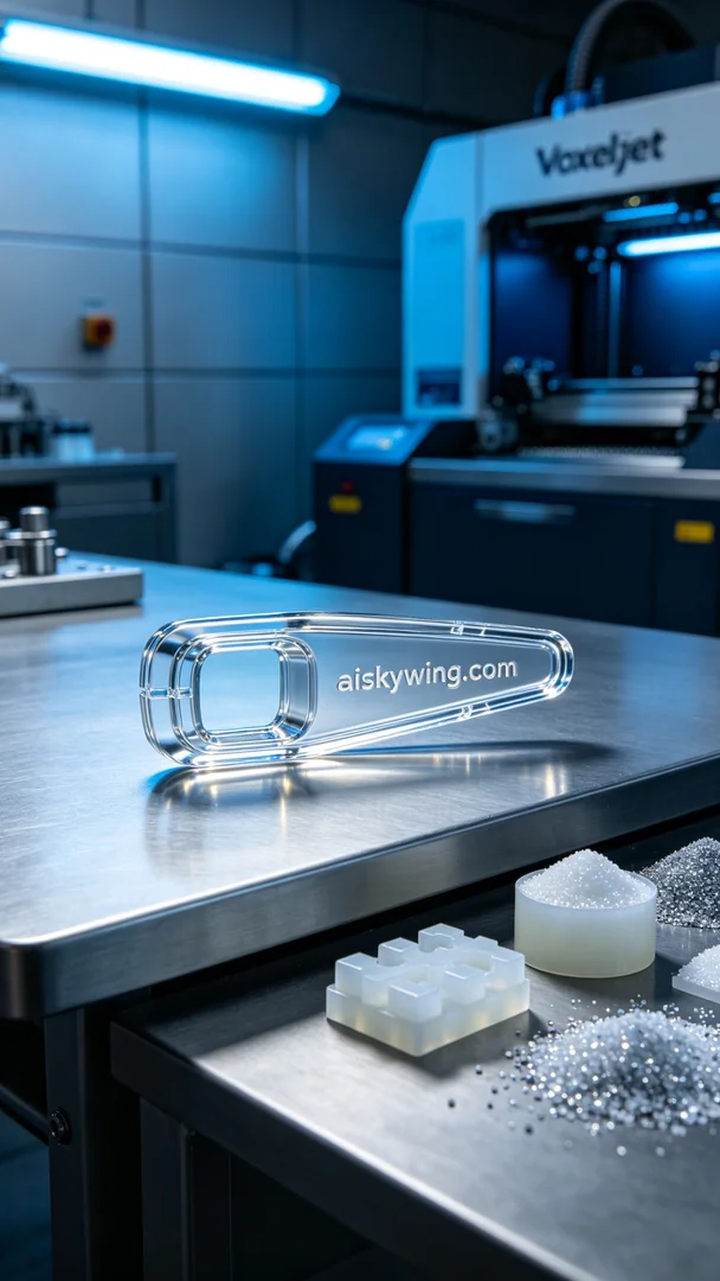
在Twitter上，有人提到他们的大众车型后视镜调节拨片存在反应迟钝的问题，这让驾驶体验受到了影响。于是，我们接到这个后视镜调节拨片的制作请求，希望能通过精准的工艺恢复它的功能。
我们选用了高透明高耐温的PC透明工程塑料作为原材料，这种材料不仅具备超高的透明度，还能在高温下保持良好的机械性能。为了确保打印效果，使用了Voxeljet打印机，设定的层厚为0.1毫米，打印温度保持在25°C，功率设定为80%，速度则控制在每小时60毫米，整个打印过程预期需要7小时。
随着打印机的启动，设备运转稳定，冷却风扇正常运转，确保了打印过程中温度的适宜。我们密切监控打印质量，定时检查细节，特别关注边缘的清晰度和表面平整度，确保每一个尺寸都在公差范围内。
打印完成后，需进行后处理。首先将成品放置在清洗槽中，用专业清洗液进行去除残留树脂，随后进行打磨，确保表面光滑。接着，将调整后的拨片放入固化设备中，设定温度为60°C，固化时间为20分钟，最后进行质量检验，确认所有规格和表面处理符合标准。
经过这一系列工序，后视镜调节拨片终于成功制作完成，恢复了应有的功能和清晰度。每一次的成功都是对我们的坚持与努力的最好回馈。
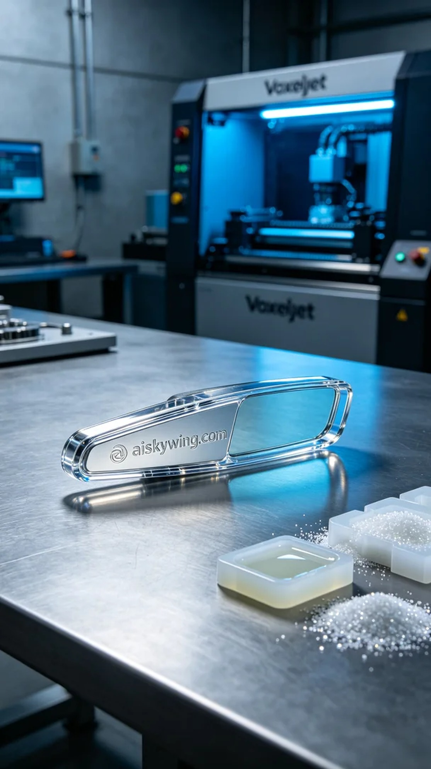
Aiskywing Industrial 3D Printing
Rearview mirror adjustment lever


