0755-咖啡机豆仓3D打印生产记录
Coffee machine bean hopper
🖨️ SLM金属打印
🖥️ 打印机: Rize
📦 材料: 摆放着未成型的液态光敏
生活的每一步都充满挑战，就像今天我们接到这个咖啡机豆仓的订单，正是为了满足人们对高品质咖啡的追求。
Every step of life is filled with challenges, just like today when we received the order for this coffee machine's bean hopper, which is aimed at satisfying people's pursuit of high-quality coffee.
________________________________________________________________________________
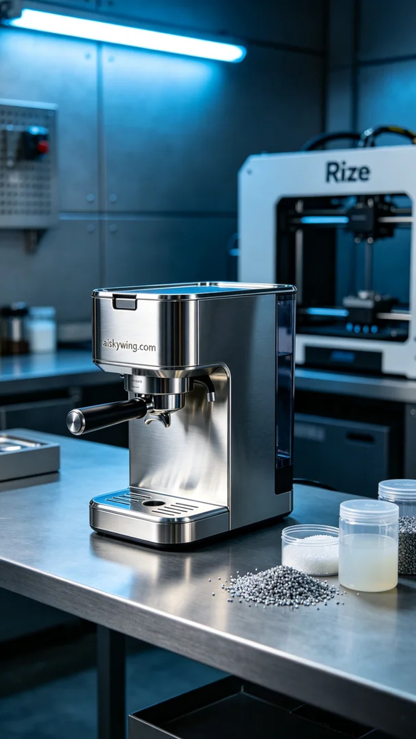
Today, a friend approached us with a request to print a coffee machine bean hopper. He found that the existing product he used lacked both sealing and aesthetic appeal, so he hoped we could provide a better solution.
To kick off the project, we chose unformed liquid photopolymer resin as our raw material. This material offers excellent fluidity and high precision, making it suitable for intricate print requirements. When using the Rize printer, we set the layer thickness to 0.1mm, maintained the temperature at 25℃, set the power at 80%, and the print speed at 60mm per second, with an estimated print time of 4 hours.
During the printing process, the Rize printer operated steadily, and I monitored the formation of each layer. The liquid photopolymer resin cured layer by layer through the light source, ensuring product stability and precision. Throughout the process, I kept a close eye on print quality, promptly adjusting parameters to address any potential fluctuations in pursuit of perfection.
Once printing was complete, we entered the post-processing phase. First, we cleaned the formed hopper to remove any excess resin. Next, we sanded it down to ensure a smooth, flawless surface, and finally cured it with a UV lamp to enhance the material’s durability. After a final inspection confirmed that the dimensions and quality met the standards, it was ready for delivery.
After a series of rigorous processes, the coffee machine bean hopper was finally revealed in its perfect state. Every detail reflects our dedication, and we look forward to enhancing the coffee experience for the user.
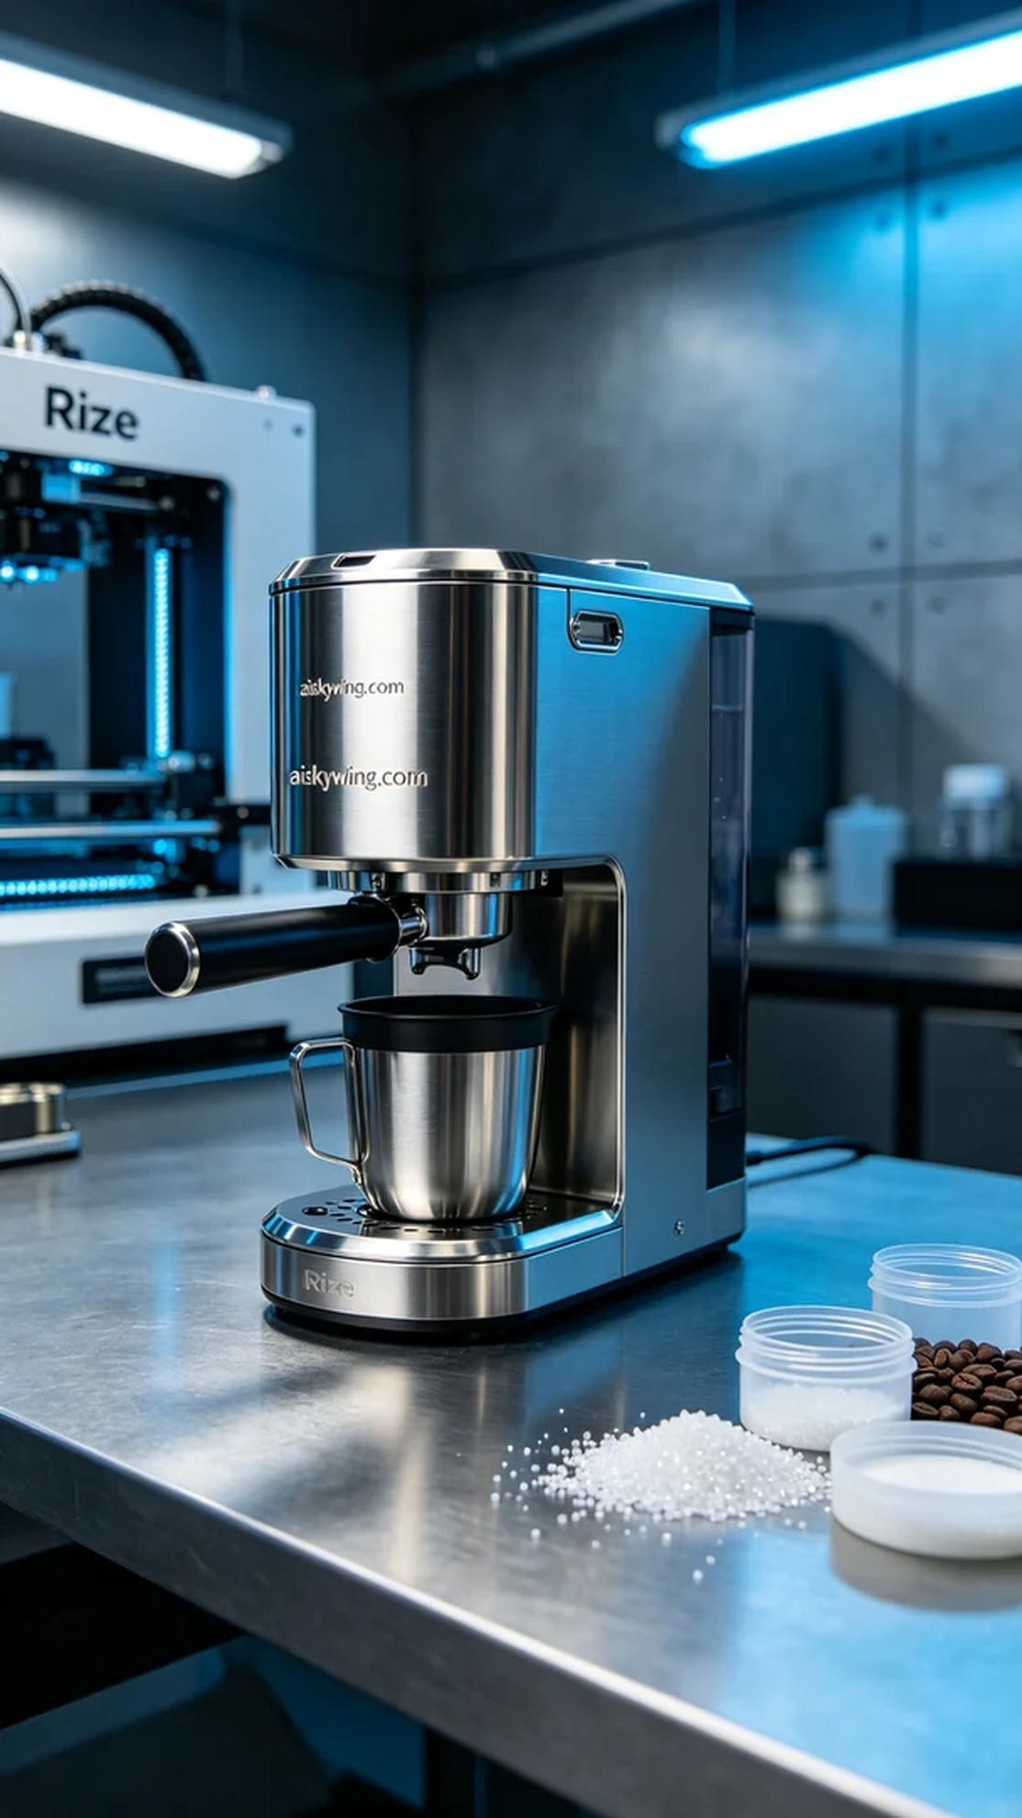
今天，我们收到了一位朋友的请求，希望我们能打印一个咖啡机豆仓。他在使用现有产品时发现，豆仓的密封性和美观性都不尽如人意，因此希望我们能提供一个更优秀的解决方案。
为了开始这一项目，我们选择了未成型的液态光敏树脂作为原材料。这种材料具有良好的流动性和高精度，适合细节丰富的打印需求。使用Rize打印机时，我们将层厚设置为0.1毫米，温度保持在25℃，功率为80%，打印速度设为60毫米每秒，预计打印时间为4小时。
在打印过程中，Rize打印机稳定运作，我观察着每一层的成型情况。液态光敏树脂通过光源逐层固化，确保了产品的稳定性与精度。整个过程中，我时刻监控着打印质量，及时调整参数以应对任何可能的波动，力求完美。
打印完成后，我们进入了后处理阶段。首先，对成型的豆仓进行清洗，以去除多余的树脂。接着，进行打磨，确保表面光滑无瑕疵，最后使用UV灯固化，增强材料的耐用性。完成检验，确认尺寸和质量达标后，便准备好交付。
经过一系列严格的工序，这个咖啡机豆仓终于完美呈现。每一个细节都体现了我们的用心，期待能为使用者带来更好的咖啡体验。
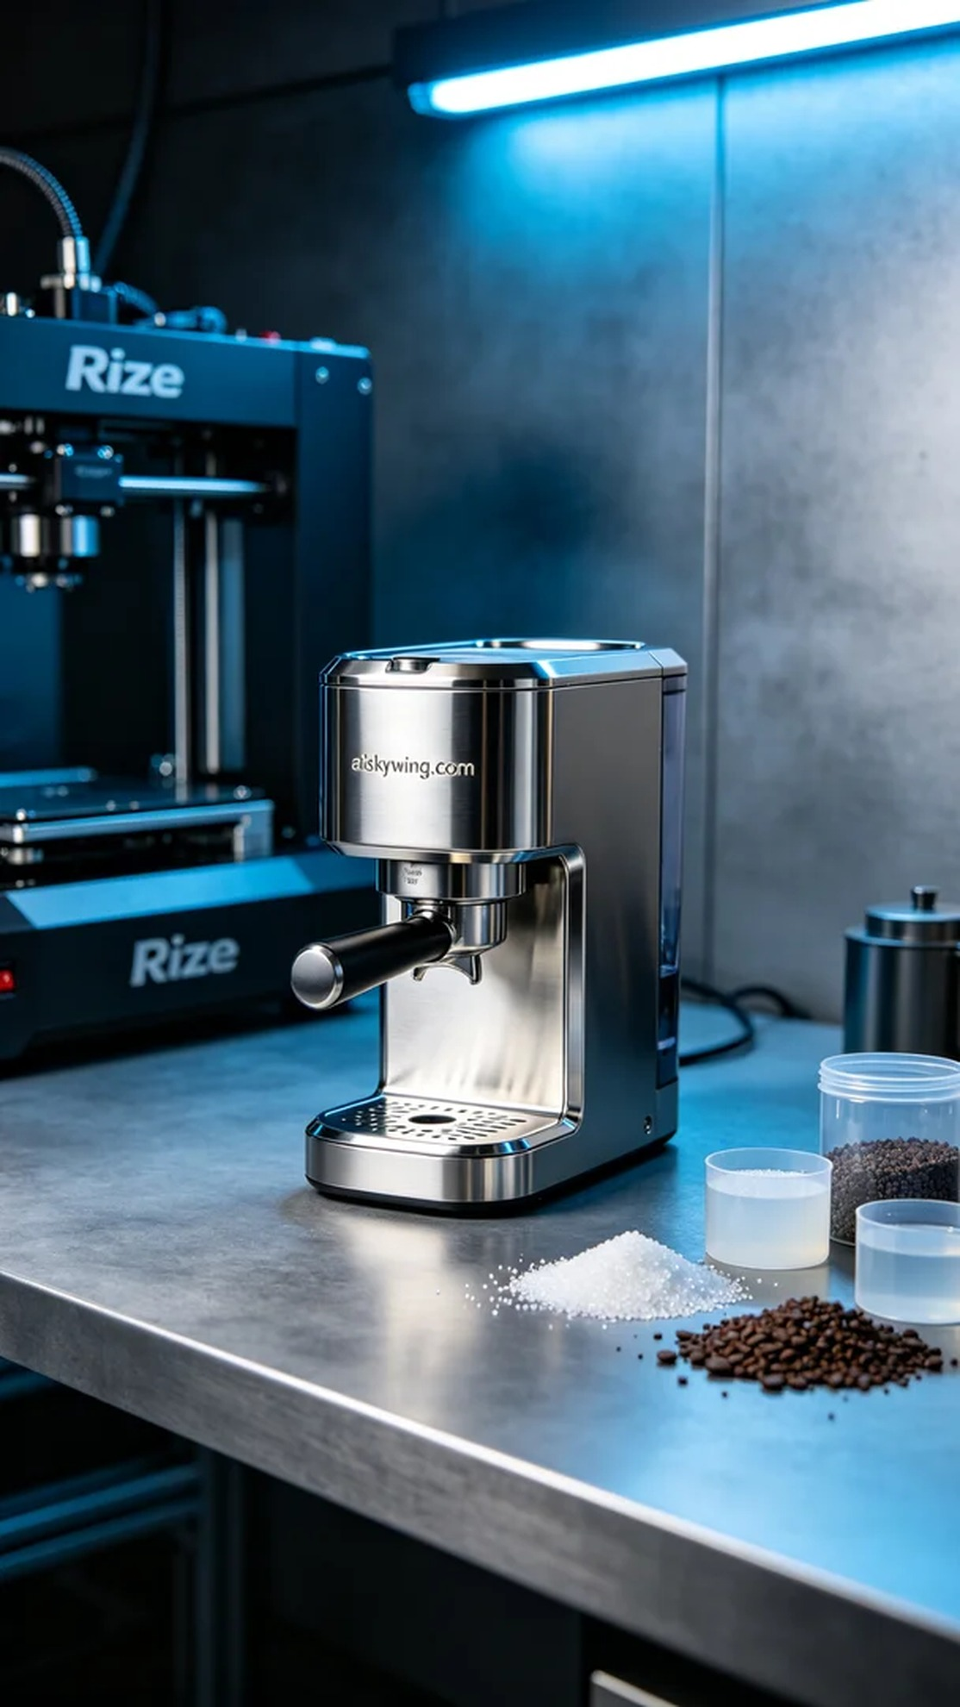
Aiskywing Industrial 3D Printing
Coffee machine bean hopper


