0758-3D打印生产记录：组件制作实录
3D Component
🖨️ 全彩3DP
🖥️ 打印机: HP
📦 材料: 摆放着未成型的液态光敏
生活就像3D打印，不停地调整和尝试，才能成就一件完美的作品。有人在Facebook上寻求帮助，想制作一个3D组件的项目。
Life is like 3D printing; it requires constant adjustments and experimentation to create a perfect piece. Someone is seeking help on Facebook to work on a project involving a 3D component.
________________________________________________________________________________
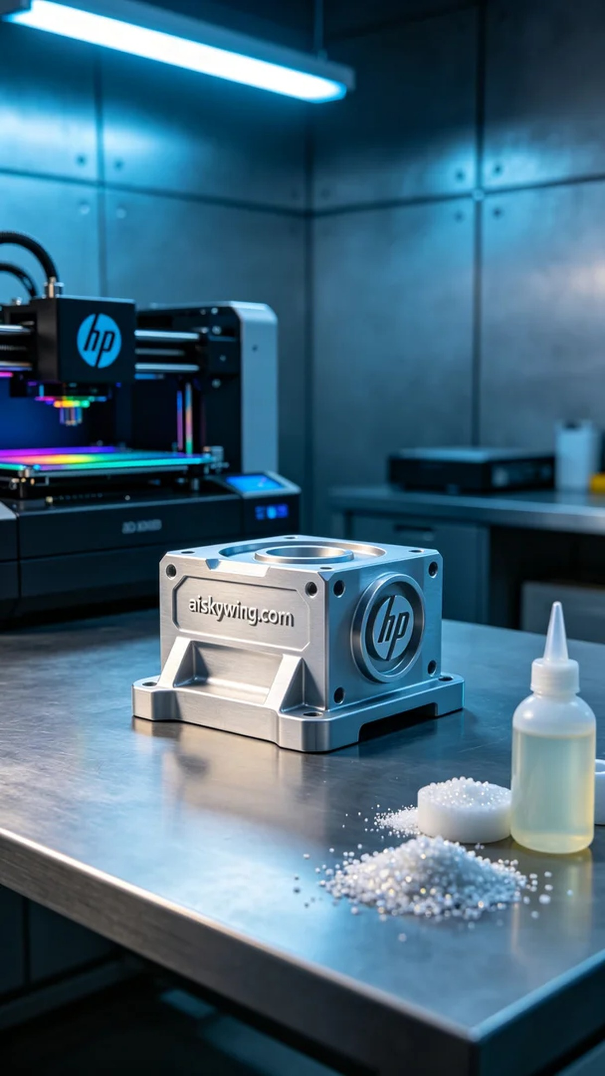
Life is like 3D printing, constantly adjusting and experimenting to achieve a perfect piece. Someone reached out on Facebook seeking help to create a 3D component for a specific design need.
To ensure quality, we selected liquid photopolymer resin, known for its excellent flowability and forming capabilities. The HP printer settings were adjusted to a layer thickness of 0.1mm, temperature maintained at 25°C, power set to 85%, and a print speed of 30mm per second, with an estimated total print time of about 8 hours. This setup is crucial for achieving the desired precision and surface quality.
During the printing process, our HP printer operated smoothly with no noticeable issues. We regularly monitored the print progress, ensuring each layer cured correctly, and observed that the details emerged beautifully, with natural color gradients.
After printing, we carried out a series of post-processing steps. First, the component was cleaned to remove excess resin; then, we sanded it down to achieve a smooth surface; finally, we used UV light for curing to enhance the material's hardness and durability. Each step was carefully inspected to ensure the final result met our standards.
In the end, the 3D component was completed on time, showcasing vibrant colors and rich details that perfectly reflected the design intent. This printing experience reaffirms the power of persistence and professionalism, and we look forward to the next project.
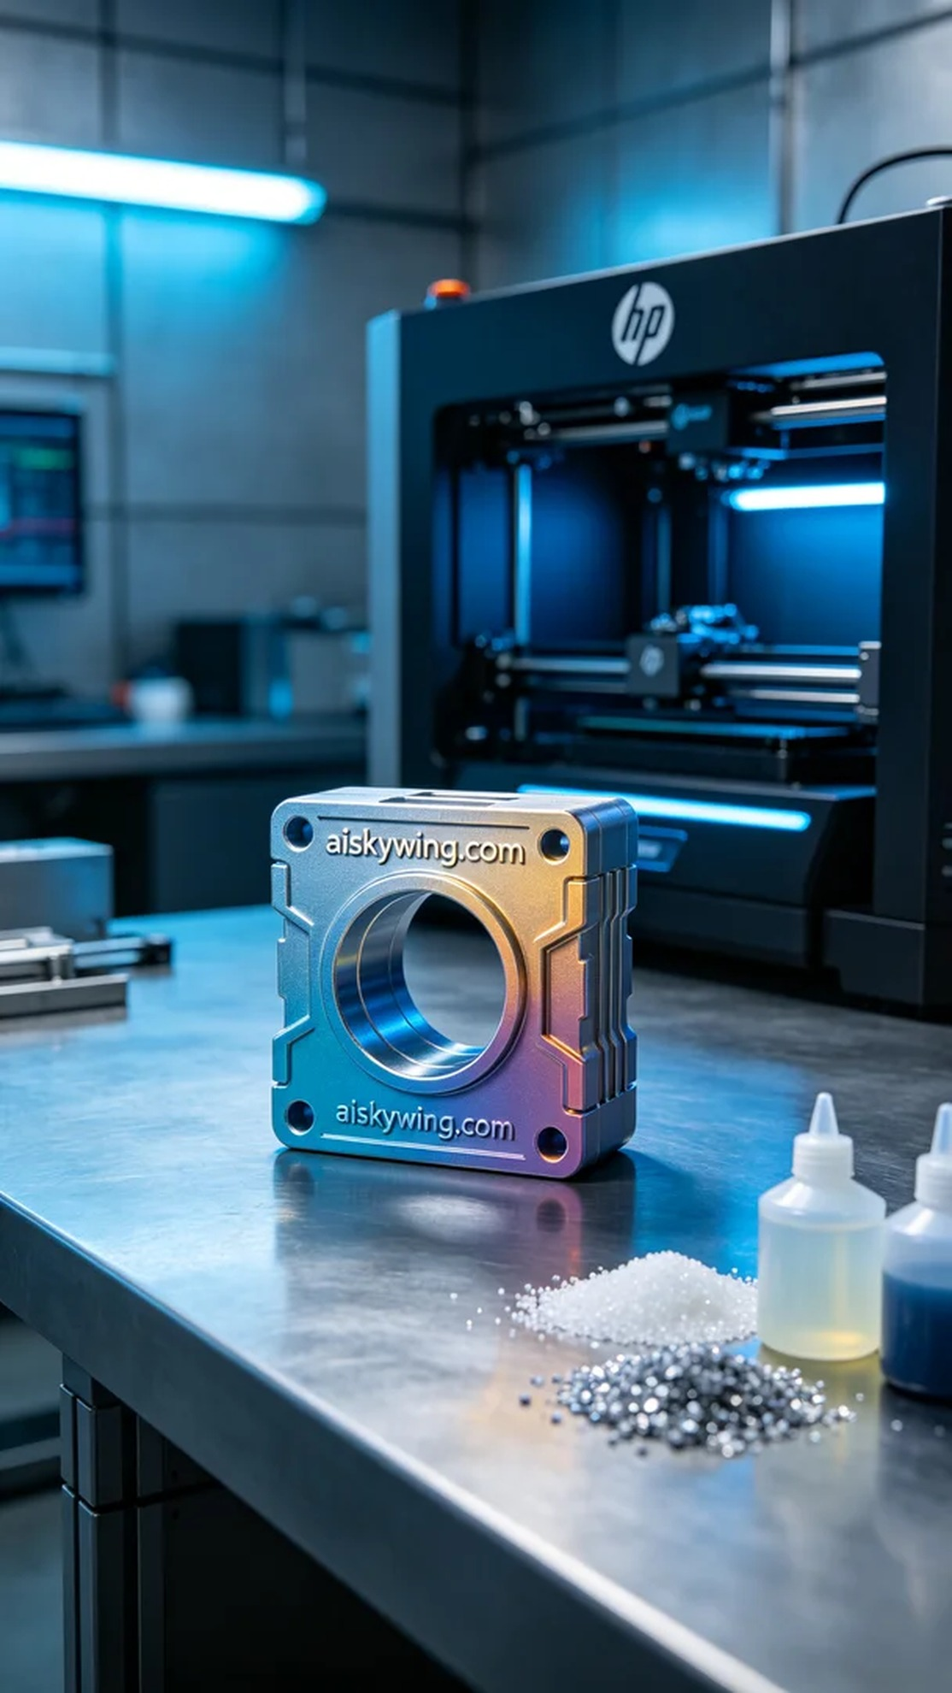
经过了解，这个3D组件的制作主要是为了解决一个具体的设计需求。有人希望我们使用高保真的彩色打印技术，打造出一个具有丰富色彩和细致纹理的产品。这个项目对材料和设备的要求非常高，我们选择了HP打印机来完成这个任务。
为了确保效果，我们选用了未成型的液态光敏树脂，具有极佳的流动性和成型能力。打印机的设置调整为层厚0.1毫米，温度保持在25℃，功率设置为85%，打印速度为30毫米每秒，预计总打印时间大约为8小时。这样可以确保打印精度和表面质量达到要求。
在打印过程中，我们的HP打印机运行得非常顺利，整个打印过程稳定，无明显异常。我们定期检查打印进度，确保每一层都能正确固化，观察到细节的呈现相当完美，色彩渐变也显示得很自然。
打印完成后，我们进行了一系列的后处理工序。首先将组件进行清洗，去除多余的树脂；然后进行打磨，确保表面光滑无瑕；最后用UV灯进行固化处理，增强材料的硬度和耐用性。每个环节的检验都十分仔细，以确保最终结果符合标准。
最终，3D组件如期完成，色彩鲜艳、细节丰富，完美地展现了设计初衷。这次的打印经历再次证明了坚持和专业的力量，期待下一个项目的到来。
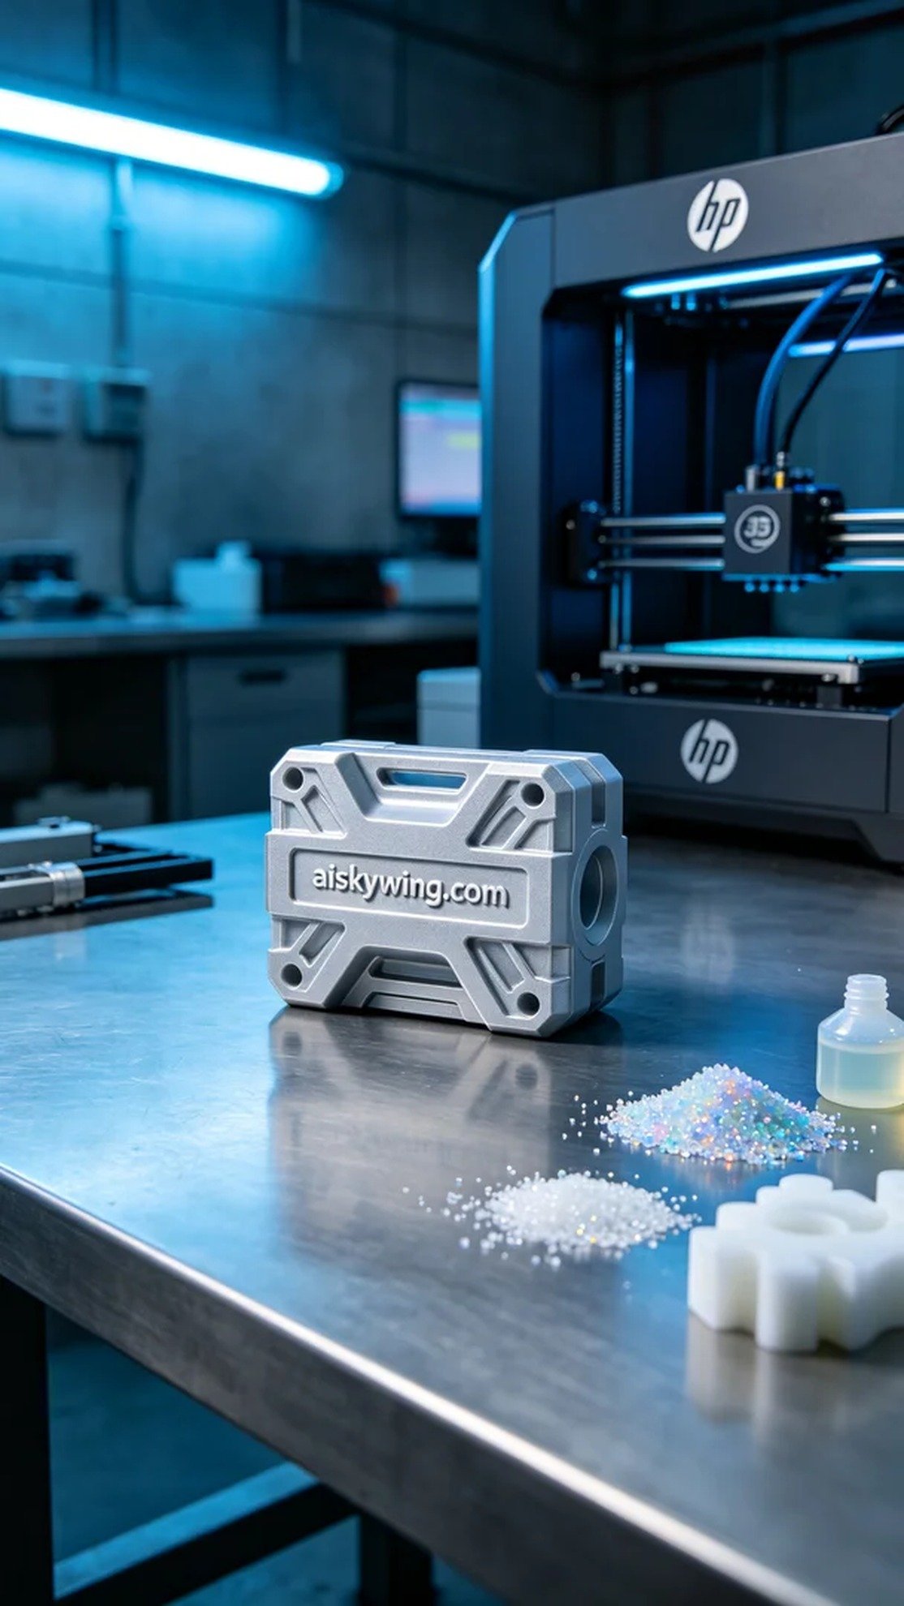
Aiskywing Industrial 3D Printing
3D Component


