0759-3D打印连接件的生产记录
3D connector
🖨️ 全彩3DP
🖥️ 打印机: Stratasys
📦 材料: 摆放着未成型的液态光敏
生活的每一个小细节，都是我们前行的动力。就像有人通过WhatsApp联系我，希望我帮忙制作这个3D连接件。
Every small detail of life is the driving force behind our progress. Just like someone contacted me via WhatsApp, hoping I could help create this 3D connector.
________________________________________________________________________________
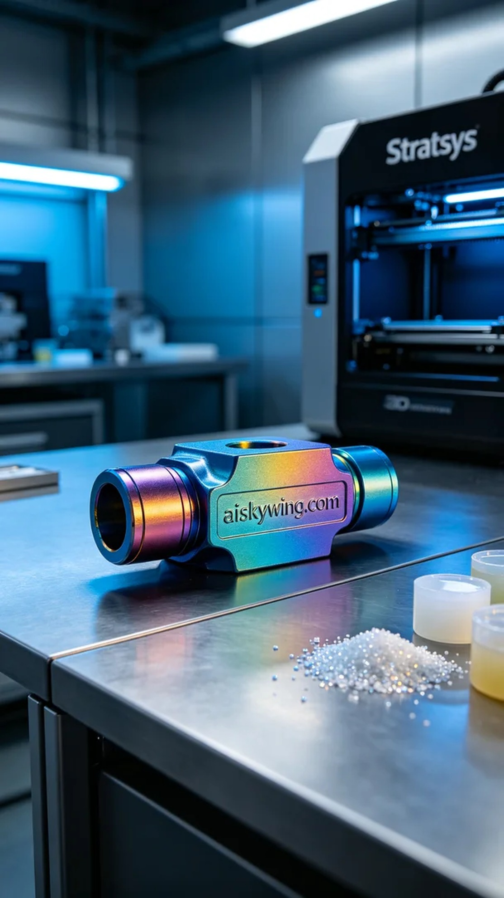
Every little detail in life is a driving force for our progress. Just like someone reached out to me via WhatsApp, asking for help in printing a 3D connector.
For this project, we used liquid photopolymer resin as the raw material due to its excellent flowability and ability to present clear details after printing, making it ideal for full-color 3DP processes. Before starting the print, I meticulously checked the settings on the Stratasys printer, adjusting the layer thickness to 0.1 mm, maintaining a printing temperature of 25°C, setting the power to 85%, and the speed to 60 mm per second, with an estimated printing time of 8 hours.
The printing process proceeded smoothly as expected, with the Stratasys printer operating steadily, evenly spraying the liquid resin. I closely monitored the print quality, ensuring the perfect presentation of color gradients and intricate details. As time passed, the 3D connector gradually took shape, with its rich colors and three-dimensional feel stunning everyone.
Once the printing was complete, I began the post-processing procedures. First, I placed the formed connector into the cleaning tank, using ultrasonic cleaning to remove excess resin. Next, I sanded the surface with fine sandpaper to ensure it was smooth. Then, I placed it in the curing chamber and used UV lights for curing, ensuring that every detail was perfected. Finally, I conducted a thorough inspection of the finished product to ensure it met all technical standards.
In the end, through a series of meticulous processes, we successfully completed the production of this 3D connector. The vibrant colors and exquisite details of the product were perfectly presented, leaving me genuinely satisfied with the results.
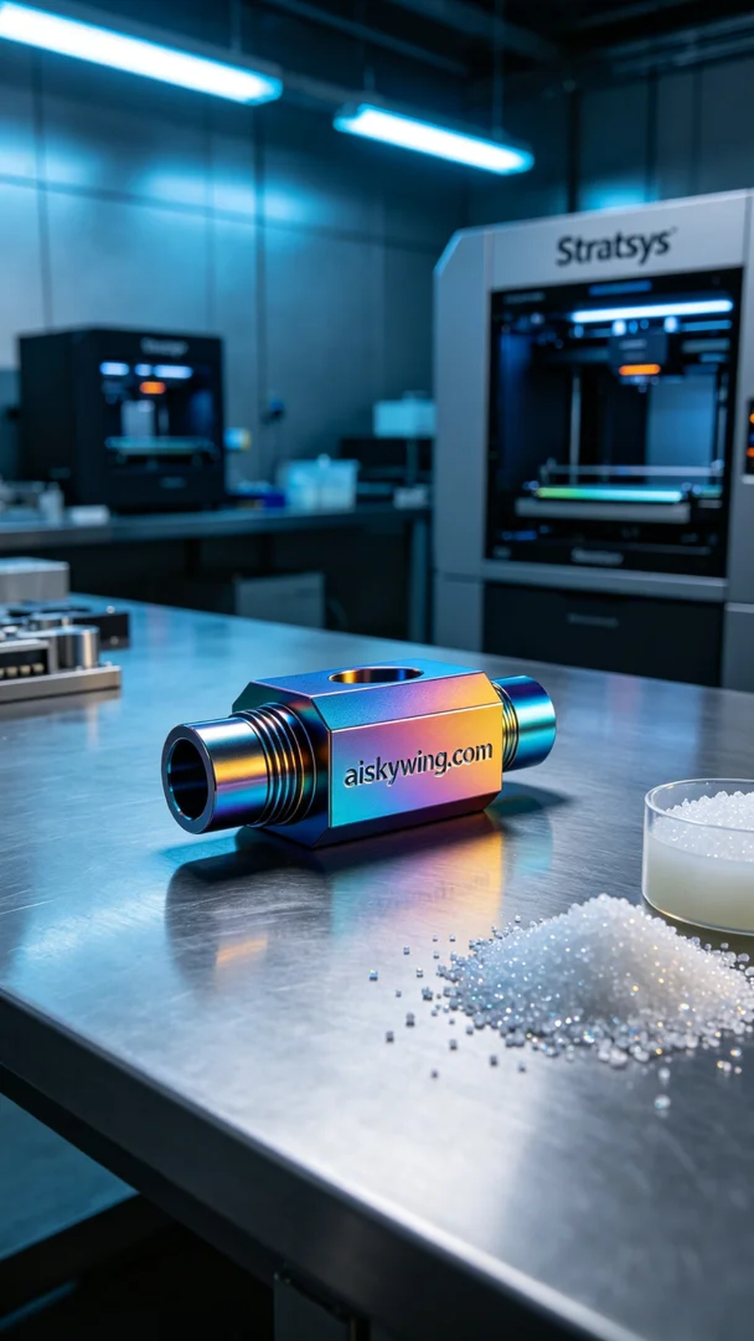
在一次忙碌的工作日，有人通过WhatsApp向我求助，想要我为他们打印一个3D连接件。他们希望这个连接件能够具有高还原度的色彩与复杂的细节，让整个设计更具吸引力。于是，我决定立即开始这个项目。
我们使用了未成型的液态光敏树脂作为原材料，因其优良的流动性和打印后能够呈现清晰细节的能力，非常适合全彩3DP打印过程。在准备打印之前，我仔细检查了Stratasys打印机的各项参数，设定层厚为0.1毫米，打印温度保持在25°C，功率设定为85%，速度调节为60毫米每秒，预计打印时间为8小时。
打印过程如预期顺利进行，Stratasys打印机稳定运行，液态树脂均匀喷射，每一层都在精确的位置交叠。我密切监控着打印质量，确保颜色渐变和细节的完美呈现。随着时间的推移，3D连接件逐渐成型，颜色的丰富性和立体感让人惊叹。
打印完成后，开始了后处理工序。首先，我将成型的连接件放入清洗槽中，使用超声波清洗去除多余的树脂。接下来，使用细砂纸对表面进行打磨，使其光滑如新。再将其放入固化室，使用UV灯进行固化，确保每个细节都达到最佳效果。最后，对成品进行全面检验，确保其符合所有技术标准。
最终，经过一系列细致的工序，我们成功完成了这款3D连接件的生产。色彩鲜艳、细节精致的产品已经完美呈现，令人满意的结果让我感到由衷的欣慰。
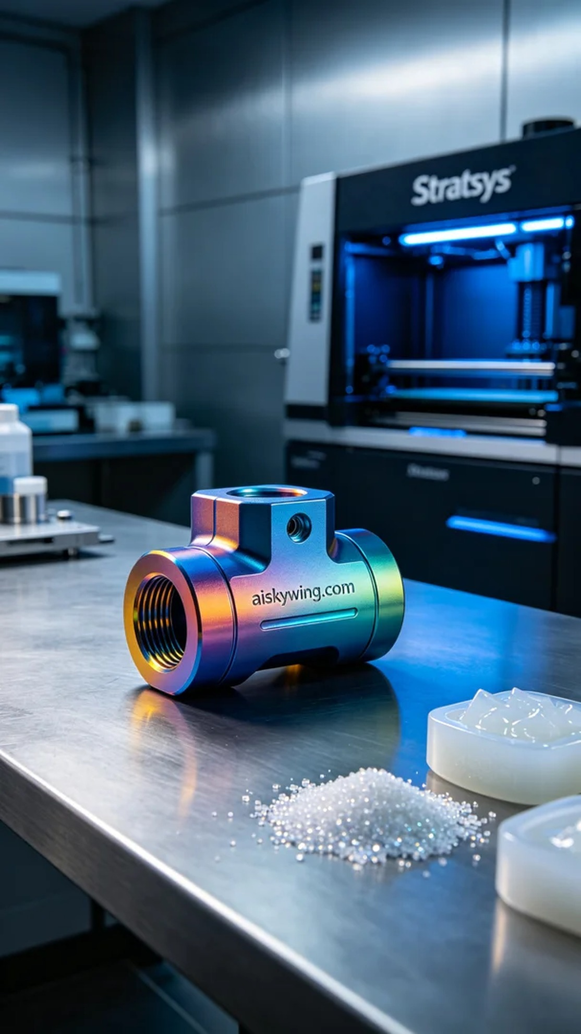
Aiskywing Industrial 3D Printing
3D connector


