0760-3D面板的打印与制作记录
3D panel
🖨️ 全彩3DP
🖥️ 打印机: Stratasys
📦 材料: 全彩3DP
生活就像3D打印，层层叠加才能成就完美。最近，有人在LinkedIn上找到我们，希望制作一款精美的3D面板。
Life is like 3D printing; it requires layers upon layers to achieve perfection. Recently, someone reached out to us on LinkedIn, hoping to create a beautiful 3D panel.
________________________________________________________________________________
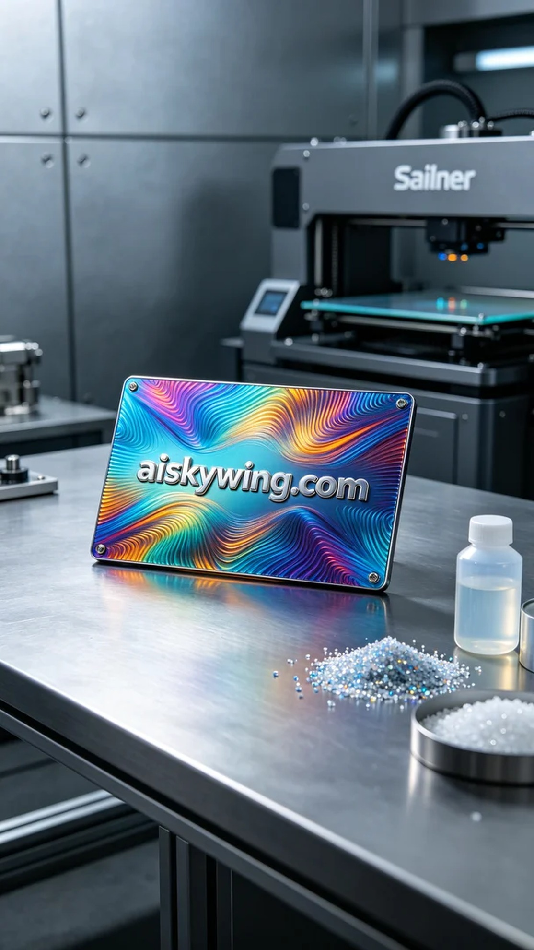
Life is like 3D printing, built layer by layer to achieve perfection. Recently, someone reached out to us on LinkedIn seeking to create a stunning 3D panel.
The task was to produce a 3D panel with the inscription "aiskywing.com" prominently displayed, requiring a rich and vibrant color finish. We chose to use a Stratasys 3D printer to ensure high-quality printing and accurate color reproduction.
The material we used was full-color 3DP, known for its excellent color richness and realism. To optimize the printing process, we set the parameters to a layer thickness of 0.1mm, a temperature of 50°C, a power of 80%, and a print speed of 30mm/s. These settings ensured that the details were well-defined while maintaining smooth color transitions.
During the printing process, the Stratasys printer operated steadily. We closely monitored the machine to ensure the print head was functioning correctly and that the material was being supplied smoothly. The entire printing process took about four hours, during which we regularly checked the printed piece to prevent any warping or uneven coloration.
After printing, we carried out detailed post-processing steps. First, we placed the formed 3D panel into a cleaning tank, using a special cleaning solution to remove any residual liquid resin from the surface. Next, we gently sanded the edges to ensure a smooth touch. Finally, the panel was placed in a curing device and subjected to ultraviolet light for complete curing, followed by a final quality inspection to ensure every detail was perfectly rendered.
In the end, this 3D panel, with its outstanding color and detail quality, successfully met their needs, showcasing the charm and potential of industrial 3D printing.
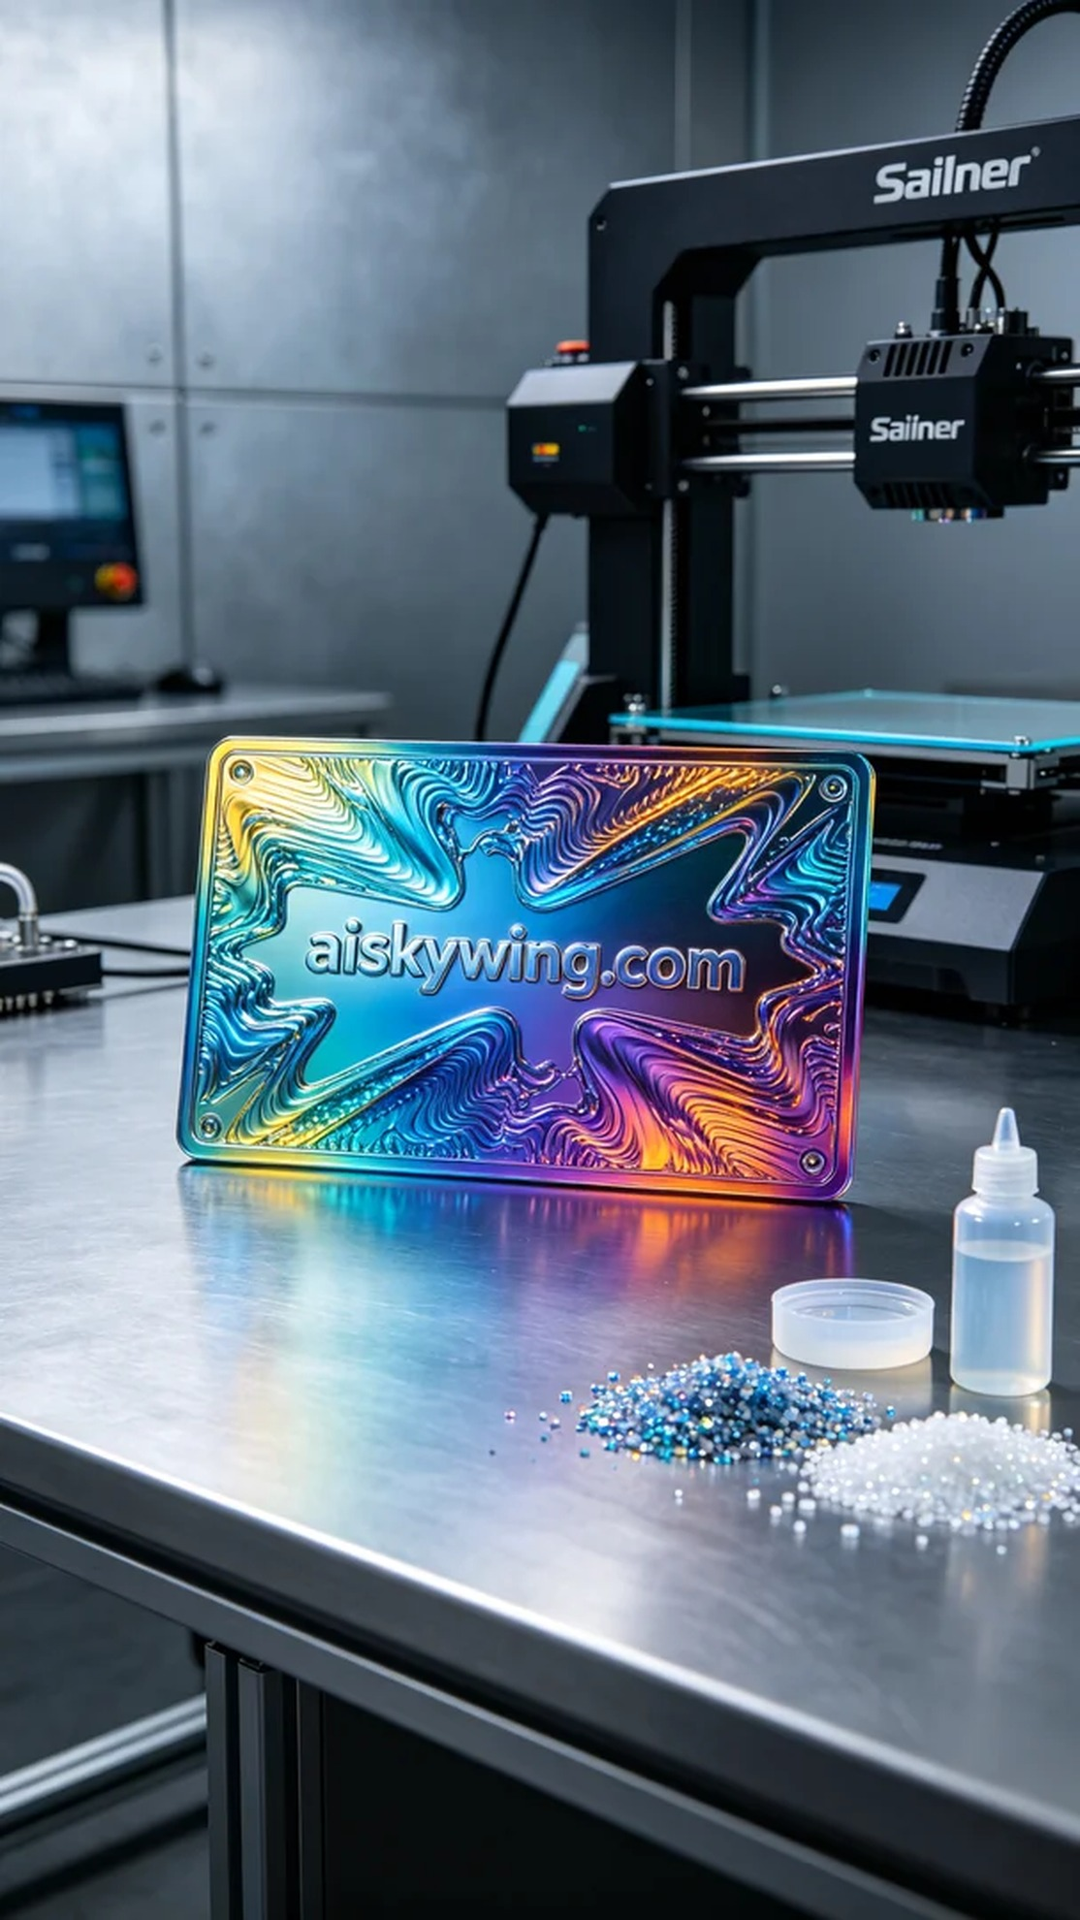
这次的任务是为有人制作一款3D面板。由于其表面需要雕刻"aiskywing.com"字样，并且呈现出丰富的全彩效果，他们希望我们能利用先进的技术来完成。我们选择了Stratasys品牌的3D打印机，以保证打印质量和色彩的真实还原。
我们使用的材料是全彩3DP，具有优异的色彩丰富性和逼真度。为了优化打印效果，我们将打印参数设置为层厚0.1mm，温度设定在50°C，功率为80%，打印速度保持在30mm/s。这样的参数能够确保在打印时细节饱满，同时色彩过渡自然。
在打印过程中，Stratasys打印机稳定地运行着。我们时刻监控设备，确保喷头工作正常，材料供应顺畅。整个打印过程大约持续了4小时，期间我们还定期检查打印件，以确保没有出现翘边或色彩不均的问题。
完成打印后，我们进行了细致的后处理工序。首先将成型的3D面板放入清洗槽，使用专用清洗液去除表面残余的光敏树脂。随后，我们用砂纸轻轻打磨边缘，以确保触感光滑。最后，将面板放置于固化设备内，经过紫外线照射进行彻底固化，并进行最终的质量检验，确保每个细节都能完美呈现。
最终，这款3D面板以其出色的色彩和细节品质，成功满足了他们的需求，展示了工业3D打印的魅力和可能性。
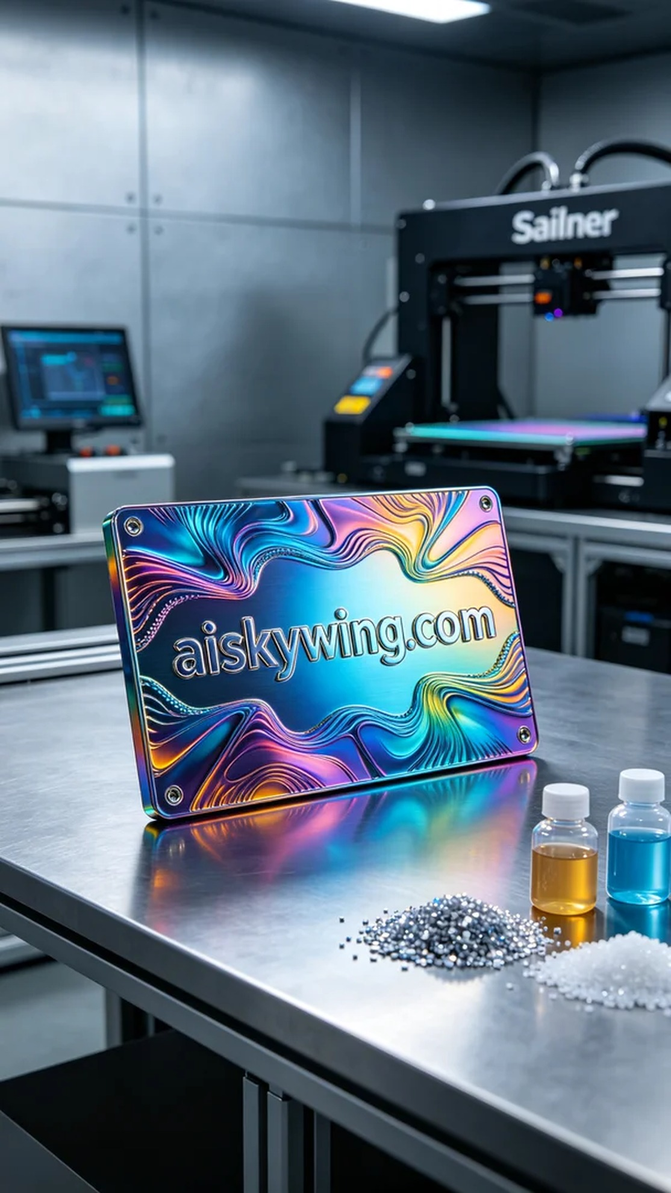
Aiskywing Industrial 3D Printing
3D panel


