0761-全彩3D打印企鹅模型生产记录
Full-color 3D printed penguin model
🖨️ 全彩3DP
🖥️ 打印机: Xjet
📦 材料: 摆放着未成型的液态光敏
生活再难，也别停下脚步。就像接下这个全彩3D打印企鹅模型的单子，面对挑战，我们总能找到解决的办法。
No matter how difficult life gets, don't stop moving forward. Just like taking on this full-color 3D printed penguin model project, we can always find a solution when faced with challenges.
________________________________________________________________________________
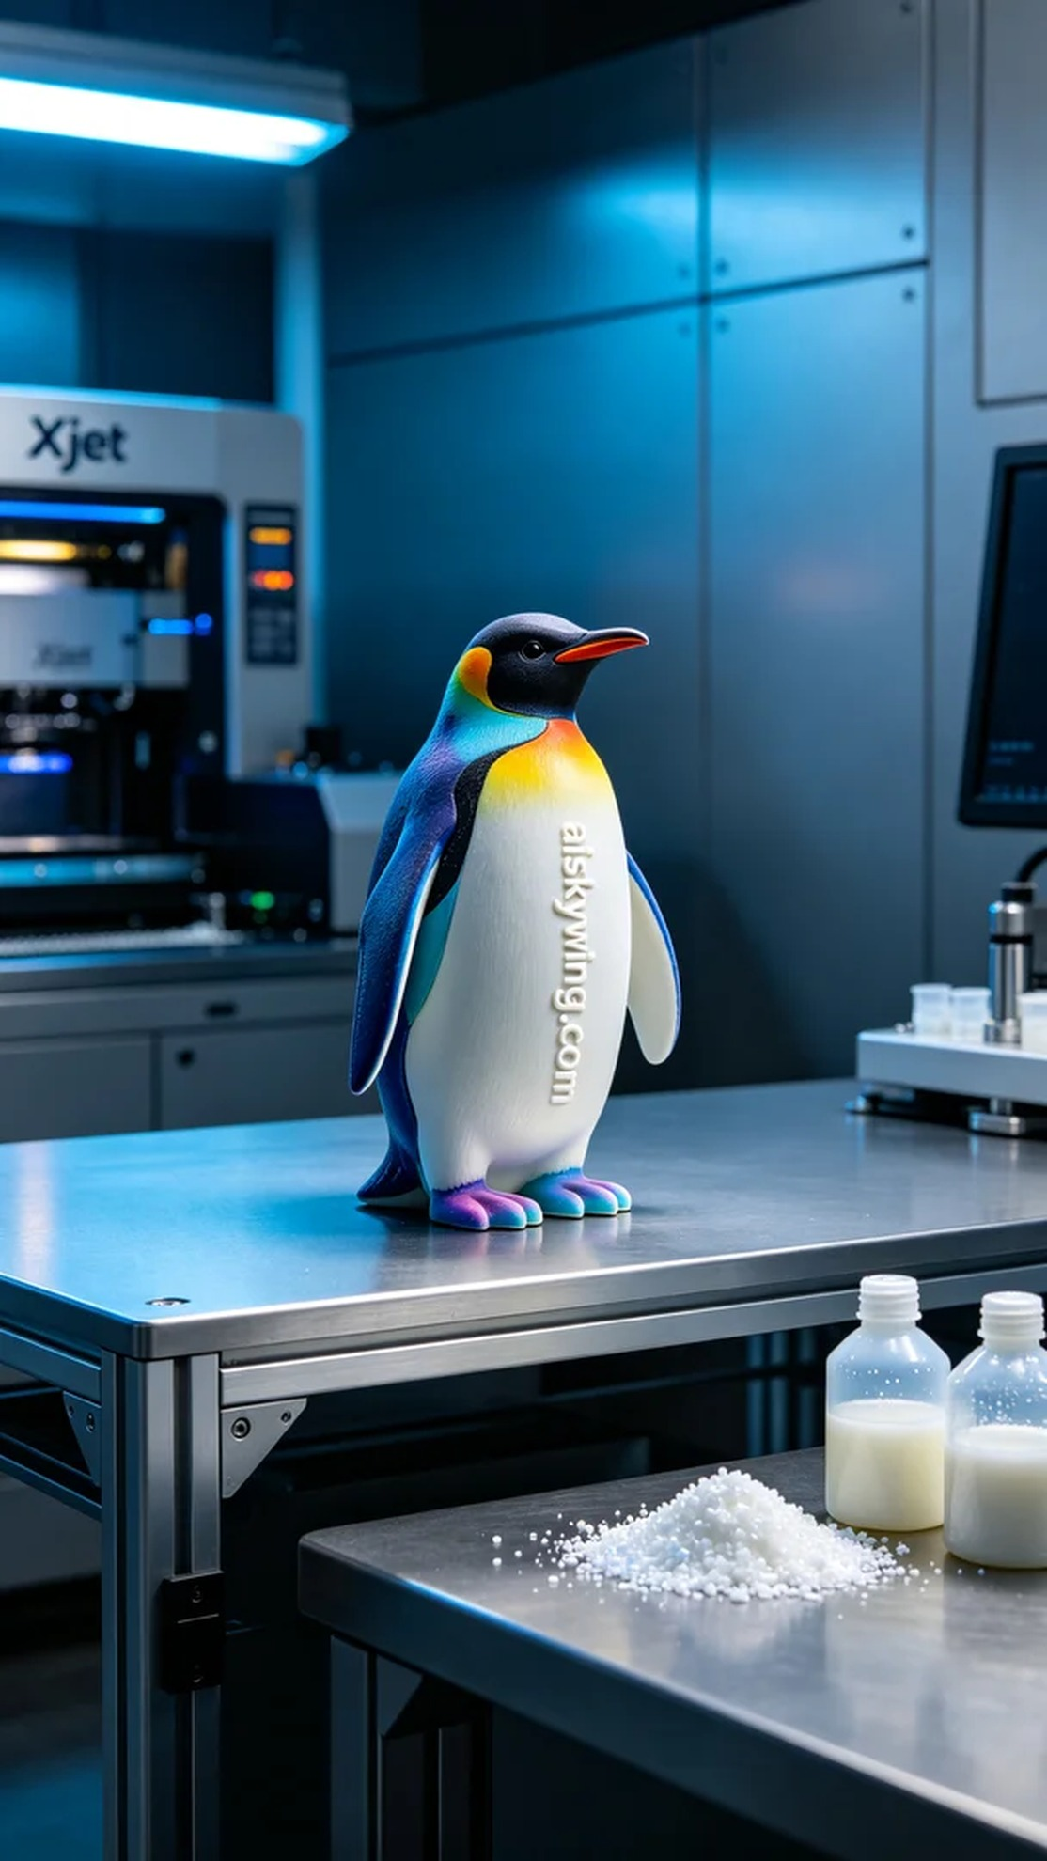
Recently on Twitter, someone reached out to us with a request for assistance in creating a full-color 3D printed penguin model. They were hoping to achieve a design that was rich in color, vivid in detail, and smooth in surface finish to truly reflect its uniqueness and appeal.
We opted for unformed liquid photopolymer resin as our printing material, known for its excellent color fidelity, which is ideal for the needs of full-color 3DP. During our preparation, we carefully set the printing parameters: layer thickness of 0.1 mm, printing temperature of 25 degrees Celsius, power of 1600 watts, and a print speed of 60 mm per hour. Ensuring each parameter was optimized was crucial to showcase every detail of the penguin model.
Throughout the printing process, the Xjet printer operated smoothly. The machine was quiet and stable, and as the print head moved, the color gradients gradually revealed themselves. We continuously monitored the device's performance to ensure print quality, making adjustments when necessary to avoid any potential flaws.
After printing, we entered the post-processing phase. First, the model was placed in a cleaning tank to remove any excess resin using a cleaning solution. Next, we sanded it down with fine-grit sandpaper to enhance its surface smoothness. Then, we cured the model to ensure its strength and durability. Finally, after thorough inspection, we confirmed that every detail of the model met our quality standards.
Completing this full-color 3D printed penguin model filled me with immense satisfaction. Watching it beautifully displayed against the silver-gray industrial tabletop, I felt a profound sense of accomplishment and pride.
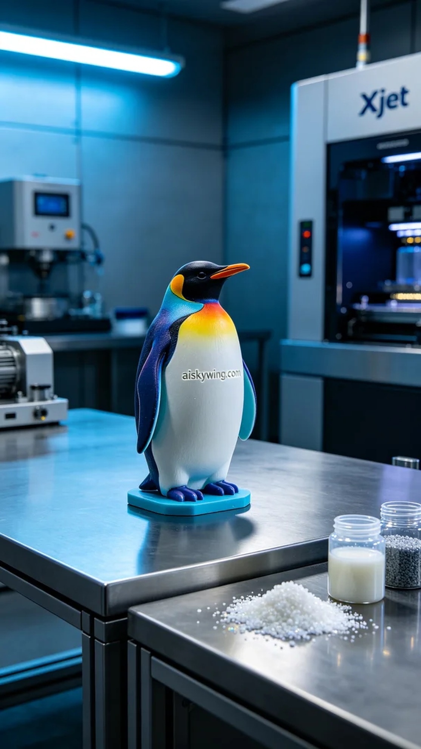
最近在Twitter上，有人找到我们，请求帮助解决全彩3D打印企鹅模型的制作问题。他希望能够制作出色彩丰富、细节逼真、表面光滑的模型，这样才更能体现它的独特性和吸引力。
我们选择了未成型的液态光敏树脂作为打印材料，这种材料的色彩还原度高，适合全彩3DP的需求。准备过程中，我们仔细设定了打印参数：层厚0.1毫米、打印温度25摄氏度、功率1600瓦、打印速度为每小时60毫米。确保每个参数都能达到最佳效果，以便让企鹅模型的每一处细节都展现无遗。
在打印过程中，Xjet打印机的运行状态一直保持良好。设备安静而稳定，随着打印头的移动，颜色的渐变逐渐显现。我们全程监控设备的运行情况，确保打印质量，不时进行观察，及时调整，以避免任何可能的瑕疵。
打印完成后，我们进入后处理环节。首先将模型放入清洗槽中，用清洗液去除多余的树脂；接着使用细砂纸进行打磨，提升表面的平滑度。然后进行固化处理，确保模型的强度和耐用性。最后，经过仔细检验，确认模型的每个细节都符合要求。
完成这个全彩3D打印企鹅模型，让我感到无比欣慰。看着它在银灰色工业桌面上的完美展示，心中充满了成就感和自豪。
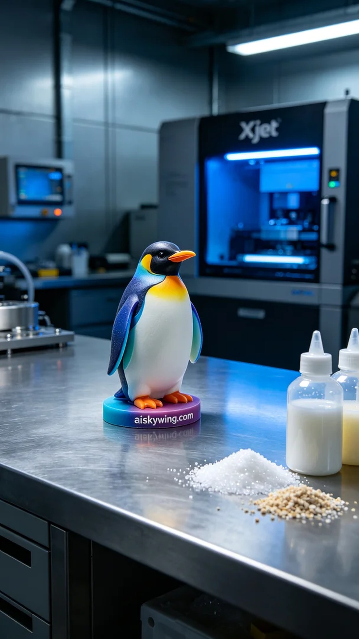
Aiskywing Industrial 3D Printing
Full-color 3D printed penguin model


