0762-全彩3D打印保龄球模型的生产记录
Full-color 3D printed bowling ball model
🖨️ 全彩3DP
🖥️ 打印机: Voxeljet
📦 材料: 摆放着未成型的液态光敏
生活就像3D打印，有时候需要精准调控与坚持不懈。最近有人通过WhatsApp找我们，希望制作一款全彩3D打印保龄球模型，问题主要在于模型的细节与颜色还原度。
Life is like 3D printing; sometimes it requires precise adjustments and perseverance. Recently, someone contacted us via WhatsApp, hoping to create a full-color 3D printed bowling ball model. The main issue lies in the model's details and color accuracy.
________________________________________________________________________________
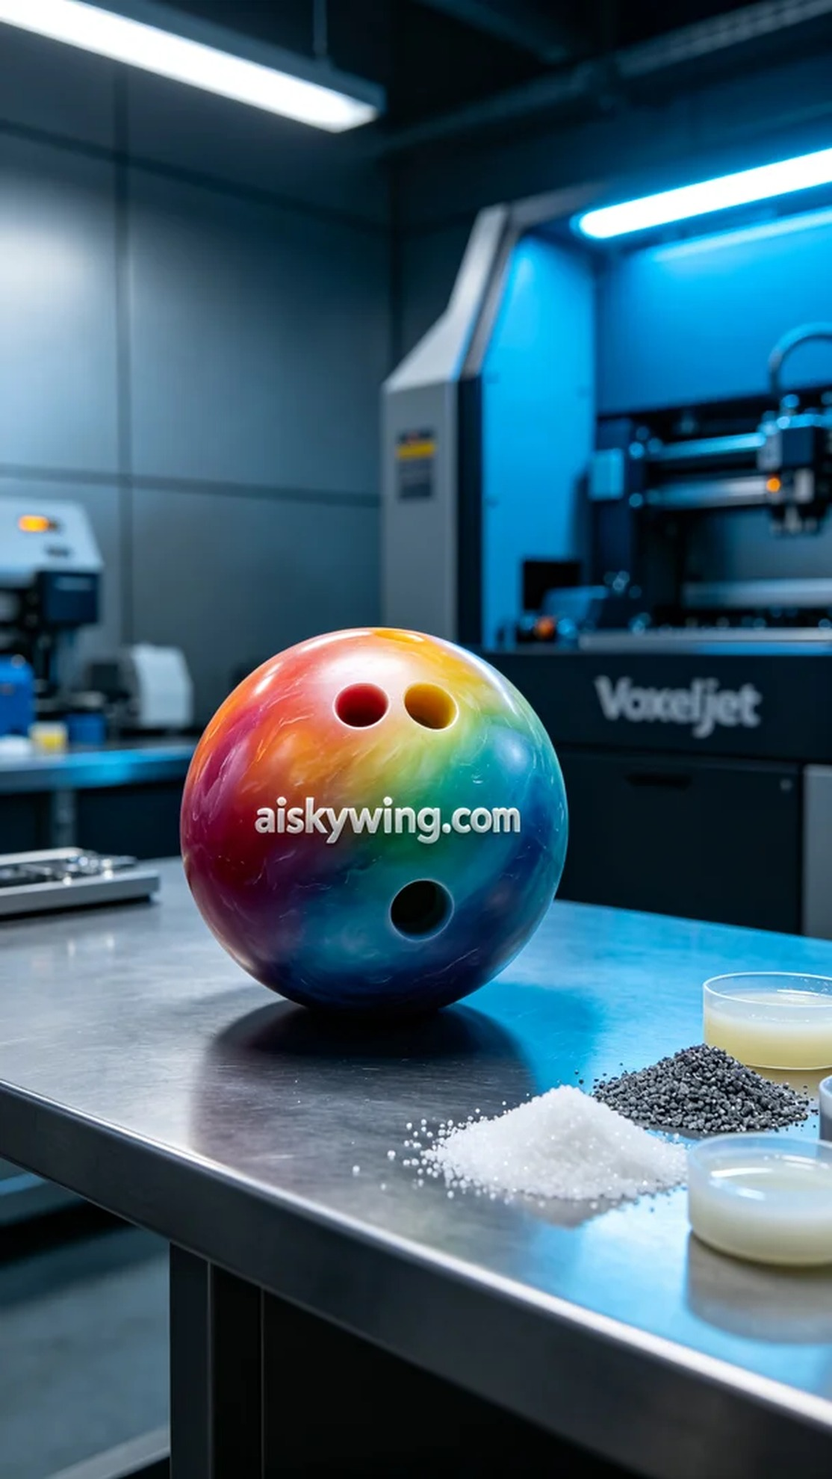
Life is like 3D printing; sometimes it requires precise control and unwavering perseverance. Recently, someone reached out to us via WhatsApp, looking to create a full-color 3D printed bowling ball model, with concerns mainly regarding the details and color accuracy of the model.
For this full-color 3D printed bowling ball model, we selected high-quality liquid photopolymer resin as the raw material. This material's fluidity and curing characteristics greatly facilitate the printing process while ensuring a smooth surface and rich color reproduction. We utilized a Voxeljet 3D printer, known for its stability and high precision, which were key reasons for our choice.
In the preparation phase, we conducted a thorough check of the printer and verified the accuracy of various parameters. The printing settings were established at a layer thickness of 0.1mm, with a temperature maintained at 25 degrees, light source power set to 150mW, and a print speed of 30mm/s, with an estimated total printing time of about 8 hours. These settings aimed to ensure that each layer would bond perfectly during the printing process, achieving the desired effect.
As the printing commenced, the device operated steadily, with the photopolymer resin curing layer by layer, gradually revealing the model's details. We closely monitored the printer's status to ensure no anomalies occurred. Every detail was meticulously crafted, resulting in a smooth surface, vibrant colors, and rich details that were truly satisfying.
After printing, the model underwent a series of post-processing procedures. First, we placed it in a cleaning solution to remove any uncured resin; next, we used fine sandpaper to smooth the surface for a pleasant tactile experience. Finally, the model was cured under UV light to enhance its durability and gloss. After careful inspection, we confirmed it was flawless, and the final product was perfectly presented.
As we wrapped up this project, the satisfaction of seeing the completed full-color 3D printed bowling ball model filled us with pride. This was not only a successful printing experience but also a testament to teamwork and technical prowess.
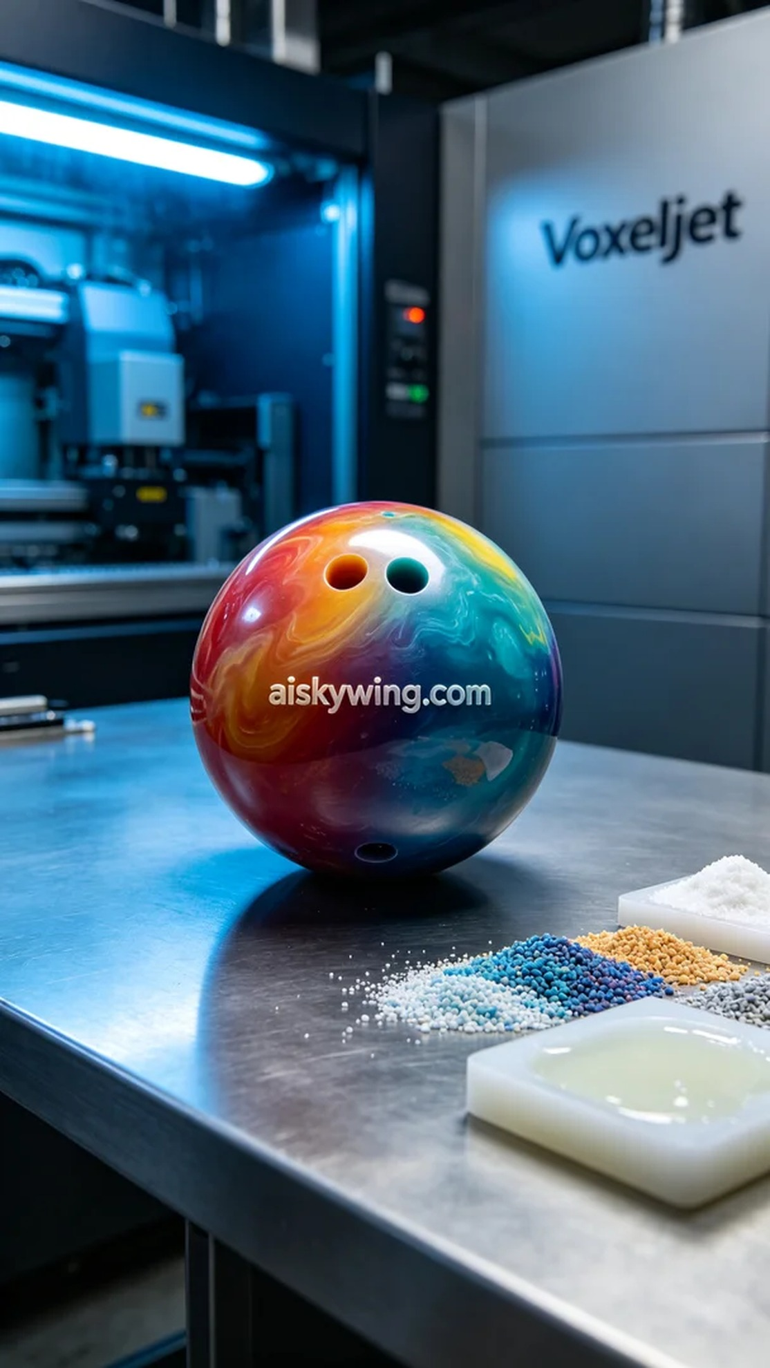
为了这款全彩3D打印保龄球模型，我们选用了高品质的未成型液态光敏树脂作为原材料。这种材料的流动性和固化特性为打印带来了极大的便利，同时也确保了细腻的表面和丰富的色彩还原。为了最佳效果，我们使用了Voxeljet品牌的3D打印机，其稳定性和高精度是我们选择的主要理由。
在准备阶段，我们对打印机进行了全面的检查，确认各项参数的准确性。打印设置为层厚0.1毫米，温度维持在25度，光源功率设定为150mW，打印速度保持在30mm/s，整个打印过程预计耗时约8小时。这些设置旨在确保打印过程中每一层都能完美结合，达到理想的效果。
打印过程开始后，设备稳稳运行，光敏树脂逐层固化，成型的细节逐渐显现。我们密切监控打印机的状态，确保没有任何异常情况发生。每个细节都在不断地被刻画，最终形成的模型表面光滑，颜色鲜艳，细节丰富，令人满意。
完成打印后，模型需要经过一系列的后处理工序。首先，我们将其置于清洗液中，去除未固化的树脂;接着，我们使用细砂纸对表面进行打磨，以确保触感顺滑。最后，模型在紫外线灯下固化，以增强其耐用性和光泽度。经过仔细检验后，确认无瑕疵，最终成品完美呈现。
结束这个项目时，看到全彩3D打印保龄球模型的成品，我们的心中充满了成就感。这不仅是一次成功的打印体验，更是团队合作与技术实力的体现。
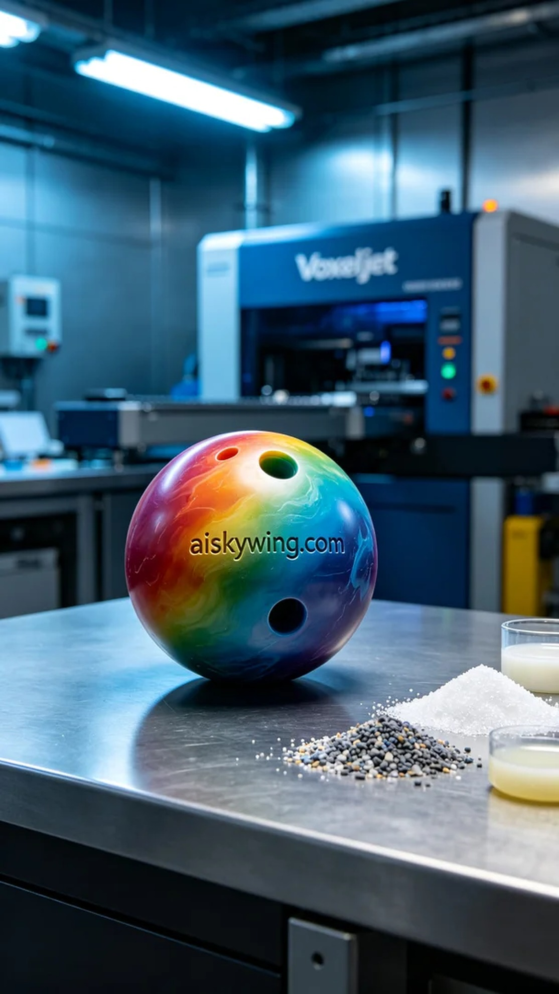
Aiskywing Industrial 3D Printing
Full-color 3D printed bowling ball model


