0764-全彩3D打印四叶草模型生产记录
Full-color 3D printed four-leaf clover model
🖨️ 全彩3DP
🖥️ 打印机: Stratasys
📦 材料: 全彩3DP
生活再难，也别停下脚步。就像接这个全彩3D打印四叶草模型的单子，有人希望能在产品发布会上展示它的独特魅力。
No matter how difficult life gets, don't stop moving forward. Just like taking on this order for a full-color 3D printed four-leaf clover model, someone hopes to showcase its unique charm at the product launch.
________________________________________________________________________________
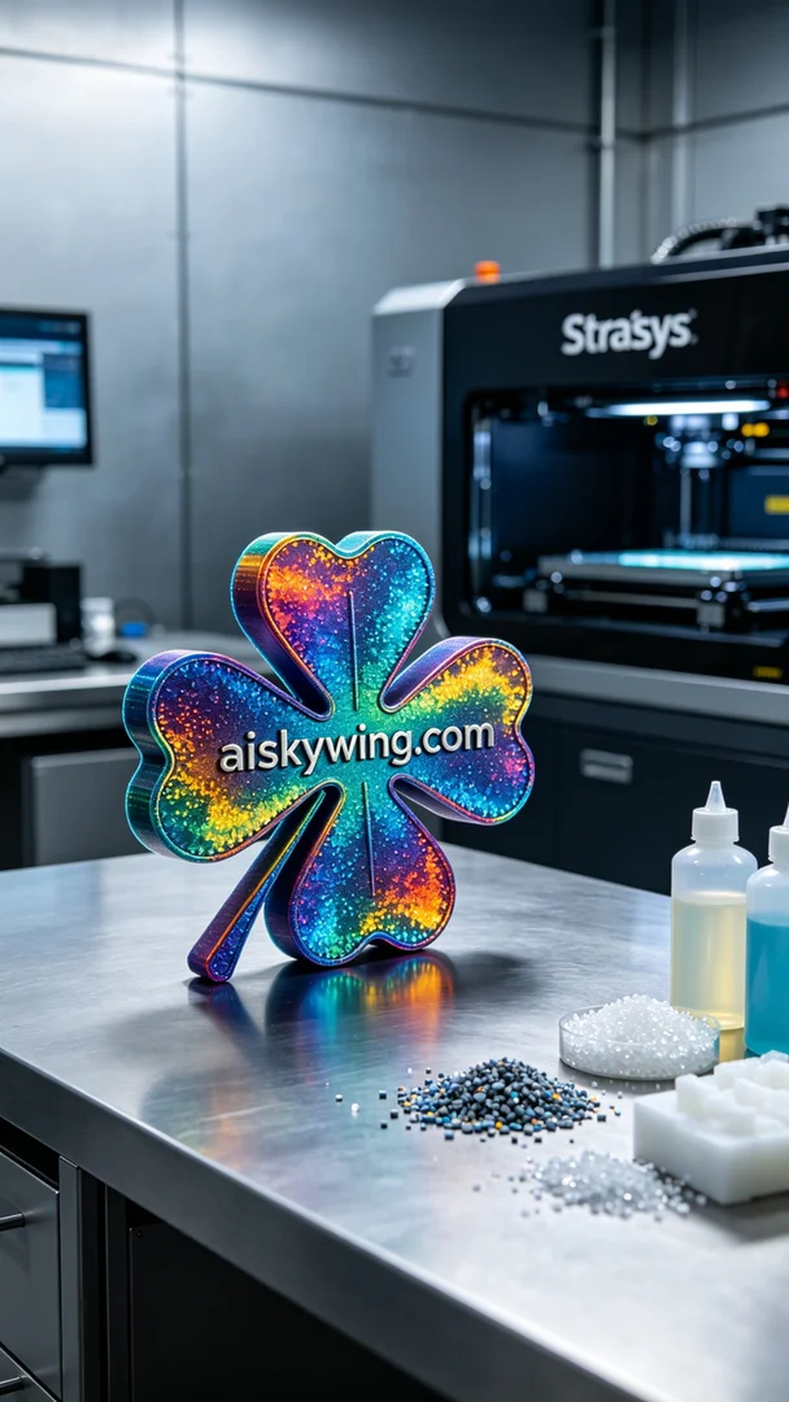
Someone contacted me via WhatsApp to inquire about the production of a full-color 3D printed clover model. They wanted to showcase this model at an upcoming exhibition, but their requirements for detail and quality were exceptionally high. Thus, we began preparing for this task.
We chose full-color 3DP as the material for this project, known for its rich colors and realism. To ensure optimal printing results, we used a Stratasys 3D printer, setting the layer thickness to 0.1mm, print temperature to 60℃, power at 80W, print speed to 30mm/s, with an estimated print time of 6 hours.
During the printing process, the machine operated smoothly as we carefully monitored the quality of each layer to ensure the color gradients and detail presentation met expectations. As the print progressed, the shape of the clover began to take form, and the high-definition colored textures started to emerge, appearing especially profound under industrial lighting.
Once printing was complete, we moved on to post-processing. First, we used a specialized cleaning solution to wash the model, removing any residual resin from the surface. Next, we sanded it with fine sandpaper to ensure every detail was smooth and pristine, followed by a curing process to enhance the durability of the model. After a rigorous inspection, the clover model finally presented itself to us, vibrant and full of life.
The production of this full-color 3D printed clover model not only met the demands but also allowed us to gain new experiences throughout the process. We look forward to seeing it shine at the exhibition.
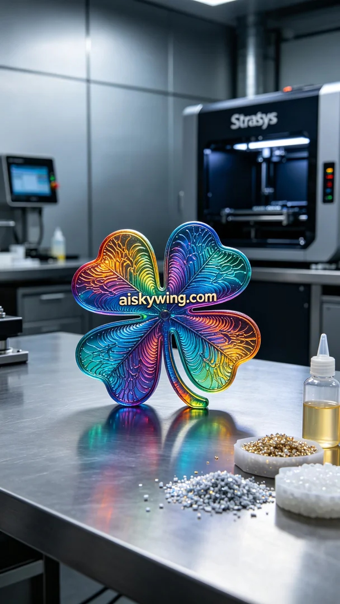
有人通过WhatsApp联系我，咨询全彩3D打印四叶草模型的生产问题。他们想要在即将到来的展会上展示这一模型，但对细节和质量要求非常高。因此，我们开始准备这一任务。
我们选择了全彩3DP作为制作材料，这种材料的色彩丰富性和逼真度都非常出色。为了确保打印效果，我们使用Stratasys品牌的3D打印机，设置了层厚0.1mm，打印温度为60℃，功率设定为80W，打印速度为30mm/s，估计打印时间需6小时。
打印过程中，设备运行平稳，我们仔细监控每一层的质量，确保颜色渐变和细节呈现符合预期。随着打印的推进，四叶草的形状开始逐渐清晰，高清彩色纹理也在渐渐显现，工业光线下显得格外深邃。
完成打印后，我们进行了后处理。首先，使用专用清洗液对模型进行清洗，去除表面残留的树脂。接着，用细砂纸进行打磨，确保每个细节都光滑如新，最后进行固化处理，确保模型的耐用性。经过严格的检验后，这款四叶草模型终于呈现在我们面前，色彩鲜明而有生气。
这次全彩3D打印四叶草模型的生产，不仅满足了需求，还让我们在过程中收获了新的经验，期待它在展会上大放异彩。
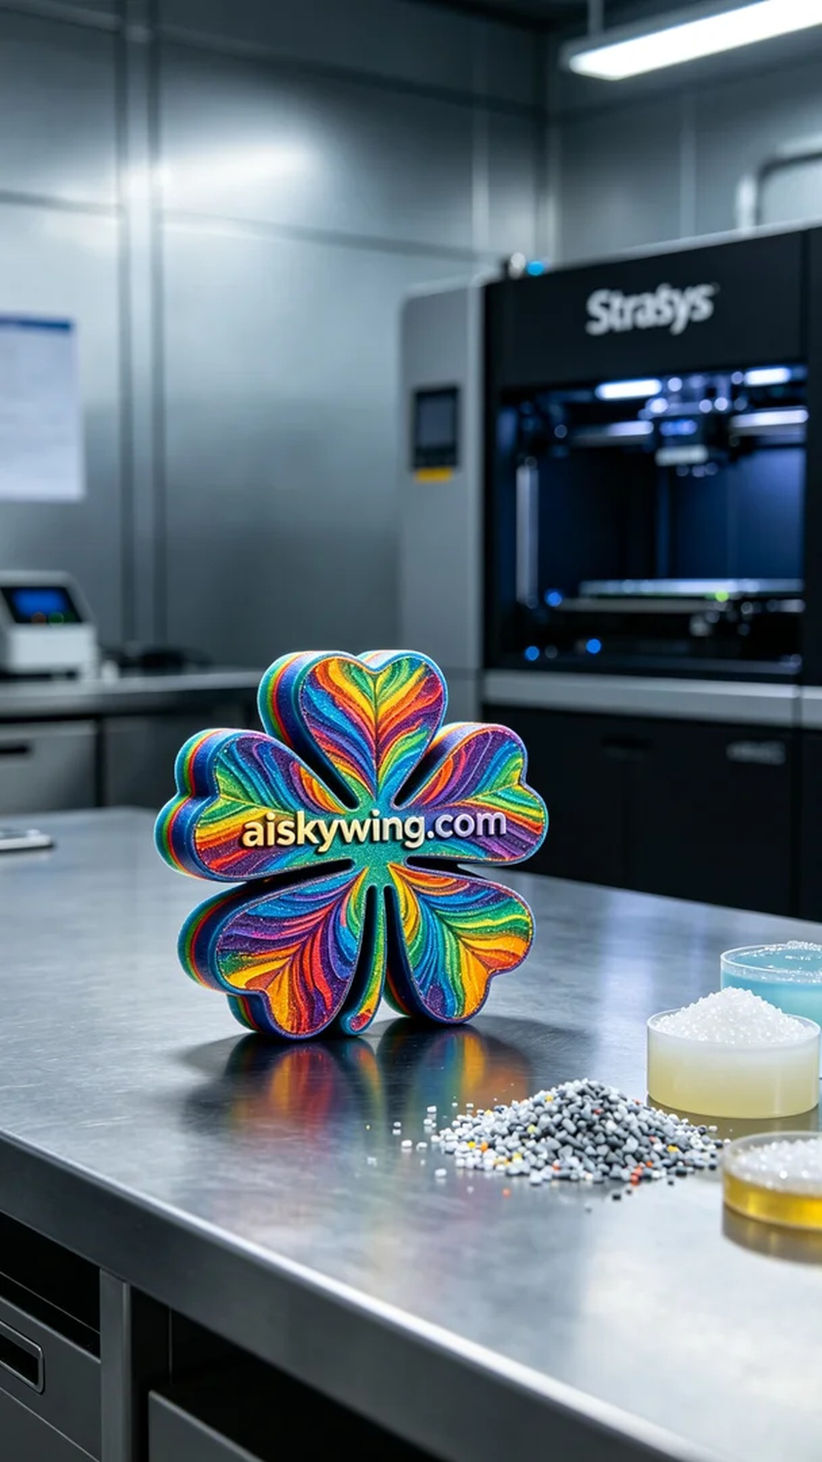
Aiskywing Industrial 3D Printing
Full-color 3D printed four-leaf clover model


