0766-全彩3D打印大熊猫模型生产记录
Full-color 3D printed giant panda model
🖨️ 全彩3DP
🖥️ 打印机: Xjet
📦 材料: 摆放着未成型的液态光敏
生活就像打印过程中的每一步，得耐心也得用心。就像有人在Facebook上找到我们，希望我们能制作这个全彩3D打印大熊猫模型。
Life is like every step in the printing process; it requires both patience and care. Just like someone found us on Facebook, hoping we could create this full-color 3D printed panda model.
________________________________________________________________________________
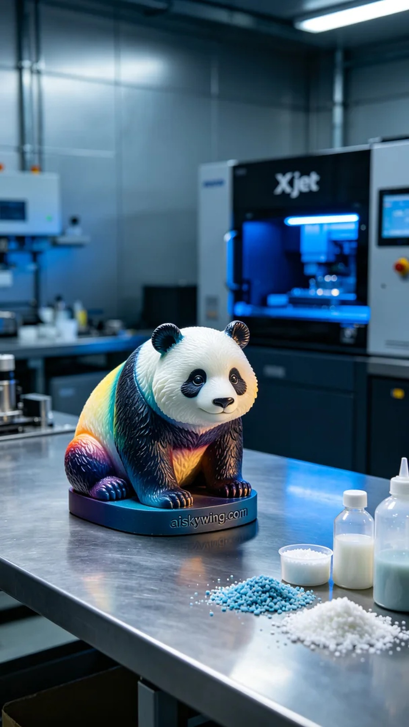
Life is like every step of the printing process; it requires patience and dedication. Someone found us on Facebook, hoping we could create this colorful 3D printed panda model.
We chose to use liquid photo-sensitive resin as our raw material, renowned for its excellent fluidity and high resolution that can reproduce fine details. For optimal results, we utilized the Xjet printer, setting a layer thickness of 0.1 mm, maintaining a temperature of 25 degrees Celsius, with a power setting of 80% and a print speed of 50 mm per hour, estimated to take around 12 hours to complete.
During the printing process, the Xjet machine operated smoothly, allowing for meticulous monitoring to ensure the quality of each layer. We kept a close eye on the printer's status, ensuring that no details were missed. The color gradients and details became remarkably vivid thanks to the photo-sensitive resin, making the panda model appear increasingly lifelike.
Once printing was complete, the model required a series of post-processing steps. First, it was cleaned in a solvent to remove any excess resin. After that, sanding was performed to ensure a smooth and flawless surface, followed by a curing process to enhance the model's hardness and durability. After rigorous inspection, the model was finally presented in its optimal form.
All the effort culminated in the success of this colorful 3D printed panda model; it is not just a model, but a testament to our dedication to craftsmanship and love for nature.
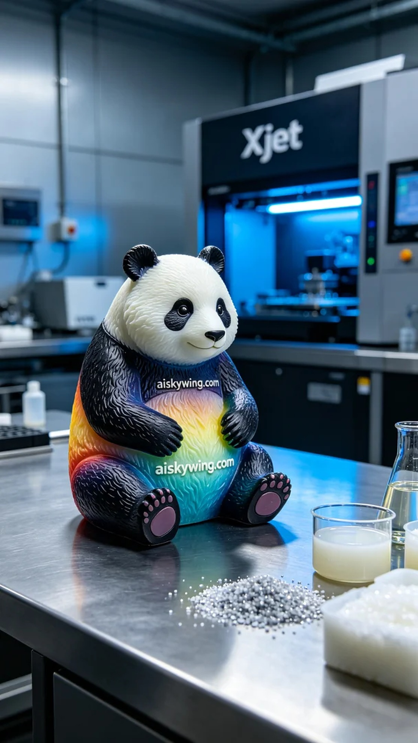
在社交平台Facebook上，有人因为想要一款栩栩如生的大熊猫模型而找到了我们。他希望这个全彩3D打印大熊猫模型不仅能展现细腻的色彩渐变，还能有真实的质感。这不仅是个模型，更是对大自然的致敬。
我们选择使用未成型的液态光敏树脂作为原材料，具有优异的流动性和高解析度，能够尽可能还原每一个细节。为了确保打印效果，我们使用Xjet打印机，设置层厚为0.1毫米，温度保持在25摄氏度，打印功率设为80%，速度调整为每小时50毫米，预计打印时间为12小时。
打印过程中，Xjet设备稳定运行，细致的监控确保了每一层的质量。我们时刻关注打印机的状态，确保无任何遗漏。颜色的渐变和细节在光敏树脂的作用下变得异常生动，使得这个大熊猫模型愈加真实。
完成打印后，模型需要经过一系列后处理工序。首先，将其放入清洗液中清洗，以去除多余的树脂。随后，进行打磨，确保表面光滑无瑕疵，最后进行固化处理，以增强模型的硬度和耐用性。经过严格检验后，这款模型终于完美呈现。
这一切的付出最终都化为了这个全彩3D打印大熊猫模型的成功，它不仅仅是个模型，更是我们心血的结晶，承载着对工艺和自然的热爱。
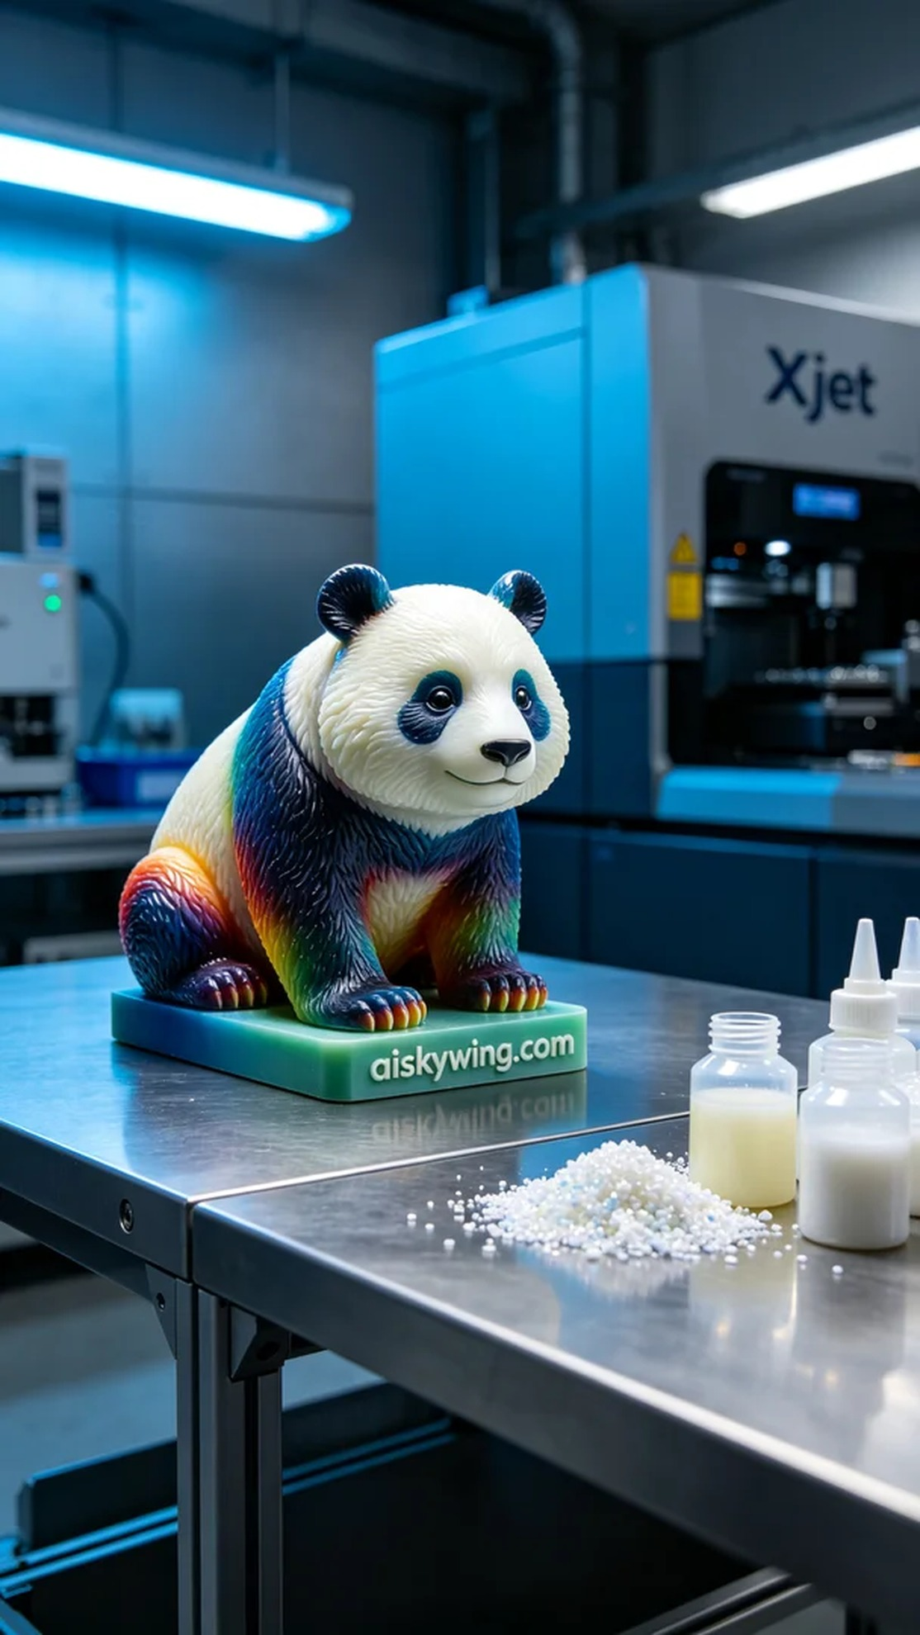
Aiskywing Industrial 3D Printing
Full-color 3D printed giant panda model


