0779-冲击钻手柄的3D打印记录
Impact drill handle
🖨️ SLS尼龙烧结
🖥️ 打印机: Rize
📦 材料: 摆放着未成型的液态光敏
在Instagram上，有人因为对工具的要求太高而找上我们。冲击钻手柄的制作，让我再次感受到技术与创造的激情。
On Instagram, someone reached out to us because their demands for the tools were too high. The production of the impact drill handle made me feel the passion for technology and creativity once again.
________________________________________________________________________________
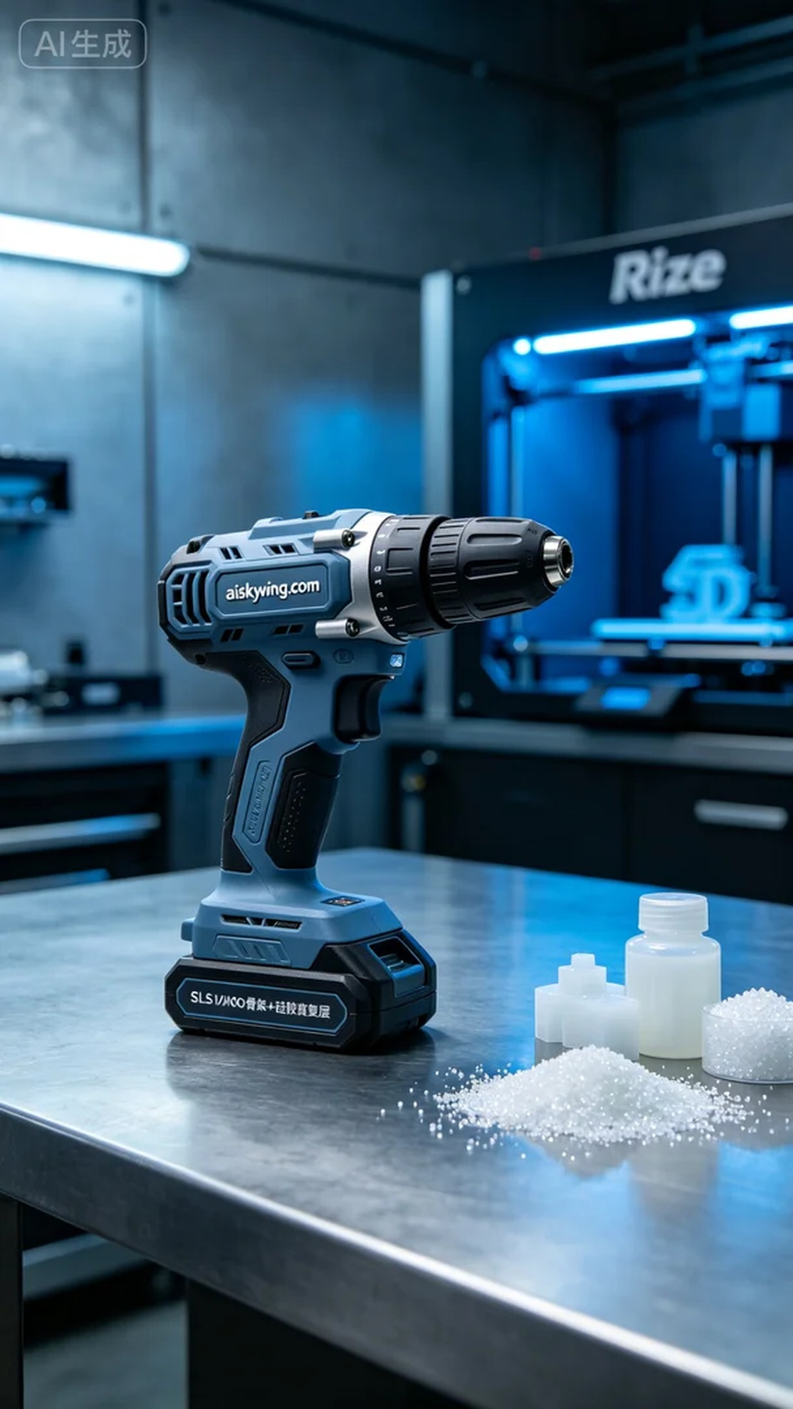
This project of creating a impact drill handle began when someone reached out to us on Instagram, expressing their need for higher quality tools. They hoped we could achieve perfection in both print quality and functionality to meet their daily operational needs.
To ensure an optimal printing outcome, we chose unformed liquid photopolymer resin as our raw material and detailed the parameter settings. Using the Rize printer, we set the layer thickness to 0.1 mm, maintained the printing temperature at 25 degrees Celsius, set the power to 80 watts, and the print speed to 60 mm per second. All parameters were carefully adjusted to ensure perfect adhesion of each layer, achieving the required precision biomimetic structure.
As the printing process began, the Rize printer operated smoothly. We continually monitored the progress to ensure every detail was accurately represented. The cold-toned ambient light illuminated the entire printing area, creating a tech-inspired atmosphere aimed at achieving the impact drill handle design that combines rigidity and flexibility.
Once printing was completed, we moved on to the post-processing stage. First, we thoroughly washed the printed piece using water and a specialized cleaning agent to remove any residual materials from the surface. Next, we performed hand sanding to eliminate any sharp edges. Finally, we placed it in a curing device for solidification, ensuring material stability and strength, followed by strict inspection to ensure every detail met standards.
After a series of complex and meticulous processes, the impact drill handle was finally completed. Every step reflected our dedication and professionalism, and we hope this piece shines in practical use.
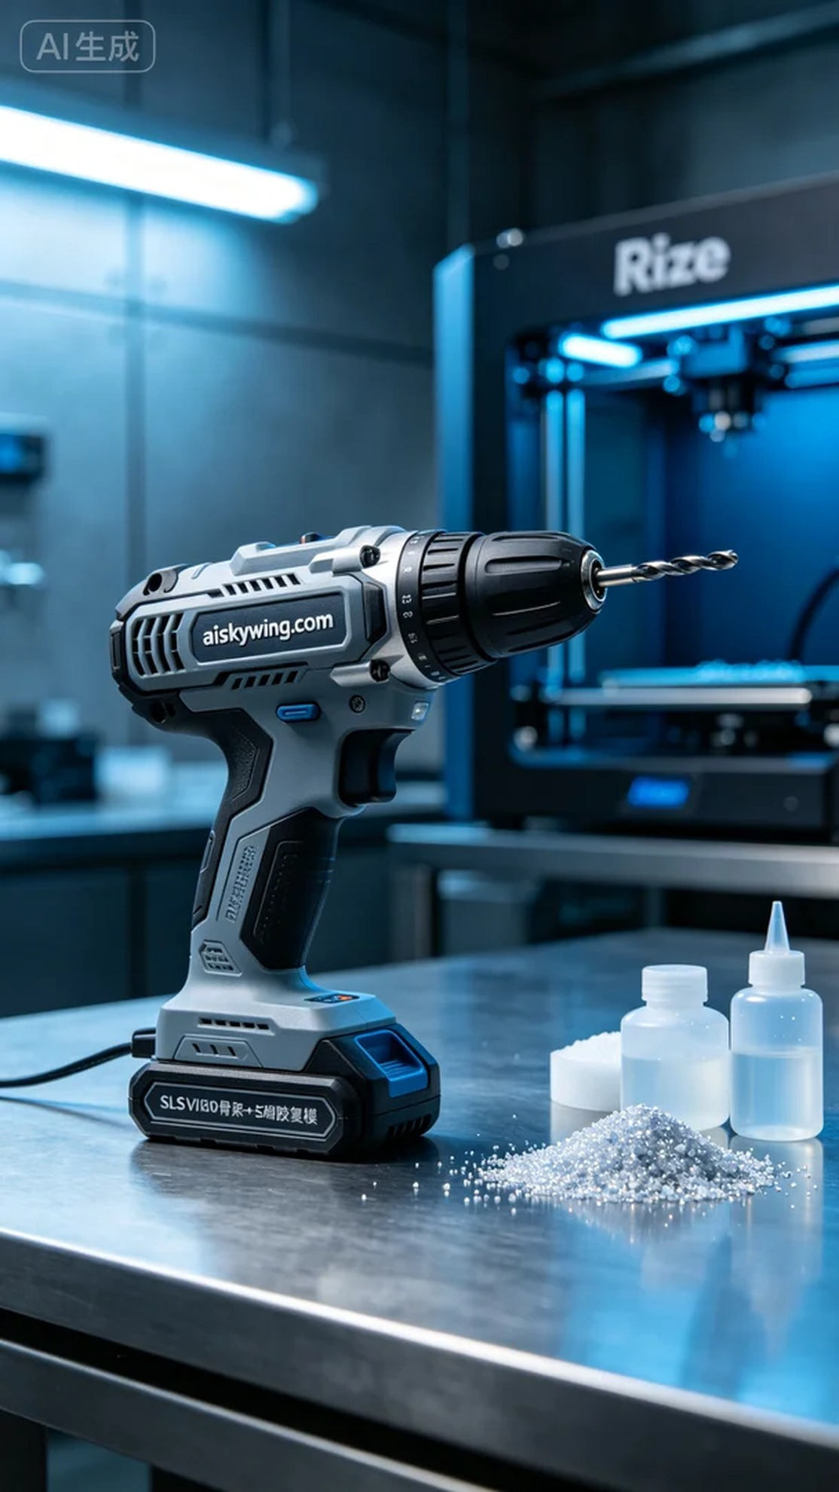
制作冲击钻手柄的这个项目，有人因为需要更高效、耐用的工具而联系我们。他们希望我们能够在打印质量和功能性上达到完美，以满足日常作业的需求。
为了确保完美的打印效果，我们选择了未成型的液态光敏树脂作为原材料，并进行了详细的参数设置。使用Rize打印机，层厚设定为0.1毫米，打印温度保持在25摄氏度，功率设定为80瓦，打印速度为60毫米每秒。所有参数都经过细致调整，以确保每一层的完美结合，达到精密仿生结构的要求。
打印过程开始后，Rize打印机的运转十分顺利。我们时刻观察打印进程，确保每个细节都能精准展现。设备在工作时，冷色调的氛围灯照亮了整个打印区，给人一种科技感十足的氛围，努力实现既有刚性又有柔性的冲击钻手柄设计。
打印完成后，我们进入了后处理阶段。首先用清水和专用清洗剂对打印件进行彻底清洗，去除表面的残留物。接着，我们进行了手工打磨，以去掉可能存在的尖锐边缘。最后将其放入固化设备中进行固化处理，确保材料的稳定性和强度，最后进行了严格的检验，确认每个细节都符合标准。
经过一系列复杂而细致的流程，冲击钻手柄终于顺利完成。每个环节都体现了我们的坚持和专业，希望这件作品能在实际使用中大放异彩。
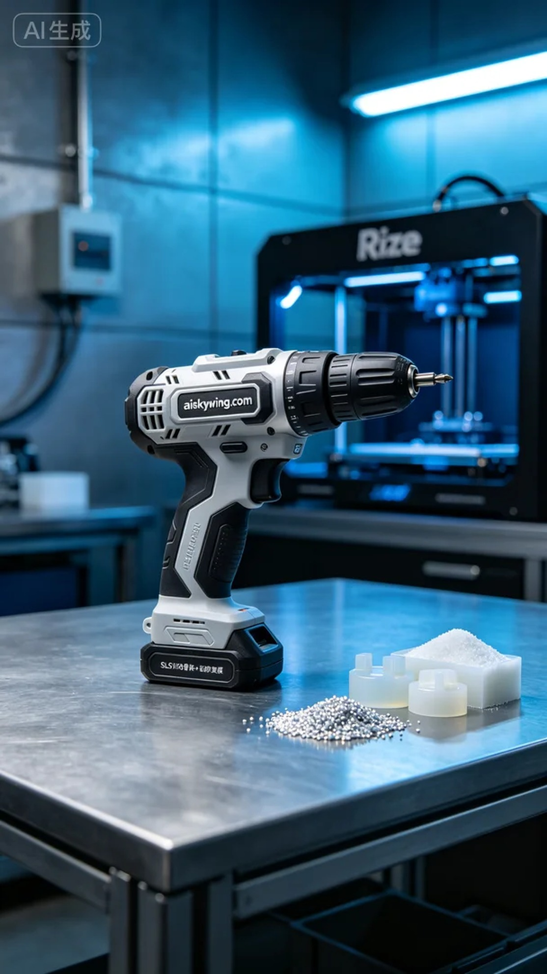
Aiskywing Industrial 3D Printing
Impact drill handle


