0781-凿手柄生产记录
Chisel handle
🖨️ SLA光固化
🖥️ 打印机: Systems
📦 材料: SLA
生活总会给我们带来挑战，就像这个凿手柄置于画面正中央的项目，听说有人因为工艺要求找上了我们，我们感受到其中的责任与期待。
Life will always present us with challenges, just like this project with the chisel handle placed right in the center of the picture. I heard that someone reached out to us due to the craftsmanship requirements, and we feel the responsibility and anticipation that come with it.
________________________________________________________________________________
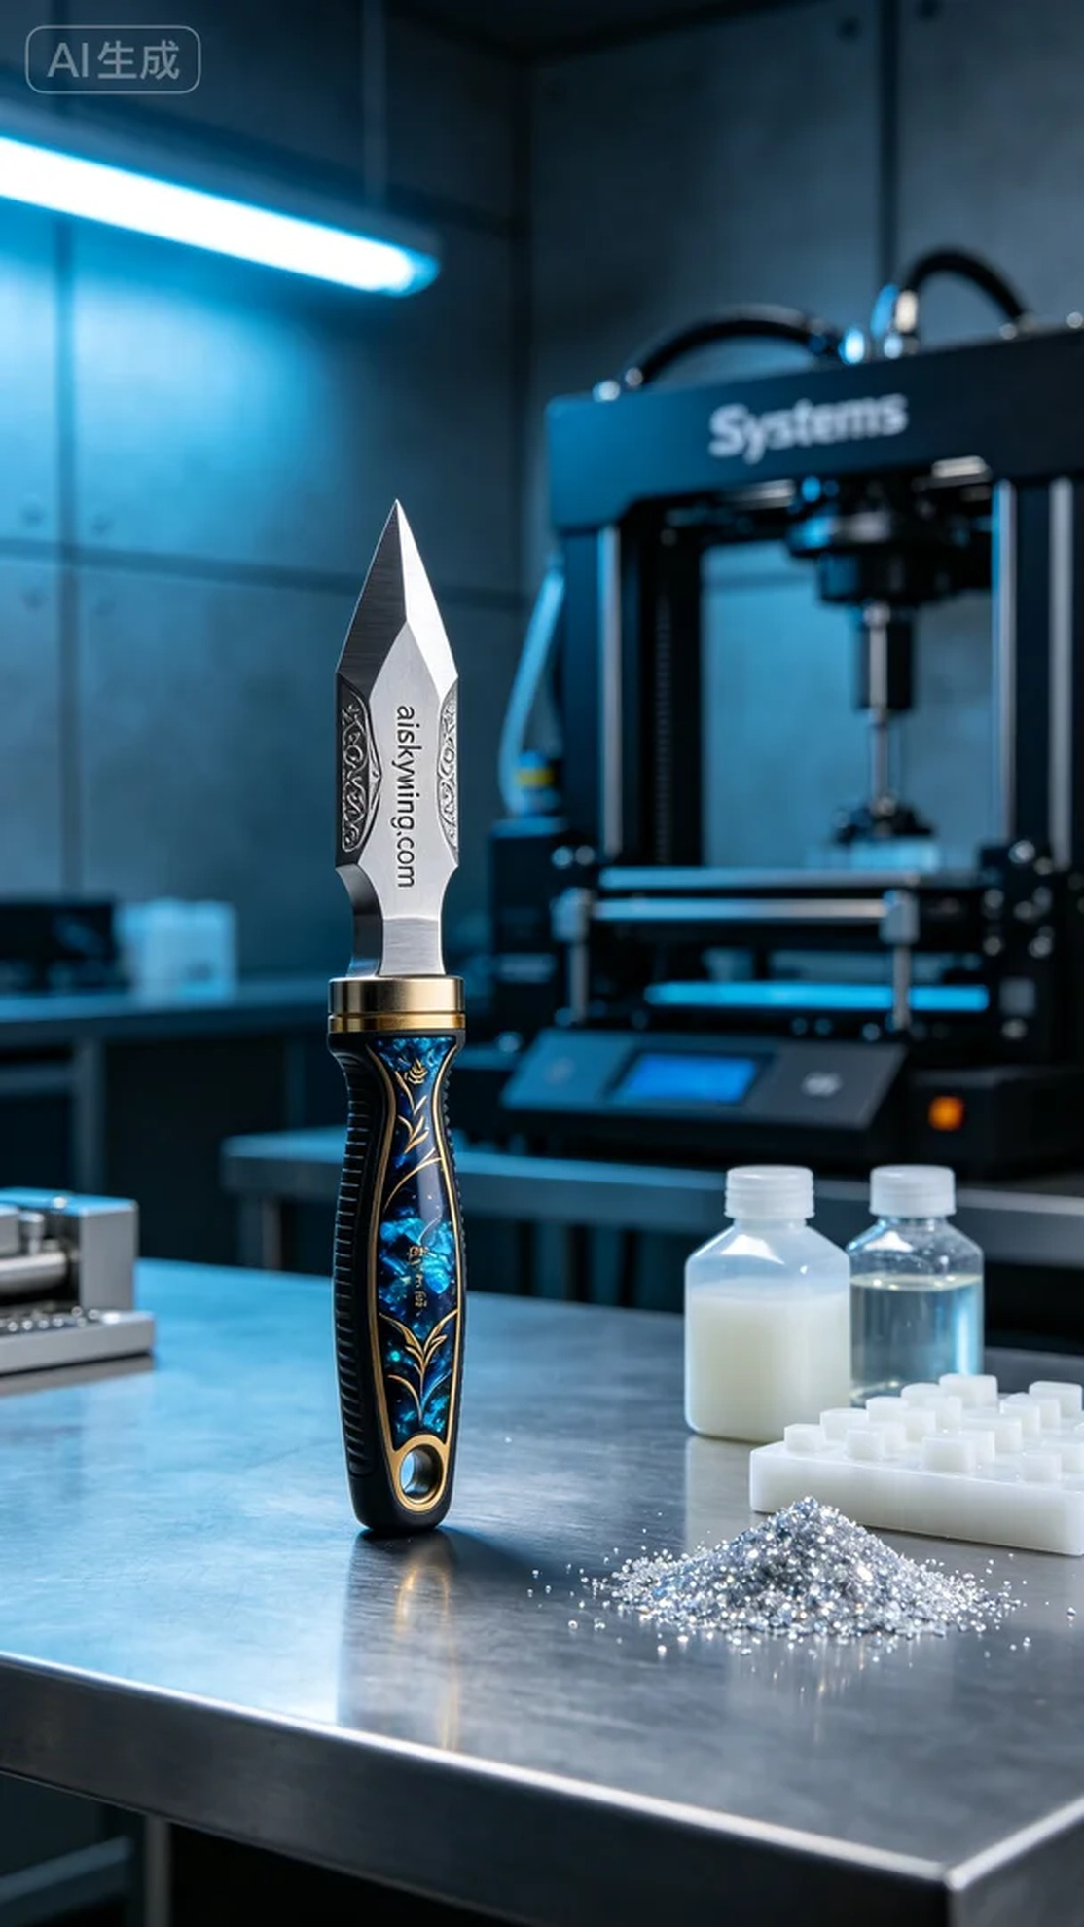
This project came to us through WhatsApp, where someone expressed an urgent need for a customized chisel handle. They had specific requirements regarding surface treatment and intricate details, and we quickly sprang into action to meet their expectations.
The material we chose was SLA photopolymer resin, which excels in printing quality and allows for personalized surface effects. We utilized a Systems brand 3D printer, setting the layer thickness to 0.05mm, maintaining a printing temperature of 20 degrees Celsius, setting the power to 50%, and controlling the printing speed at 30mm/s, with an estimated printing time of approximately 2 hours.
As the printing commenced, the machine operated smoothly, and we monitored the quality in real-time. Each layer’s photopolymerization was effective, showcasing the intricate carvings and text clearly, ensuring high-quality results. We continuously adjusted the printing parameters to accommodate different detail requirements, striving for perfection in every aspect.
After printing, we carried out a series of post-processing steps. First, we cleaned the handle using an ultrasonic cleaner to remove any residual photopolymer resin, followed by sanding the surface with fine-grit sandpaper to ensure a smooth touch. Next, we placed the chisel handle in a UV curing machine to ensure its strength and durability met standards. Finally, after rigorous inspection, we confirmed every piece was flawless and ready for delivery.
After all these processes, the chisel handle exceeded our expectations in precision and showcased a stark industrial aesthetic. This production experience once again highlighted the charm of 3D printing.
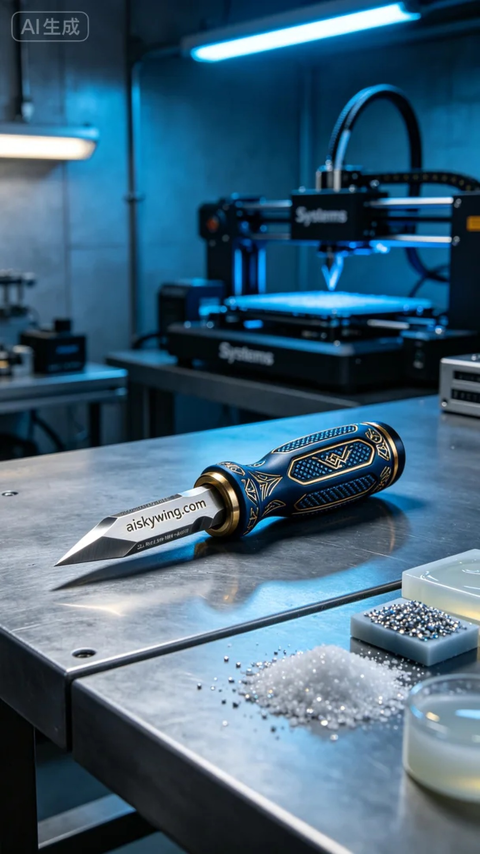
这次的项目是通过WhatsApp联系到我们的，听说有人对凿手柄的定制化需求很急，尤其是对表面处理和细节雕刻的要求。我们立刻着手准备，确保能第一时间满足他们的需求。
选择的材料是SLA光敏树脂，这种材料在打印过程中表现出色，既具备良好的细节还原能力，又能实现个性化的表面效果。我们使用的设备是Systems品牌的3D打印机，设置了层厚0.05mm，打印温度保持在20摄氏度，功率设定为50%，打印速度控制在30mm/s，预计打印时间约为2小时。
打印开始后，机器稳定运行，整个过程顺利，配合监控系统，我们实时跟踪打印质量。每层的光固化效果都很好，细致的雕刻和字样都显现得淋漓尽致，确保了产品的高品质。我们不断调整打印参数，以适应不同的细节需求，确保每一处都尽善尽美。
在打印完成后，我们进行了一系列后处理工序。首先进行清洗，使用超声波清洗器去除残留的光敏树脂，然后用细砂纸打磨表面，确保触感光滑。接着，我们将凿手柄放入UV固化机中进行固化，确保其强度和耐用性达到标准。最后，经过严格的检验，确认每个产品都没有瑕疵后，准备交付。
经过这一系列工序，凿手柄不仅在精度上超出了预期，整体效果也呈现出一种冷峻的工业美感，让人对它的使用充满期待。这次的生产经历，让我们再次感受到了3D打印的魅力。
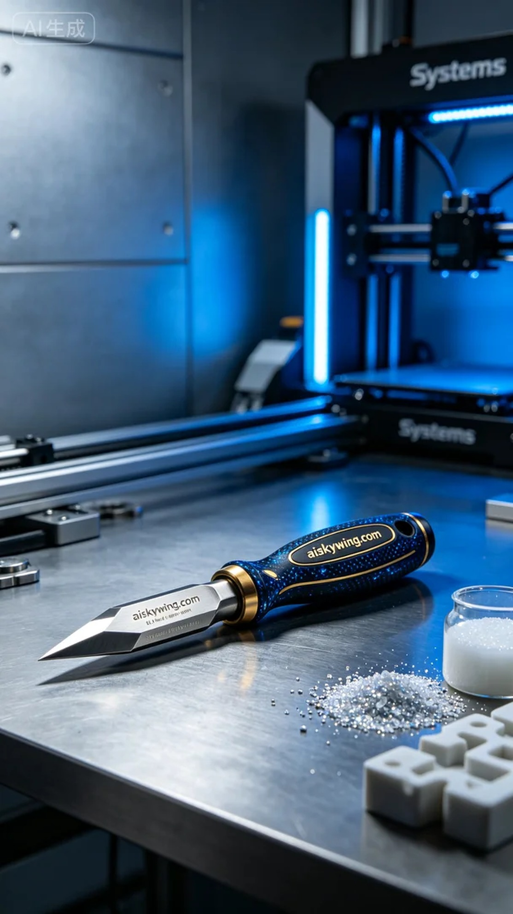
Aiskywing Industrial 3D Printing
Chisel handle


