0782-刮刀手柄的3D打印生产记录
Scraper handle
🖨️ SLS尼龙烧结
🖥️ 打印机: Voxeljet
📦 材料: 摆放着未成型的液态光敏
生活再难，也别停下脚步。就像接下这个刮刀手柄置于画面正中央的单子，有人因为寻找合适的生产方式而联系我，通过WhatsApp询问我们能提供什么解决方案。
No matter how difficult life gets, don't stop moving forward. Just like this order for a scraper handle placed right in the center of the picture, someone reached out to me through WhatsApp, inquiring about the solutions we can provide while searching for the right production method.
________________________________________________________________________________
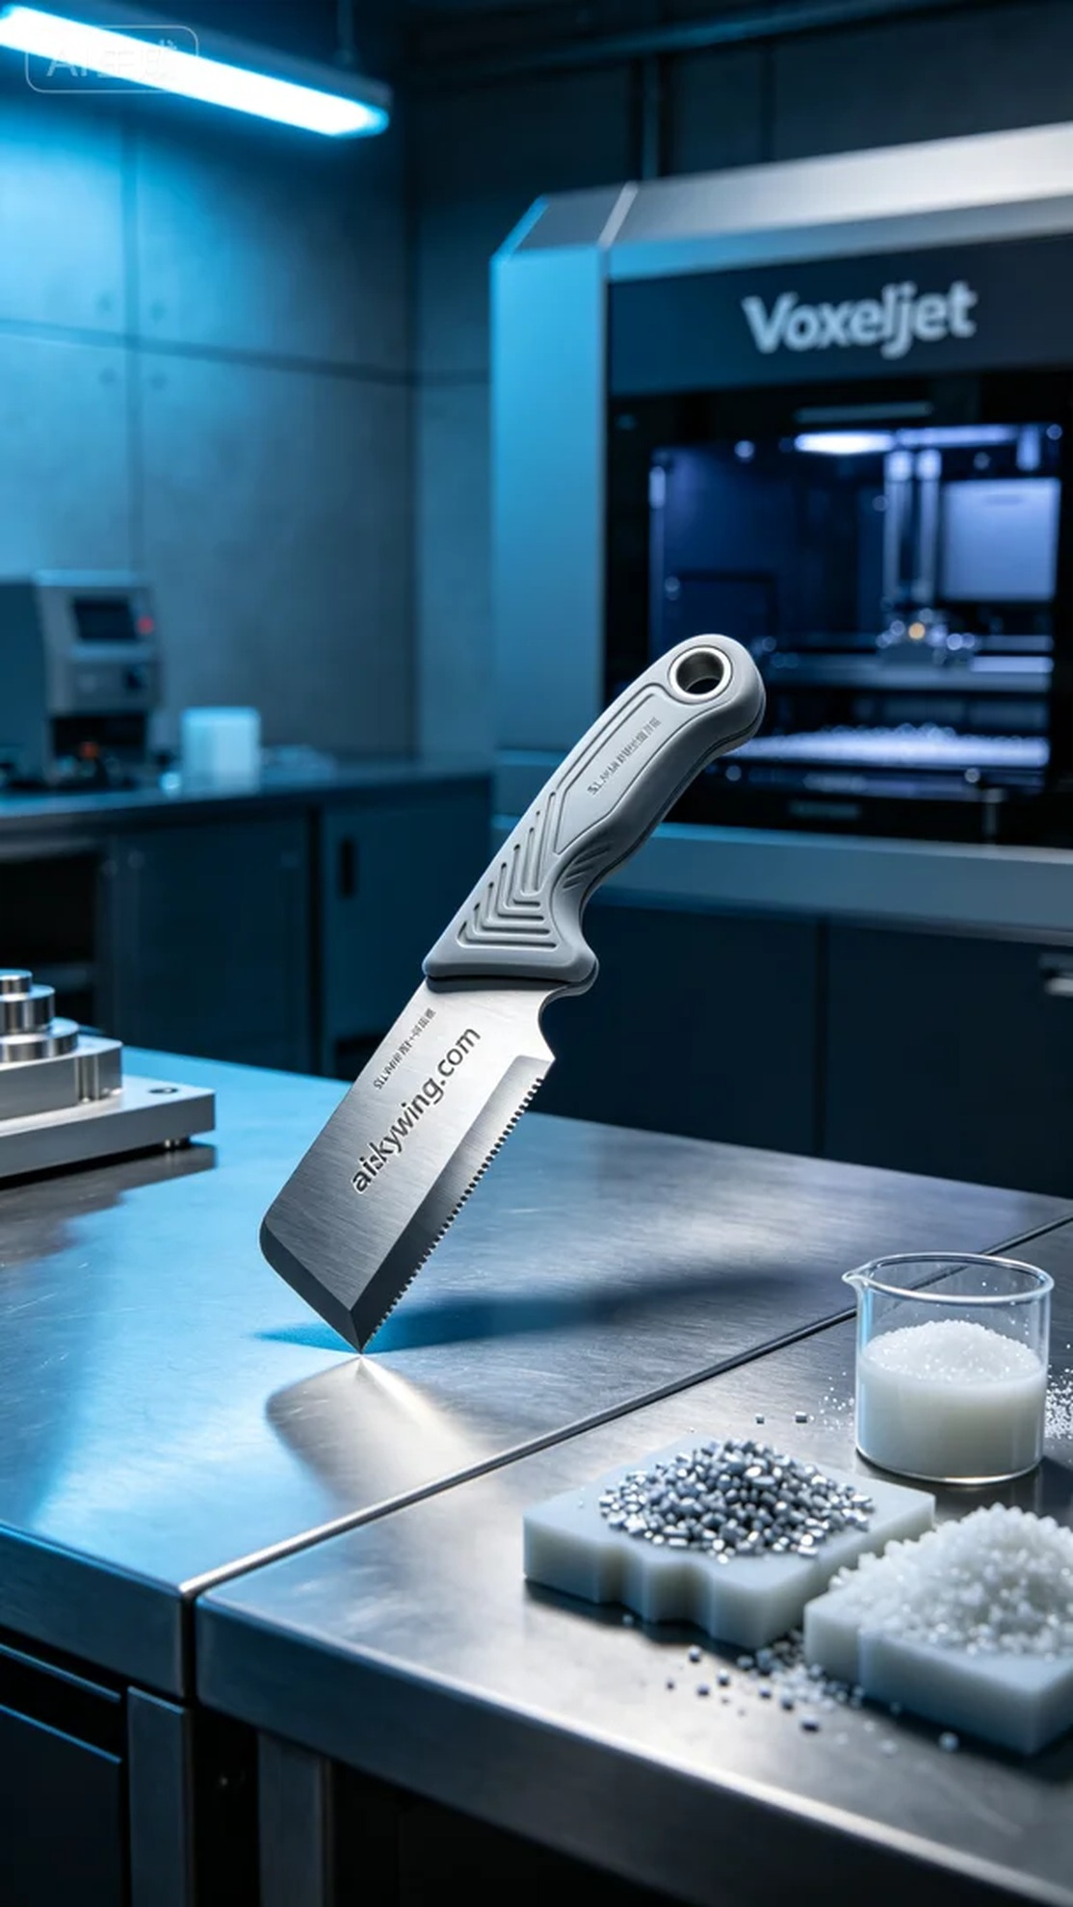
Life can be tough, but we should never stop moving forward. Just like when I took on the task of creating the scraper handle placed at the center of the frame. Someone reached out to me via WhatsApp, seeking a suitable production method.
Through our conversation, I learned they needed a scraper handle that was precise, durable, and comfortable to use. After discussing their needs, we decided to use the SLS nylon sintering process to ensure high quality and functionality for their product.
We chose to use unformed liquid photopolymer resin as the raw material, which would ensure excellent detail in the printed scraper handle. We utilized a Voxeljet printer, setting the layer thickness to 0.1 mm, controlling the temperature at 180 degrees Celsius, with printing power at 80% and speed adjusted to 60 mm per second. The estimated printing time was around 5 hours, allowing for precise reproduction of every detail.
During the printing process, the equipment ran smoothly, and we conducted continuous quality monitoring to ensure each layer was evenly laid down. We kept a close eye on the printing progress, adjusting parameters promptly to prevent any quality issues. Ultimately, the printed scraper handle had a smooth surface, with the engraved "aiskywing.com" clearly visible, showcasing a precise biomimetic structure.
The post-processing stage was crucial. We began by cleaning the printed parts to remove any excess resin, followed by sanding to ensure a flawless finish. Next, we cured them using UV light to enhance the strength and durability of the material. Finally, each part underwent rigorous inspection to ensure they met our production standards.
After this detailed process, the final scraper handle not only looked outstanding but also provided an extremely comfortable user experience. This production journey reminded me once again that focus and persistence can always lead to satisfying results.
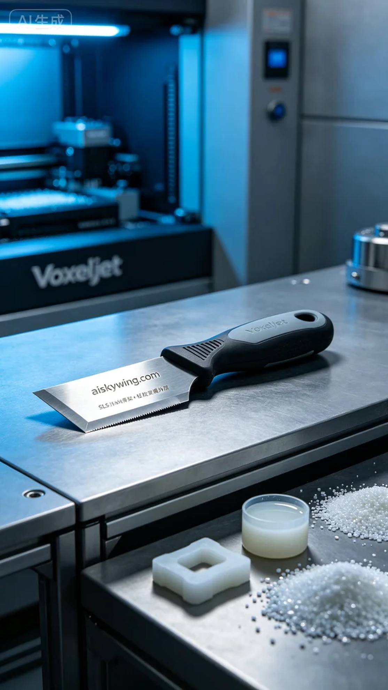
在和这位朋友的交流中，了解到他们急需一款刮刀手柄，这个产品需要精密、耐用且具备良好的手感。经过讨论，我们决定采用SLS尼龙烧结工艺来满足他们的要求，确保产品的质量和功能。
我们选用摆放着未成型的液态光敏作为原材料，确保打印出的刮刀手柄具有良好的细节表现。使用的是Voxeljet品牌的打印机，设定层厚为0.1毫米，温度控制在180摄氏度，打印功率设置为80%，速度调整为60毫米每秒。打印时间大约预计为5小时，确保每一个细节都能精确还原。
在打印过程中，设备运行得相当稳定，经过持续的质量监控，确保每一层都能均匀铺展。我们随时观察打印进度，及时发现并调整参数，以防止出现任何质量问题。最终，打印出来的刮刀手柄表面光滑，雕刻的“aiskywing.com”字样清晰可见，展现出精密的仿生结构。
后处理阶段十分关键，我们首先将打印出的部件进行清洗，去除多余的树脂，然后进行打磨，确保表面平整无瑕。接着，我们对其进行固化处理，通过UV灯照射，增强材料的强度和耐久性。最后，每个部件都经过严格的检验，确保符合出厂标准。
经过这一系列的精细打磨与处理，最终的刮刀手柄不但外观出众，使用体验也非常舒适。这次生产过程让我再次感受到，专注与坚持总能创造出令人满意的成果。
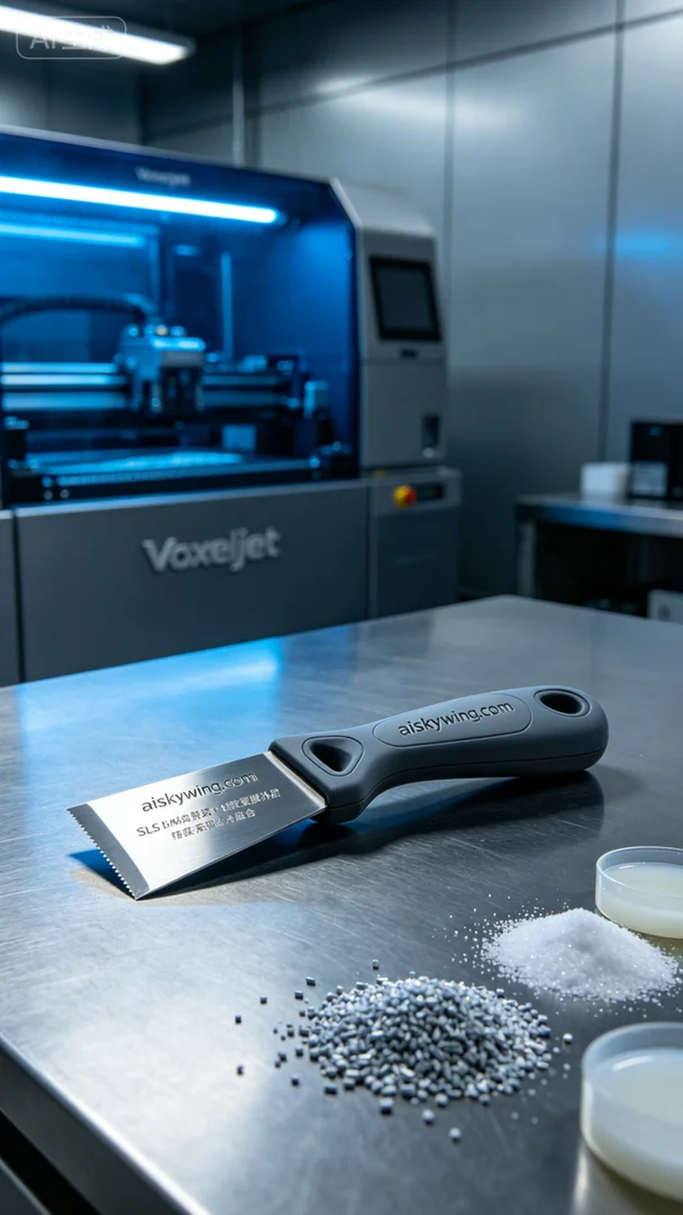
Aiskywing Industrial 3D Printing
Scraper handle


