0783-精密刷手柄的3D打印记录
Brush handle
🖨️ SLA光固化
🖥️ 打印机: Stratasys
📦 材料: SLA
生活就像3D打印，耐心与细致才能成就完美。这次有人向我们求助，想要制作一款刷手柄，挑战在于如何做到极致的清晰锐利。
Life is like 3D printing; patience and attention to detail are essential to achieving perfection. This time, someone has sought our help to create a brush handle, and the challenge lies in how to achieve an extreme level of clarity and sharpness.
________________________________________________________________________________
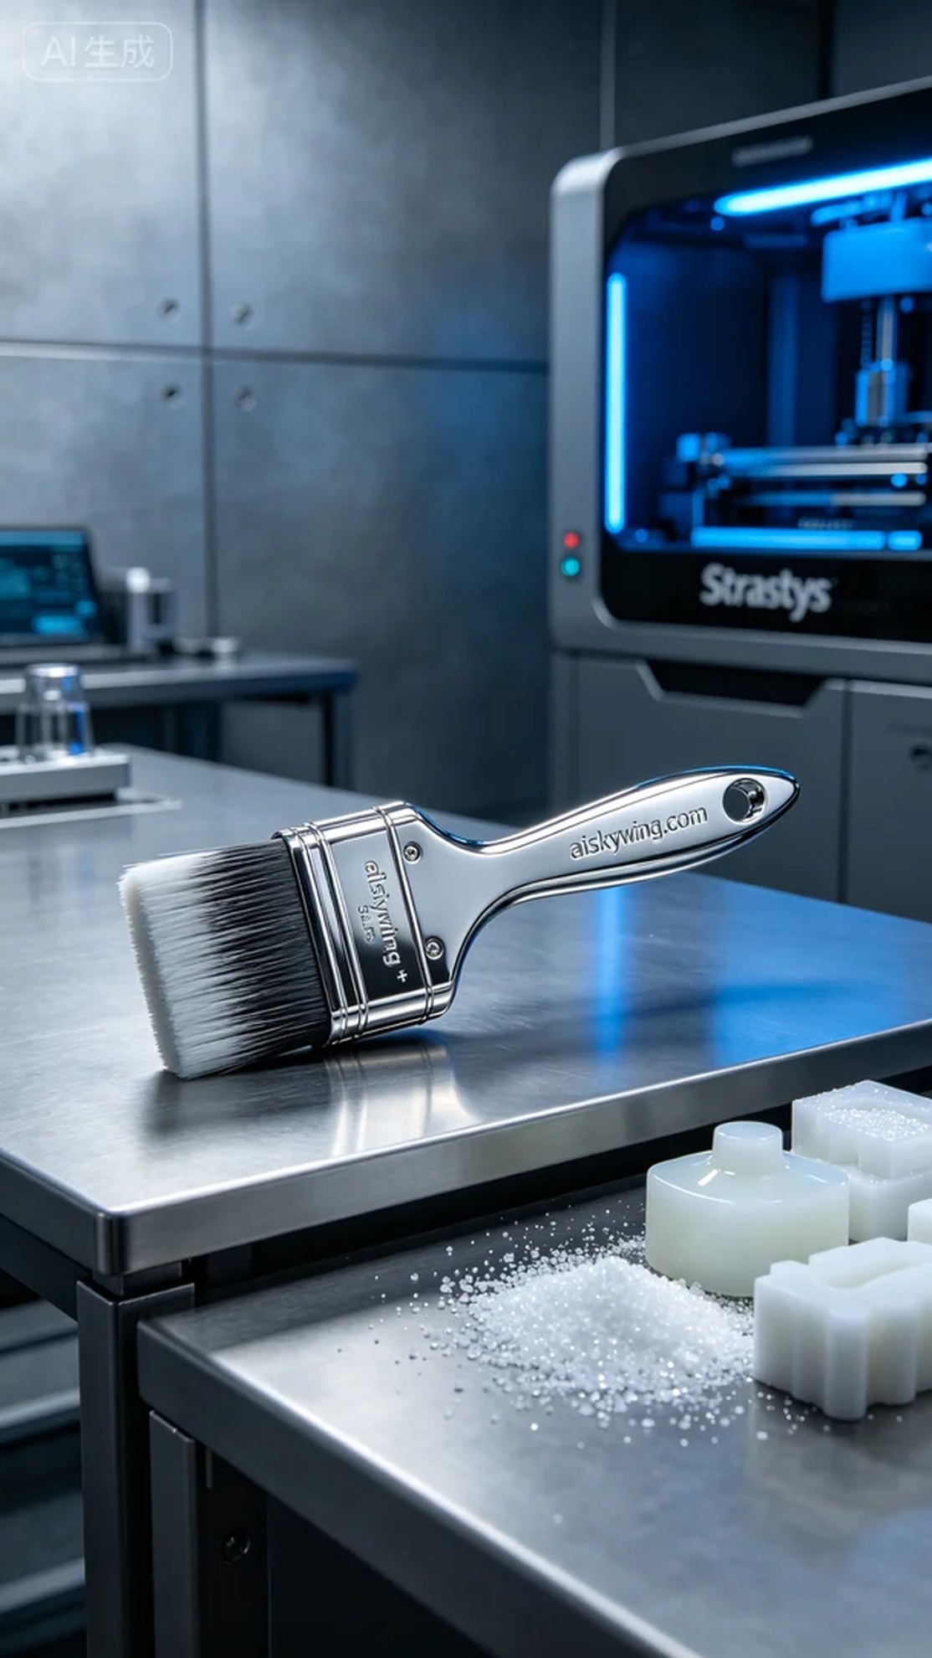
Life is like 3D printing; patience and attention to detail can achieve perfection. Recently, someone approached us looking to create a brush handle, with the challenge being to achieve extreme clarity and sharpness.
We utilized SLA photopolymer resin as the material, known for its excellent fluidity and high precision. After careful consideration, we opted for the Stratasys printer to execute the print. We set the layer thickness to 0.05mm, printing temperature at 25°C, power at 70%, printing speed at 40mm/s, with an estimated print time of 8 hours.
During the printing process, the Stratasys printer operated steadily, with the liquid photopolymer resin curing layer by layer. We maintained constant quality monitoring of the equipment to ensure no bubbles or impurities appeared during printing, while closely observing the details of each layer to meet high standards.
Upon completion, we carried out meticulous post-processing. First, we cleaned the finished product with isopropyl alcohol to remove any uncured resin from the surface. Then, we sanded with fine-grit sandpaper to achieve a smoother finish, followed by UV curing to ensure the strength met requirements. After multiple inspections and confirmations, we successfully completed the production of the brush handle.
Through this project, we transformed design concepts into a tangible product, proving that with dedication, we can master every detail and achieve ideal results.
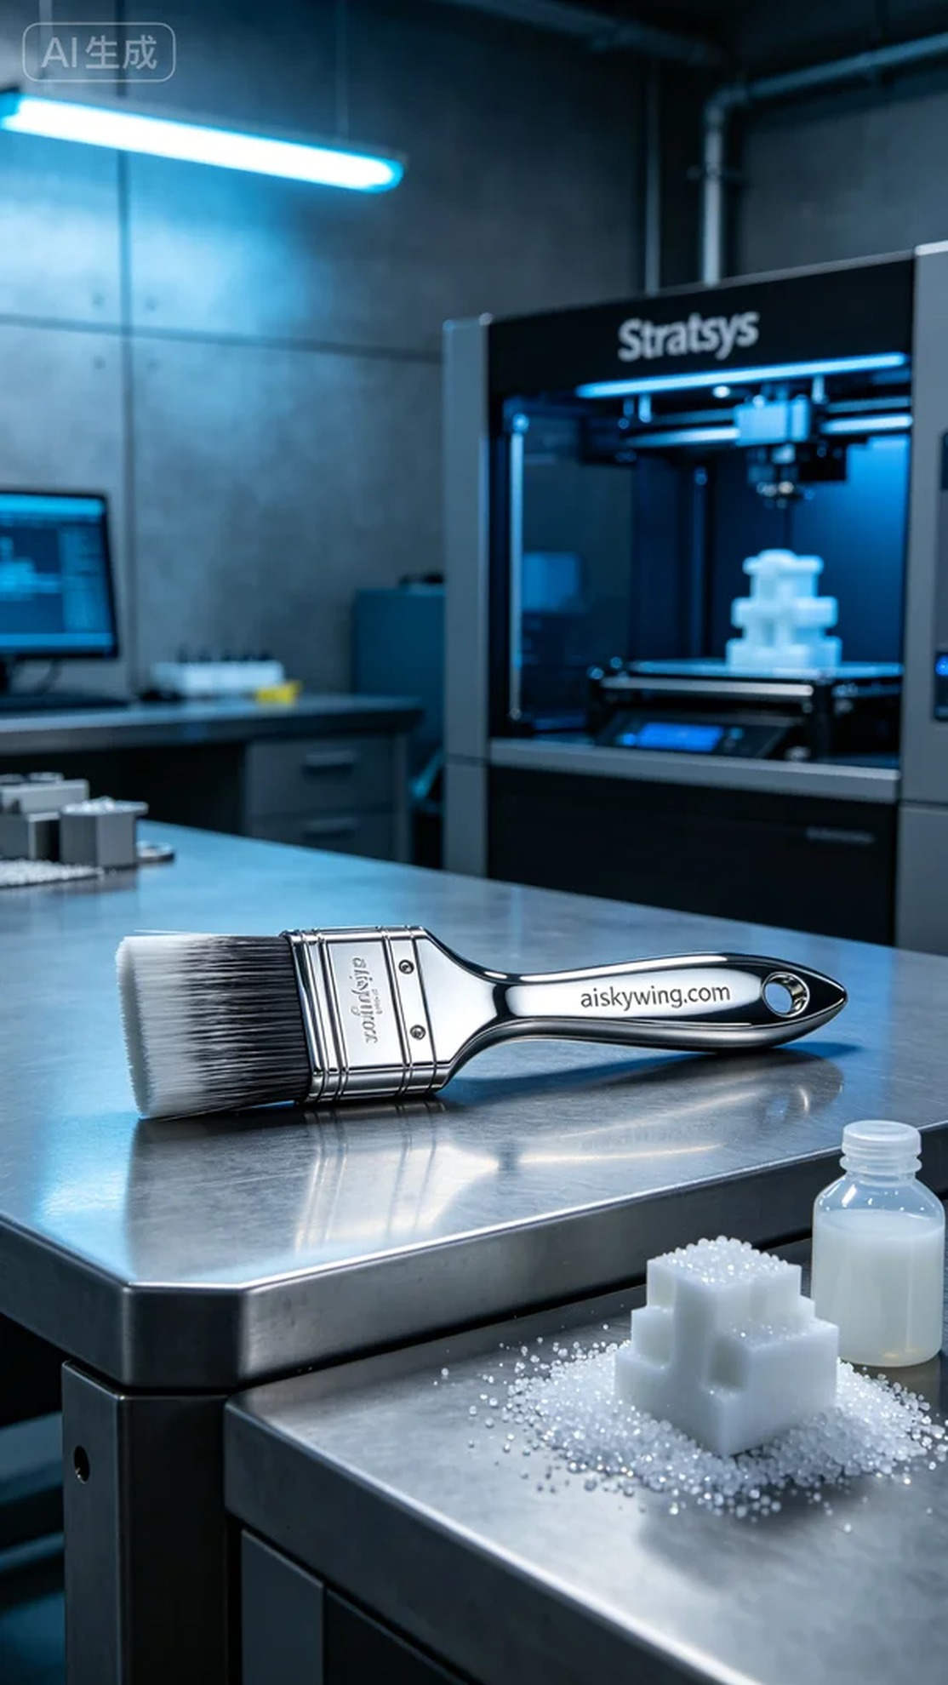
在LinkedIn上，有人因为需要一款高质量的刷手柄而找到我们，要求表面雕刻清晰且质感出众。我们接下这个任务，目标是利用SLA光固化工艺，打造出符合要求的产品。
使用的原材料是SLA光敏树脂，这种材料具有优良的流动性和高精度特性。经过仔细研究，我们选择了Stratasys打印机进行打印，设置了层厚为0.05mm，打印温度为25°C，功率设定在70%，打印速度为40mm/s，预计打印时间为8小时。
打印过程中，Stratasys打印机稳定运转，液态光敏树脂逐层固化。我们始终保持对设备的质量监控，确保打印过程中无气泡和杂质出现，同时观察每一层的细节，以确保最终效果能够达到高标准。
打印完成后，我们进行了精细的后处理。首先用异丙醇对成品进行清洗，确保去除表面未固化的树脂。接着，采用细砂纸进行打磨，使表面更加光滑，最后再进行UV固化，确保强度达到要求，经过多次检验，确认无误，最终完成了这款刷手柄的制作。
通过这次制作，我们成功地将设计理念转化为实际产品，证明了只要用心，就能把握住每一个细节，成就理想的结果。
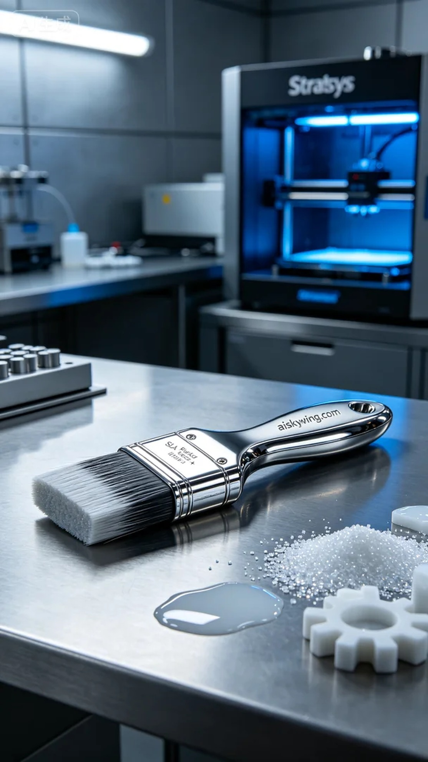
Aiskywing Industrial 3D Printing
Brush handle


