0784-加湿器水箱盖3D打印生产记录
Humidifier water tank cover
🖨️ SLA光固化
🖥️ 打印机: Mimaki
📦 材料: SLA
生活就像3D打印，每一层都需要扎实耐心。有人因为加湿器水箱盖的问题找到了我们。
Life is like 3D printing; each layer requires solid patience. Someone found us because of an issue with the humidifier's water tank cover.
________________________________________________________________________________
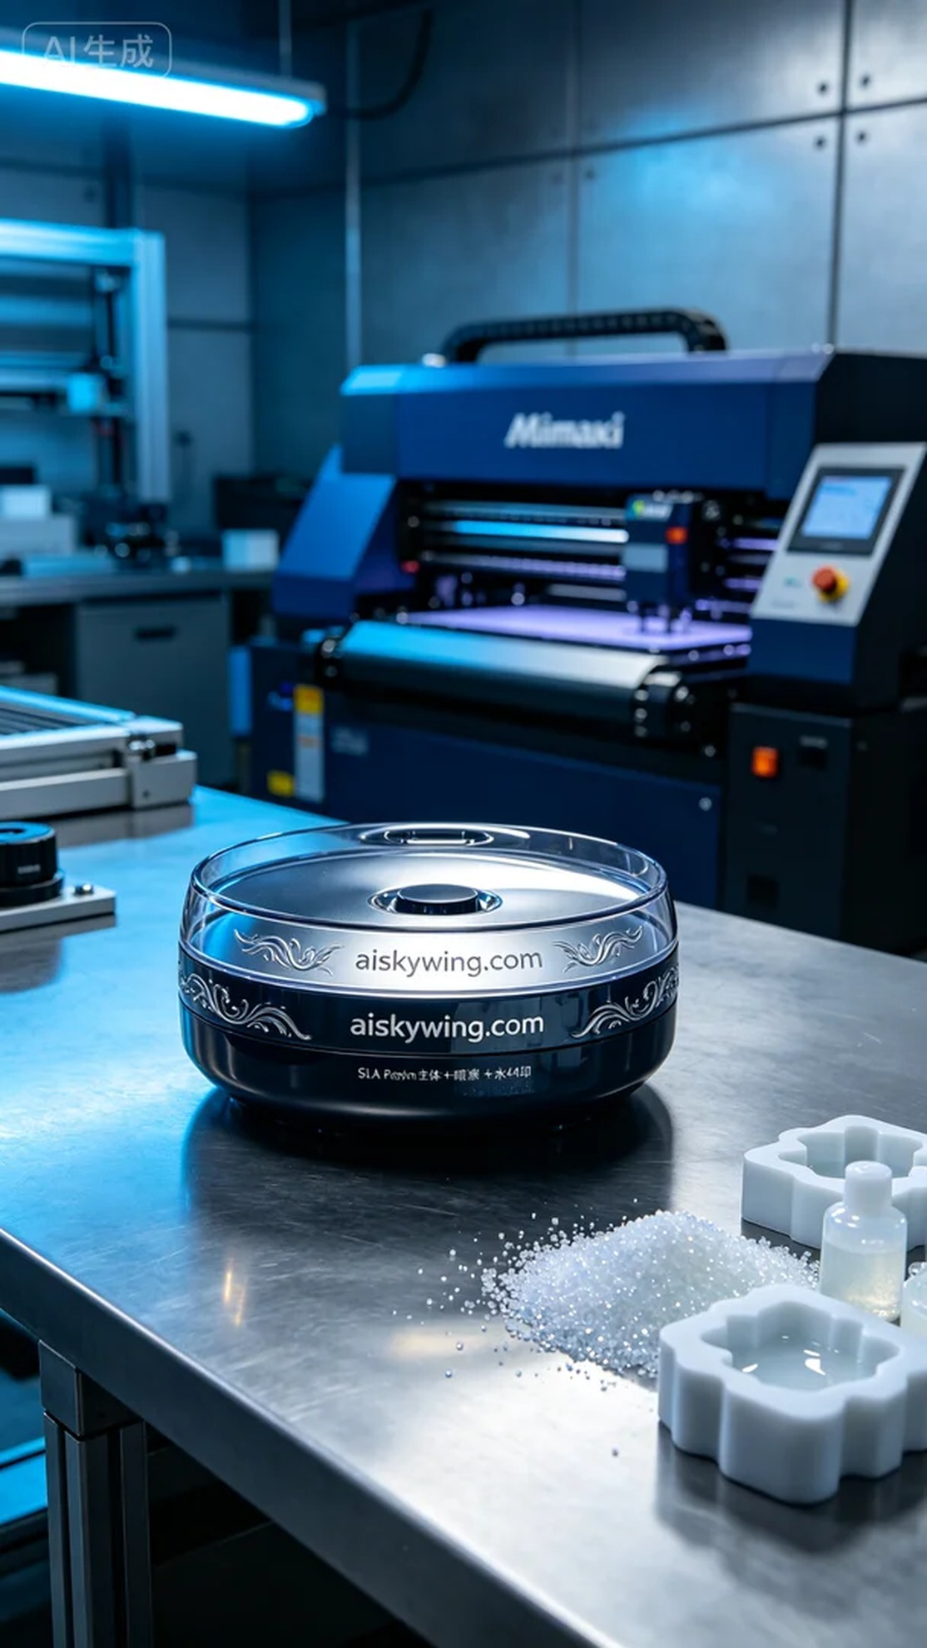
Life is like 3D printing; every layer requires solid patience. Recently, someone reached out to us via YouTube about an issue with their humidifier water tank lid and needed a custom replacement.
For this project, we selected high-quality SLA resin as our printing material. This material has excellent photopolymerization properties, allowing for intricate surface details. We set the Mimaki 3D printer with a layer thickness of 0.05mm, maintained a printing temperature of 25°C, set the power to 50%, and the printing speed at 30mm/s, with an expected printing time of about 6 hours. Throughout, we ensured that every parameter was optimized for the best results.
As the printing process commenced, the Mimaki printer steadily built up the layers. We closely monitored the operation to make real-time adjustments to ensure quality. As the lid took shape, it presented a smooth surface with the engraved “aiskywing.com” text clearly visible, showcasing superior quality.
Once printing was complete, we proceeded with rigorous post-processing. First, we soaked the printed part in a cleaning solution to remove any uncured resin. After cleaning, we meticulously sanded the surface to eliminate minor imperfections, ensuring a smooth texture. Finally, we placed it into the curing device, exposing it to UV light for solidification, ensuring durability and hardness. After inspection, the final product met our high standards.
After this series of processes, the humidifier water tank lid was complete, both aesthetically pleasing and functional, perfectly addressing the issue. With persistence and effort, one can always see the glow of achievement.
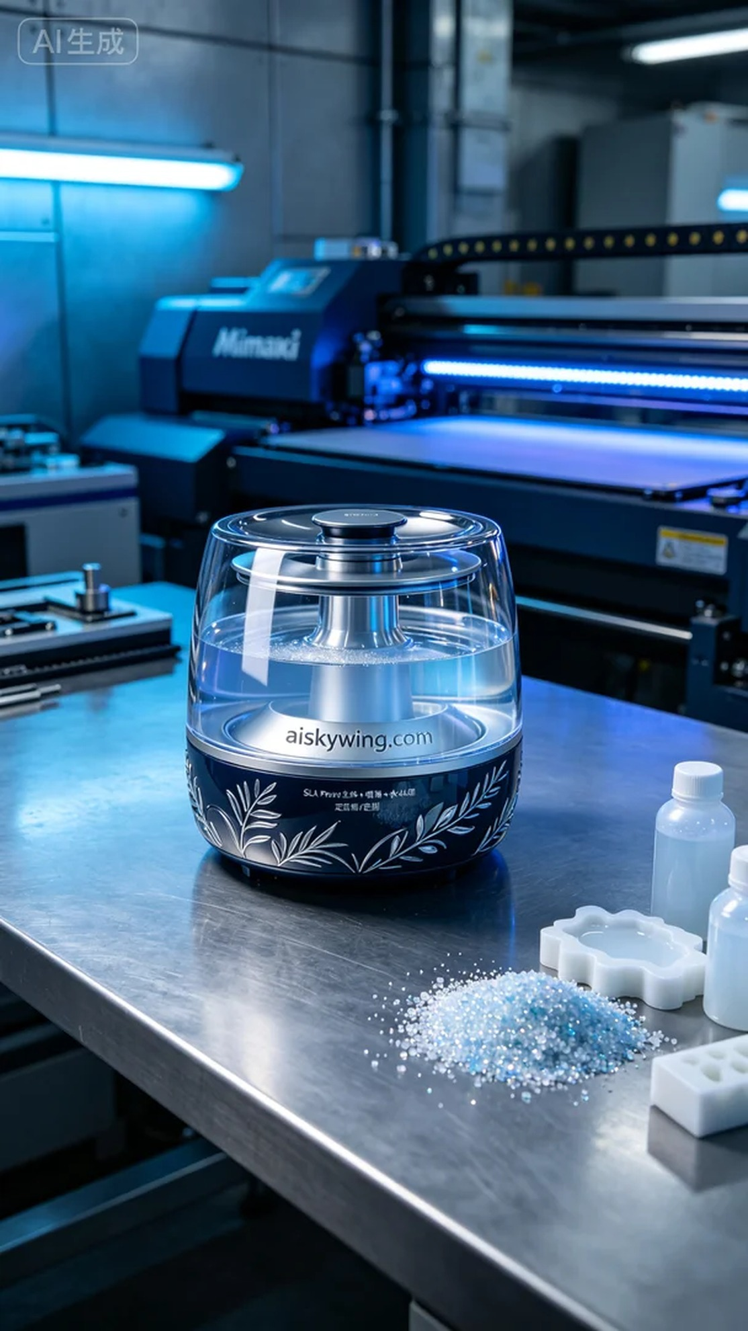
我们最近接到一个来自YouTube的询问，有人遇到了加湿器水箱盖损坏的问题，希望能定制一个新的。这个产品不仅要完美匹配，还要在外观上有所提升，让使用者满意。
在准备阶段，我们选择了高品质的SLA树脂作为打印材料。这种树脂材质具有优异的光固化性能，能够呈现出细腻的表面细节。使用的Mimaki 3D打印机设定了层厚为0.05mm，打印温度控制在25°C，功率为50%，打印速度设为30mm/s，预计打印时间约为6小时。在这段时间内，我们确保打印机的每一个参数都处于最佳状态。
打印过程开始后，Mimaki打印机稳稳地将图层叠加。我们全程监控设备运行情况，及时调整打印参数以确保质量。在打印的后期，水箱盖逐渐成型，表面光滑，雕刻的“aiskywing.com”字样清晰可见，展现出了优质的效果。
打印完成后，我们进行了严格的后处理。首先将成品放入清洗液中浸泡，以去除未固化的树脂。清洗后，经过细致的打磨，去除表面微小的瑕疵，确保质感光滑。最后将其放入固化设备中，经过UV光照射进行固化，确保其耐用性和硬度。经过检验，最终的产品达到了我们的高标准。
经过这一系列的工序，加湿器水箱盖终于完成，既美观又实用，完美解决了问题。努力坚持，总会看到成果的光芒。
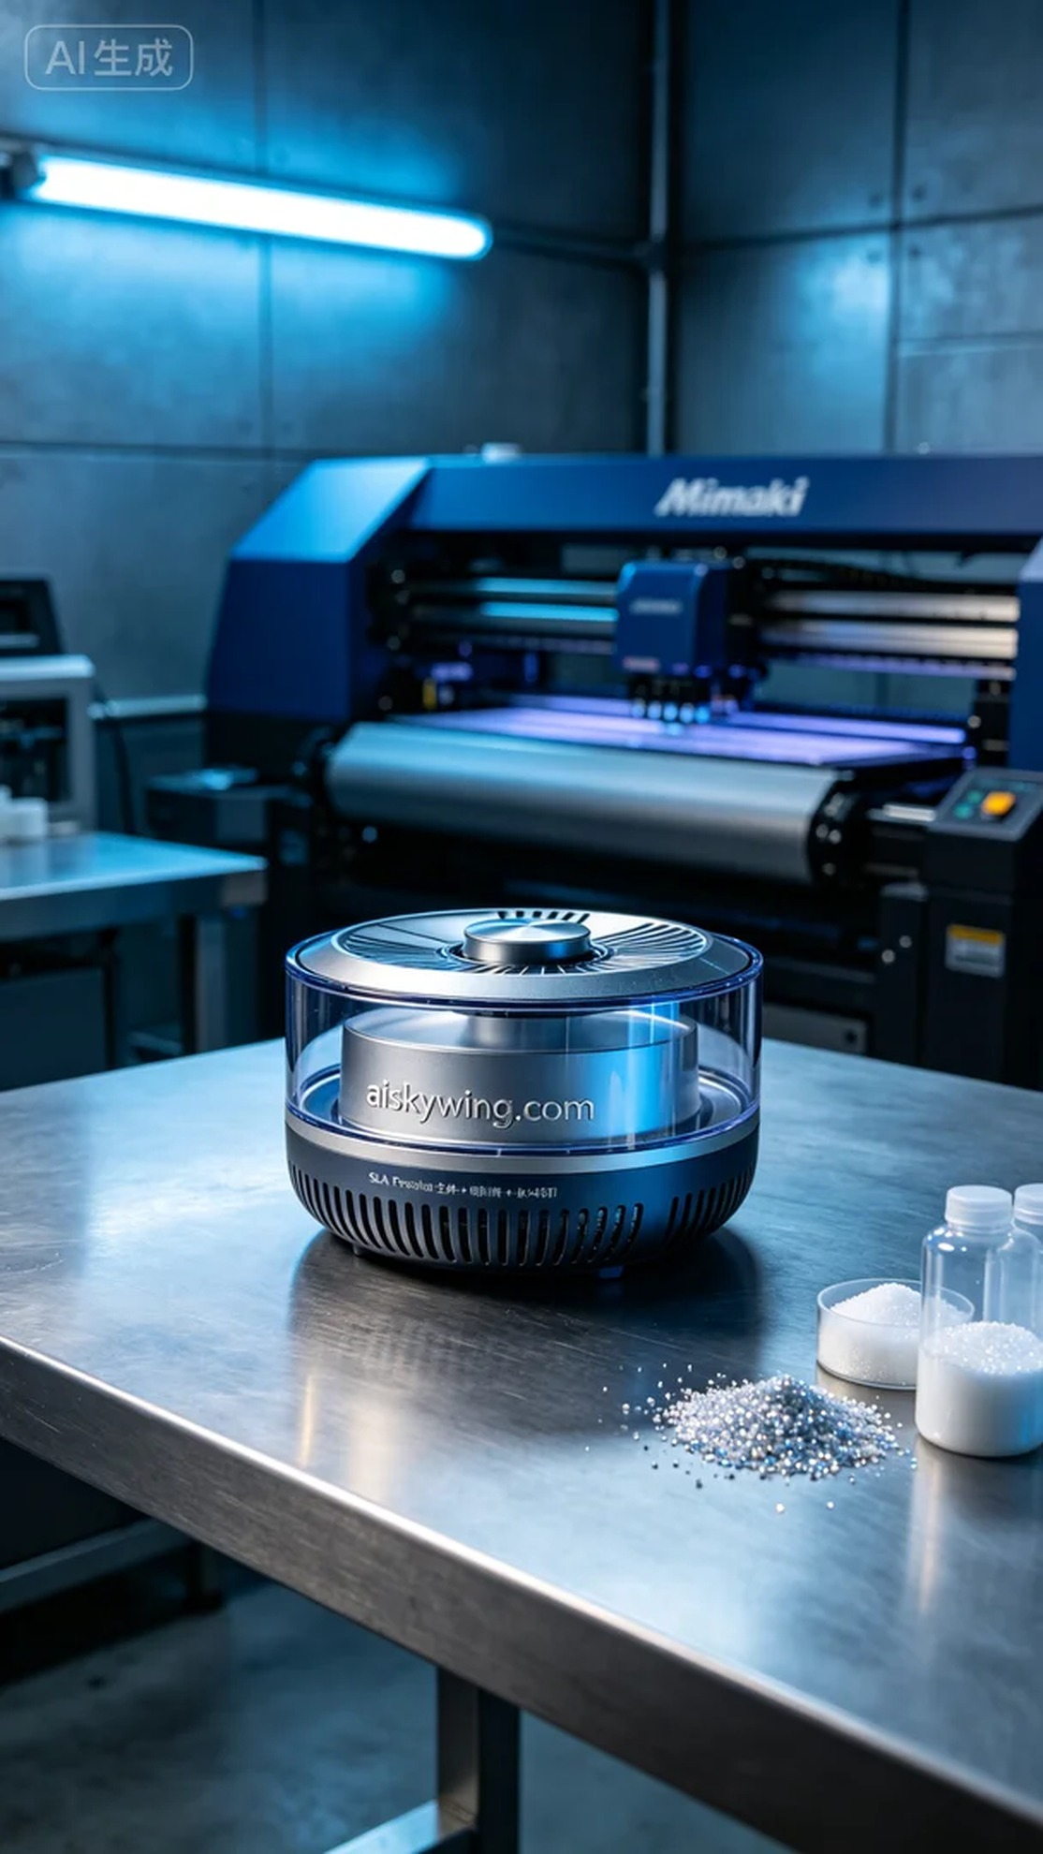
Aiskywing Industrial 3D Printing
Humidifier water tank cover


