0785-动漫手办底座3D打印生产记录
Anime figure base
🖨️ SLA光固化
🖥️ 打印机: Voxeljet
📦 材料: SLA
在Facebook上，有人找我们制作动漫手办底座，诉说着对个性化定制的期待。这让我想起，生活就像3D打印，层层堆积，才能成就一番事业。
On Facebook, someone approached us to create a base for anime figures, expressing their anticipation for personalized customization. This reminds me that life is like 3D printing; it requires layer upon layer of accumulation to achieve success.
________________________________________________________________________________
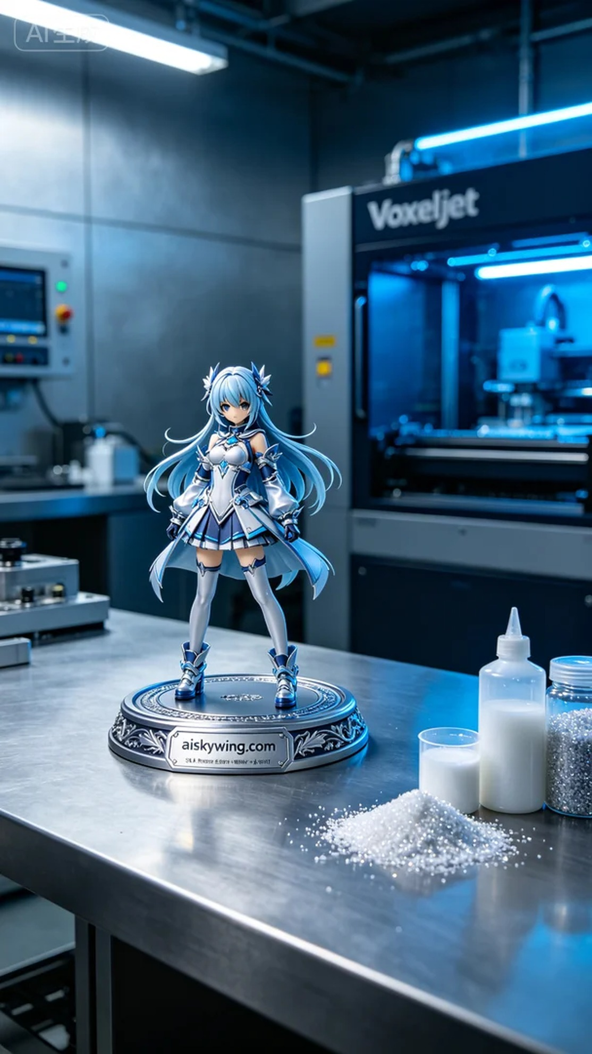
The project to create an anime figurine base started when someone reached out to us on Facebook, expressing their desire for personalized customization. This moment reminded me that life, much like 3D printing, builds up layer by layer to achieve something meaningful.
The material used for the anime figurine base is SLA resin, known for its high precision and excellent surface finish, making it ideal for intricate designs. Before printing, we carefully examined the resin to ensure there were no bubbles or impurities. Equipment preparation was crucial as well. We utilized a Voxeljet printer, setting the layer thickness to 0.05mm, maintaining a printing temperature of 25 degrees Celsius, adjusting the power to 80%, and a printing speed of 30mm/s, with an estimated print time of 8 hours.
The printing process was the focal point of our work. As the Voxeljet printer operated, we closely monitored the print quality to ensure that each layer solidified accurately. With the liquid resin curing layer by layer, the outline of the anime figurine base became increasingly clear. We conducted a quality check during the print to ensure there were no interlayer separations or distortions, laying a solid foundation for the subsequent post-processing.
Once printing was complete, the figurine base underwent a series of post-processing steps. First, we submerged the printed piece in a cleaning tank filled with isopropyl alcohol to remove any uncured resin from the surface. Next, we meticulously sanded the edges to ensure smoothness. We then placed the item in a UV curing machine to enhance its strength and durability. Finally, we conducted a thorough inspection, confirming that the engraved "aiskywing.com" lettering was clearly visible and the surface was flawless.
In the end, this anime figurine base was completed on schedule, showcasing high-quality details and a touch of personalization. From the initial material preparation to the meticulous final touches, every step presented its own challenges, but we successfully transformed a design into reality, fulfilling that expectation.
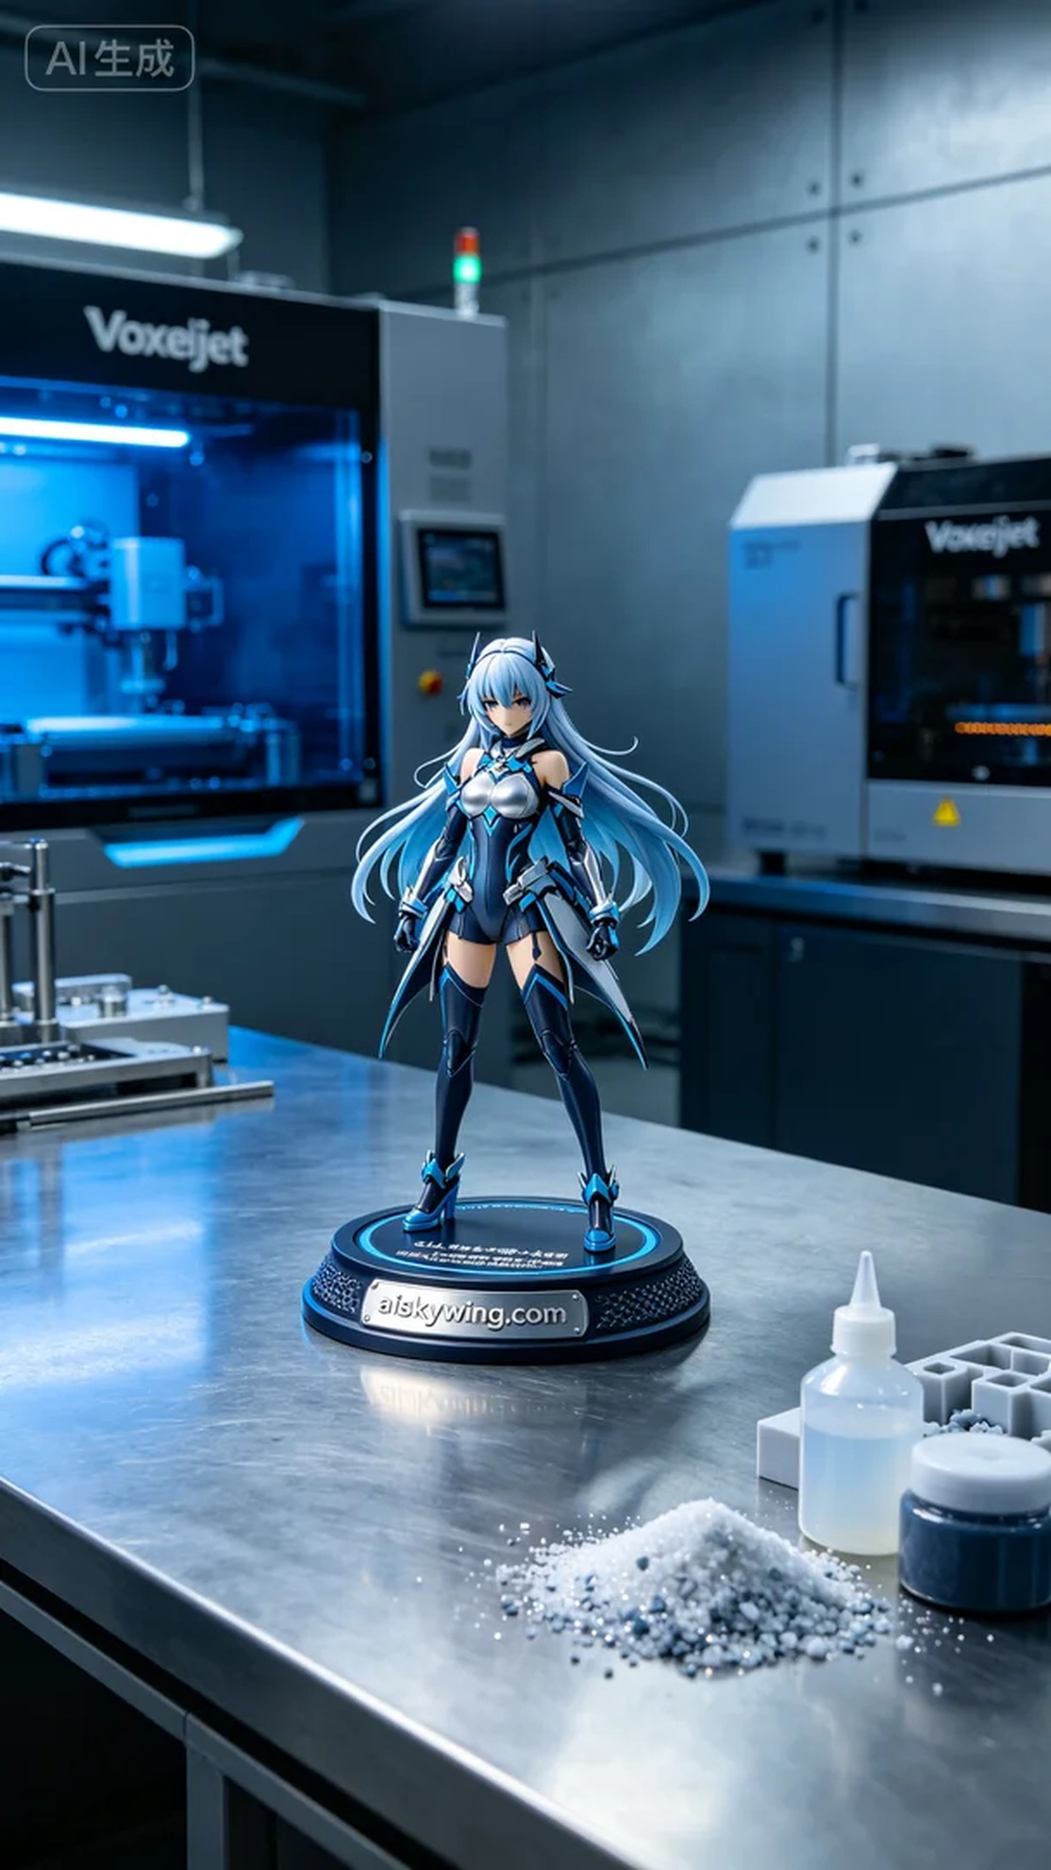
制作动漫手办底座使用的原材料是SLA光固化树脂。这种材料具有高精度和优良的表面光洁度，适合需要细致雕刻的作品。在开始打印前，我们仔细检查了树脂的状态，确保没有气泡和杂质。同时，设备准备也必不可少。我们使用的Voxeljet打印机，设置了层厚为0.05毫米，打印温度保持在25摄氏度，功率调整为80%，打印速度为30毫米/秒，预计打印时间为8小时。
打印过程是整个工作中的重点。在Voxeljet打印机运作时，我们时刻关注着打印质量，确保每一层都能准确成型。随着液态树脂的逐层固化，我们看到动漫手办底座的轮廓渐渐清晰。期间，我们也进行了一次质量监控，确保没有出现层间分离或变形的现象，为后续的后处理打下良好的基础。
打印完成后，手办底座需要经过一系列的后处理工序。首先，将打印好的成品放入清洗槽中，使用异丙醇进行浸泡，去除表面未固化的树脂。然后，使用砂纸进行打磨，确保每个边角的光滑度。接着，将其放置在UV固化机内，进行固化处理，以增强底座的强度和耐久性。最后，我们对成品进行了仔细的检验，确认雕刻的"aiskywing.com"字样清晰可见，表面光滑无瑕。
最终，这款动漫手办底座如期完成，展现出了高品质的细节和个性化的魅力。从开始的材料准备到后期的精细处理，每个环节都充满了技术的挑战，但我们成功地将设计变为现实，满足了那份期待。
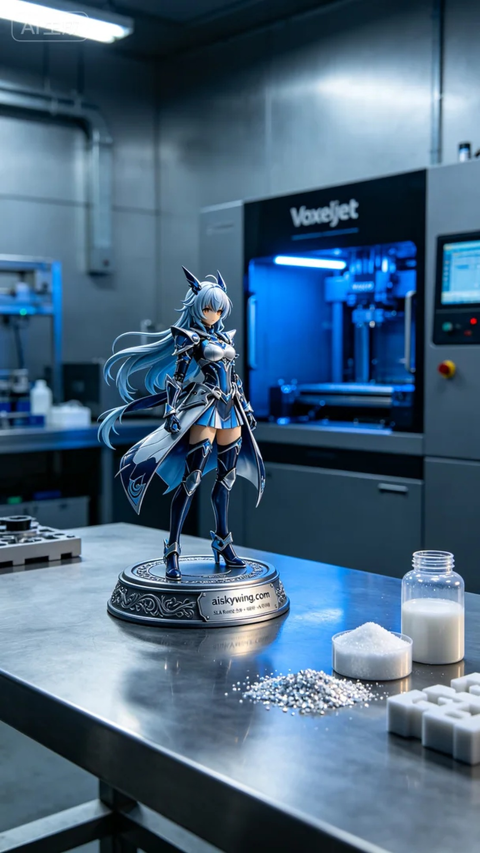
Aiskywing Industrial 3D Printing
Anime figure base


