0786-动漫手办替换手型3D打印记录
Anime figure interchangeable hand parts
🖨️ SLS尼龙烧结
🖥️ 打印机: Voxeljet
📦 材料: 摆放着未成型的液态光敏
生活再难，也别停下脚步。就像接下这个动漫手办替换手型的单子，迎接每一个挑战，都是成长的机会。
No matter how difficult life gets, don't stop moving forward. Just like taking on this order for replacing hand parts of an anime figure, every challenge is an opportunity for growth.
________________________________________________________________________________
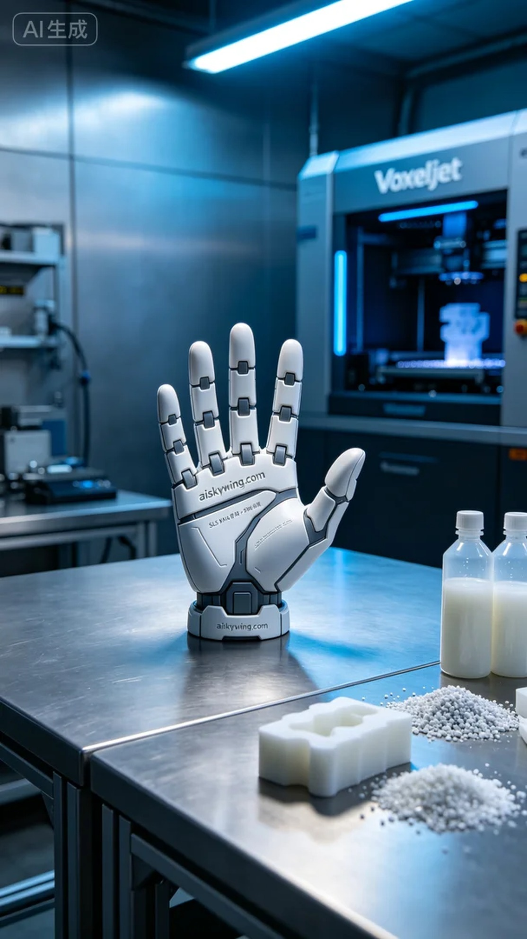
Life can be tough, but we must keep moving forward. Taking on the project of an anime figure's replacement hands has reminded me that facing every challenge is a chance to grow.
On Facebook, someone sought us out due to the lack of personalized figure accessories, hoping to create a high-quality anime figure's replacement hands. This request filled us with anticipation as we prepared to deliver a unique experience.
For this print, we used liquid photopolymer resin as the primary material, known for its excellent resolution and fine surface finish. We chose the Voxeljet 3D printer and set the parameters: layer thickness at 0.1mm, temperature at 25°C, power at 80W, and speed at 30mm/s, with an expected print time of 8 hours. These settings were aimed at ensuring every detail was perfectly rendered.
During the printing process, the machine operated smoothly. We closely monitored the formation of each layer, observing the print status to ensure no defects occurred. The cool ambient lighting in the workshop enhanced the tech vibe while bringing each finely crafted piece to life.
Once printing was complete, we moved on to the post-processing steps. First, we cleaned the printed hands using a specialized solvent to remove any residual photopolymer. Next, we performed sanding to ensure a smooth surface. Finally, the hands were placed in a curing device, exposed to UV light to increase their durability. Every step was pursued with precision, and we conducted thorough quality checks to ensure every detail met our standards.
After all these processes, the anime figure's replacement hands were finally completed. It stands not just as a piece of art, but as a testament to our commitment to excellence, where every detail matters.
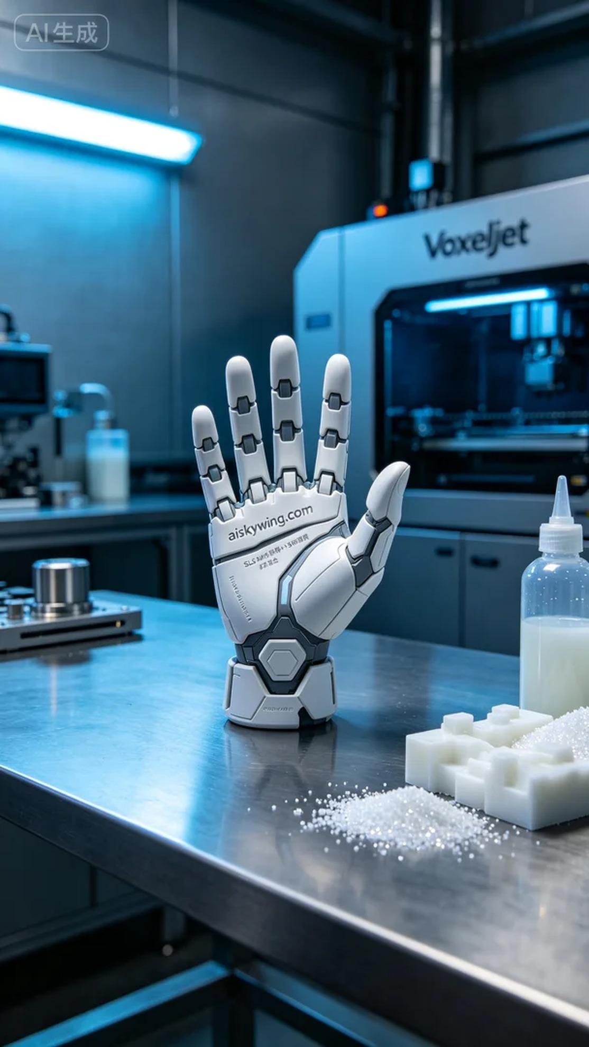
在Facebook上，有人因为缺少个性化的手办配件而找上我们，希望能制作一款质量上乘的动漫手办替换手型。这一需求，让我们充满了期待，准备为他们带来不一样的体验。
这次的打印采用了摆放着未成型的液态光敏树脂作为主要材料，具备优良的解析力和细腻的表面效果。我们选择了Voxeljet的3D打印机，设定了合适的打印参数：层厚0.1mm，温度设定在25℃，功率为80W，速度保持在30mm/s，预计打印时间为8小时。这些参数旨在确保每一个细节都能完美呈现。
打印的过程中，设备运行得相当稳定。我们密切监控了每一层的成型情况，通过观察打印状态，确保没有任何缺陷出现。在打印过程中，冷色调的氛围灯照射着工作室，增强了整个环境的科技感，同时也让每一件细致的作品都显得更加生动。
完成打印后，我们开始了后处理工序。首先，对打印好的手型进行清洗，使用专用清洗剂去除表面残留的光敏树脂。接着，进行打磨处理，确保表面光滑无瑕疵。最后，将手型放入固化设备中，经过紫外线照射使其更加坚固。每一步都力求完美，最终通过严格的质量检验，确保每一个细节都符合标准。
经过一系列的制作流程，这个动漫手办替换手型终于完成。既是一件艺术品，也是我们追求卓越品质的体现，每一步都不容忽视。
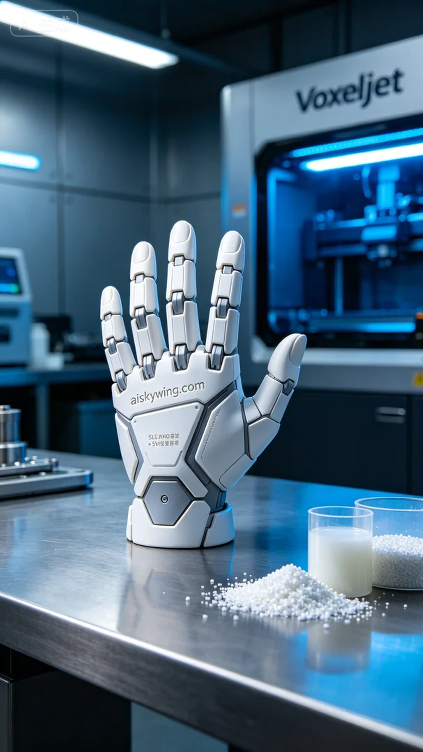
Aiskywing Industrial 3D Printing
Anime figure interchangeable hand parts


