0787-动漫手办替换面部3D打印生产记录
Anime figure face replacement
🖨️ SLA光固化
🖥️ 打印机: EOS
📦 材料: SLA
生活就像3D打印，层层叠加，才会成型。刚在LinkedIn上，有人希望我们制作一款动漫手办替换面部，挑战重重，但我们绝不退缩。
Life is like 3D printing, built layer by layer until it takes shape. Just recently on LinkedIn, someone expressed a desire for us to create an anime figurine with interchangeable faces. There are many challenges, but we will never back down.
________________________________________________________________________________
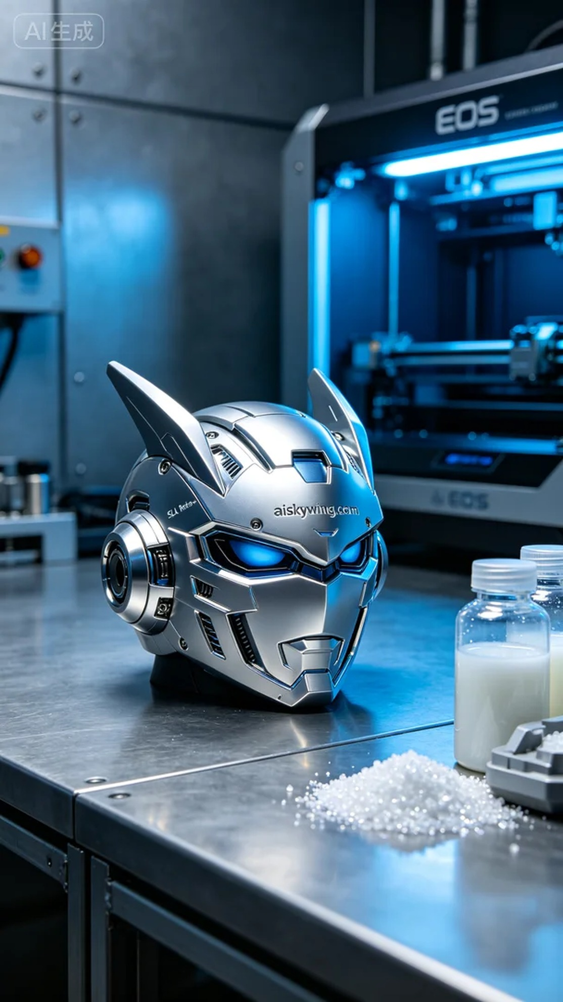
Life is like 3D printing, layer by layer, it takes shape. Just found a request on LinkedIn from someone wanting us to create a replacement face for an anime figure. The challenge is on, but we won't back down.
This project came from a request on LinkedIn where someone wanted an anime figure replacement face. The person wanted this figure to showcase extreme clarity and a high-gloss mirror finish, so we decided to use SLA photopolymerization for production.
We chose SLA resin as the primary material due to its excellent flow properties and detail capture. When using the EOS printer, we set the printing parameters to a layer thickness of 0.05mm, a temperature of 25°C, a laser power of 50mW, and a printing speed of 80mm/s. This setup ensures we can achieve high precision while improving printing efficiency.
During the printing process, the EOS equipment operated steadily, with the resin solidifying layer by layer. We monitored every detail of the print in real-time to ensure no bubbles or delamination occurred. The printing process lasted about four hours, resulting in a beautifully printed anime figure replacement face with clearly visible facial details.
After printing, we executed systematic post-processing. First, we soaked the figure in a cleaning solution to remove any uncured resin from its surface. Next, we used fine sandpaper to smooth the surface and remove support points. Finally, the figure underwent a curing process to enhance its hardness and durability. After rigorous inspection, we ensured that each product met high-quality standards.
After all these processes, the anime figure replacement face is finally complete. From printing to post-processing, every detail reflects our craftsmanship. We look forward to more such projects in the future.
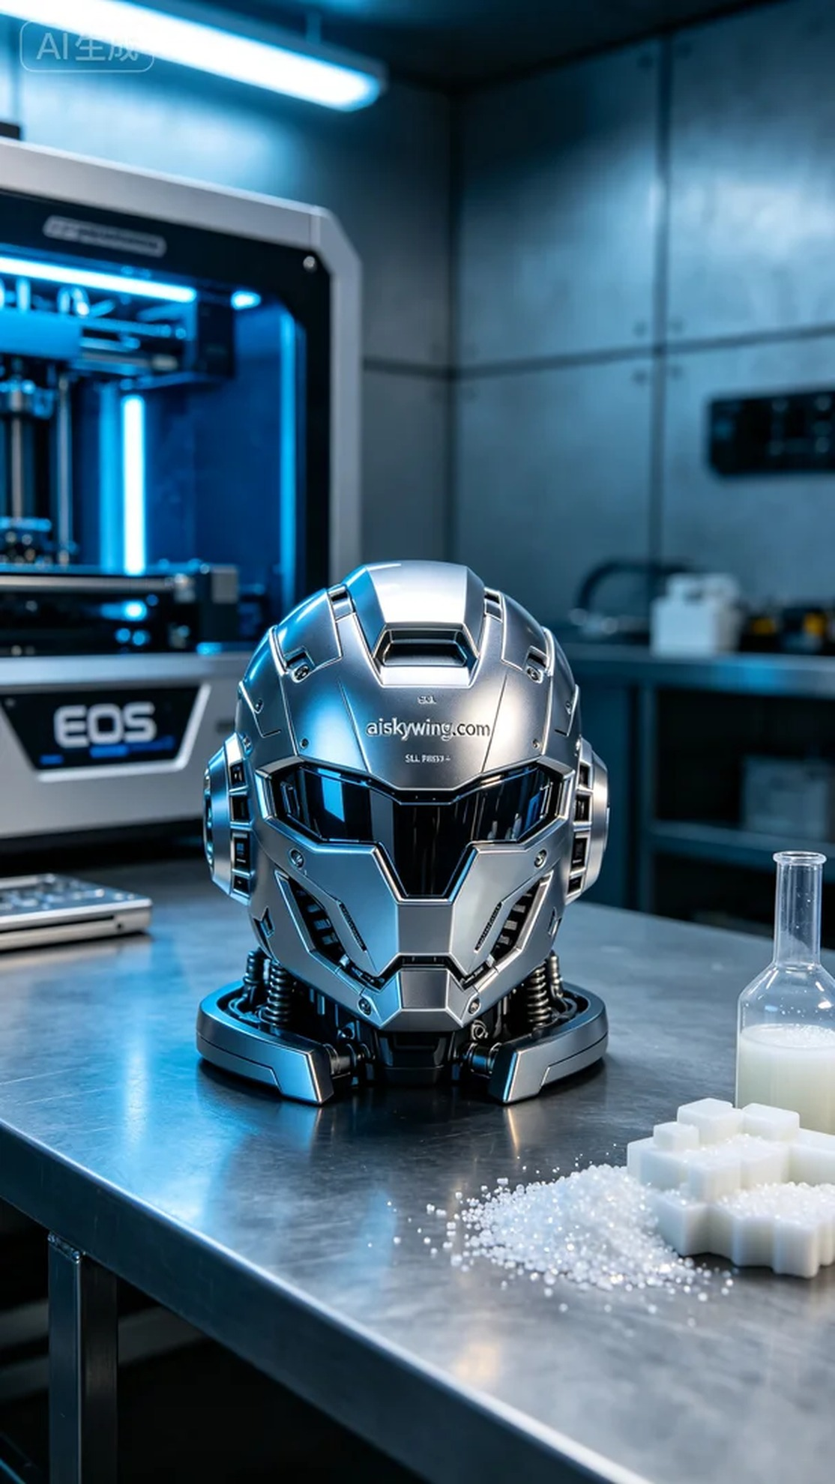
这次的项目源于LinkedIn上的一个需求，有人想要一款动漫手办替换面部。客户希望这款手办能够展现出极致的清晰度和高光的镜面效果，因此我们决定采用SLA光固化工艺进行生产。
我们选择了SLA树脂作为主要材料，具有良好的流动性和细节捕捉能力。使用EOS打印机时，打印参数设定为层厚0.05毫米，温度控制在25摄氏度，激光功率设定为50毫瓦，打印速度为80毫米/秒。这样的设置确保了我们能够在保证精度的同时，提升打印效率。
打印过程中，EOS设备稳定地运行着，树脂在光固化的过程中逐层成型。我们对每一个打印细节进行实时监控，确保没有出现任何气泡或层间附着不良的情况。打印过程持续了大约四个小时，最终呈现出一件完美的动漫手办替换面部，面部细节雕刻清晰可见。
完成打印后，我们进行了系统的后处理。首先将手办浸泡在清洗液中，去除表面的未固化树脂。接着，使用细砂纸进行打磨，确保表面光滑并去除支撑点。最后，手办经过固化处理，以增强其硬度和耐用性。经过严格检验，确保每一件产品都符合高标准的质量要求。
经过这一系列工序，动漫手办替换面部终于完成了。从打印到后处理，每一个细节都体现了我们的工匠精神。期待在未来，有更多这样的项目与我们合作。
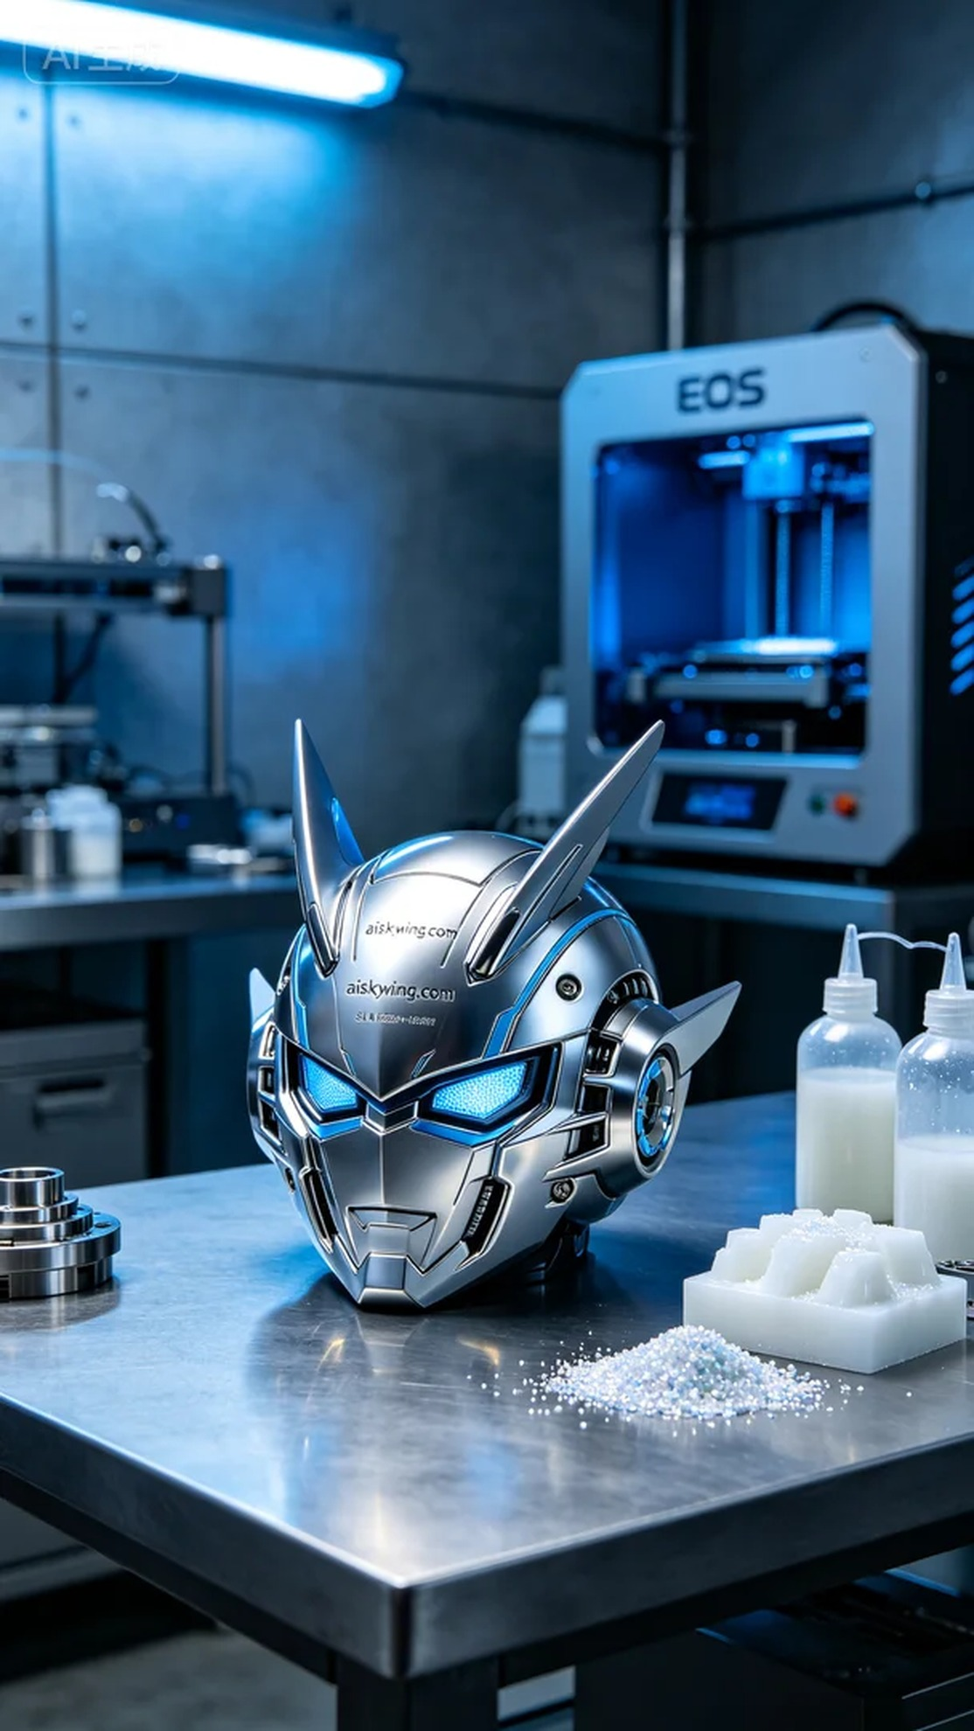
Aiskywing Industrial 3D Printing
Anime figure face replacement


