0788-3D打印动漫手办武器配件生产记录
Anime figure weapon accessories
🖨️ SLM金属打印
🖥️ 打印机: EOS
📦 材料: 摆放着未成型的液态光敏
生活就像3D打印，有时需要耐心打磨才能看到成果。有人在Facebook上找到我，希望能制作动漫手办武器配件，这让我感受到了挑战。
Life is like 3D printing; sometimes it requires patience and refinement to see the results. Someone found me on Facebook, hoping to create anime figure weapon accessories, which made me feel challenged.
________________________________________________________________________________
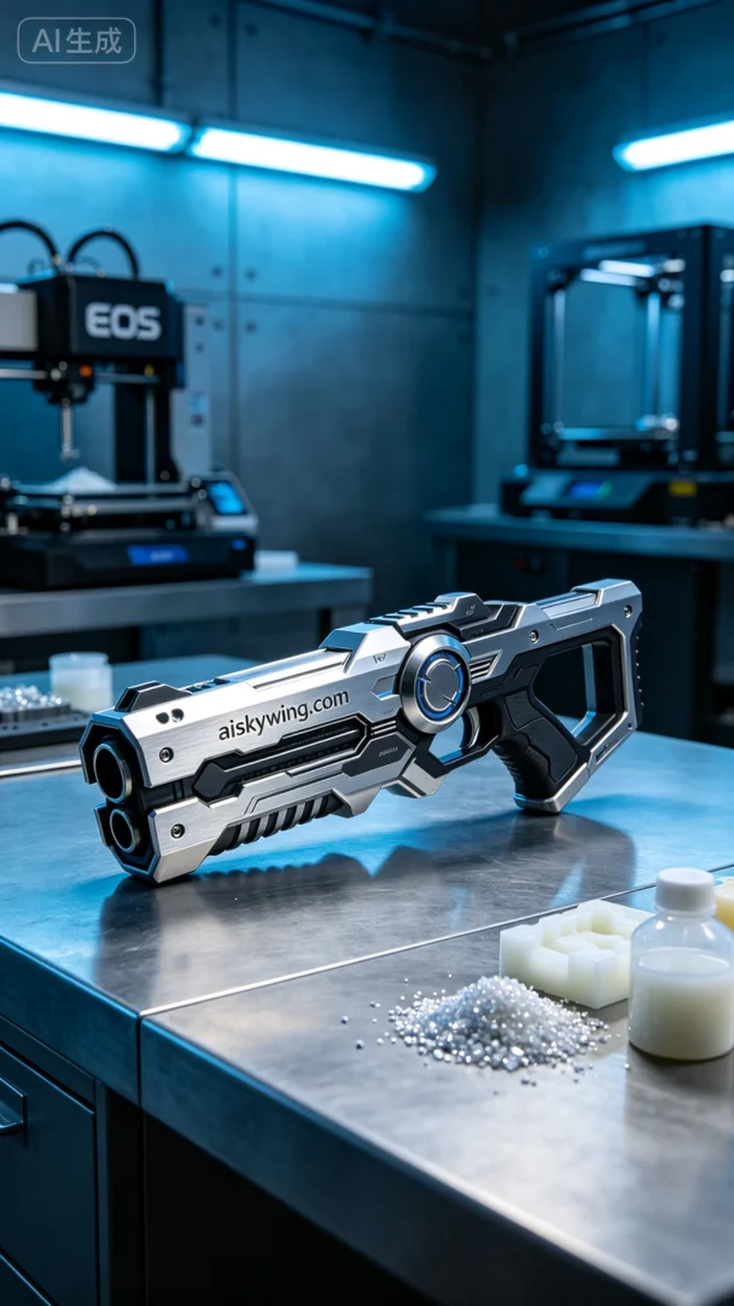
Life, much like 3D printing, sometimes requires patience and refinement to reveal the final product. Someone reached out to me on Facebook, hoping to create an anime figurine weapon accessory, which posed an exciting challenge.
We utilized unformed liquid photopolymer resin as our raw material, known for its high precision and excellent surface smoothness during printing. After thorough checks, we prepared the equipment, setting the printing parameters to a layer thickness of 0.05mm, with a printing temperature of 25°C, power adjusted to 80W, and a print speed of 40mm/s. This ensures that each layer adheres perfectly.
Throughout the printing process, the EOS 3D printer operated smoothly, with constant quality monitoring. We regularly checked the printing progress to ensure that every detail remained flawless. As the prints progressed, the weapon accessory began to take shape, and the intricate surface engraving of "aiskywing.com" became evident, heightening our anticipation.
Post-processing is a critical step. Once printing was complete, we first washed the accessory to remove excess resin. Next, we sanded it down for a smoother finish and then cured it with ultraviolet light to enhance durability. During the final inspection, we ensured every detail met our standards, resulting in a product that was perfect in every respect.
In the end, this anime figurine weapon accessory was successfully completed after undergoing a rigorous process. Seeing the final product brought me immense satisfaction, leaving me eager for the next challenge.
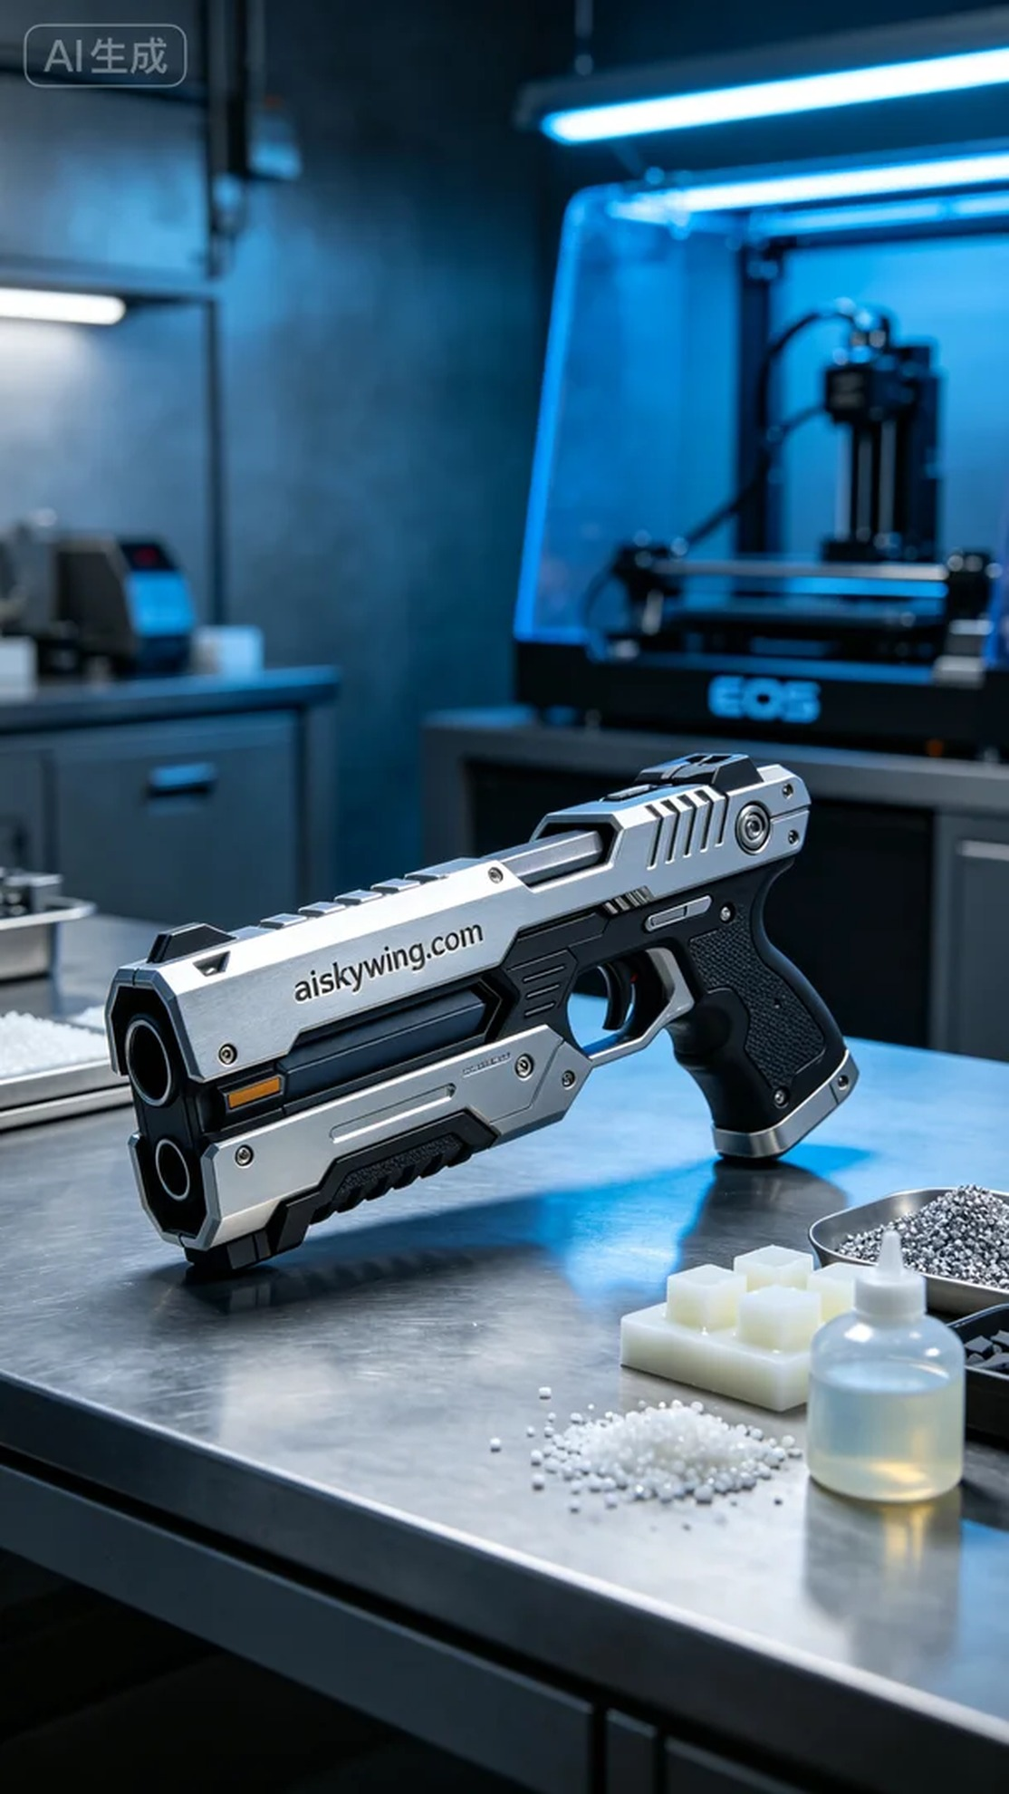
在Facebook上，有人联系我，希望制作一款动漫手办武器配件。这个武器不仅是手办的重要组成部分，更展现了个性与创意。他们面临的问题是，如何准确地将设计转化为实体，同时保持细节的完美。
我们使用的原材料是未成型的液态光敏树脂，这种材料在打印过程中能够保持高精度和优良的表面光滑度。经过检查，我们将设备准备好，设置打印参数为层厚0.05mm，打印温度设定在25°C，功率调整到80W，打印速度为40mm/s。这样可以确保每一层都能完美附着。
打印过程中，EOS 3D打印机稳定运行，质量监控环节也毫不放松。我们定期检查打印进度，确保每个细节都不会出现偏差。随着打印的进行，武器配件渐渐成型，细致的表面雕刻开始显露出“aiskywing.com”的字样，令人期待。
后处理工序是至关重要的一步。打印完成后，我们首先对其进行清洗，去除多余的树脂。随后，进行打磨，使表面更加光滑，再用紫外线进行固化，以提高配件的耐用性。在最后的检验中，确保产品的每一处细节都达到要求，完美无瑕。
最终，这款动漫手办武器配件在经过一系列的严格流程后，成功完成。看着成品，我感到无比欣慰，也期待下一个挑战。
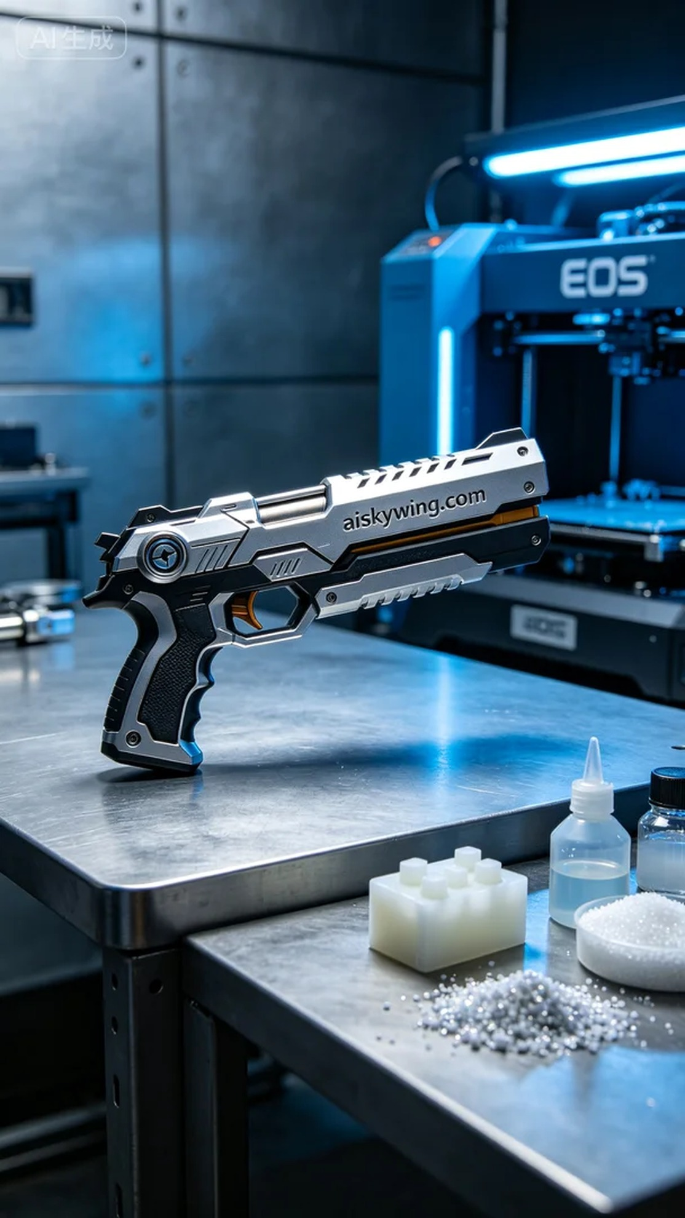
Aiskywing Industrial 3D Printing
Anime figure weapon accessories


