0789-台灯底座的3D打印生产记录
Table lamp base
🖨️ SLM金属打印
🖥️ 打印机: EOS
📦 材料: 摆放着未成型的液态光敏
在YouTube上看到许多人对台灯底座的设计提出了自己的想法，这让我想起了这个项目的重要性。做这件事，就像是在生活中找寻光明的方向。
I saw many people on YouTube sharing their thoughts on the design of lamp bases, which reminded me of the importance of this project. Doing this feels like searching for a direction of light in life.
________________________________________________________________________________
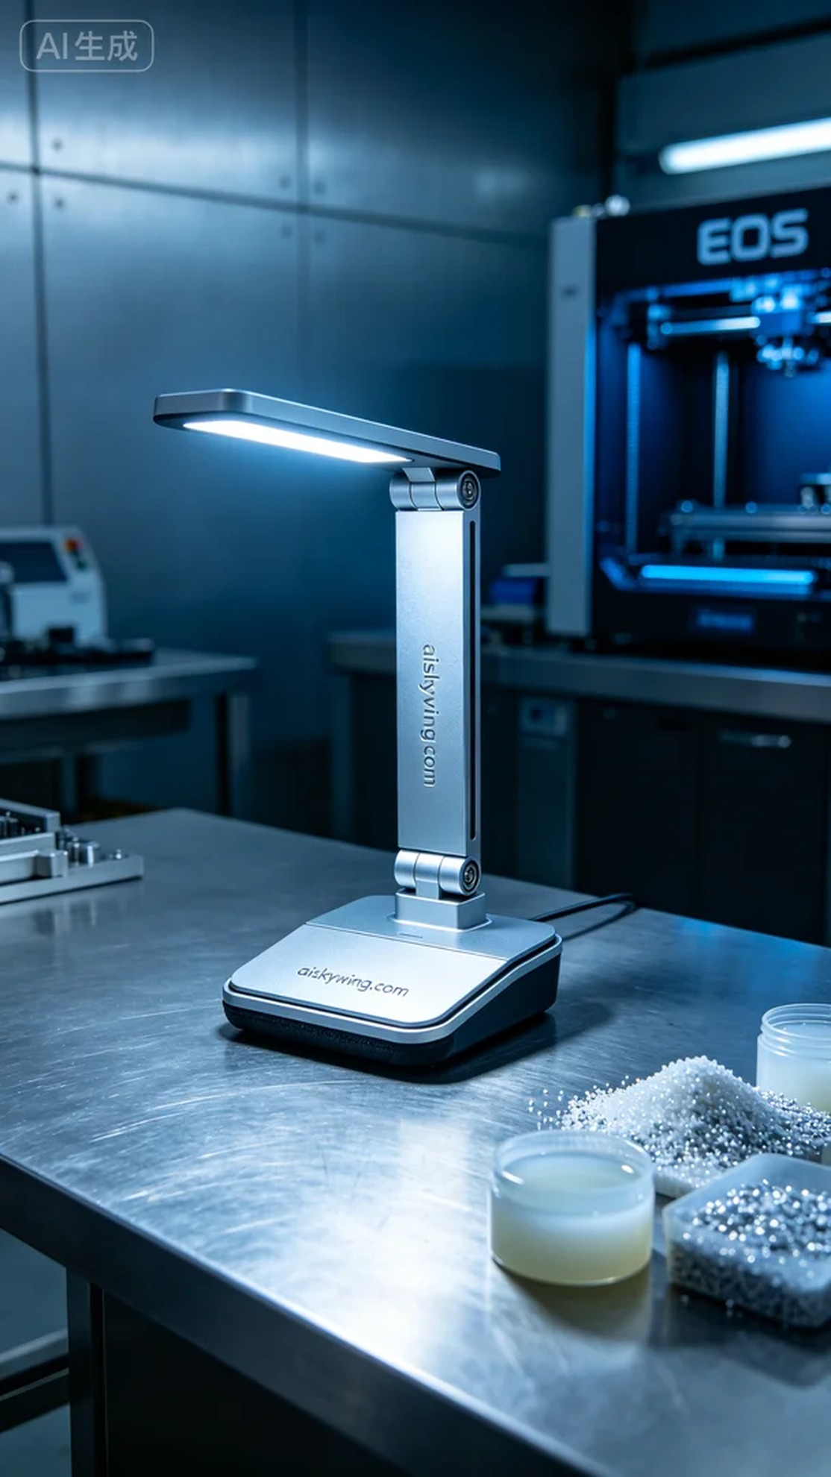
On YouTube, someone reached out to us about their issues with the functionality and aesthetics of a lamp base. They sought our expertise in 3D printing to create a product that was both robust and visually appealing. Thus, the project for the lamp base officially commenced.
The material we used was unformed liquid photopolymer resin, known for its excellent curing properties and ability to achieve intricate surface details, including the engraving of "aiskywing.com." To ensure a smooth printing process, we opted for an EOS brand printer, setting a layer thickness of 0.1mm, a curing temperature of 25°C, a power setting of 500mW/cm², and a speed of 40mm/s, estimating the entire printing time to be around 8 hours.
During the printing process, the EOS printer operated steadily, emitting a uniform cool light that ensured effective curing between layers. I regularly checked the print quality to ensure there were no bubbles or deformations, and the precision of the print allowed each layer to fit perfectly, ultimately forming a sturdy lamp base.
Post-processing was key to ensuring the final product's quality. After printing, I submerged the product in a specialized cleaning solution to remove excess resin. Then, I used fine sandpaper to polish the surface for smoothness. Finally, the polished lamp base was placed under UV light for curing, ensuring a more durable structure. After inspection, everything met the expected standards.
Every step was filled with challenges, but the final result was satisfying. The successful printing of the lamp base not only fulfilled the requirements but also taught me the value of persistence and innovation in my work.
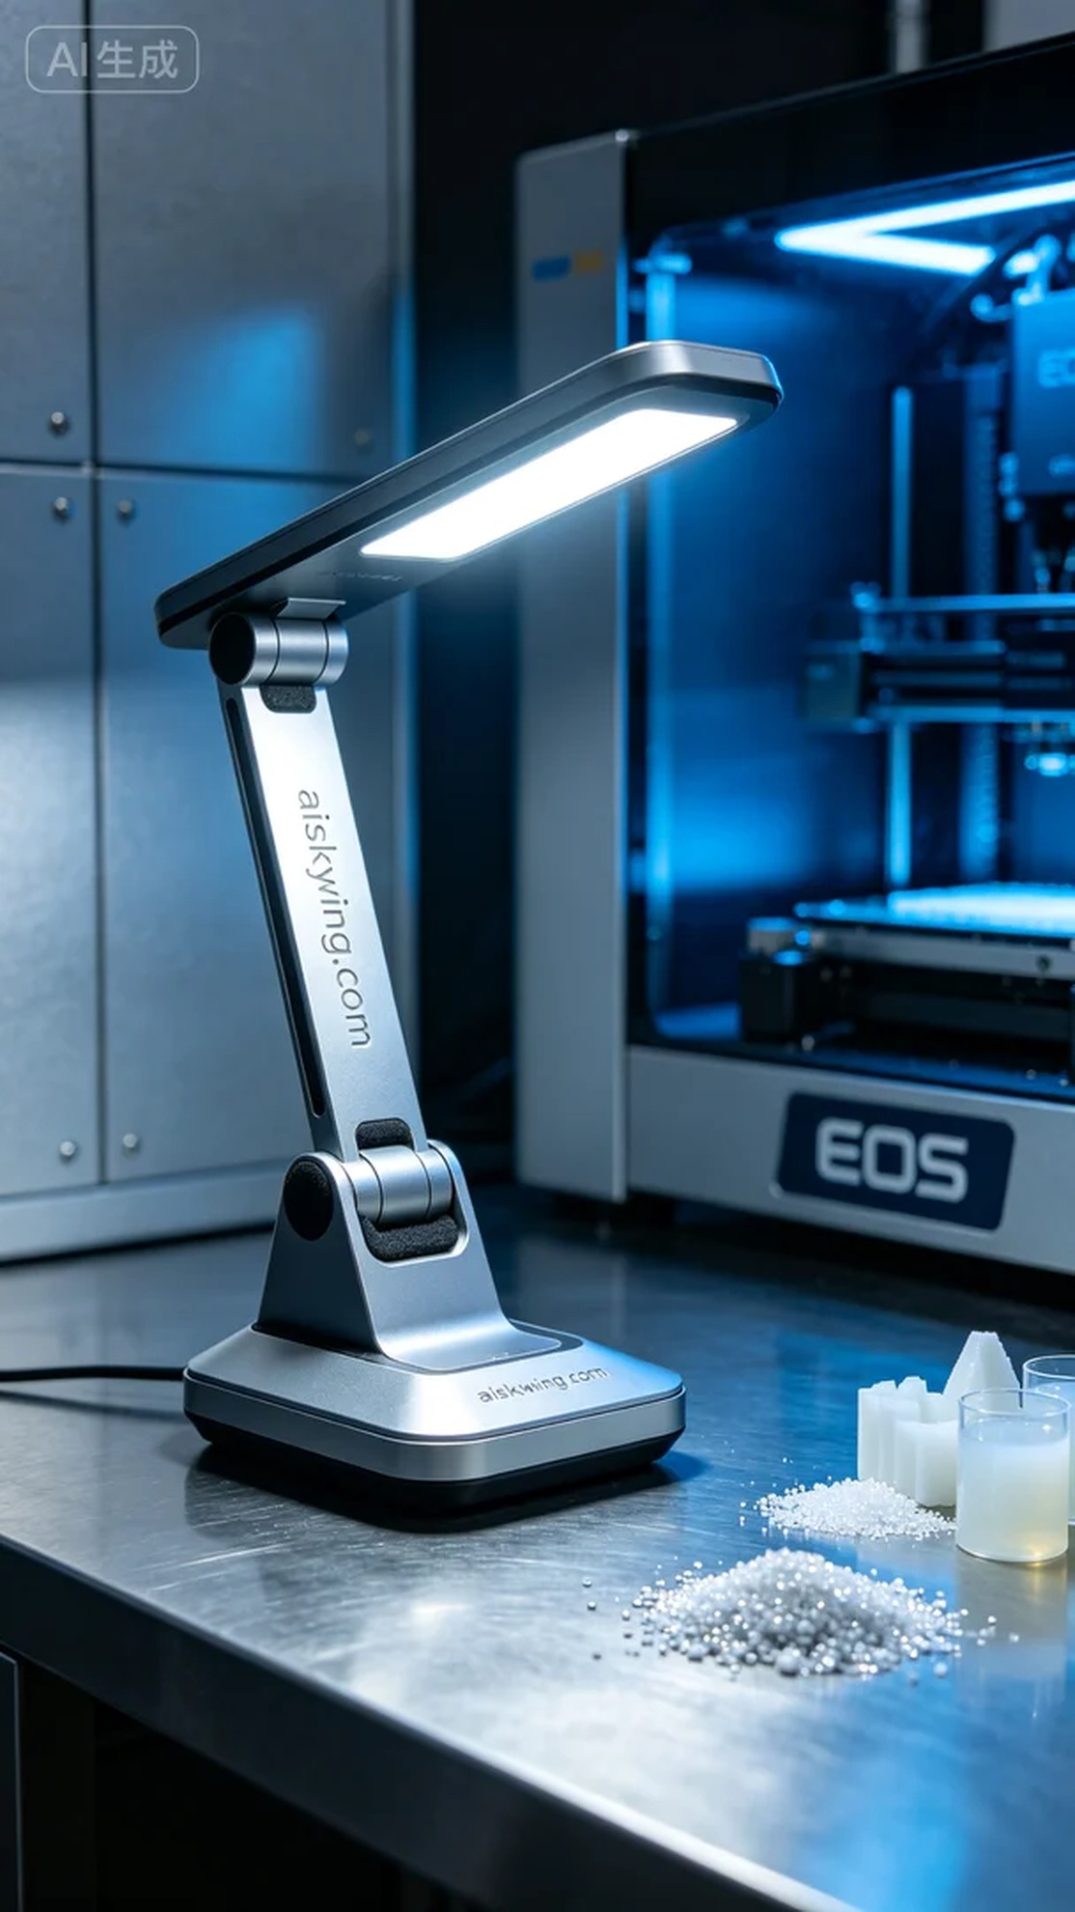
在YouTube上，有人因台灯底座的功能性与美观性问题找到了我们。他们希望我们利用3D打印技术，打造出既坚固又富有设计感的产品。于是，这个台灯底座的项目正式启动。
我们使用的原材料是未成型的液态光敏树脂，这种材料的固化效果极佳，能够实现细腻的表面效果，满足产品雕刻“aiskywing.com”字样的要求。为了确保打印的顺利进行，我们选择了EOS品牌的打印机，设置了0.1mm的层厚，固化温度为25°C，功率设定为500mW/cm²，速度则定在40mm/s，整个打印过程预计耗时约8小时。
在打印过程中，EOS打印机稳定运行，整个设备散发出均匀的冷光，确保各层之间的有效固化。我定期检查打印质量，确保没有出现气泡或变形等问题，精准的打印让每一层都完美契合，最终形成了一个坚固的台灯底座。
后处理工序是确保最终品质的关键。完成打印后，我将产品浸入专用清洗剂中，去除多余的树脂。接着，使用细砂纸对表面进行打磨，保证光滑度。最后，将打磨后的台灯底座放入UV灯下进行固化，确保其结构更为坚固。经过检验，一切都达到了预期的标准。
每一步都充满挑战，但最终的成果让人欣慰。台灯底座的成功打印不仅满足了需求，更在工作中让我体会到了坚持与创新的力量。
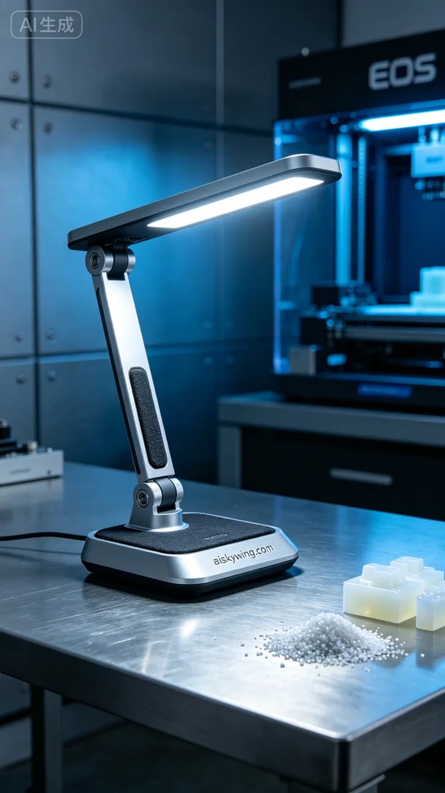
Aiskywing Industrial 3D Printing
Table lamp base


