0790-台灯开关装饰生产记录
Table lamp switch decoration
🖨️ SLA光固化
🖥️ 打印机: Systems
📦 材料: SLA
生活就像3D打印的过程，每一步都需要耐心与坚持。最近，有人因台灯开关装饰而找到我们，希望能解决他们的个性化需求。
Life is like the process of 3D printing, where each step requires patience and perseverance. Recently, someone reached out to us regarding a decorative lamp switch, hoping to address their personalized needs.
________________________________________________________________________________
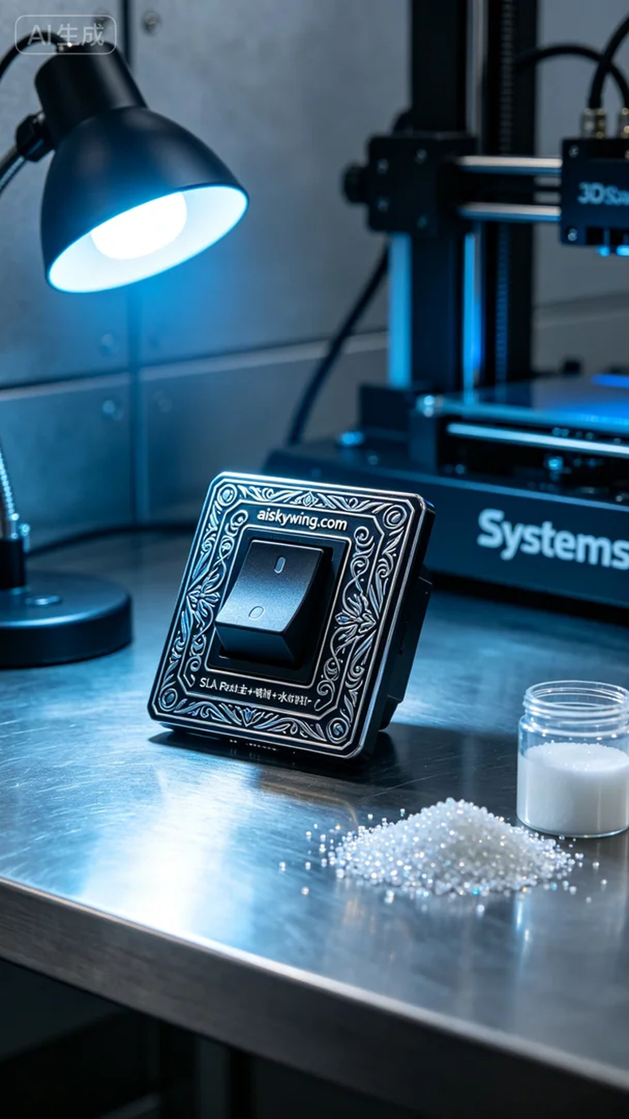
Life is like the process of 3D printing, requiring patience and perseverance at every step. Recently, someone reached out to us through LinkedIn with a request for a lamp switch decoration, hoping to solve their customization needs.
To meet this request, we prepared SLA photopolymer resin as the primary material. This material excels in detail representation, allowing for intricate engravings. We then used a Systems 3D printer, setting the layer thickness to 0.05 mm, maintaining a printing temperature of 25°C, adjusting the power to 50, and setting the printing speed to 30 mm per second, estimating a printing time of 8 hours.
During the printing process, the machine operated smoothly. I monitored the quality closely, ensuring each layer adhered correctly. As the printing progressed, the shape of the product began to take form, reflecting a unique industrial aesthetic with its light reflections and details.
Once printing was complete, we moved on to the post-processing stage. First, we cleaned the printed piece, thoroughly removing any residual resin with isopropanol. Next, we sanded the surface to ensure it was smooth, then placed the item into a UV curing machine for hardening. Finally, we meticulously inspected the finished product to ensure every detail met our standards.
After a series of meticulous processes, the lamp switch decoration arrived as expected, showcasing a satisfying outcome. This is not just a product but a testament to our team's effort and craftsmanship.
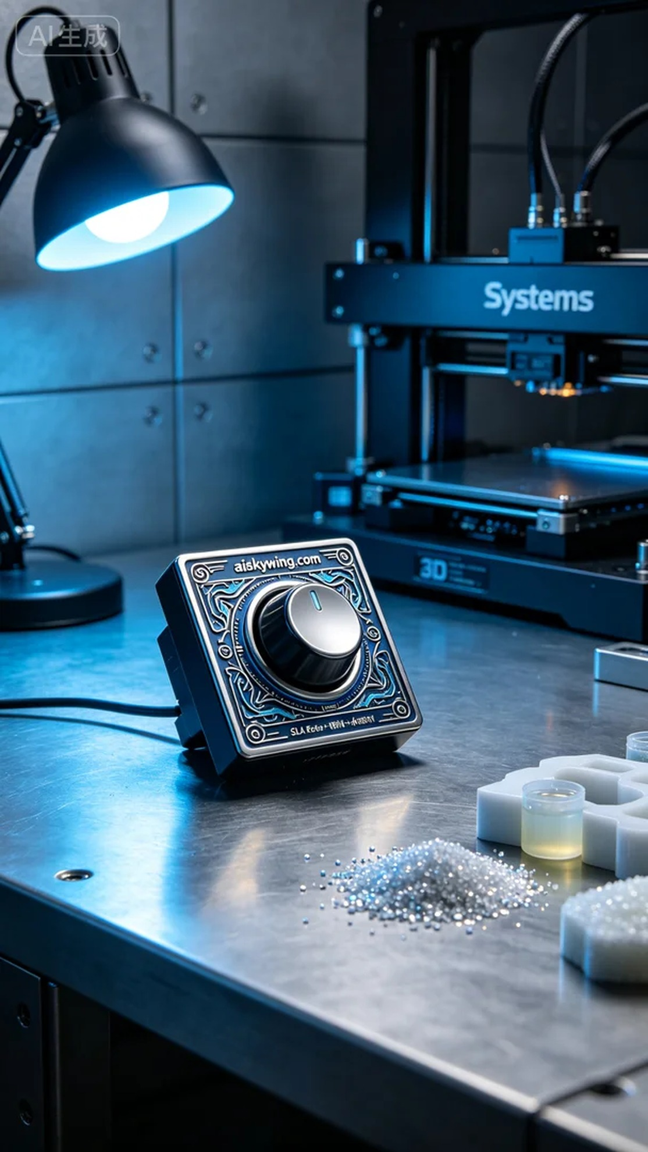
我们最近通过LinkedIn接到一位对台灯开关装饰有需求的朋友，想要在他们的产品中增添个性化的设计。他们遇到的困难在于如何将他们的理念转化为现实，并希望我们能够帮助实现他们的想法。
为了满足这位朋友的要求，我们准备了SLA光敏树脂作为主要材料。这种材料具有优越的细节表现能力，能更好地实现复杂的雕刻。接着，我们使用了Systems品牌的3D打印机，设定了层厚为0.05毫米，打印温度保持在25摄氏度，功率调整至50，打印速度设置为30毫米每秒，预计打印时间为8小时。
在打印过程中，设备运转得相当平稳。我时刻监控着打印质量，确保每一层都能准确附着。随着打印的推进，可以看到产品的形状逐渐成型，光线的反射和细节展现出了一种独特的工业美感。
打印完成后，我们进入了后处理的环节。首先要进行清洗，使用异丙醇将打印件表面的残留树脂彻底清除。接着，我们进行了打磨，以确保表面光滑，之后将其放入UV固化机中进行固化。最后，我们仔细检查了成品，确保每个细节都符合标准。
经过一系列的工艺流程，最终的台灯开关装饰如期而至，展现出令人满意的效果。这不仅仅是一个产品，更是我们团队努力与技艺的体现。
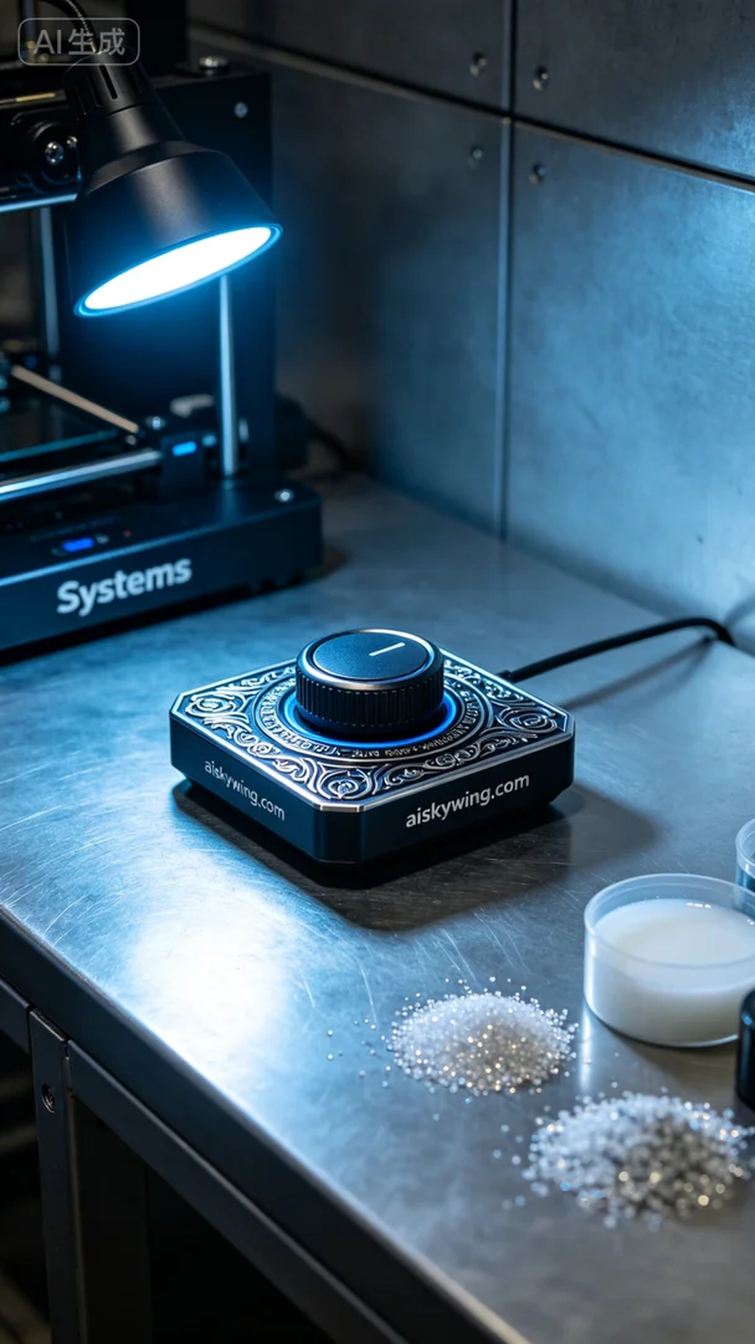
Aiskywing Industrial 3D Printing
Table lamp switch decoration


