0791-产品框架的3D打印制作记录
Product Framework
🖨️ SLA光固化
🖥️ 打印机: Stratasys
📦 材料: SLA
生活再难，也别停下脚步。就像接下这个产品框架置于画面正中央的单子，我知道每一步都至关重要。
No matter how difficult life gets, don't stop moving forward. Just like taking on this product framework and placing it right in the center of the screen, I know that every step is crucial.
________________________________________________________________________________
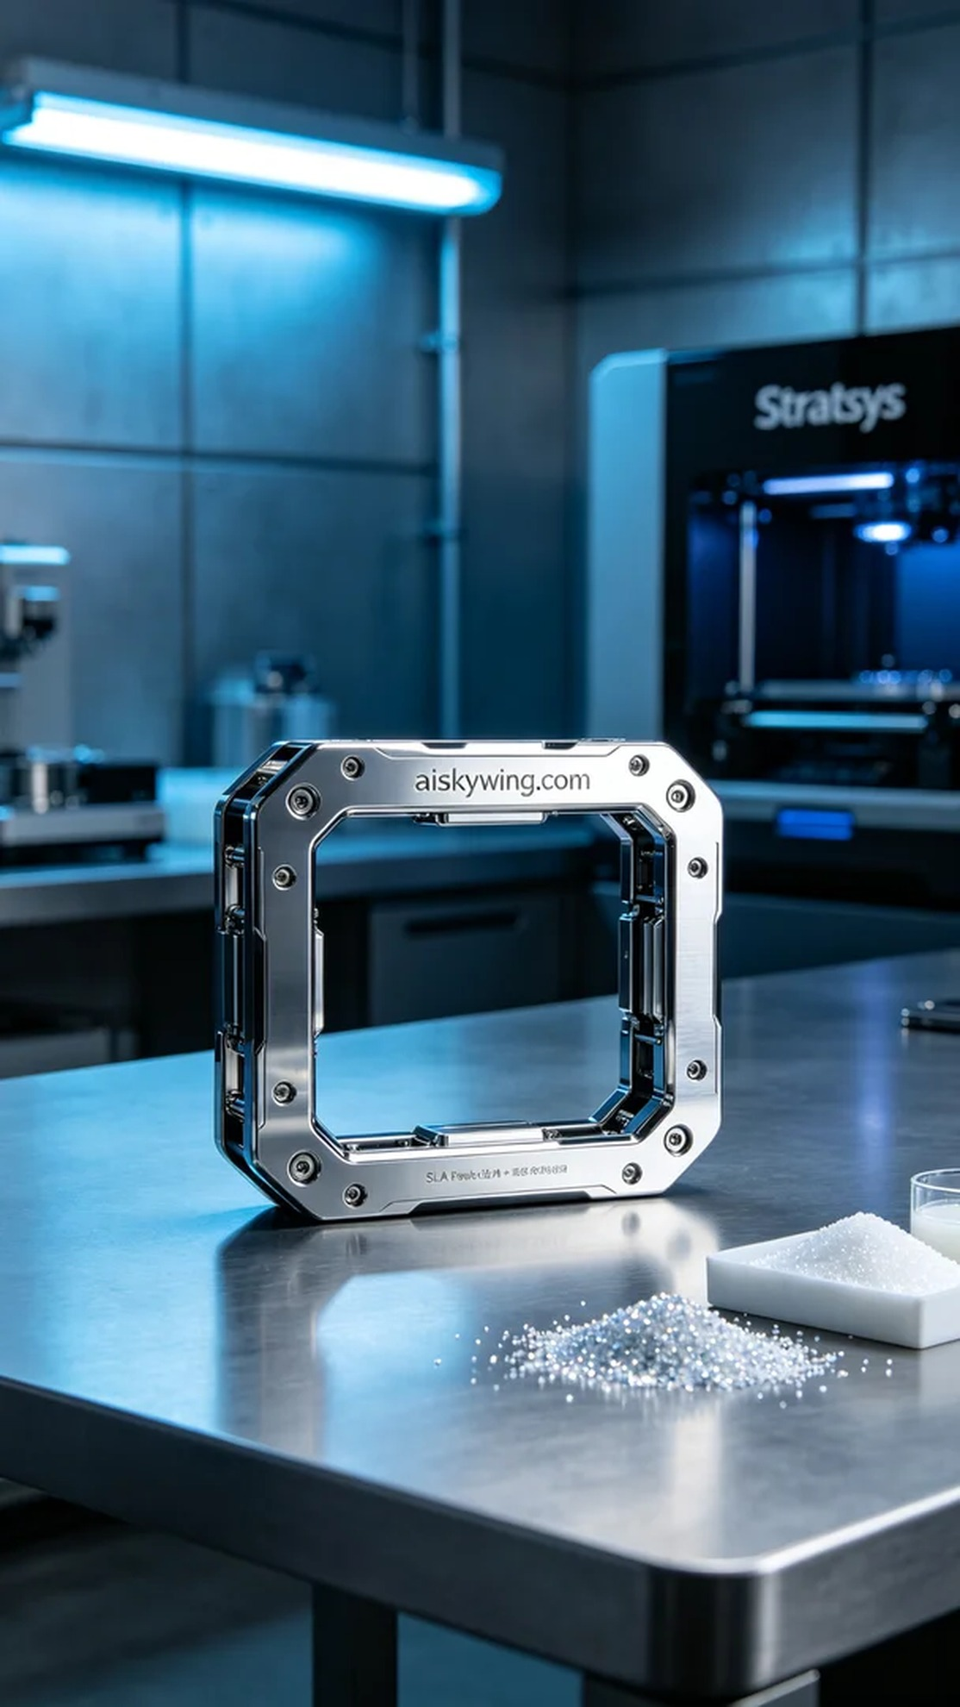
Life can be tough, but we must keep moving forward. Just like taking on this project for the product frame placed centrally in the image, I know every step is crucial.
On Instagram, someone reached out to us seeking high-quality commercial product photography, specifically requiring a product frame. They wanted the surface to exhibit extreme clarity and a glossy finish, which is precisely our forte.
We used SLA (Stereolithography) technology, with the material being high-performance SLA resin. This material possesses excellent optical properties and a fine surface finish, making it ideal for product displays. During printing, we set the layer thickness to 0.05 mm, maintained a temperature of 25°C, adjusted the power to 1200 mW, and kept the printing speed at 30 mm/s to ensure every detail was accurately captured.
Throughout the printing process, the Stratasys printer operated smoothly, ensuring the model was precisely stacked layer by layer. I conducted real-time quality monitoring to prevent issues such as bubbles and warping, and after about 8 hours, the product frame was successfully completed.
Post-processing was equally important. We utilized a dedicated cleaning device to immerse the printed frame in a cleaning solution for about 15 minutes to remove any residual resin. Next, we meticulously sanded the surface to enhance its smoothness, followed by UV curing to ensure the frame's strength and durability, confirmed through a final inspection.
In conclusion, through this meticulous process, the product frame revealed extreme detail and a mirror-like finish, perfectly meeting the requirements. This printing experience has once again made me appreciate the charm and possibilities of 3D printing.
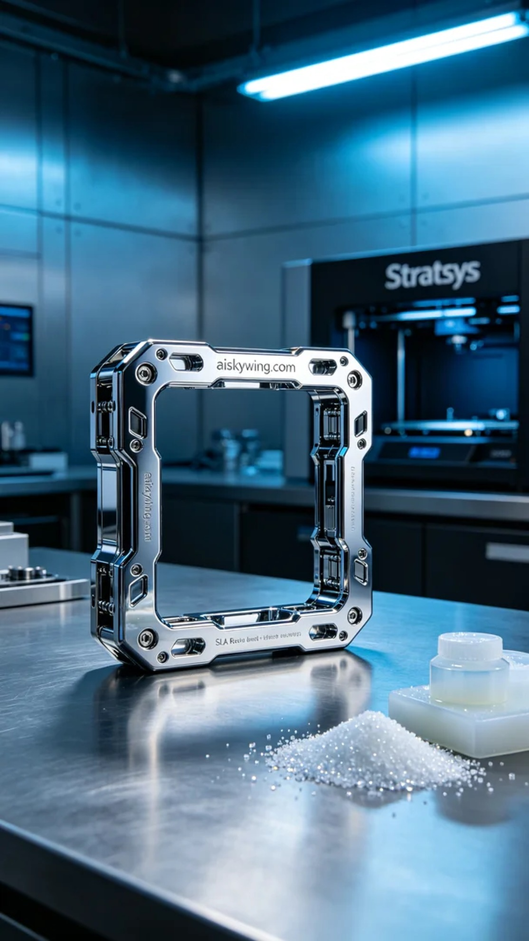
在Instagram上，有人因为寻找高质量的商业产品摄影而找上我们，特别是对产品框架的需求。他们希望框架的表面能够展现出极致的清晰和高光质感，这正是我们的强项。
我们使用的是SLA光固化技术，材料采用高性能SLA树脂，由于该材料具有优异的光学性质和细腻的表面效果，非常适合产品展示。打印时，我们设置了层厚0.05毫米，温度保持在25°C，功率调整为1200mW，打印速度为30mm/s，这样可以确保每个细节都极为准确。
打印过程中，Stratasys打印机的运行非常稳定，确保了模型在每一层的精确堆叠。我对打印质量进行了实时监控，确保无气泡和变形等问题，最终在大约8小时后，产品框架顺利完成。
后处理环节同样不可忽视。我们使用专用清洗设备，将打印完成的框架放入清洗槽中，浸泡约15分钟以去除残留的树脂。随后，进行了精细的打磨，以提升表面的光滑度，最后进行UV固化，确保框架强度和耐用性，在检验后确认无误。
最后，经过这样的制作过程，产品框架展现出了极致的细节和镜面效果，完美满足了需求。这一次的打印体验，再次让我感受到3D打印的魅力与可能性。
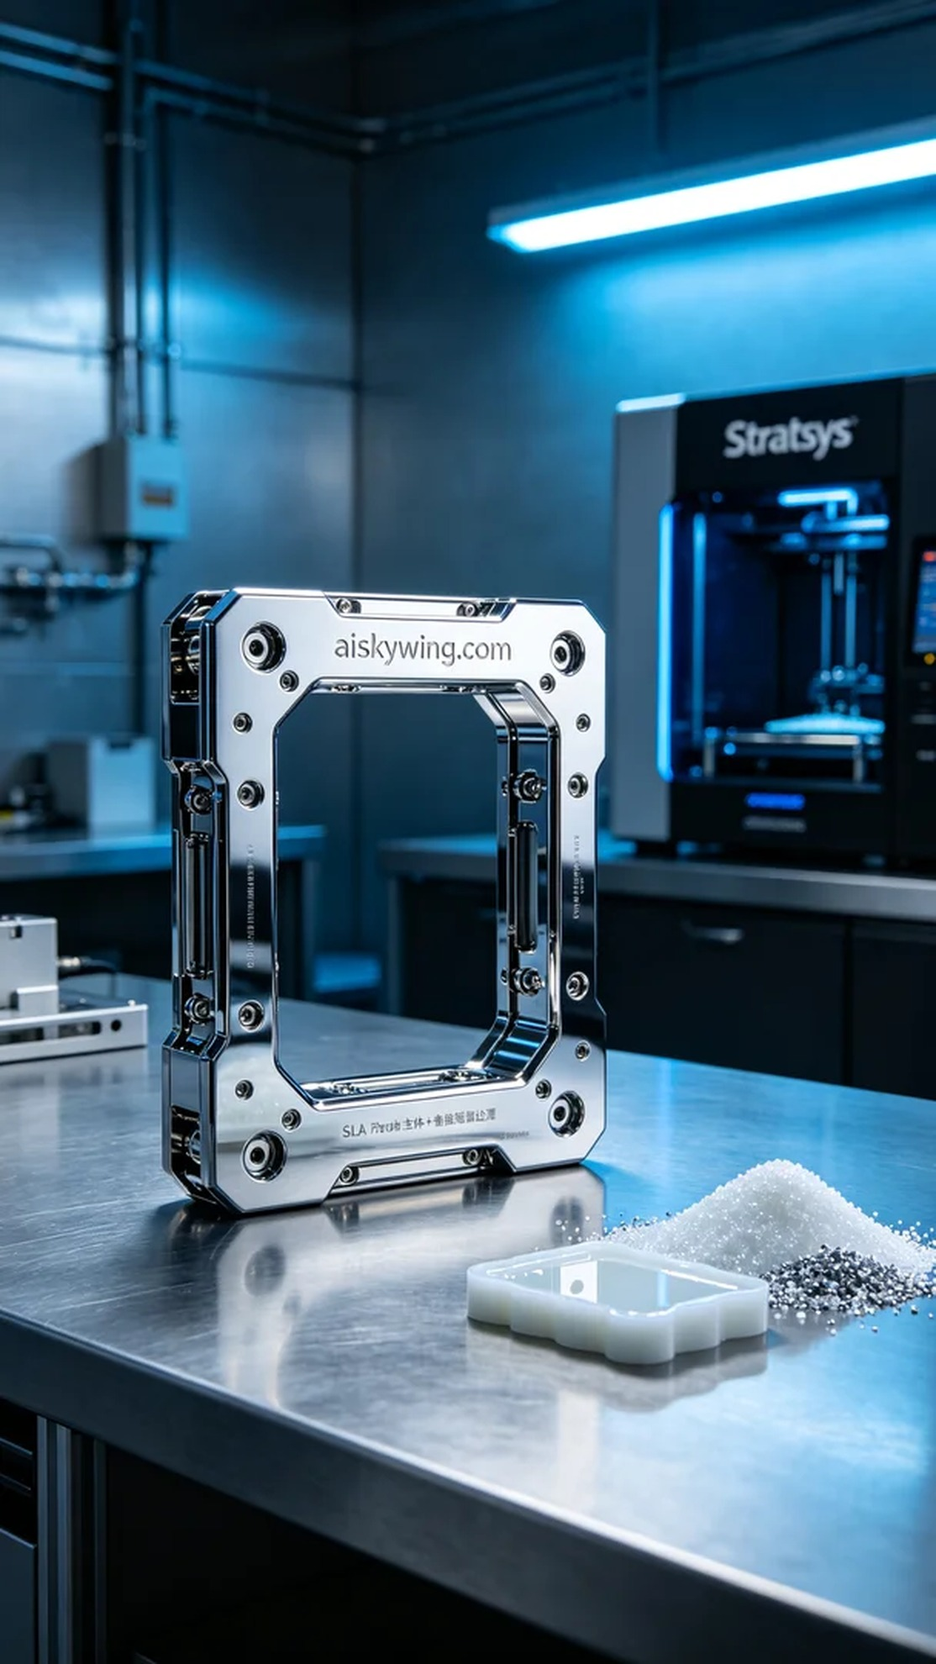
Aiskywing Industrial 3D Printing
Product Framework


