0792-3D打印仪器防护套生产记录
Instrument protective cover
🖨️ SLS尼龙烧结
🖥️ 打印机: Xjet
📦 材料: 摆放着未成型的液态光敏
生活中有时候，我们需要为某些设备提供保护。就像这份在Facebook上有人提到的仪器防护套，正是为了抵御外界的损伤而生。
In life, sometimes we need to provide protection for certain devices. Just like this instrument protective case mentioned by someone on Facebook, which is designed to withstand external damage.
________________________________________________________________________________
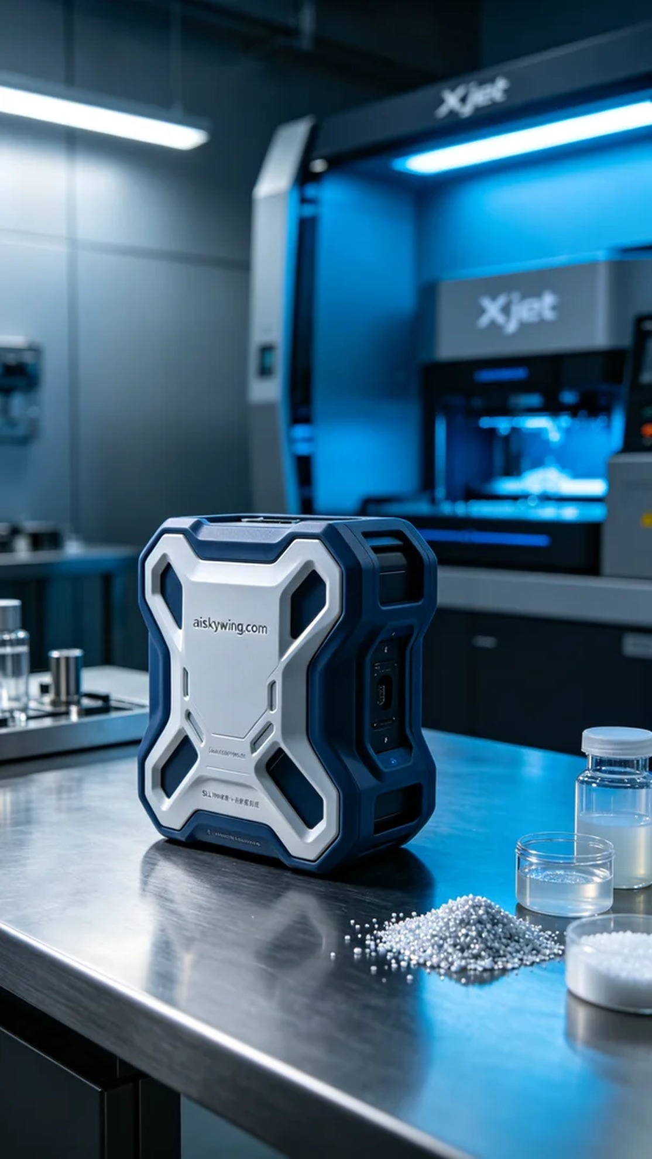
Sometimes in life, we need to provide protection for certain devices. Just like the instrument protective cover mentioned by someone on Facebook, it was designed to resist external damage.
This project originated from a friend's request on Facebook, expressing the need for a high-strength instrument protective cover. Their instruments have faced many external impacts during regular use, requiring an effective protection solution. I decided to take on this order for the instrument protective cover, striving to provide them with the best solution.
For materials, we chose unformed liquid photopolymer resin, which has excellent flow characteristics and forming capabilities, making it suitable for high-precision printing needs. To ensure the printing quality, we utilized the Xjet 3D printer, setting the layer thickness to 0.1mm, printing temperature at 60℃, power at 150W, and printing speed at 50mm/s. These parameters allow the material's properties to shine, guaranteeing the precision of each layer.
During the printing process, the stable operation of the Xjet provided peace of mind. The material was evenly sprayed onto the build platform, and as each layer was added, the structure of the protective cover gradually emerged. Throughout this process, we maintained strict quality monitoring, checking the progress regularly and making instant adjustments to any anomalies, ensuring the final product met expected standards.
After printing, we entered the post-processing stage. First, we cleaned the finished product to remove any residual liquid photopolymer resin from the surface. Next, we performed sanding to ensure a smooth surface and avoid sharp edges. Finally, we placed the product in a curing machine to enhance its strength and durability. After a careful inspection, we ensured every detail met the design requirements, marking a perfect ending for this protective cover.
Through this project, we not only completed a functional product but also deeply understood the importance of details and quality. The final instrument protective cover not only looks good but also demonstrates its robustness and durability in actual use, which makes me feel very gratified.
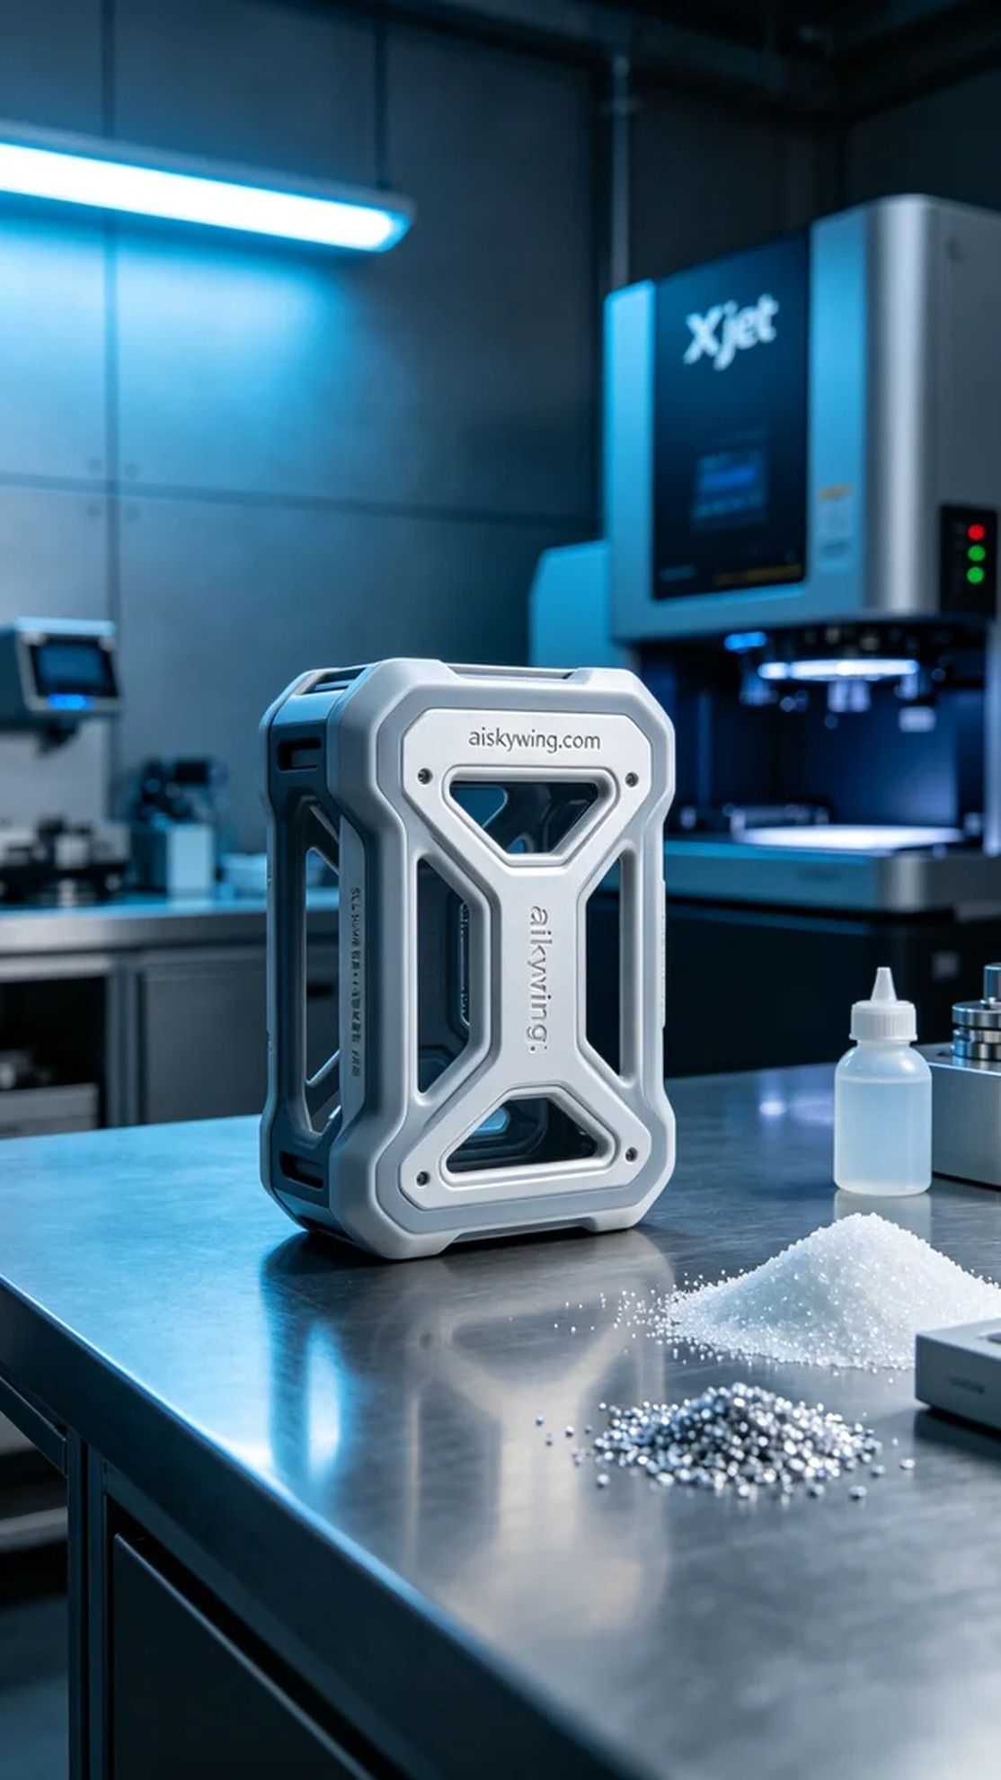
这次的项目源于一位朋友在Facebook上发求助，表达了希望得到一款高强度的仪器防护套。他们的仪器在日常使用中受到了不少外部冲击，需要一种有效的保护方案。这让我决定接下这个仪器防护套的订单，力求为他们提供最好的解决方案。
原材料方面，我们选择了未成型的液态光敏树脂，这种材料具有良好的流动性和成型性能，非常适合高精度的打印需求。为了确保打印效果，我们使用的是Xjet 3D打印机，设置了层厚0.1mm，打印温度设定在60℃，功率150W，打印速度为50mm/s。这样的参数能够充分发挥材料的特性，保证每一层的精度。
打印过程中，Xjet稳定的设备运行让我感到安心。材料均匀地喷洒在打印平台上，随着每一个打印层的叠加，仪器防护套的结构逐渐显现。在这个过程中，我们始终保持严格的质量监控，定期检查打印进度，并对任何异常情况做出即时调整，确保最终成品能够达到预期的标准。
完成打印后，我们进入了后处理工序。首先，对成品进行清洗，去除表面残留的液态光敏树脂。随后，我们进行了打磨处理，以确保表面光滑，并且避免锐利的边缘。最后，将产品放入固化机中进行固化，以增强其强度和耐用性。经过仔细检验后，确保每一处细节都符合设计要求，给这款防护套打下一个完美的结尾。
通过这次的项目，我们不仅完成了一件功能性产品，也深刻体会到细节和品质的重要性。最终的仪器防护套，不仅造型美观，更在实际使用中展现出它的坚固和耐用，这让我倍感欣慰。
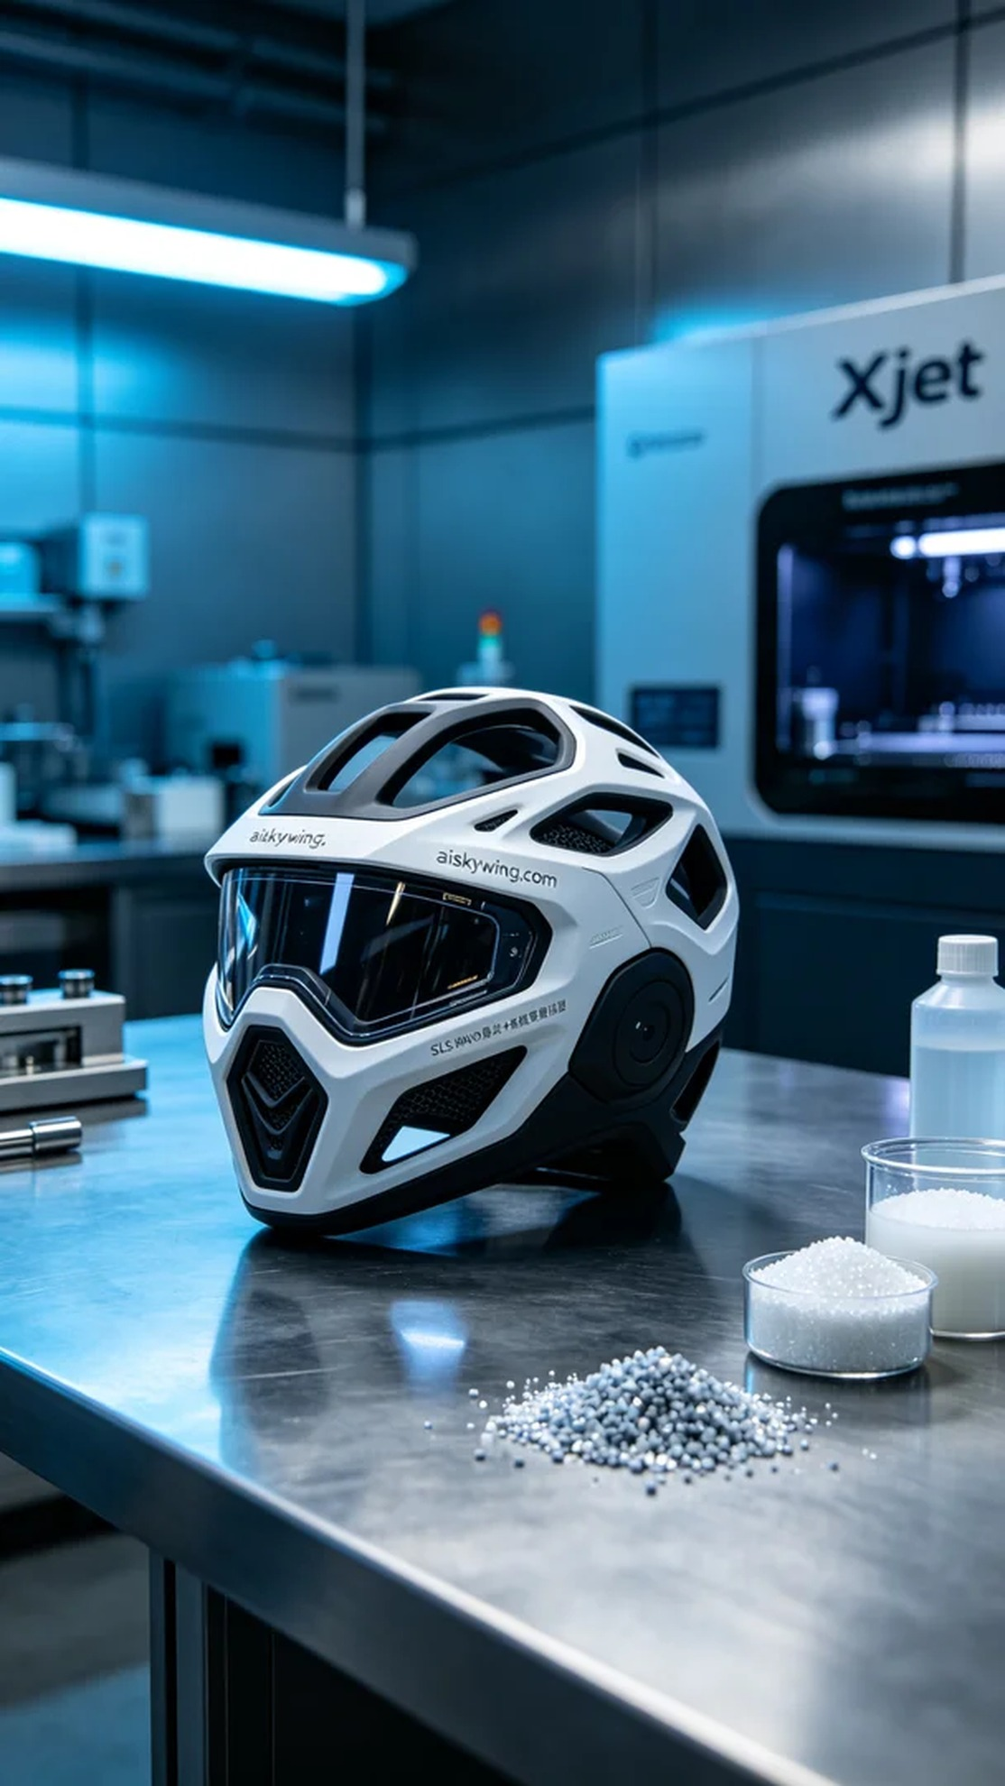
Aiskywing Industrial 3D Printing
Instrument protective cover


