0793-传感器保护套的3D打印生产记录
Sensor protective cover
🖨️ SLA光固化
🖥️ 打印机: Carbon
📦 材料: SLA
生活中总会遇到挑战，就像有人在Instagram上找到我们，希望制作一款传感器保护套。我们知道，这不仅是个产品，更是对保护的承诺。
In life, we always encounter challenges, just like when someone found us on Instagram, hoping to create a sensor protective case. We know that this is not just a product, but a commitment to protection.
________________________________________________________________________________
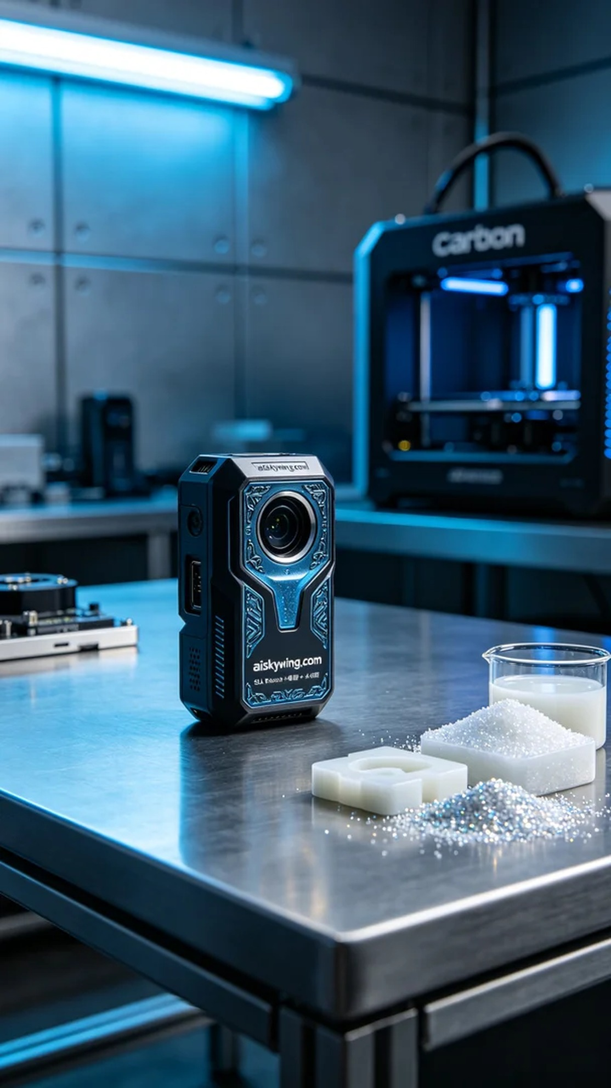
Life is full of challenges, just as someone reached out to us on Instagram, hoping to create a sensor protection case. We know this is more than just a product; it's a commitment to safeguarding their technology.
For this project, we chose SLA (Stereolithography) technology, using high-performance photosensitive resin that offers excellent detail and smooth surface finish. We utilized a Carbon printer, setting the layer thickness to 0.1mm, a printing temperature of 25°C, power at 50mW, and a printing speed of 80mm per second, with an estimated printing time of about 3 hours.
During the printing process, the Carbon printer operated efficiently, monitoring quality in real time. We carefully observed every detail to ensure the engraved “aiskywing.com” was clearly visible. Throughout the entire process, the equipment remained stable, with no faults, and the print quality met our expectations.
Once printing was complete, the protection case underwent post-processing. First, we cleaned the finished product with a cleaning solution to remove any residual liquid resin. Then, we meticulously sanded the case to ensure a smooth surface. Finally, we placed it in a curing chamber for hardening to ensure durability and strength, followed by a thorough inspection to ensure that every piece met our high standards.
After this series of production steps, the sensor protection case not only was successfully printed but also showcased outstanding quality and personalized design, fully reflecting our technical prowess and dedication to quality.
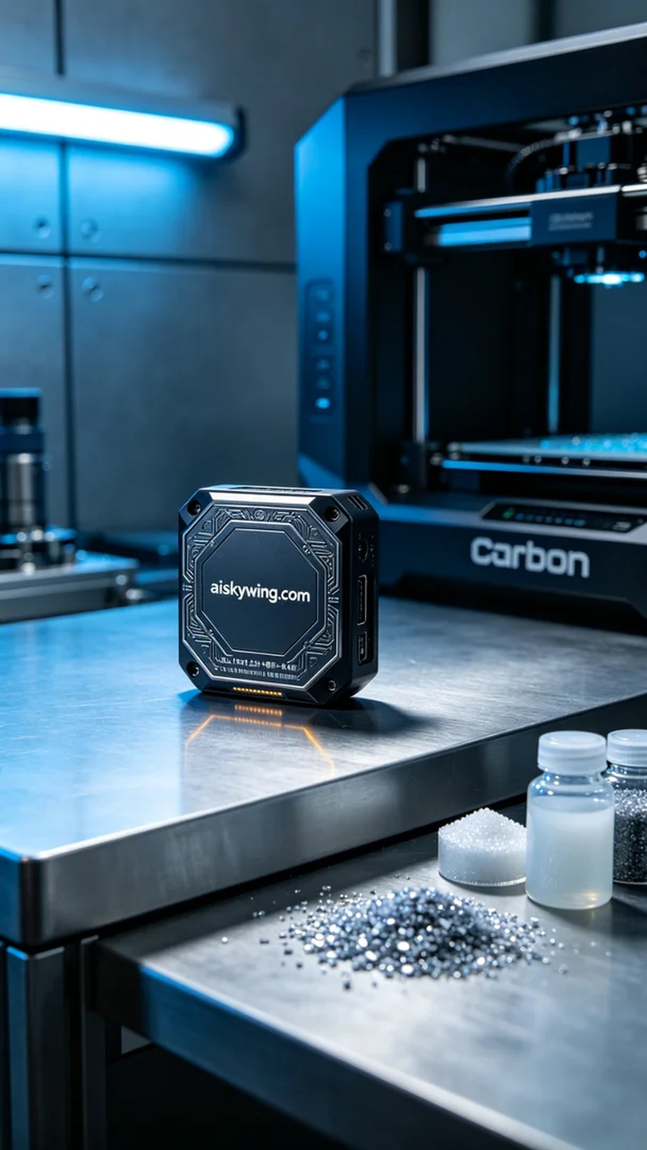
我们最近接到一个来自Instagram的需求，有人希望我们为其制作一款传感器保护套。由于工作环境特殊，客户希望这个保护套不仅具备耐用性，还能体现出个性化的设计元素，以保护传感器的同时增强其外观。
为此，我们选择了SLA光固化技术，原材料为高性能的光敏树脂，能够提供优异的细节和表面光滑度。设备方面，我们使用了Carbon打印机，打印层厚0.1毫米，打印温度设定在25°C，功率为50mW，打印速度为80毫米每秒，预计打印时间大约为3小时。
在打印过程中，Carbon打印机高效运转，实时监控质量。我们仔细观察打印的每一个细节，确保表面雕刻的“aiskywing.com”字样清晰可见。整个打印过程中，设备稳定，未出现任何故障，打印质量也达到了预期效果。
完成打印后，保护套进入后处理工序。首先使用清洗液对成品进行清洗，去除残留的液态光敏树脂。随后，我们对保护套进行细致的打磨，确保表面光滑无瑕。最后，将其放入固化设备中进行固化处理，确保其耐用性和强度，最后经过逐一检验，确保每一件产品都符合标准。
经过这一系列的制作流程，传感器保护套不仅成功完成了打印，还展现出卓越的品质与个性化设计，充分展现了我们的技术实力与对质量的追求。
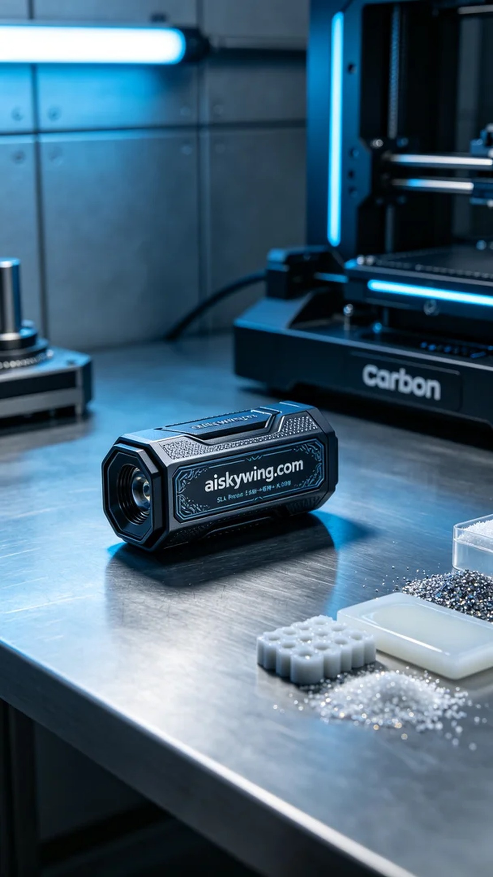
Aiskywing Industrial 3D Printing
Sensor protective cover


