0794-刀具保护套的3D打印生产记录
Knife sheath
🖨️ SLM金属打印
🖥️ 打印机: Voxeljet
📦 材料: 摆放着未成型的液态光敏
生活再难，也别停下脚步。就像接下这个刀具保护套的单子，一场关于技术与创新的旅程。
No matter how difficult life gets, don't stop moving forward. It's like taking on the order for this knife sheath—a journey of technology and innovation.
________________________________________________________________________________
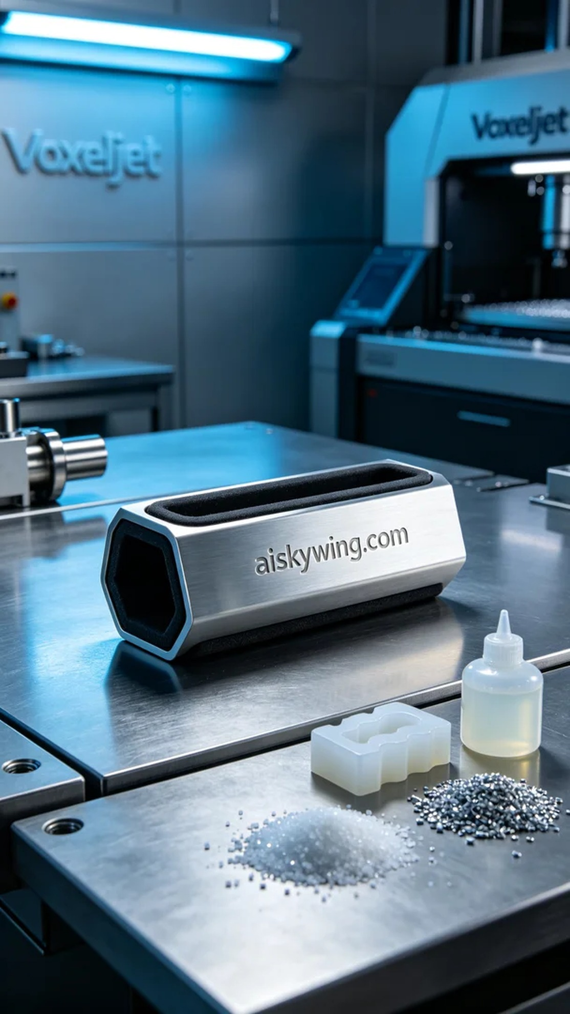
Life can be tough, but we must keep going. Just like when we took on the order for the knife sheath, a journey of technology and innovation.
On LinkedIn, someone reached out to us regarding issues with knife sheaths, requesting us to use 3D printing technology to produce a new batch. They wanted this product not only to effectively protect the knives but also to showcase a professional appearance in an industrial setting.
We chose to use unformed liquid photopolymer resin as the primary material, setting detailed parameters to ensure every detail of the printing process was optimized. With the Voxeljet printer, we set the layer thickness to 0.1mm, maintained a printing temperature of 25 degrees Celsius, set the laser power to 80 watts, and a printing speed of 20mm per hour, with an estimated print time of 4 hours to ensure fine quality and structural strength.
As the printing process began, the Voxeljet printer operated steadily, with the liquid photopolymer resin forming layer by layer under the light source. We monitored the equipment's operation throughout, with real-time visual checks for each layer's print quality to ensure no defects. Each emerging layer sparked a sense of anticipation in our hearts.
After printing, we moved into post-processing procedures. First, we cleaned the knife sheaths to remove any uncured photopolymer resin, ensuring every detail was pristine. Next, we sanded the surfaces to enhance smoothness and improve the feel. Then, we placed them in a curing device for UV curing to ensure material stability and durability, finally conducting stringent inspections on each product to meet quality standards.
After a series of meticulous processes, we successfully completed the production of the knife sheaths. This was not just a technical challenge but also a test of our team's cohesion. Each sheath that left our facility was a recognition of our craftsmanship.
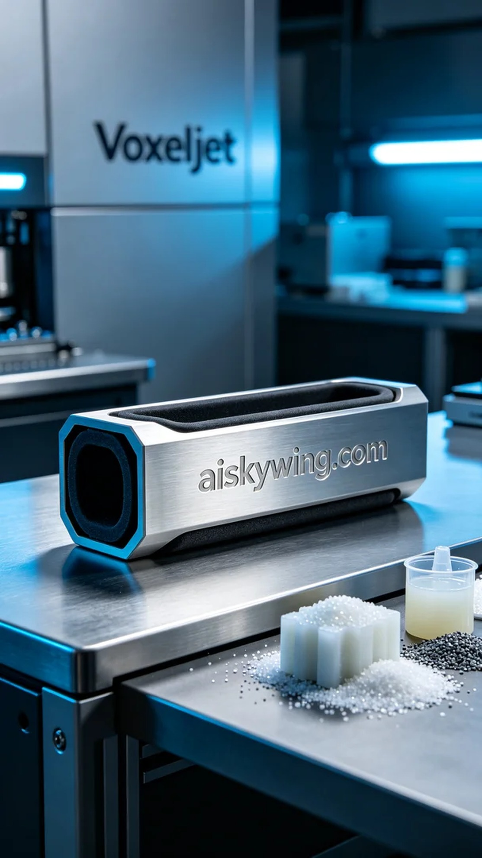
在LinkedIn上，有人因为刀具保护套的问题找上了我们，要求我们利用3D打印技术来生产一批新的保护套。他们希望这款产品不仅能有效保护刀具，也能在工业环境中展现出专业的气质。
我们选择了摆放着未成型的液态光敏树脂作为主要原材料，经过详细的参数设置，确保打印过程中的每一个细节都能达到最佳效果。使用Voxeljet打印机，层厚设置为0.1毫米，打印温度控制在25摄氏度，激光功率为80瓦，打印速度为每小时20毫米，预计打印时间为4小时，以确保精细的质量与结构强度。
打印过程开始后，Voxeljet打印机稳步运行，液态光敏树脂在光源的照射下逐层成型。我们全程监控设备的运作，每一层的打印质量都通过摄像头实时检测，确保没有任何缺陷。每当看到一层层的结构在逐渐显现，心中难免生出几分期待。
完成打印后，我们进入后处理工序。首先对刀具保护套进行清洗，去除表面未固化的光敏树脂，确保每一个细节都干净无瑕。接着进行打磨，使表面更加光滑，提升手感。然后，我们将其放入固化设备中，进行UV固化，确保材料的稳定性与耐用性，最后对每个产品进行严格的检验，确保符合质量标准。
经过一系列的精细制作，我们成功完成了刀具保护套的生产任务。这不仅是一次技术的挑战，更是对我们团队默契的考验。每个保护套的出厂，都是对自己工艺的认可。
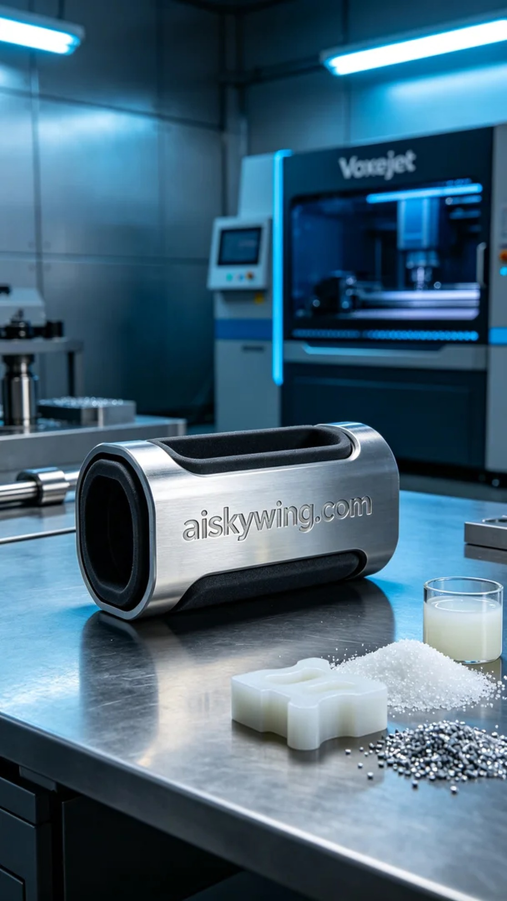
Aiskywing Industrial 3D Printing
Knife sheath


